Dr. Sarah J. Nilsson, Esq.
Sarah Nilsson has both an aviation and a legal background.
She began her pilot career in 1994 and has run a flight school at a local high school magnet program, flown cargo aircraft, and business jets, having been typed in a Citation. She holds an FAA Airline Transport Pilot (ATP) certificate in multi and single engine fixed-wing airplanes, a gold seal flight instructor CFI, CFII, MEI, a small UAS or drone pilot certificate and a TRUST certificate. She also holds North Carolina’s Division of Aviation UAS Operators Knowledge Test Certificate of Completion. In Canada, she holds Transport Canada’s Pilot Certificate in Small Remotely Piloted Aircraft Systems (RPAS), Visual Line-of-sight (VLOS). In the EU, Sarah holds UK’s Drone and model aircraft certificate in A1 & A3 Open Subcategory.

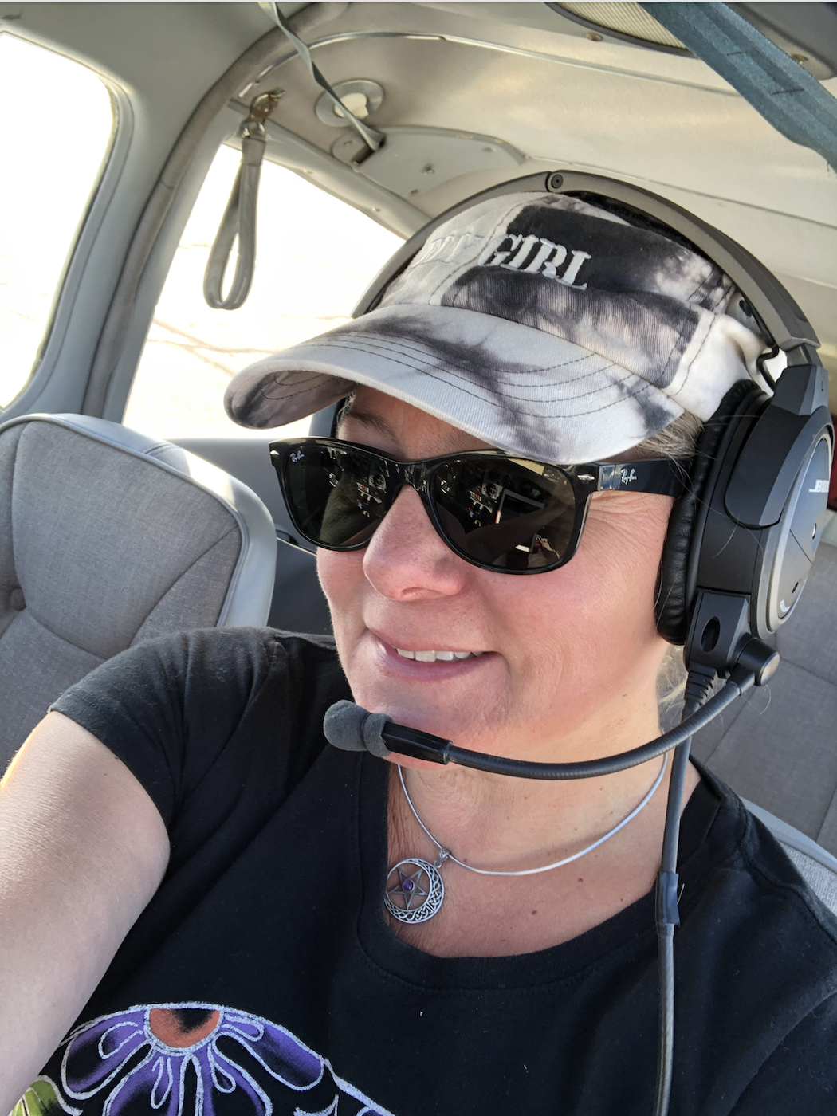

In 2014, Sarah began her legal career, becoming licensed by the State Bar of Arizona and becoming founder and managing attorney of Nilsson Law, PLLC. Since 2015, she has been full-time faculty at Embry-Riddle Aeronautical University (ERAU) in Prescott, Arizona, teaching Aviation Law, Global UAS Regulations, Concepts in Advanced Air Mobility (AAM), Global UAS Risk Management, UAS Ground School, How to start a small UAS Business, Business Law, and Business Ethics. She is now a tenured professor, and for four years led the Faculty Senate as Speaker. Sarah volunteers as a FAA Safety Team Representative with the Scottsdale Flight Standards District Office (FSDO). During the pandemic, she flew as a command pilot with Angel Flight West as she felt the need to put her Cherokee 235 (aka Flying Broom) to good use!
Sarah is co-author of the 6th, 7th, and soon to be 8th edition of Practical Aviation and Aerospace Law, with Scott Hamilton. In 2017, she published her own book on U.S. Drone Law for the American Bar Association entitled Drones Across America. And in 2023, she published a free eBook for ERAU entitled Drones Across the World. Sarah has made multiple media appearances as an expert in UAS regulation, law, and policy and has published many articles and research documents for the FAA and NASA.
