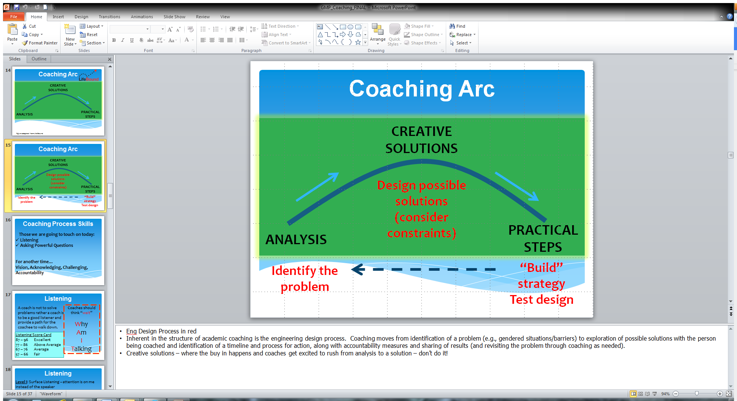

**Practical steps – specific strategies, timeline, accountability, etc. ormplementation**

**Brainstorm Creative Solutions – also consider constraints**

**Analysis – ID the problem**