Robert’s Rules of Order
Summary of 295 pages of Parliamentary Procedure
By Sarah J. Nilsson, Esq.

Rules of Order: shows how business is introduced in a deliberative assembly, and then follows it step by step until the vote is taken and announced

Motions: used to accomplish certain objects – proposal that assembly take an action or express certain views – member can make 2 motions at a time only by general consent
- Privileged Motion = while having no relation to pending question, are of such urgency or importance as to require them to take precedence over all other motions – undebatable – no subsidiary motion can be applied to them, except motion to fix time to which to adjourn and to take a recess, which may be amended
  - Fix the time to which to adjourn (if made while another question is pending)
  - Adjourn (if unqualified and if it has not the effect to dissolve the assembly)
  - Take a recess (if made when another question is pending)
  - Raise a question of privilege
  - Call for the orders of the day

- Incidental Motion = arises out of another question that is pending and must be decided before the pending question or other business – no fixed rank but take precedence of motion from which they arise
  - Accept or adopt a report (upon subject referred to committee)
  - Adjourn at, or to, (a future time)
  - Adjourn (dissolve assembly with no provision for reconvening)
  - Appoint the time and place for next meeting
  - Amend the constitution, by-laws, standing rules, resolutions, etc. (already adopted)
  - Ratify or confirm (action taken)
  - Rescind or repeal (action taken)
most common incidental motions:
    - Questions of order and appeal
    - Suspension of the rules
    - Objection to the consideration of a question
    - Division of a question
    - Consideration by paragraph or seriatim (taking one subject after another in regular order, point by point)
    - Division of the assembly
    - Motions relating to methods of voting, or closing or reopening the polls
    - Motions relating to methods of making, or to closing, or reopening nominations
    - Requests growing out of business pending or that has just been pending (a Parliamentary inquiry, a request for information, for leave to withdraw a motion, to read papers, to be excused from a duty, or for any other privilege)

- Subsidiary Motion = may be applied to a main motion for purpose of modifying them, delaying action upon them, or disposing of them – also known as secondary motions – all except for to lay on the table the previous question and to postpone indefinitely may be amended
  - Lay on the table
  - The previous question
  - Limit or extend limits of debate
  - Postpone definitely or to a certain time
  - Commit or refer or recommit
  - Amend
  - Postpone indefinitely

- Main Motion = made to bring before the assembly any particular subject – NO main motion can be made when another motion is PENDING – debatable – subject to amendment – also known as principal motion – if referred to committee it carries with it only pending amendments – can be:
  - original (brings a new subject, or resolution) that can be prevented to be considered by 2/3 vote or
  - incidental (relates to business of assembly or past/future action)

Accepting a report = adopting it
Receiving a report = allowing it to be presented to the assembly
Assembly = deliberative body = proper name of society, club etc.
Chair = presiding officer, whether temporary or permanent
Meeting = the assembling of the members of a deliberative body for any length of time during which they do not separate for longer than a few minutes
Session = the entire series of meetings lasting several days
Pending = question stated by chair that has not yet been disposed of either permanently or temporarily
Immediately Pending = when several questions are pending, the last one stated by the chair and thus the first disposed of
Previous Question = motion to close debate and take the vote at once on the immediately pending question (and such other questions as specified in the motion)
Substitute = amendment where an entire resolution or section, or one or more paragraphs, is struck out and another resolution or section, or one or more paragraphs, is inserted in its place
Plurality = when one candidate has a larger vote than any other candidate – in an assembly it never elects except by virtue of a rule to that effect
Majority = when one candidate has more than half the votes cast, ignoring blanks – in an assembly a quorum must be present
Two-thirds Vote = two-thirds of votes cast
Resolution = always a main motion – should be in writing starting with Resolved, That… - if paid employees are in the assembly then replace resolved with ordered – to seek adoption of resolution member says I move the adoption of the following resolution then reads it (reasons for it may be stated in preamble each clause of which constitutes a paragraph starting Whereas – no periods in preamble – each paragraph should close with comma or semicolon followed by and except last paragraph which ends with therefore, be it. – changes to preamble are always done last)

Obtain the floor
- Member raises hand and addresses chair – Mr./Madam Chair
- Member states name (if unknown to chair)
- Chair recognizes member (if entitled) and announces members name to assembly

Before debate
- Member who has obtained the floor makes a motion – I move that…
- Motion is seconded (with certain exceptions) – to prevent waste of time in considering a question that only one person favors – I second the motion
Motions that DO NOT require a second:
- To raise a question of privilege
- Questions of order
- Objection to the consideration of a question
- Call for orders of the day
- Call for division of the question
- Call for division of the assembly (in voting)
- Call up motion to reconsider
- Filling blanks
- Nominations
- Leave to withdraw a motion
- Inquiries of any kind
- Chair states the motion (making it the immediately pending question) – It is moved and seconded that the following resolution be adopted… - if the matter is debatable or amendable the chair says Are you ready for the question? – if no one rises then the chair should put the question to vote

Member has precedence who first raises to address chair after floor is yielded
Except:
- When a debatable question is immediately pending – preference is given to member who brought question and member who reports or submits a committee report and member who made motion to reconsider – member who has not yet spoken gets precedence over member who already spoke – otherwise friends and enemies of a measure take turns
- When an undebatable question is immediately pending – or if no question is pending then member who rises to reconsider a vote, or to call up a previously made motion to reconsider, or to take a question from the table, is entitled to the floor ahead of a main motion
- When no question is pending – when one series of motions has been disposed of and assuming no question is pending then next in series – motion may be introduced to lay a question on the table temporarily in order to take up more urgent business – when a member moves to reconsider a vote for the announced purpose of amending the motion, if the vote is reconsidered, she must get preference

In order when another has the floor
After a member is assigned the floor she can only be interrupted by:
- Motion to reconsider
- Point of order
- Objection to the consideration of the question
- Call for the orders of the day (when not conformed to)
- Question of privilege
- Request or demand that question be divided (when it contains more than one independent resolution on different subjects)
- Parliamentary inquiry
- Request for information (when it requires immediate answer)

Debate
All resolutions, reports of committees, communications to the assembly, all amendments proposed to them, and all motions except undebatable ones may be debated until final action is taken, unless by 2/3 vote (quorum present) the assembly decides to dispose of them without debate
In debate each member can speak twice on same question on same day (but can’t make second speech until others who had no say get to speak)
No one can speak for more than 10 minutes at a time without permission of the assembly
Debate must be limited to merits of immediately pending question
Speakers must address remarks to chair
Speakers must be courteous in their language and deportment
Speakers must avoid all personal comments never alluding to the officers or other members by name or to the motives of members

Putting the question and announcing the vote
When debate closed chair puts the vote and says Are you ready for the question?
The question is to…
Those in favor of the resolution say aye and show hands
Those opposed say no and show hands
The ayes have it and the resolution is adopted OR The noes have it and the resolution is lost
The vote should always be announced

Motions requiring 2/3 vote
- Motion to suppress or limit debate
- Motion to prevent the consideration of a question
- Motion without notice to rescind action previously taken
- Motion to amend by-laws, constitutions, and rules of order already adopted
- Motion to rescind action previously taken

Rank of Ordinary Motions
Highest on top
When any one is immediately pending the motions above it are IN ORDER
Those below it are OUT OF ORDER
2/3 means requires a two-thirds vote
The rest require a majority

Undebatable | Fix the time to which to adjourn  (Can be amended)  (Privileged only when made while another question is pending and when no provision for another meeting on the same or next day) | Privileged | Majority
Undebatable | Adjourn  (Privileged only when made while another question is pending and when no provision for another meeting on the same or next day) | Privileged | Majority
Undebatable | Take a recess  (When privileged can be amended)  (Privileged only when made while other business is pending) | Privileged | Majority
Undebatable | Raise a question of privilege | Privileged | Majority
Undebatable | Call for the orders of the day | Privileged | Majority
Undebatable | Lay on the table  To lay a question aside temporarily with the right to take it up at any moment when the time is right even next session  Carries with it all subsidiary motions
Undebatable | Previous question  To close debate and bring a vote | Subsidiary | 2/3
Undebatable | Limit or extend limits of debate  (Can be amended)  Objection to its consideration  To prevent any consideration of the question | Subsidiary | 2/3
Debatable | Postpone to a certain time  (Can be amended)  Defer action to another day  Make a special order (2/3 vote)  To take action at other than proposed time that it was deferred to | Subsidiary | Majority
Debatable | Commit or refer  (Can be amended)  If too time consuming to make changes the question can be referred to a committee | Subsidiary | Majority
Debatable | Amend  (Can be amended)  When motion is improperly worded or requires change  Amend by inserting, adding, striking out, striking out and inserting, or substituting one or more paragraphs | Subsidiary | Majority
Debatable | Postpone indefinitely  To suppress a question  Equivalent to rejecting it | Subsidiary | Majority
Debatable | A main motion  (Can be amended) | Subsidiary | Majority
 | To consider a question a second time  To take from the table  When a question has not been voted on but has been laid on the table |  | Majority
Reconsider
If motion has been adopted, or rejected, or postponed indefinitely, and afterwards members change views so that they may want to reverse action
Rescind
If motion has been adopted, or rejected, or postponed indefinitely, and no one is both able and willing to move to reconsider the vote question can be brought up by moving to rescind
To prevent final action on a question in an unusually small or unrepresentative meeting
Member must move to reconsider the vote and have it entered on the minutes

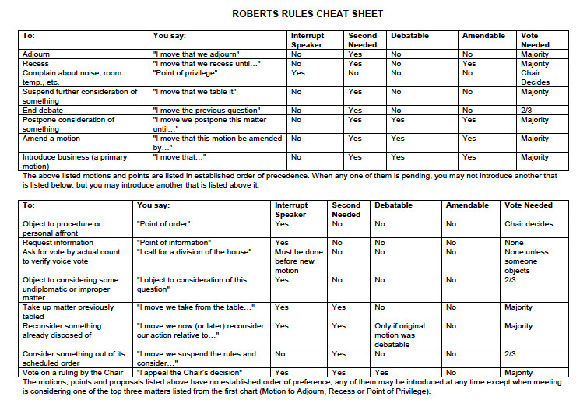

Typical Order of Business

A. Call to Order
B. Opening Exercises, if applicable
C. Roll Call/Determination of a Quorum
D. Adoption of the Agenda
E. Reading and Approval of the Minutes of the Previous Meeting
F. Reports of Officers
G. Reports of Standing Committees
H. Reports of Special (Ad hoc) Committees
I. Special Orders
J. Unfinished Business and General Orders
K. New Business
L. Program, if applicable
M. Announcements
N. "Good of the Order"
O. Adjournment

