Prescott Regional Airport: Growing pains in 2022?

This paper addresses some of the growing pains around the Ernest A. Love Field – Prescott Regional Airport (PRC). First, an overview of how funding for the airport has been, and continues to be, obtained from the Federal Aviation Administration (FAA) in the form of Airport Improvement Program (AIP) grants including the grant assurances, or strings attached to said grants. Next, an overview of the Airports Capital Improvement Plan (ACIP) will provide additional insight. Zooming in from national to state planning, a brief overview of the Arizona Department of Transportation (ADOT) Airport Master Plan; and zooming in further, a brief look at local planning and the City of Prescott Airport Specific Area Plan (ASAP). Finally, addressing the land around the airport, a brief look at the zoning map approved by the city as well as the Land Development Code (LDC). Throughout this paper, issues will be addressed including, but not limited to, land use zoning, noise, safety, and avigation easements.
Airport Improvement Program (AIP)
The AIP provides grants to public agencies for the planning and development of public-use airports that are included in the National Plan of Integrated Airport Systems (NPIAS). NPIAS identifies nearly 3,310 existing and proposed airports that are included in the national airport system, the roles they currently serve, and the amounts and types of airport development eligible for federal funding under the AIP over a span of 5 years. The NPIAS contains all commercial service airports, all reliever airports, and selected public-owned general aviation airports.
The current NPIAS list describes Ernest A. Love Field – Prescott Regional Airport (PRC) as being publicly owned (as opposed to private, military, or Native American). PRC offers primary commercial service (as opposed to non-primary commercial service, reliever, or general aviation). PRC is classified as a small nonhub (a hub is defined in statute to delineate commercial service airports based on the percentage of total passenger enplanements). Nonhubs constitute the largest group of primary airports and accounted for almost 15% ($6.2 billion) of the development needs in 2021.
Airfield reconstruction, bringing the airport up to standards, terminals, and safety (like pavement reconstruction, obstruction removal, acquiring Aircraft Rescue and Fire Fighting (ARFF) equipment, and runway safety area improvements) improvements are the FAA’s focus for the nonhub airports from 2021 through 2025. The enplaned passengers, the number of revenue passengers that boarded aircraft at PRC during calendar year 2018 (fiscal year 2020), was 10,337. PRC’s based aircraft (the number of registered aircraft hangared or based at PRC) was 264. Note that this total includes single engine, multi engine, jets, and helicopters but not military aircraft, ultralights, gliders, and balloons.
The development estimate is defined as a 5-year estimate of airport improvements that are eligible for federal development grants under the AIP. The costs associated with planning (master plans, regional and State system plans, and environmental studies) are not captured in the development cost total. The development estimate for PRC for the 5-year period from 2021 to 2025 was $15,521,226.
For large and medium primary hub airports, the AIP grant covers 75% of eligible costs (or 80% for noise program implementation). For small primary, reliever, and general aviation airports, the grant covers a range of 90-95% of eligible costs, based on statutory requirements. To be eligible for a grant, an airport must be included in the NPIAS, which is prepared and published every 2 years and identifies public-use airports that are important to public transportation and contribute to the needs of civil aviation, national defense, and the Postal Service. Recipients of grants are referred to as “sponsors”. Eligible grant activities relate to capital items serving to develop and improve the airport in areas of safety, capacity, and noise compatibility.
For the FAA to consider a project for AIP funding, the project must be reasonably consistent with the plans of planning agencies for the development of the area in which the airport is located, and the project must be depicted on a current Airport Layout Plan (ALP) approved by the FAA. Hence, the pages that follow include Arizona Department of Transportation (ADOT) Airport Master Plan for Prescott, and the City of Prescott Airport Specific Area Plan (ASAP).
Additionally, and of great significance, a sponsor must be legally, financially, and otherwise able to carry out the assurances and obligations contained in the project application and grant agreement. Hence, the pages that follow include the entitled Grant Assurances and Obligations for all existing AIP disbursements.

The image below from the most current NPIAS shows PRC to be classified as a small/nonhub airport.
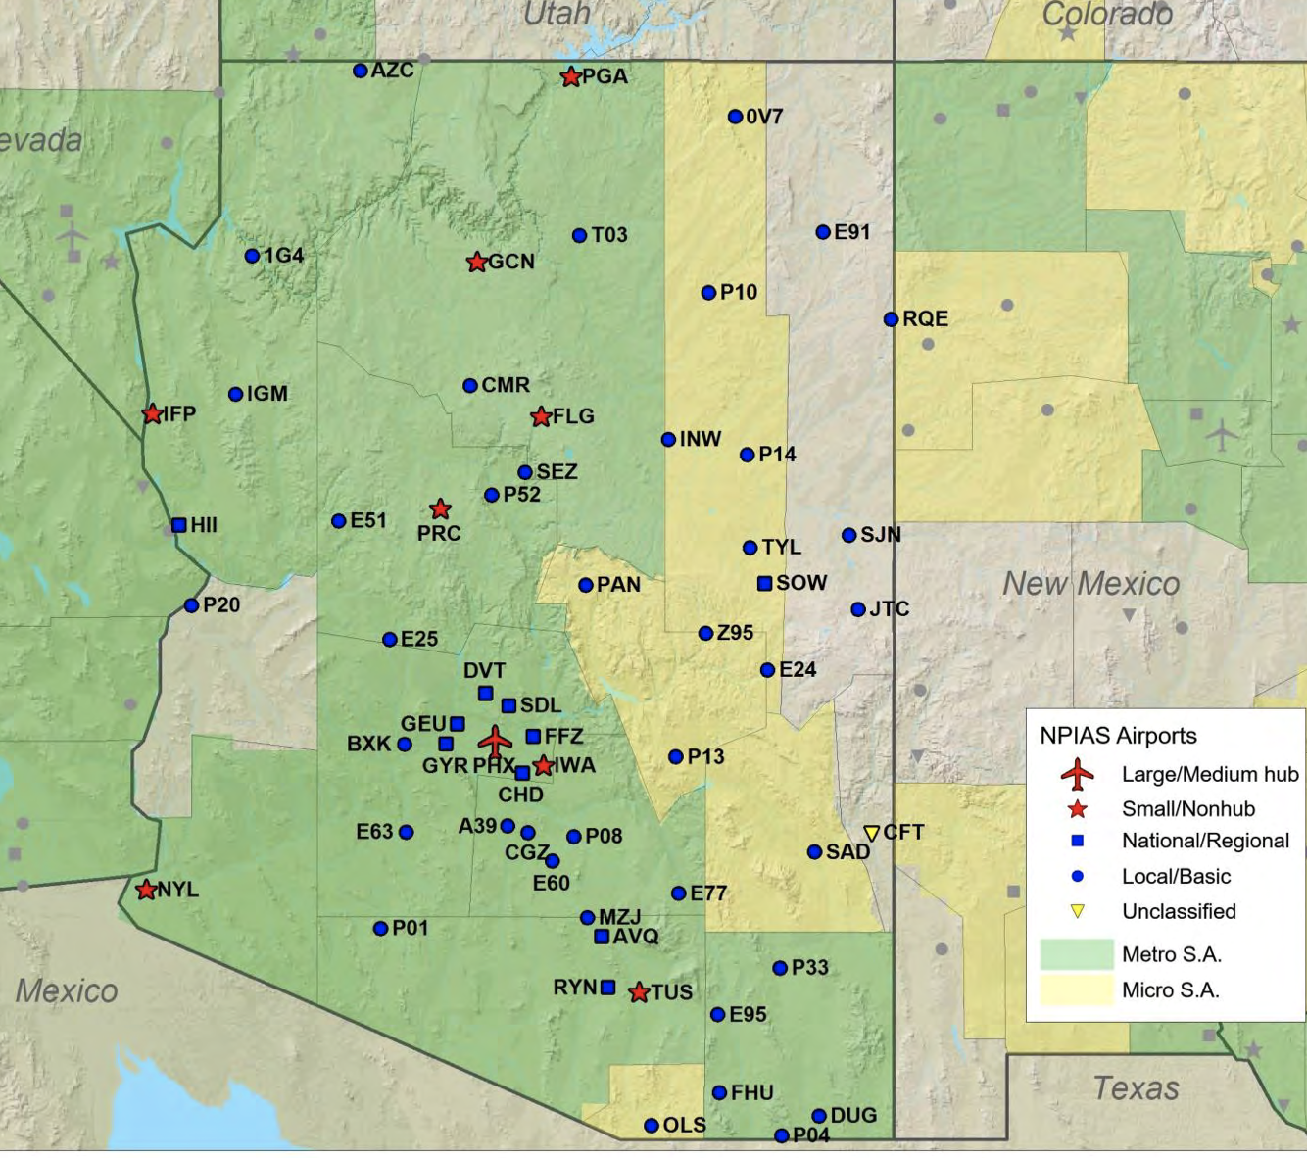
The FAA reviews the airports in the NPIAS on a periodic basis and adjusts their hub/role in the federal system. The next review by the FAA will be complete in 2022. The FAA last completed a national capacity evaluation in early 2020, prior to the substantive impacts of the COVID-19 public health emergency on aircraft activity levels across the system. Thus, the evaluation should be understood as a representative snapshot of 2019 activity levels and forecasts. Future results should therefore be interpreted with caution as the timing of airport congestion levels is expected to be markedly slower than presented here due to the uncertain timeframe for recovery of the aviation industry. The FAA is expected to update this evaluation using revised forecasts in the 2023 NPIAS.
AIP funding splits into two categories and types of funding according to AIP legislation: (1) apportioned funds, or entitlements, designated under 49 U.S.C. § 47114 which are determined by formula and available to airport sponsors annually; and (2) discretionary funds, designated under 49 U.S.C. § 47115, which remain after entitlement distributions and include several set-aside amounts for specific project types designated under 49 U.S.C. § 47116 and 49 U.S.C. § 47117.
Airports Capital Improvement Plan (ACIP)
The national Airports Capital Improvement Plan (ACIP) is an internal FAA document that serves as the primary planning tool for identifying and prioritizing critical airport development and associated capital needs for the National Airspace System (NAS). It also serves as the basis for the distribution of grant funds under the AIP. ACIP guidance is available in the Formulation of the NPIAS and ACIP, Order 5090.5. The FAA Airport Improvement Program Branch prepares the national ACIP annually based on 9 Regional ACIPs. Each FAA Regional Airports Office prepares its Regional ACIP from information provided by individual airports or state airport planning agencies on anticipated development needs over the next 3 to 5 years.
The ACIP, a subset of the NPIAS, is a needs-based and financially constrained plan for funding development over a rolling 3-year period. Rolling means that the start date of the 3-year term updates on a specific date every year so that the current year is the beginning of the term. It serves as the basis for the distribution of AIP grant funds, and it emphasizes funding the highest priority projects.
Arizona Department of Transportation (ADOT) Airport Master Plan for Prescott
In 2010, ADOT, published the Airport Master Plan for Prescott. Updating an Airport Master Plan (AMP) is a standard industry practice. The FAA suggests that updates should be considered approximately every 5-20 years to maintain the currency of the data, the airport standards, and reassess airport needs. The AMP has two components: (1) the Report which documents the analytical process and the Airport Layout Plan (ALP) which serves as the graphic representation for future development at the airport. It is the ALP which is approved by the FAA and the airport sponsor, in this case the City of Prescott. Alternative use of the AMP is to serve as a guide for the city when reviewing private investment at the airport and when reviewing land use development around the airport to ensure compatibility with FAA airspace requirements and the environment. What follows are pictures of the Land Use and Access Plan, the Terminal Area Plan, the Runway Plans and Profiles, and the Airport Layout Plan.
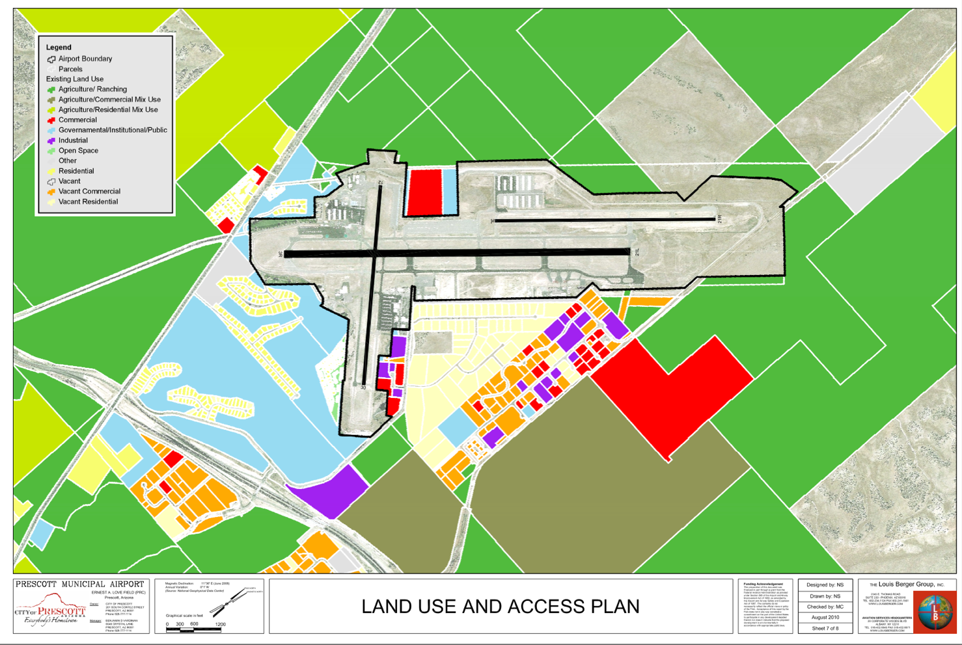
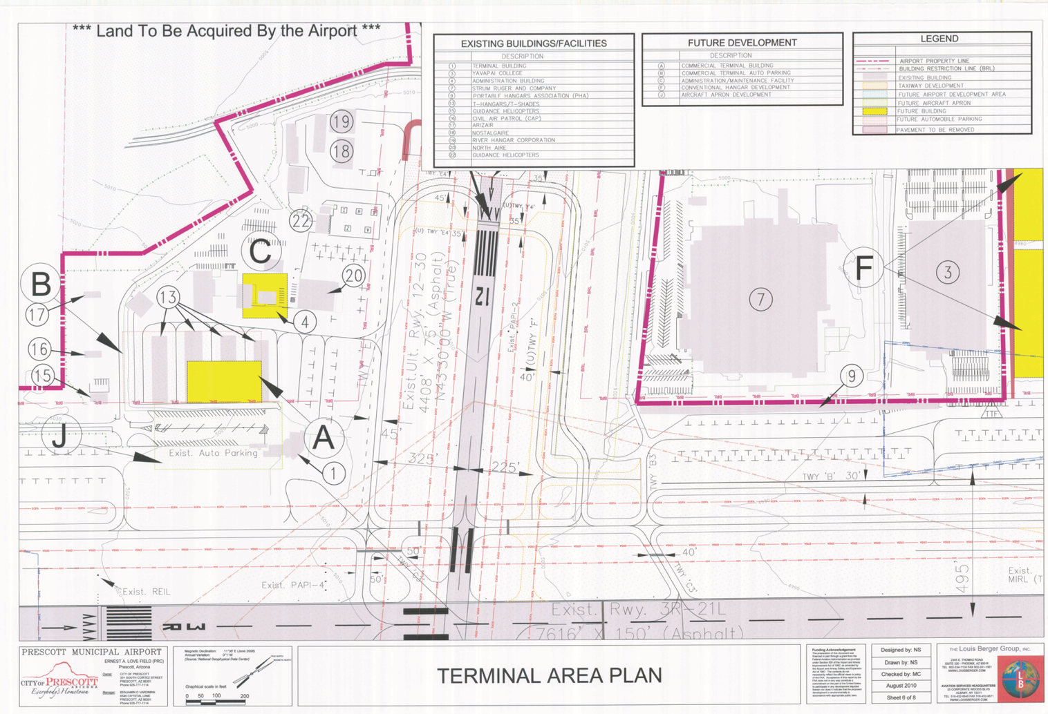
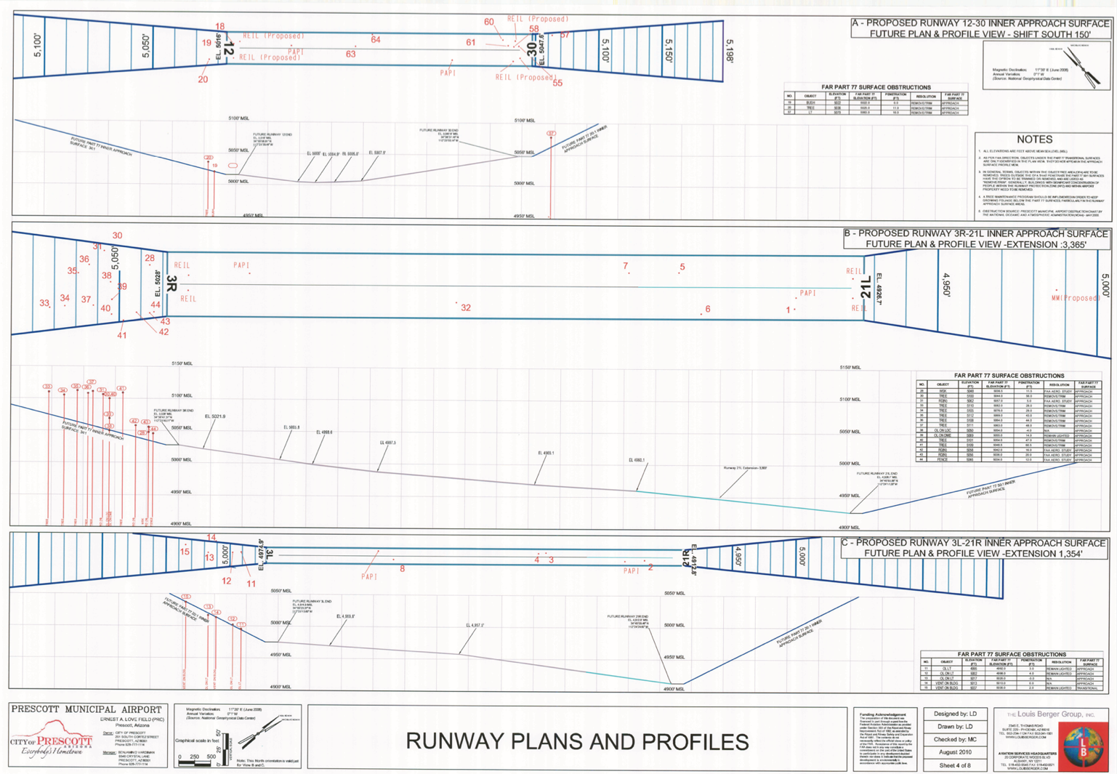
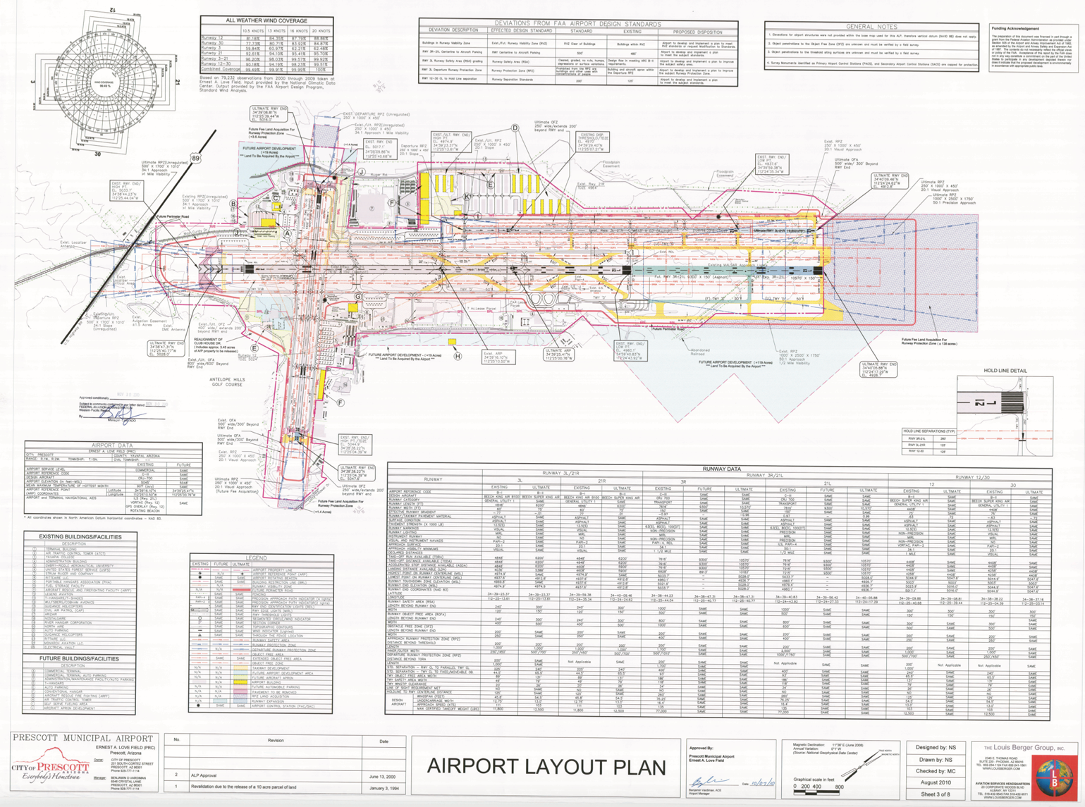
Between 2000 and 2010, more than 60% of operations at PRC were local, highlighting the contribution of flight training operations at the airport. As of 2021, Embry-Riddle Aeronautical University operates more than 45 airplanes. Airline service in 2021 is offered by United Express operated by SkyWest Airlines, which operates under the provisions of an Essential Air Service (EAS) contract. The EAS is a program operated by the USDOT that provides subsidies to airlines which agree to provide service on historically non-profitable routes to rural areas.
Based aircraft are defined as non-transient aircraft that either hangar or tie down at the airport. These aircraft are one of the biggest factors in planning for future facility needs. The number of based aircraft correlates to the operational demands they place on airport facilities such as runways, taxiways, lighting, and navigational/visual aids. Additionally, they directly relate to ground facilities, such as hangar storage, fueling facilities, and aircraft service and repair needs.
Flight training by Embry-Riddle Aeronautical University, Guidance Helicopters, Inc., North-Aire Aviation, LLC., Alpha International Aviation, Leighnor Aircraft, TacAero, and Universal Helicopters, constitutes more than 70% of daily operations in 2021. This makes Prescott the 25th busiest airport in the nation.
Regulations on the protection of an airport’s airspace are defined by 14 Code of Federal Regulations (CFR) Part 77, Objects Affecting Navigable Airspace. Part 77 establishes a requirement for anyone proposing to build a structure near an airport to report their intentions to the FAA. Additionally, it defines a series of standards used for determining obstructions to an airport’s navigable airspace. This is accomplished through the establishment of a set of airport imaginary surfaces, that if penetrated represent an obstruction to air navigation. In some instances, they may be also classified by the FAA as a hazard.
Airport imaginary surfaces consist of the following 5 elements.
(1) Primary Surface is longitudinally centered on each runway and extends 200 feet beyond each runway end (if the runway is paved). The elevation of the primary surface of a given runway is the same as that of the nearest point on the runway centerline.
(2) Approach Surface is a trapezoidal-shaped surface that begins at the primary surface of each runway end, upwards and outwards for a prescribed slope and distance based on the type of approach (visual, non-precision, or precision).
(3) Transitional Surface is a plane with a 7:1 slope (horizontal to vertical) that extends upwards, outwards, and at right angles from the primary and approach surfaces, terminating at the airport horizontal surface.
(4) Horizontal Surface is a horizontal plane 150 feet above the established airport elevation. This surface is defined by drawing semi-circles of a given radius from the ends of the primary surfaces. The radius of the circle is determined by the type of approach serving each runway end.
(5) Conical Surface is an enclosed plane that extends upward and outward from the horizontal surface at a 20:1 slope.
What follows is an excerpt from the AMP.
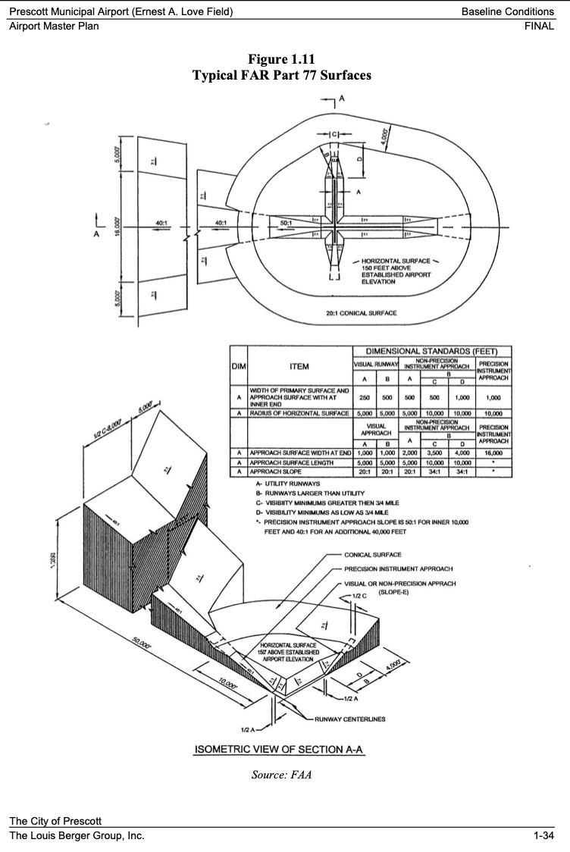
As mentioned above the slope and distance is based on the type of approach (visual, non-precision, or precision). Here is a table that depicts the slope for each end of the three runways at PRC.
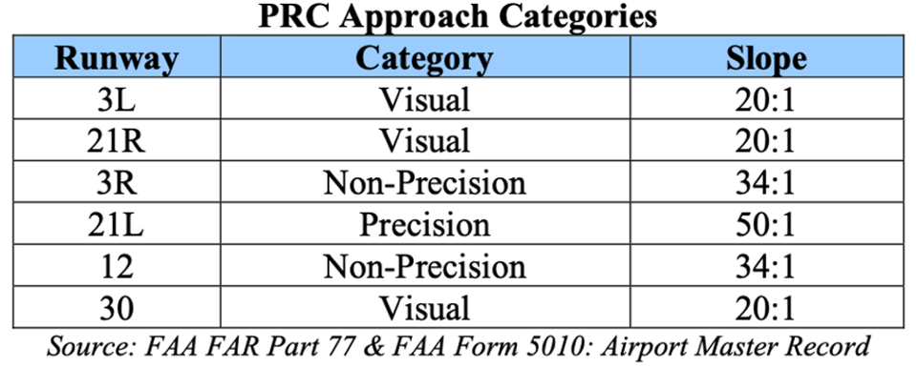
According to the AMP, the land use for the areas east and north of the airport are classified in the General Plan as Commercial/Employment use for up to ½ mile followed by Recreational/Open Space. The area east of the airport is classified as Commercial and it falls under the Commercial Corridor Overlay (CCO) whose purpose is as follows:
“Promote quality commercial, industrial, and multi-family development that is compatible with surrounding natural areas and/or developed and developing residential neighborhoods. All new development in the CCO District should:
- Minimize the impacts of new commercial development on nearby neighborhoods.
- Protect and enhance the character of highway and arterial corridors, which are mainly defined by surrounding residential neighborhoods and scenic natural features.
- Create pleasing places to view and experience through thoughtful building orientation, parking placement, pedestrian access, landscaping, and screening.
- Integrate new development, functionally, internally, and externally to the site and to surrounding neighborhoods.
- Preserve safe and logical access, and the carrying capacity of designated corridors.
- Promote the provision of usable pedestrian areas, such as plaza with street furniture, public art, etc.
- Ensure the provision of public services and facilities needed to accommodate planned land uses and population densities, as well as vehicular, pedestrian, and bike access.”
The land use for the areas north and west is classified for Agriculture/Ranching. The area southwest and south of the airport is zoned Residential Single Family, Low-Medium Density Residential and Recreational Open Space. A traffic sensitive area along U.S. Highway 89 which provides direct access to the airport terminal area is in this area. The Antelope Golf Resort and Community is in this area. The City of Prescott established a policy regarding Open Space so that it may be: “Preserved and managed in a manner consistent with low impact public use. Such lands can include scenic vistas, floodplains, trail corridors, historically recognized wildlife corridors, farmlands, highly visible natural areas along arterial streets, and open space buffers at the city’s perimeter.” Furthermore, it states that: “Development within the preserved open space will be limited to features that enhance and encourage ecotourism.” This can be seen in the diagram below.
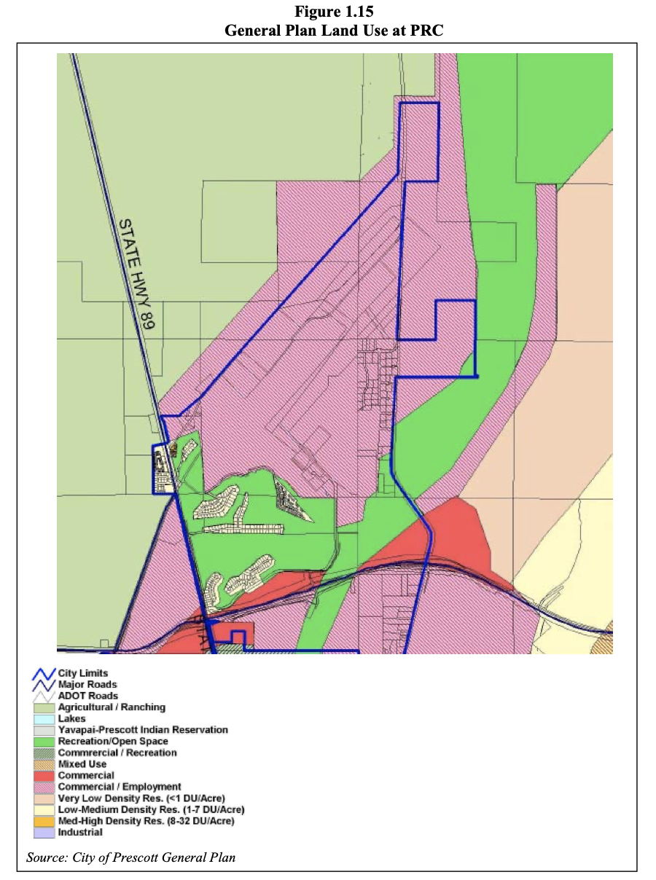
In addition to approach surfaces, one must also look at noise. The AMP describes average daily flight operations by aircraft type defined in the FAA’s Integrated Noise Model (INM) and the resulting noise exposure. The INM analyzes airport noise by considering airport activity over a 24-hour period. The standard technique in noise contour development is to consider the annual average day. The performance (arrival descent and departure climb profiles) and noise information for all the fixed-wing aircraft at the airport are provided in a database that is part of the INM. In the model, touch-and-go altitudes for training flights were set at the traffic pattern altitudes prescribed for the airport as indicated in the U.S. Chart Supplement, formerly known as the Airport/Facility Directory. The traffic pattern altitude for helicopters used in the model was imported to the INM from another FAA program, the Helicopter Noise Model (HNM).
Using operations information from 2007, day-night average sound level (DNL) contours were generated based on DNL levels of 55, 60, 65, 70, and 75 decibels (dBs). Here is a picture of the contours.
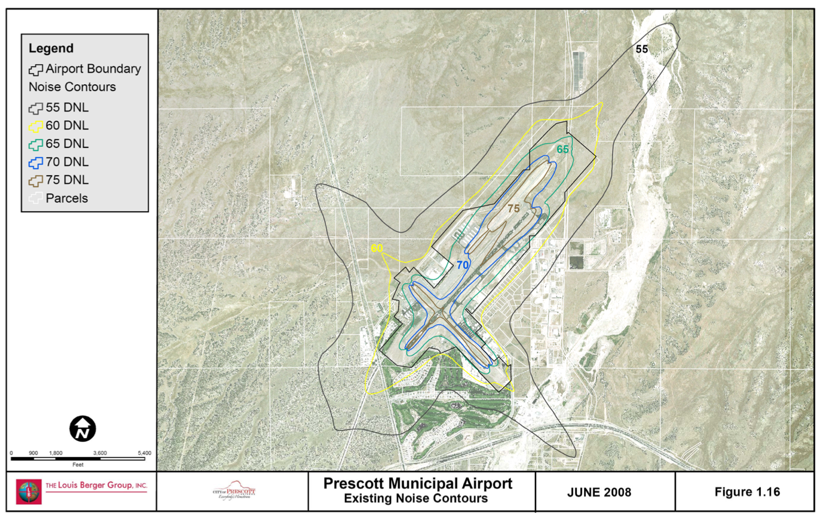

Airport development constraints mentioned in the AMP include the following. Airfield infrastructure (e.g., runways, taxiways, safety areas) is generally the first consideration in developing airport alternatives because of their primary role in supporting and directing aircraft movements. Airfield development also tends to dominate airport land use; therefore, selection of an airfield concept will usually affect the amount and location of other types of land uses. The following three options, A, B, and C for estimated land acquisitions proposed by ADOT in 2010 would be required by the city to provide adequate control over the area encompassed by the Runway Protection Zones (RPZ):
(Option A) Runway 12 RPZ – 3.8 acres
Runway 30 RPZ – 1.4 acres
Runway 21L and 21R RPZs – 168 acres
For a total of 173.2 acres (see picture below)
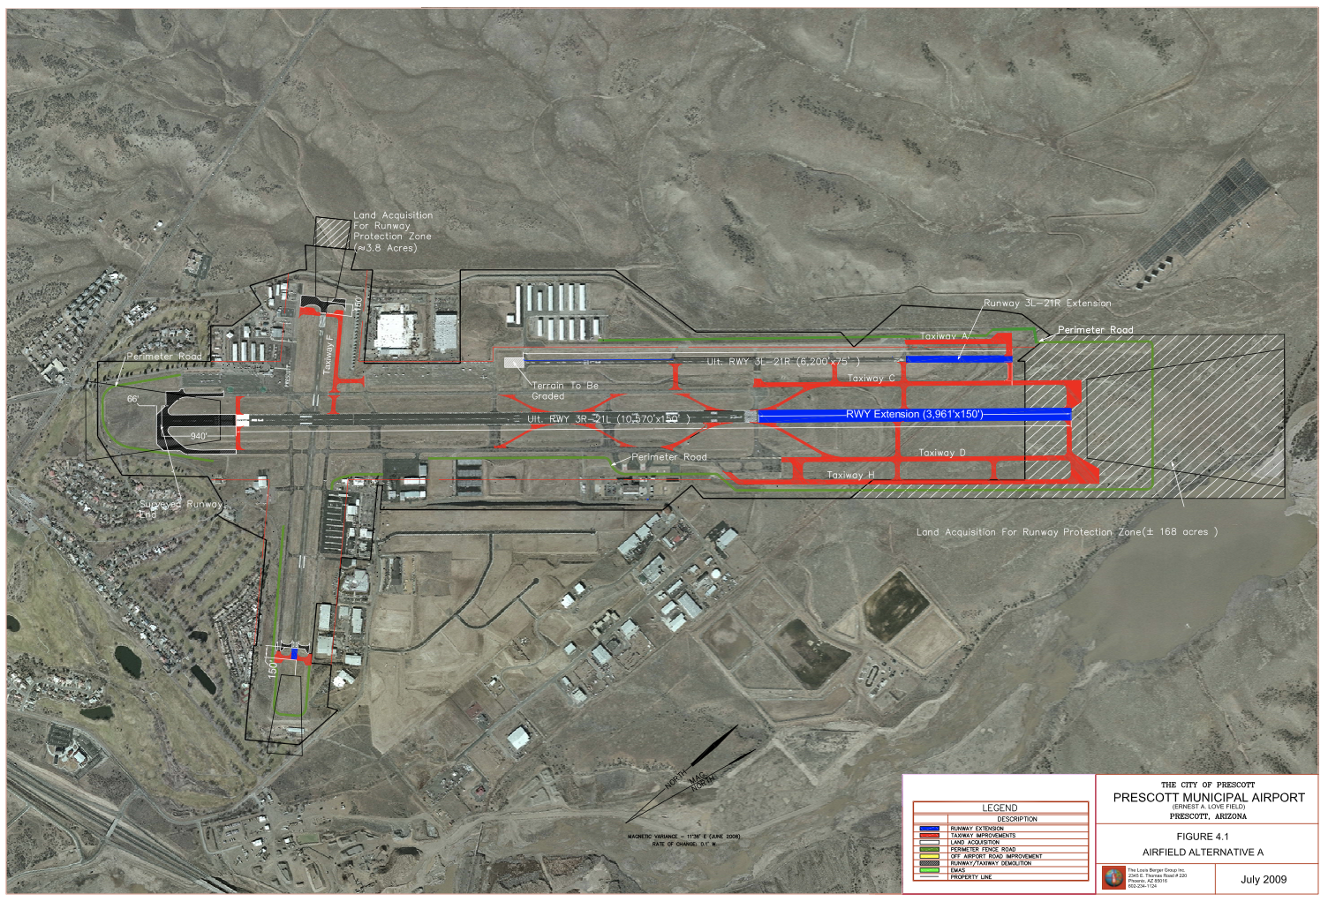
(Option B) Runway 12 RPZ – 4.0 acres
Runway 3R RPZ – 1.0 acres
Runway 21L and 21R RPZs – 138 acres
For a total of 143.0 acres (see picture below)
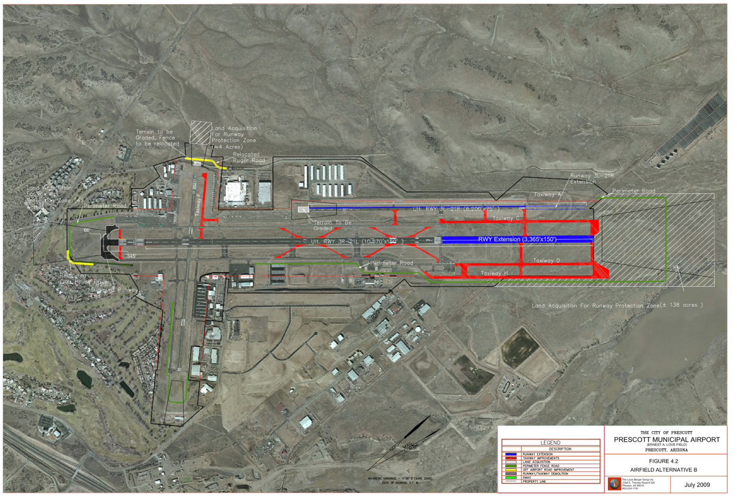

(Option C) Runway 12 RPZ – 4.0 acres
Runway 21L and 21R RPZs – 118.0 acres
For a total of 122.0 acres (see picture below)
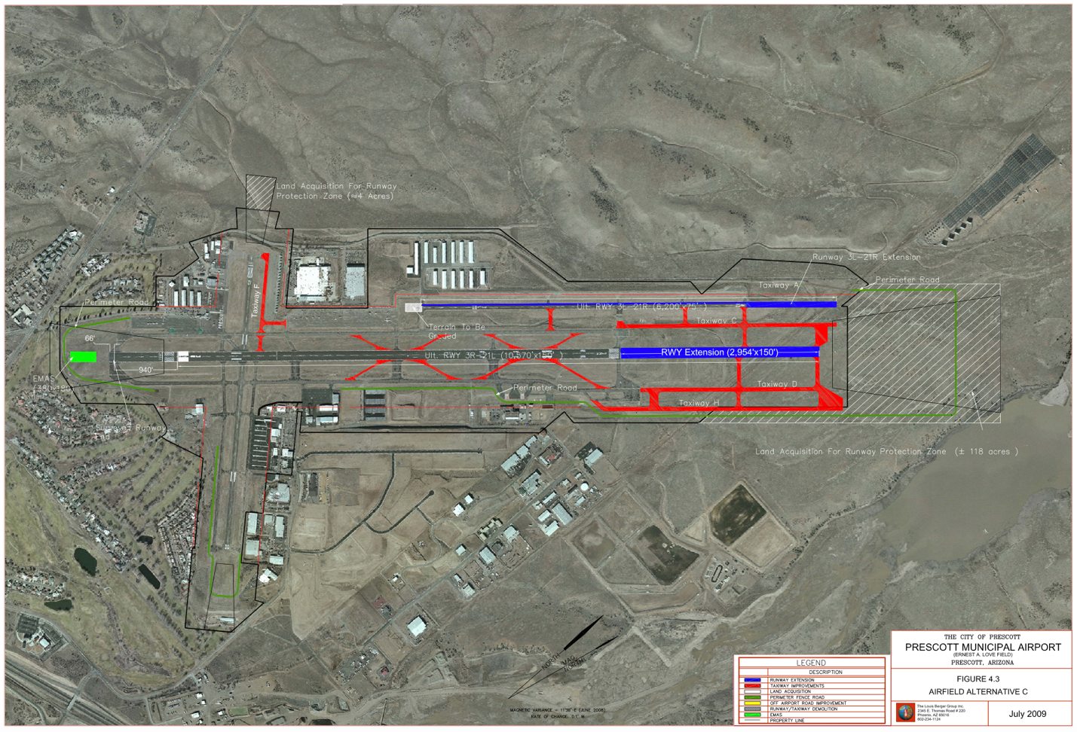

The Runway Protection Zone (RPZ), also known as Airport Impact Zone (AIZ) 1, is trapezoidal in shape and centered about the extended runway centerline. It extends from 200 feet beyond the end of the area usable for takeoff and landing. The narrower end of each RPZ is the closest to the runway end. The most critical segment of flight occurs within the RPZ. In this zone aircraft are most vulnerable and the risk of accident is very high.

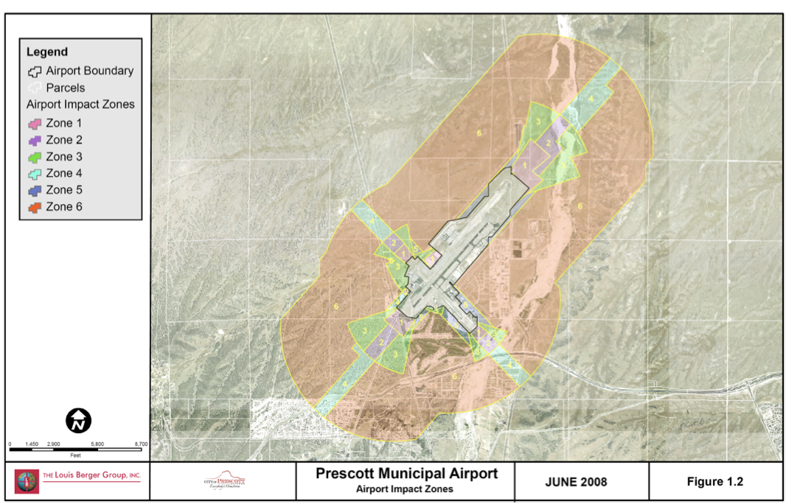
The official Airport Influence Area (AIA) is the primary and only method of airport protection. It extends 3-5 miles from the runway intersection based on the length and activity level of each runway, creating a 1-mile-wide approach/departure corridor where residential use is not generally allowed. This methodology was adopted by the City of Prescott, Yavapai County, and Town of Prescott Valley, to further identify the proper land use for the properties directly and potentially affected by airport operations, in addition to the noise contours in the diagram below.
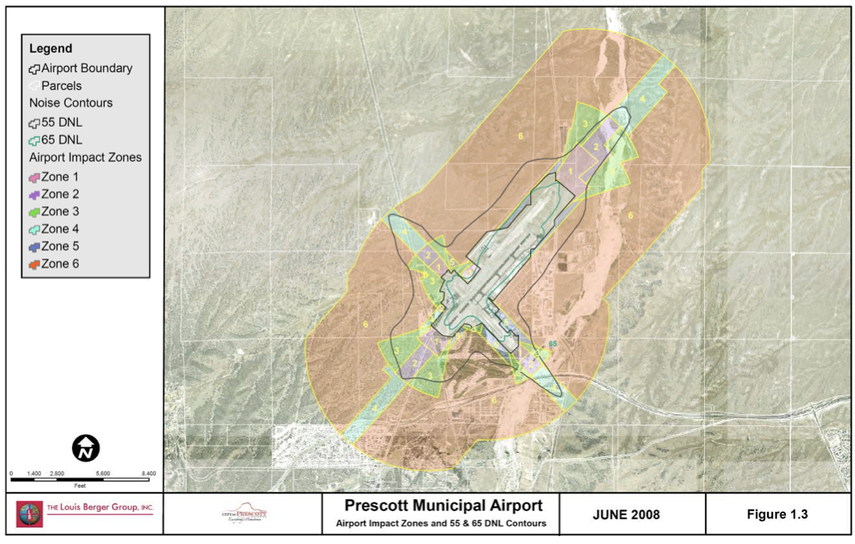
As per current FAA guidance standards, Airport Impact Zones (AIZs) are identified for each runway in use at PRC. AIZs are widely adopted by airports nationwide and adopted by states as a standard to limit the damages caused by an aviation accident, to protect the viability of the airport, and to limit the impact of noise on residential areas.
The Inner Safety Zone, also known as Airport Impact Zone (AIZ) 2, is rectangular in shape and centered about the extended runway centerline extending from the wider edge of the RPZ. The Inner Safety Zone together with the RPZ encompasses 30% to 50% of all near-airport accident sites.
The Inner Turning Zone, also known as Airport Impact Zones (AIZ) 3, is conical in shape which is encompassed by a 30-degree angle to either side of the extended runway centerline, and a radius of 5,000 feet. Its vertex is situated on the runway centerline 200 feet off the runway end. It encompasses the location where especially general aviation aircraft are turning from their final approach legs of the standard traffic pattern and are descending from pattern altitudes, as well as the area where departing aircraft normally complete their transition from takeoff power and flap setting to a climb mode and have begun turning to their enroute heading.
The Outer Safety Zone, also known as Airport Impact Zone (AIZ) 4, is rectangular in shape and centered about the extended runway centerline. It extends from the outer edge of the Inner Safety Zone. At airports with high-activity levels, like PRC, it encompasses the areas used by approaching aircraft at an altitude typically less than traffic patterns, as it is applicable to airports with straight-in instrument approach procedures.
The Sideline Safety Zone, also known as Airport Impact Zone (AIZ) 5, is rectangular in shape and centered on the runway centerline. It is defined by a 1,000-foot centerline offset on each side of the runway that connects the Inner Turning Zone on each end of the runway. While this zone is typically within airport boundaries, and it is not overflow, it is designed to mitigate the damages that could be caused by an aircraft losing directional control on takeoff.
The Traffic Pattern Zone, also known as Airport Impact Zone (AIZ) 6, is defined by an area 5,000 feet wide, centered on the runway centerline, extending from the Sideline Safety Zone to the edges of the Outer Safety Zone. It encompasses all other portions of regular traffic patterns and pattern entry routes. While the risk of an accident within this zone is low, potential consequences can be severe. The table below is a summary of the above six AIZ descriptions.
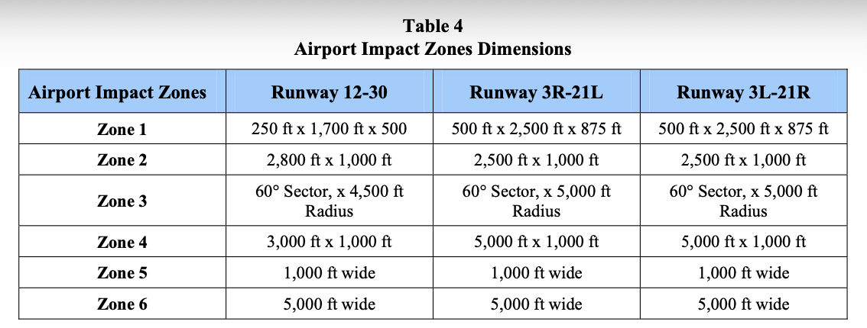
The AMP developed a Land Use Plan outlined here. The primary objective of the Airport Land Use Plan is to provide a review of the current land use and to develop guidelines for future land use at and surrounding PRC. The guidelines are formulated in agreement with the need of maintaining the viability of PRC, FAA guidelines, industry standards with regards to noise and safety and same land use planning’s goals and objectives stipulated in the Prescott General Plan and Airport Specific Area Plan (ASAP). This document is intended as a tool to assist city officials and airport management in the evaluation and creation of adequate and compatible airport land uses, which will guarantee the future viability of PRC and foster the economic development of nearby communities. This document supplements the current ASAP.
The FAA, in 14 CFR Part 150, defines criteria to identify the sensitivity to noise pollution of the major land use categories to mitigate the impact of aircraft noise on nearby communities and to prevent the non-compatible development of such lands. The following defines the extremely sensitive, moderately sensitive, and non-sensitive land uses.
Extremely sensitive land uses are those for which the receptor’s, customary or anticipated, activities may be disrupted to a significant degree by aviation noise impacts more than 65 DNL, for which sufficient mitigation to ensure compatibility with current or future airport operations is not feasible. The following land uses categories are typically considered extremely sensitive receptors:
- Low density residential areas, other than mobile home and transient lodging, where there is an expectation of a quiet surrounding and where it is difficult to provide sufficient noise mitigation to achieve outdoor and indoor Noise Level Reductions (NLR).
- Outdoor theaters, amphitheaters, and public assembly areas.
- Campgrounds (with overnight sleeping facilities).
- Schools, libraries, where measures to achieve outdoor and indoor NLR cannot be incorporated.
- Medical facilities, such as hospitals and nursing homes, assisted living facilities, where measures to achieve outdoor and indoor NLR cannot be incorporated.
Moderately sensitive land uses are those for which the receptor’s, customary or anticipated, activities may be disrupted to a significant degree by aviation noise impacts more than 70 DNL, for which sufficient mitigation to ensure compatibility with current or future airport operations is feasible by the incorporation of special design features and construction techniques. Also, activities associated with the land use are confined exclusively or almost exclusively to indoor areas. The following land uses categories are typically considered moderately sensitive receptors:
- Schools and libraries.
- Medical facilities, such as hospitals and nursing homes, assisted living facilities.
- Mortuaries and funeral parlors.
- Churches, auditoriums, and concert halls.
- Governmental services.
- Offices, business, and professional services.
- Wholesale and retail.
- Hotels and motels.
- Indoor theaters, music halls, meeting halls, and other indoor public assembly facilities.
- Studios – radio, television, recording, rehearsal, and performance facilities.
- Schools and day care centers (excluding aviation related).
- Museums (excluding aviation related).
Non-Sensitive land uses are those for which the receptor’s, customary or anticipated, activities are not disrupted by aviation noise impacts. The following land use categories are typically non-sensitive receptors:
- Mining, fishing, and resources production and extraction.
- Transportation facilities: railroad, rapid rail transit, street railway transportation, motor vehicle transportation, aircraft transportation, highway, and street right-of-way.
- Agriculture (except livestock).
The following table summarizes the above descriptions.
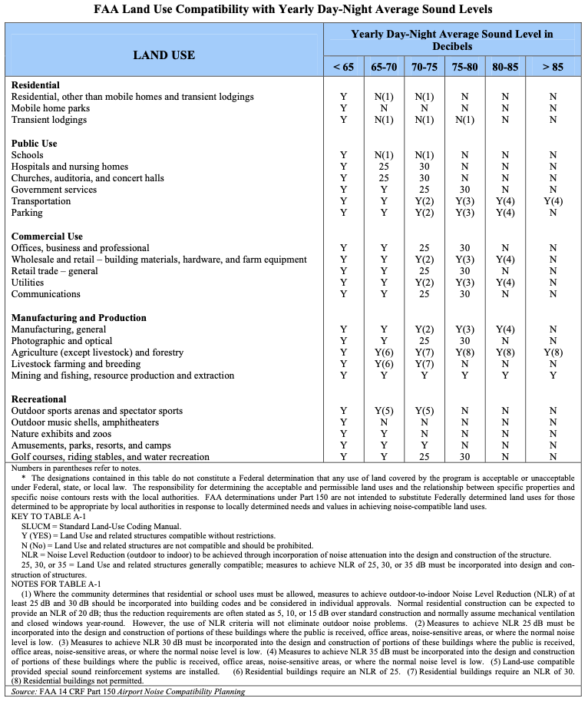

Airport development projects that meet the FAA’s discretionary funds eligibility requirements could receive up to 91.06% of the project cost from the AIP. The following outlines the 20-year ACIP for PRC organized into three phases: Phase 1 (2010-2015); Phase 2 (2016-2020); and Phase 3 (2021-2030). See tables below.
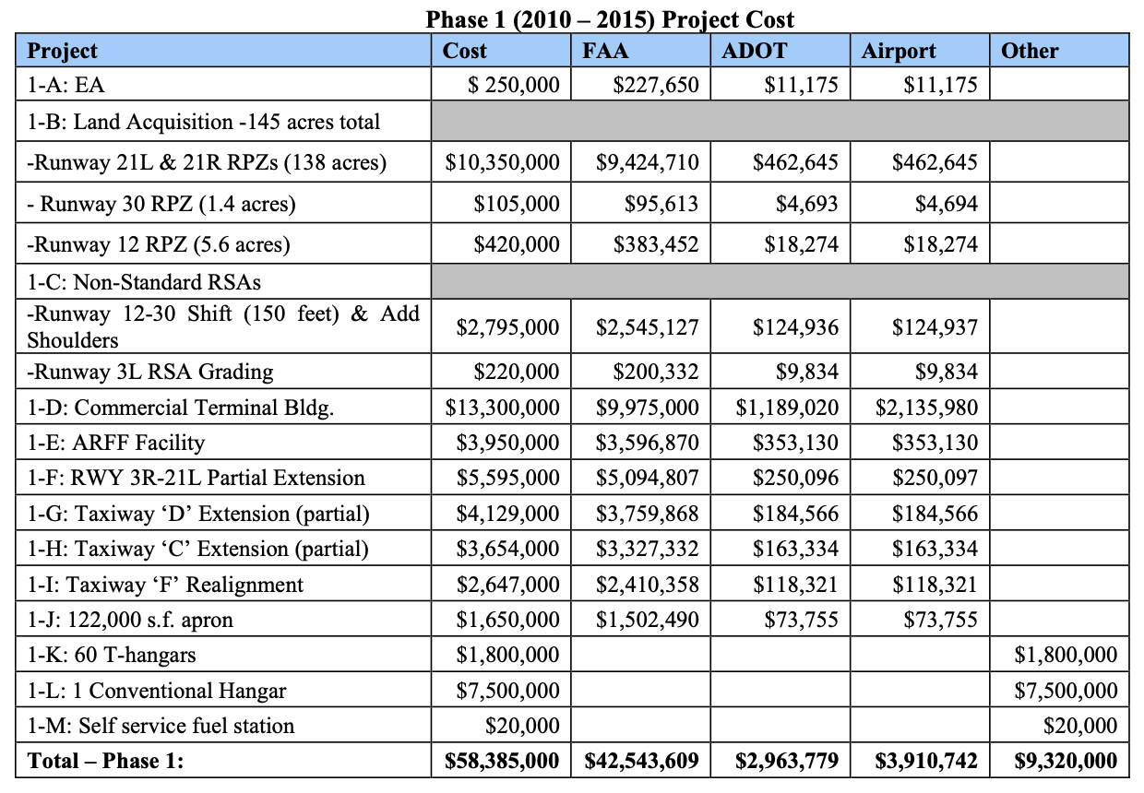
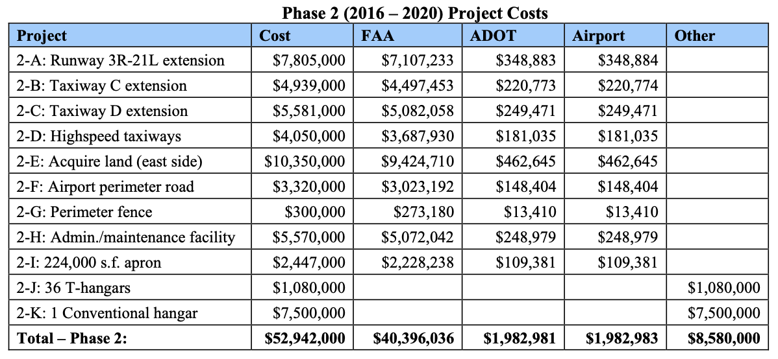
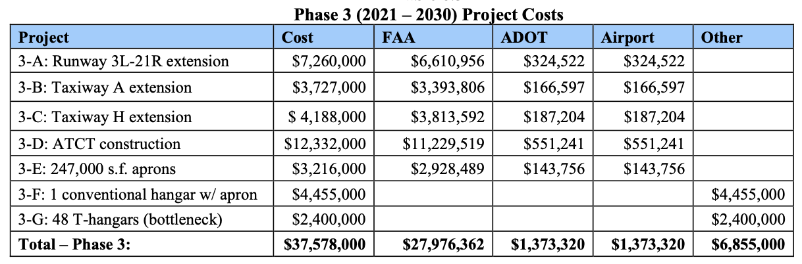
City of Prescott Airport Specific Area Plan (ASAP)
The planning area encompasses about 50 square miles and is dominated by undeveloped lands devoted to cattle ranching. Prior to this ASAP, the only community plan in place was Yavapai County’s 1991 Granite Dells Community Plan, which covers the south-central portion of ASAP. The 1997 Prescott General Plan supported this ASAP planning effort where it acknowledged the regional value of the airport and the need to protect it from encroachment of residential development. The ASAP instructed those habitable buildings within the six AIZs mentioned above be constructed using noise attenuation techniques to limit noise within each structure. Interior noise must be attenuated per the Airport Noise Overlay Soundproofing guidelines of Land Development Code (LDC) 5.2.7. It was further recommended that habitable buildings outside of the 6 AIZs but falling within the Airport Influence Area also be constructed using noise attenuation techniques. Building height for all structures shall coincide with and be constrained by 14 CFR Part 77.

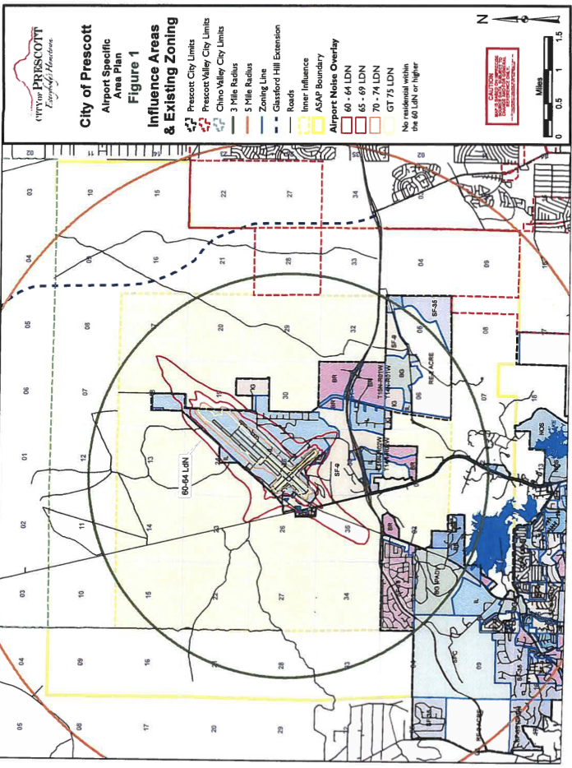

Some of ASAP’s goals and objectives dealing with immediate airport protection and land use are as follows:
- Establish Airport Influence Area (AIA) boundaries for PRC sufficient to protect the long-term viability of the airport. Evaluate the need for avigation easements within the AIA.
- Create a multi-jurisdictional land use plan for the greater airport area that addresses the needs of the region’s only airport, applicable jurisdictions, subject property owners, existing neighborhoods, and established industrial parks.
- Investigate ways to promote implementation and adherence of ASAP recommendations by all area jurisdictions that may hold or attain land development regulatory authority.
- Identify appropriate types and locations of commercial development given the evolving regional roadways that cross the plan area, and the service and shopping needs of existing and future residential neighborhoods.
- Determine which, if any, of the interchanges along the planned Airport Connector are suitable for highway-related commercial development.
- Investigate outside funding sources to enable the proposed multi-purpose center recently studied by the City of Prescott. The conceived conference center and equestrian facilities would provide a core use for other spinoff non-residential uses appropriate between SR 89 and old 89A.
- Consider permitting campgrounds and RV parks that capitalize on area trails, lakes, views, and other outdoor amenities.
- Inventory the needs and contributions of area employers to ascertain expansion goals, adequacy of infrastructure, and desired support services.
- Evaluate sites suitable for new employment centers that concurrently capitalize on access availability and airport buffering.
- Assess sites that may be appropriate for heavy industrial uses that support the Tri-City region, based on input from applicable users, property owners, and applicable jurisdictions.
- Site assessment for heavy industrial use shall include opportunities and impacts related to circulation infrastructure, environmental issues, truck travel times and routes, topography and wind patterns, and proximity to residential areas.
- Assess appropriate locations and densities of residential development within the greater AIA, taking into consideration airport activities, surrounding land uses, access, community plans, zoning, and other input from applicable surrounding jurisdictions, property owners, and other interested parties.
- Evaluate if city-provided water and sewer service can provide sufficient incentives to locate and design residential areas compatible with the AIA goals.
In 2015, the Prescott General Plan was updated and the Deep Well Ranch property to the west and northwest of PRC was annexed into the City of Prescott and zoned with a mix of industrial light (IL), business regional (BR), multi-family high (MFS-H), and single-family (SF-18) to create a mixed-use regional core and economic engine adjacent to PRC.
Protecting PRC from potential nearby incompatible land uses is important for the long-term viability of PRC. It is not uncommon to see airports having to buy out nearby residences, or to close or relocate when residential development has crowded its borders. The AIA notice in ARS 28-8485 gives airports operated by local governments authority to establish influence areas in proximity to airports which thereby provides County-recorded notice of the airport noise and overflights.
The images below map overflight patterns for the 21L/21R main runway (80% of operations) and a composite of the remaining 3 runways (20% of operations). The average maximum altitude of aircraft activity is about 500 feet within the bounds of ASAP. Takeoffs and landings average over 1 per minute during daylight hours.
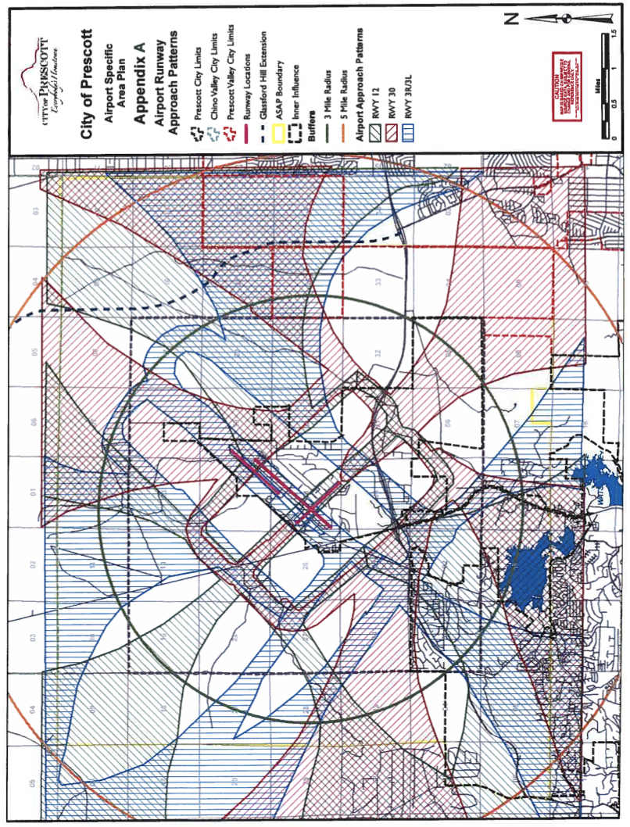
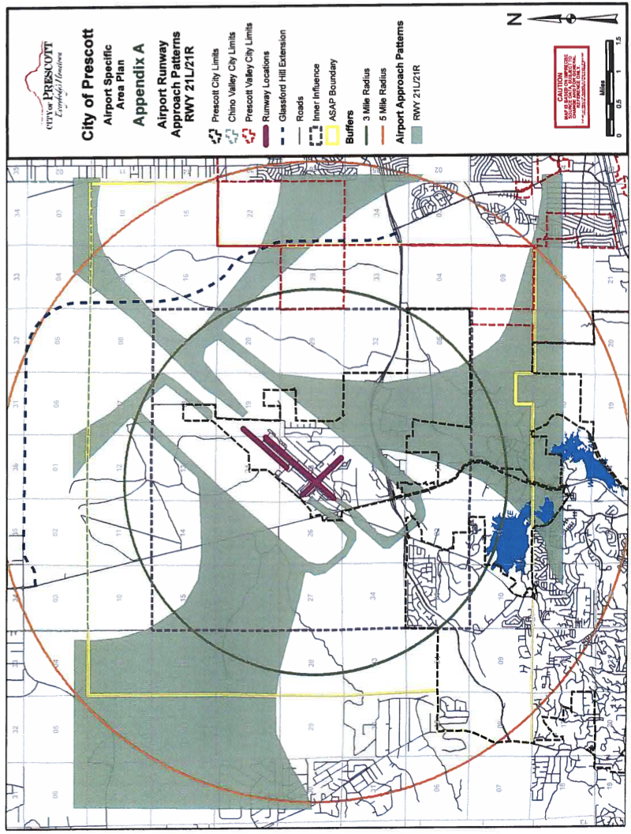
Another reason for ASAP’s extensive scope for land use planning is to protect PRC well beyond the year 2020. The Tri-City region has an opportunity to plan proactively for airport protection, which many larger jurisdictions now lament not having done before incompatible growth and development hemmed in their airports. ASAP is a long-range plan that promotes a responsible approach to land use changes. Limitations can be loosened in the future as technologies improve but attempting greater restrictions after the fact is extremely costly, if not impossible.
Deep Well Ranch lies mainly west of the old Atchison Topeka and Santa Fe railroad bed (now the Peavine Trail) and includes 15 square miles within ASAP. Jointly owned Granite Dells Ranch and Point of Rocks Ranch lie mainly east of the old RR line and comprise almost 14 square miles of the study area. Rifle Ranch and adjacent Diamond E Ranch include about 400 acres lying between Willow Creek Road and SR 89, south of the new airport connector alignment. Approximately 13 square miles within ASAP are State Trust lands. City of Prescott owns over 2,000 acres including the airport and some industrial land surrounding it – also Antelope Hills Golf Course, Willow Lake and Heritage Park. The city also co-leases with the County the 930-acre, BLM-owned Pioneer Park. This is all depicted below.
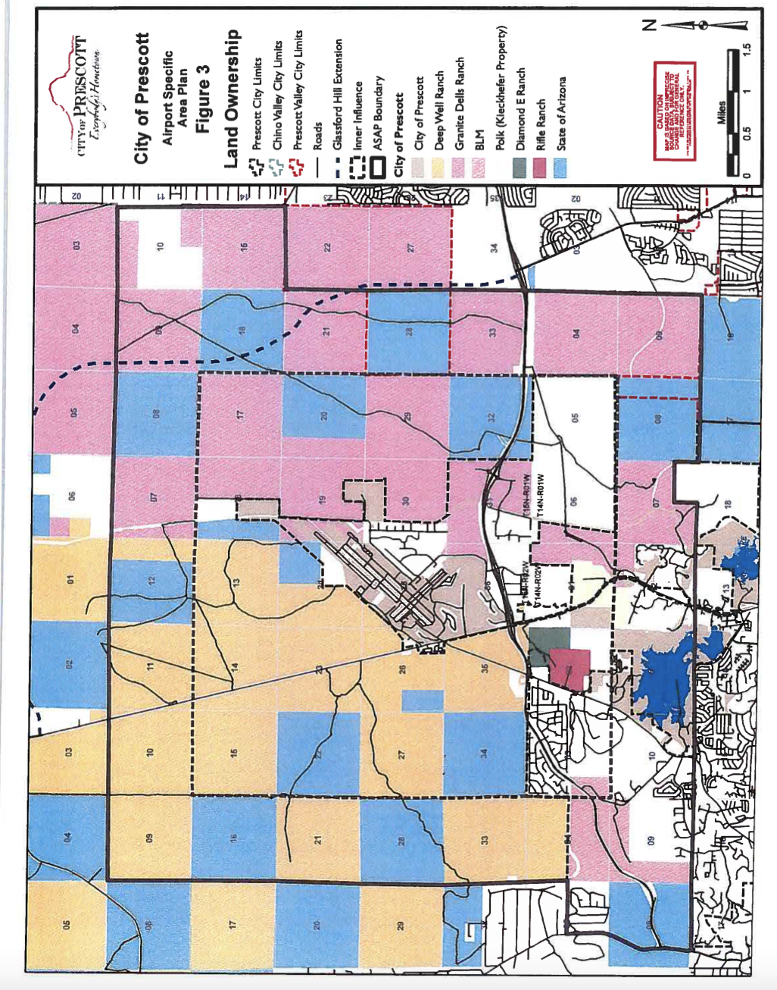
In December 2019, the Airport Master Plan for PRC was updated once again by the City Council. Future projects include: (1) in the next 5 years, relocating Taxiway C, improving Runway 12-30 Runway Safety Area, acquiring land and constructing Runway 3R-21L Extension; constructing ARFF Facility (2) In the next 10 years, constructing a new Air Traffic Control tower, relocating taxiway F, and updating the Airport Property Map; and (3) In the next 20 years, expanding commercial service terminal, the FBO and the parking lot, as well as constructing high-speed exit taxiways. The following pictures provide a summary of the proposed changes for the next 20 years.
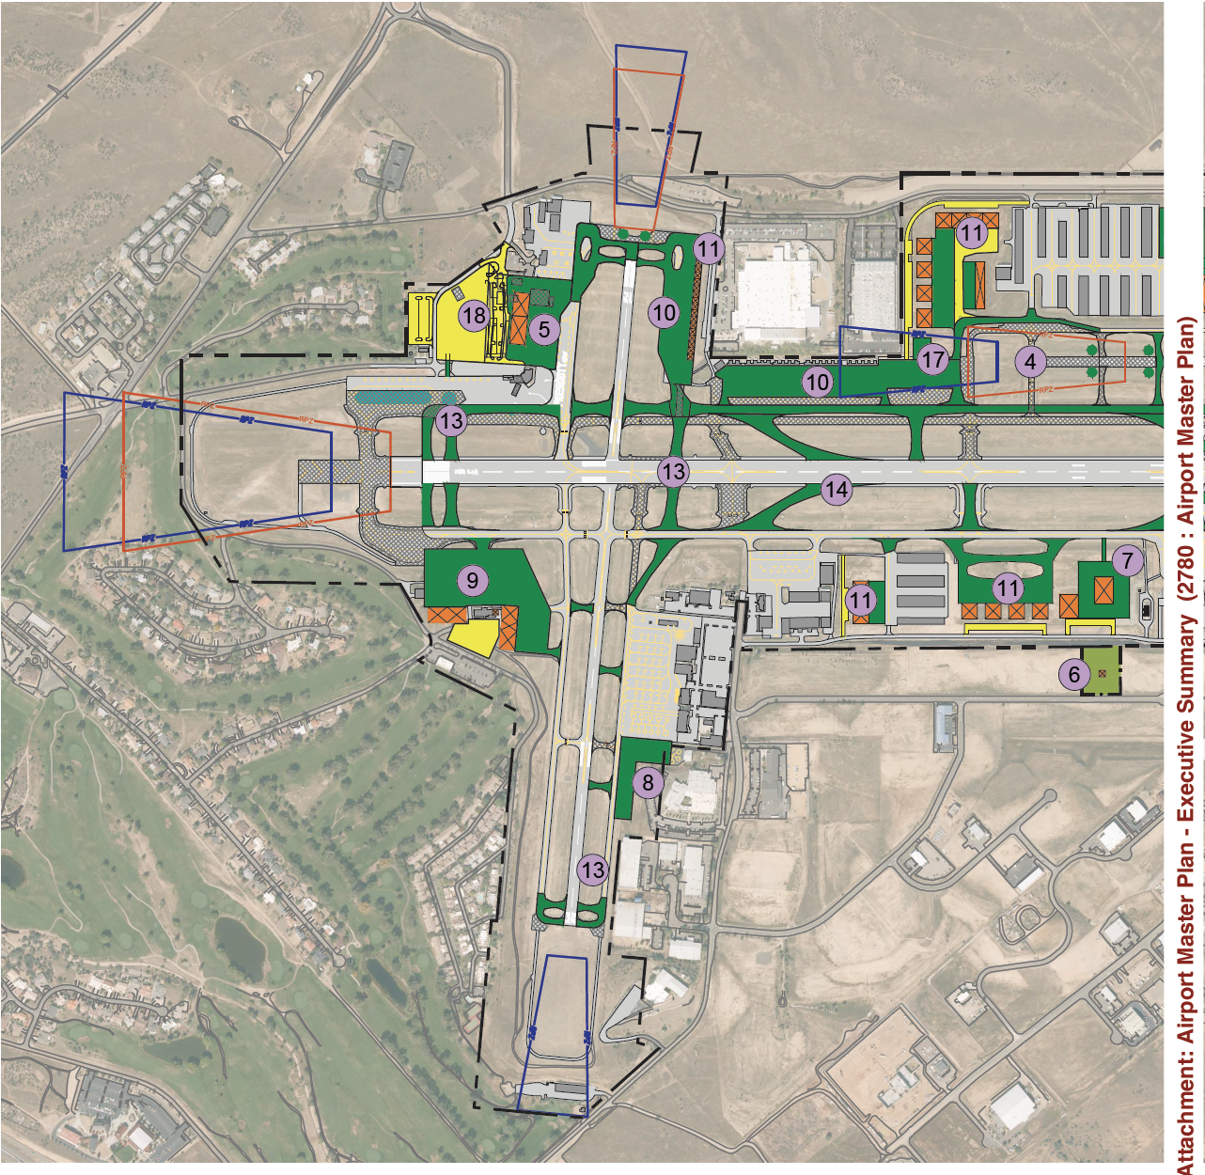
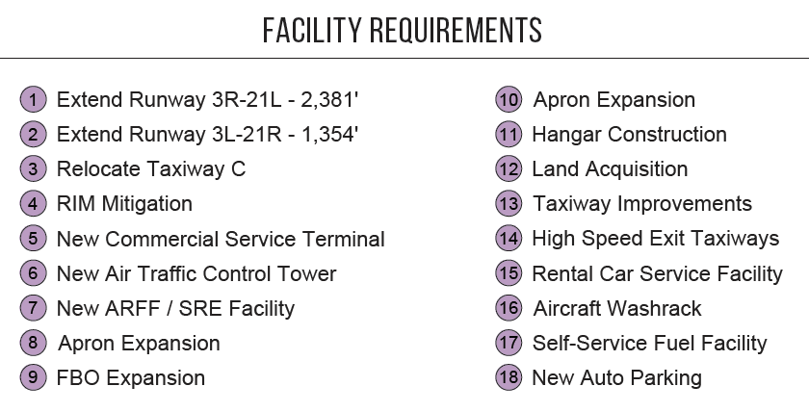
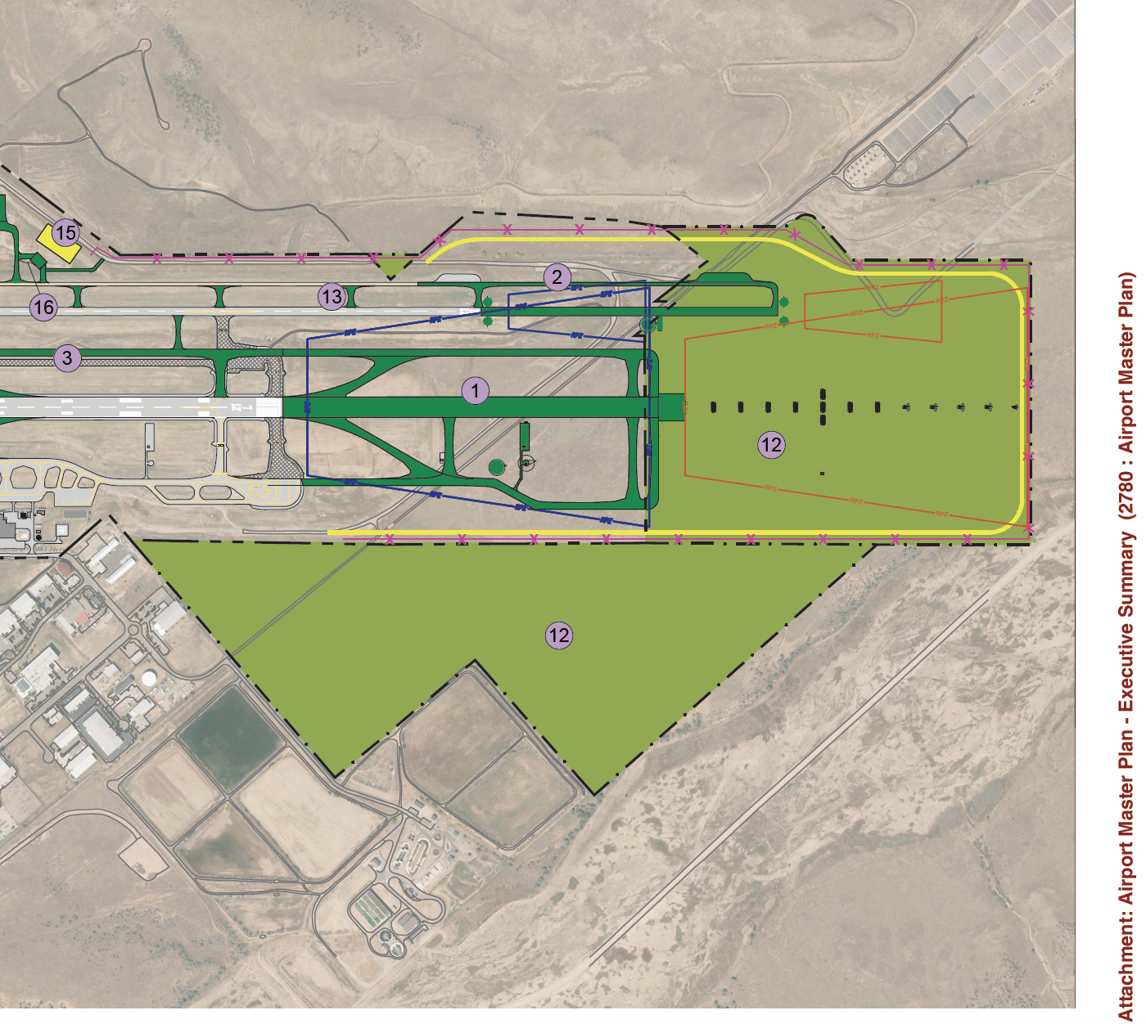
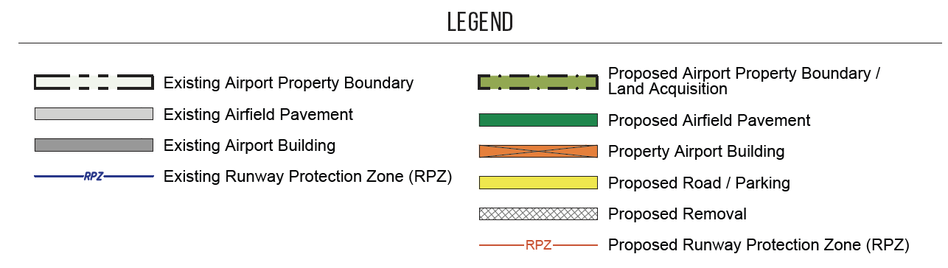
In addition to the establishment of AIAs per 14 CFR Part 77, the FAA also recommends the use of avigation easements, which are a more rigorous form of notice that run with the dedicating property, and typically grant “navigable airspace” above the dedicating property. Gaining avigation easements within the recommended AIA will only occur if required by the applicable ASAP jurisdiction.
Controlling the type and placement of specific land uses in proximity to the airport is an essential component of long-term protection of the airport. Compatible land uses close to the airport include industrial, commercial, ranching, and open space. Concentrations of residential development near the airport are not desirable, although multi-family residential may be reasonable outside the approach and departure corridors where air traffic patterns are lighter.
To further protect the airspace within the same 28 square mile AIA and to better inform property owners of aircraft noise and overflights, ASAP proposed all applicable jurisdictions should agree to require a dedicated avigation easement from the subject property owner(s) prior to land development activity within the AIA.
A Land Use Plan from 2013 is shown next with descriptions below it.
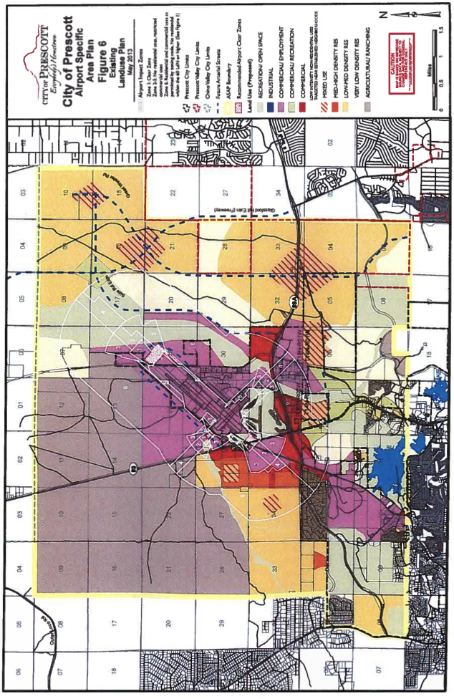
Government/Institutional
- Public or semi-public uses.
- May include government centers, police and fire substations, schools, libraries, community centers, water plants, wastewater treatment plants, college or university campuses and related uses and activities, including student dormitories.
- Not intended for residential uses other than student housing.
Recreation/Open Space
- Precluded from development except for active and passive public recreational facilities or natural preserves.
- Open space areas intended to be left in a natural state due to topographic, drainage, vegetative, and/or landform constraints or the need to provide buffers between incompatible land uses, or to protect viewsheds.
- Impact Zone 1 is limited to Natural Open Space, which may include: wildlife movement corridor/habitat, passive recreation (hiking trail, wildlife viewing), limited utility infrastructure and airport buffering as well as sand and gravel extraction, as permitted, within the Granite Creek wash.
Agricultural/Ranching
- Areas intended to remain in agricultural or ranching production over the long-term.
- Anticipated to transition to other land uses over time.
- May allow residential development of up to one dwelling unit per acre depending upon zoning classification.
- Public service demands not anticipated to be as great as in residential designations.
- No commercial or industrial development is anticipated.
- Designation intended to be revisited in the future when property owners wish to quit ranching and consider developing.
- New land use designations will be determined based on adopted ASAP goals and objectives.
- Permitted in Impact Zones 1 through 6.
Commercial/Employment
- Professional offices, tourism, recreation, service uses, warehousing, and light industrial uses are generally appropriate.
- Requires appropriate buffering considerations from adjoining residential areas.
- Uses determined based on zoning of each particular site and will consider adjacent land uses, traffic impacts, and the intensity of any proposed development.
- Residential uses not anticipated in this designation.
- Uses such as lodging, school, and churches may not be permitted or desired within the airport’s 65 DNL noise contour.
- Permitted in Impact Zones 1 through 6, however, no new residential uses are permitted within Impact Zones 1 through 5 or within the 60 DNL noise contour unless accompanied by a holistic land use plan to protect the long-term operations of PRC.
Commercial
- Typical community or regional commercial uses.
- Intended uses include office, retail, service, civic, lodges, health related, and other similar uses as permitted by the appropriate zoning designations.
- Residential uses of all density categories are permitted, but subject to density and buffering standards set out by the overlying zoning districts.
- Permitted in Impact zones 2 through 6, however, no new residential uses are permitted within Impact Zones 1 through 5 or within the 60 DNL noise contour, unless accompanied by a holistic land use plan to protect the long-term operations of PRC.
Commercial/Recreation
- Intended to allow a mix of retail commercial uses, but with an emphasis on recreation related uses such as resorts, campgrounds, equestrian facilities, lodges, hotels/motels, RV parks, fishing camps, and swimming pools.
- May also include civic, and office uses.
- Residential uses not anticipated.
- Permitted in Impact zones 2 through 6, however, no new residential uses are permitted within Impact Zones 1 through 5 or within the 60 DNL noise contour.
Very Low Density Residential (less than 1 DU/AC, or dwelling unit per acre)
- Intended for large-lot single-family housing in a rural setting.
- Development will consist mainly of detached single-family homes on 2-acre minimum sized lots or larger.
- Basic character of development is rural, with most natural features of the land retained.
- Keeping of horses or other livestock is permitted, possibly in association with pre-existing and ongoing farming or ranching.
- Public services demand not as great as in higher density, more urban development.
- No commercial or industrial development is anticipated.
- Permitted only in Impact Zone 6, however, not within the 60 DNL noise contour, unless accompanied by a holistic land use plan to protect the long-term operations of PRC.
Low-Medium Density Residential (1-7 DU/AC, or dwelling unit per acre)
- Intended for predominantly single-family detached residential development.
- Areas are quiet residential single-family neighborhoods but in some areas a mix of single-family, duplexes, and townhouses would also be appropriate.
- May also include such supporting land uses as neighborhood shops and services, parks and recreation areas, religious institutions, and schools.
- Full range of urban services and infrastructure is required.
- Would allow residential development as described for Very Low Density Residential category.
- Permitted only in Impact Zone 3 and 6, however, not within the 60 DNL noise contour, unless accompanied by a holistic land use plan to protect the long-term operations of PRC.
Medium-High Density Residential (8-32 DU/AC, or dwelling unit per acre)
- May include duplexes, manufactured and modular homes, apartments, town homes, and other forms of attached or detached housing on smaller lots.
- May also include such supporting land uses as neighborhood shops and services, parks and recreation areas, religious institutions, and schools.
- Full range of urban services and infrastructure required.
- Would also allow residential development as described for Low-Medium Density and Very Low Density Residential categories.
Mixed Use
- Generally located at an existing or anticipated circulation nexus and/or placed between higher intensity uses and adjoining residential land uses.
- Intended to be compatible with the surrounding area while providing a mix of commercial, employment, public and residential uses.
- Expected to support neighborhood oriented commercial uses and may include master-planned and developed mixed communities intended to replicate the traditional downtown mixture of commercial and residential uses of all density categories.
- Residential uses permitted, but subject to density and buffering standards set out by the overlying zoning districts.
- Commercial uses permitted in Impact Zones 2 through 6.
- New residential uses permitted only in Impact Zone 6, however, not within the 60 DNL noise contour, unless accompanied by a holistic land use plan to protect the long-term operations of PRC.
Grant Assurances and Obligations
When airport owners or sponsors, planning agencies, or other organizations accept funds from FAA-administered airport financial assistance programs, they must agree to certain obligations (or assurances). These obligations require the recipients to maintain and operate their facilities safely and efficiently and in accordance with specified conditions. The assurances may be attached to the application or the grant for federal assistance and become part of the final grant offer or in restrictive covenants to property deeds. The duration of these obligations depends on the type of recipient, the useful life of the facility being developed, and other conditions stipulated in the assurances. The most current list of grant assurances that apply to PRC may be found on the FAA’s website. Of particular interest is Grant Assurance 21 dealing with Compatible Land Use which states: It (meaning the sponsor) will take appropriate action, to the extent reasonable, including the adoption of zoning laws, to restrict the use of land adjacent to or in the immediate vicinity of the airport to activities and purposes compatible with normal airport operations, including landing and takeoff of aircraft. In addition, if the project is for noise compatibility program implementation, it will not cause or permit any change in land use, within its jurisdiction, that will reduce its compatibility, with respect to the airport, of the noise compatibility program measures upon which federal funds have been expended.
The FAA publishes its Airport Compliance Manual – Order 5190.6B which sets forth policies and procedures, in other words basic guidance, for FAA personnel in interpreting and administering the various continuing commitments airport owners make to the U.S. as a condition for the grant of federal funds or the conveyance of federal property for airport purposes. This Order discusses the obligations set forth in the standard airport sponsor assurances, addresses the application of the assurances in the operation of public use airports, and facilitates interpretation of the assurances by FAA personnel.
The basis of sponsor federal obligations resides with federal statute, the AIP grant program, land transfer documents, and surplus property agreements. It is the responsibility of the FAA Airports District Offices (ADOs) and regional airports divisions to advise sponsors of their compliance requirements and to ensure that sponsors comply with their federal obligations. The FAA Airport Compliance Program enforces contractual federal obligations that a sponsor accepts when receiving federal grant funds or the transfer of federal property. These contractual federal obligations serve to protect the public’s interest in civil aviation and achieve compliance with federal statutes. The compliance program primarily focuses on education with the goal of achieving voluntary compliance, and supplements with periodic compliance monitoring and vigorous investigation of potential violations. Generally, violations occur because sponsors do not understand specific requirements or how a requirement applies to a specific circumstance. Informal resolution is the preferred course of action. When all reasonable efforts have failed to achieve voluntary compliance on the part of the sponsor, the FAA may take more formal compliance actions. This may result in withholding federal funds, issuing a Notice of Investigation (NOI) under 14 CFR Part 16, or initiating judicial action if warranted.
Under the various federal grant programs, the sponsor of a project agrees to assume certain federal obligations pertaining to the operation and use of the airport. These federal obligations are embodied in the application for federal assistance as sponsor assurances. The federal obligations become a part of the grant offer, binding the grant recipient when it accepts federal funds for airport development.
Since 1946, the FAA has administered three grant programs for development of airports: (1) the Federal Aid to Airports Program (FAAP) pursuant to the Federal Airport Act of 1946, as amended, until repealed in 1970; (2) the Airport Development Aid Program (ADAP) pursuant to the Airport and Airway Development Act of 1970 (1970 Airport Act), as amended, until repealed in 1982; and (3) the Airport Improvement Program (AIP) pursuant to the Airport and Airway Improvement Act of 1982 (AAIA), as amended. (See Title 49 U.S.C. § 47101, et seq.)
Each of these FAA administered federal airport financial assistance programs required airport sponsors to agree to certain assurances under the authorizing legislation of the grant programs. Certain assurances remain consistent from one grant program to the next. Other assurances were added by legislative mandate as the grant programs developed. Some assurances were superseded over time. In addition, the FAA has statutory authority to prescribe additional assurances or requirements for sponsors. (See 49 U.S.C. § 47101(g).) Also, some grant agreements contain special covenants or conditions intended to address an airport-specific situation.
The useful life of a federally funded airport development project extends only for the period during which it is serviceable and usable with ordinary day-to-day maintenance. Reconstruction, rehabilitation, or major repair of a federally funded airport project without additional federal aid does not automatically extend the duration of its useful life as it applies to grant agreements. Land, however, has no limit to its useful life. As such, obligations associated with land do not expire. Federal obligations relating to the use, operation, and maintenance of the airport remain in effect throughout the useful life of the facilities developed under the project, but not to exceed 20 years. In cases where land was acquired with federal assistance under AIP, the federal land obligations remain in perpetuity.
Additionally, there are three assurances for which the obligation continues without limit if the airport is used as a public use airport: (1) Grant Assurance 23, Exclusive Rights; (2) Grant Assurance 25, Airport Revenues; and (3) Grant Assurance 30, Civil Rights.
The FAA uses three separate sets of standard sponsor assurances: (1) Airport Sponsors (owners/operators); (2) Planning Agency Sponsors; and (3) Nonairport Sponsors Undertaking Noise Compatibility Program Projects (referred to as nonairport sponsor assurances).
There are five types of airport grant programs or projects that include assurances from one of the three sets of standard assurances: (1) Airport development programs undertaken by an airport sponsor; (2) Noise compatibility programs undertaken by an airport sponsor; (3) planning projects undertaken by an airport sponsor; (4) planning projects undertaken by planning agency sponsors; and (5) noise compatibility programs undertaken by nonairport sponsors.
Grant agreements list the assurances in three separate groups, A, B, and C. Group A, General, sets for the basic requirement binding the sponsor to all federal grant assurances. This general assurance states the basic requirement for the sponsor to abide by all applicable assurances as a condition of accepting a federal grant for airport development, noise compatibility, and airport planning. The general assurance requires the sponsor to include these assurances as part of its grant application. When the sponsor accepts the grant offer, FAA incorporates these assurances into the grant agreement. When the sponsor accepts, the agreement binds both the federal government and the sponsor to its terms.
Group B, Duration and Applicability, establishes the length of time that assurances remain in effect and identifies which assurances apply to the various programs or projects.
Group C, Sponsor Certification, lists all the standard assurances that the sponsor must adhere to under the grant agreement. As of September 2009, there were 39 numbered assurances in the sponsor certification group for airport sponsors. All these assurances apply to airport development programs and noise compatibility programs undertaken by an airport sponsor, but only 11 of them apply to planning projects undertaken by an airport sponsor.
To determine if an airport is federally obligated one source that is used is FAA Order 5190.2R – List of Public Airports Affected by Agreements with the Federal Government. This Order contains a listing of all publicly and privately owned public use airports that are affected by agreements with the federal government and handled by the FAA. PRC is listed in this document as having the following obligations: G (Grant agreement under FAAP, ADAP, or AIP); Y (Assurance pursuant to Title VI, Civil Rights Acts); and 3 (Expired AP-4 Agreement (under DLAND or DCLA Programs) however, Statutory Exclusive Rights Prohibition (Federal Aviation Act, Section 308A) remains in force for as long as the property is used as an airport). PRC is identified as an airport certificated under 14 CFR Part 139. More information may be found on the Airport Data and Information Portal facility map with facility details.

Here is a tabulated list of all AIP federal funds awarded to PRC in reverse chronological order up to the year 2000:

Year | Total Funding Amount | Description of Work
2021 | $5,407,787 | Shift of Reconfigure Existing Taxiway
2021 | $950,000 | Airport Wildlife Hazard Assessment/Management Plan, Construct Terminal Building
2020 | $10,000,000 $1,300,000 $4,000,000 | Construct Terminal Building  Reconstruct Taxiway  Shift or Reconfigure Existing Taxiway
2019 | $647,500  $150,000 | Reconstruct Taxiway  Reconstruct Taxiway
2018 | $800,000  $4,557,837 | Rehabilitate Runway Lighting – 7,619 feet of the current Runway 03R/21L  Rehabilitate Runway – Runway 03R/21L (7,619 feet) including removal of Taxiway C2 (RIM location PRC-HS2)
2003 | $91,060 | Conduct Environmental Study
2002 | $150,000 | Improve Access Road
2001 | $1,541,000 | Runway 3L/21R Safety area and infield area improvements, install landing hold short operation signs and marking, Phase II and construct service road and other runway incursion action team related improvements
2000 | $532,113 | Acquire Aircraft Rescue and Fire Fighting Vehicle

Here is a list of all the strings attached to the AIP grant, the grant assurances by the airport sponsors, in this case, the City of Prescott:
Grant Assurance | Title | Summary
1 | General Federal Requirements | All applicable Federal laws, regulations, executive orders, policies, guidelines, and requirements
2 | Responsibility and Authority of the Sponsor | Public agency sponsor has legal authority to apply for grant, to finance and carry out proposed project, including all understandings and assurances
3 | Sponsor fund availability | Sponsor has sufficient funds for their portion to assure operations and maintenance of items funded
4 | Good title | Sponsor owns good title to land of airport site
5 | Preserving rights and powers | Sponsor will not take or permit any action which would deprive it of rights and powers necessary to perform terms, conditions and assurances and will act promptly to acquire, extinguish, or modify any outstanding rights or claims of right of others which would interfere with performance by sponsor
6 | Consistency with local plans | Project is reasonably consistent with plans (existing at the time of submission of this application) of public agencies for development of the area surrounding the airport
7 | Consideration of local interest | Fair consideration to interest of communities in or near where project may be located
8 | Consultation with users | Reasonable consultations. With affected parties using the airport at which project is proposed
9 | Public hearings | In projects involving the location of an airport, an airport runway, or a major runway extension, sponsor has afforded opportunity for public hearings to consider economic, social, and environmental effects and consistency with community planning
10 | Metropolitan planning organization | In projects involving the location of an airport, an airport runway, or a major runway extension at medium or large hub airport, sponsor has given metropolitan planning organization proposed amendment to ALP
11 | Pavement Preventive Maintenance | Projects approved after 1-1-1995, for replacement or reconstruction of pavement at the airport, sponsor assures or certifies it has implemented an effective airport pavement maintenance-management program for useful life of pavement reconstructed or repaired with federal financial assistance
12 | Terminal development prerequisites | For projects which include terminal development, sponsor has all safety equipment required and has provided access to passenger enplaning and deplaning area
13 | Accounting system, audit, and record keeping requirements | Fully disclose amount and disposition, total cost of project, and other financial records, and makes them available to  Secretary and the Comptroller General of the U.S. etc.
14 | Minimum wage rates | Sponsor shall include in all contracts more than $2,000 for work which involve labor, provisions establishing minimum rates of wages
15 | Veteran’s Preference | Sponsor shall include in contracts preference to Vietnam era veterans, Persian Gulf veterans, Afghanistan-Iraq war veterans, disabled veterans, and small business concerns owned and controlled by disabled veterans
16 | Conformity to plans and specifications | Sponsor shall execute the project subject to plans, specifications, and schedules approved by the Secretary
17 | Construction inspection and approval | Sponsor shall provide and maintain competent technical supervision at the construction site throughout the project
18 | Planning projects | In accordance with approved program narrative contained in application
19 | Operation and maintenance | Airport and facilities shall be always operated in a safe and serviceable condition and in accordance with the minimum standards as prescribed by applicable federal state and local laws
20 | Hazard removal and mitigation | Sponsor will take appropriate action to assure that such terminal airspace as is required to protect instrument and visual operations to the airport will be adequately cleared and protected, and by preventing the establishment or creation of future airport hazards
21 | Compatible land use | Sponsor will take appropriate action, to the extent reasonable, including the adoption of zoning laws, to restrict the use of land adjacent to or in the immediate vicinity of the airport to activities and purposes compatible with normal airport operations, including landing and takeoff of aircraft. In addition, if the project is for noise compatibility program implementation, it will not cause or permit any change in land use, within its jurisdiction, that will reduce its compatibility, with respect to the airport, of the noise compatibility program measures upon which Federal funds have been expended.
22 | Economic nondiscrimination | Airport will be available for public use on reasonable terms and without unjust discrimination to all types, kinds, and classes of aeronautical activities
23 | Exclusive rights | Sponsor will permit no exclusive right for the use of the airport by any person providing, or intending to provide, aeronautical services to the public
24 | Fee and rental structure | Sponsor will maintain a fee and rental structure for the facilities and services at the airport which will make the airport as self-sustaining as possible
25 | Airport revenues | All revenues generated by the airport and any local taxes on aviation fuel established after 12-30-1987 will be expended by it for the capital or operating costs of the airport; local airport system, or other local facilities owned by the sponsor
26 | Reports and inspections | Submitted by sponsor to Secretary
27 | Use by government aircraft | All facilities made available to government aircraft
28 | Land for Federal Facilities | Sponsor will furnish without cost to federal government areas within four months after receipt of a written request by Secretary
29 | Airport Layout Plan | Sponsor will keep ALP up to date.
30 | Civil rights | Sponsor ensure no person shall on the grounds of race, creed, color, national origin, sex, age, or disability be excluded from participation in, denied benefits of, or discriminated in respect to funds received from the grant
31 | Disposal of land | For land purchased under a grant for noise compatibility purposes, including land serving as a noise buffer, sponsor will dispose of the land, when the land is no longer needed, at fair market value, at the earliest practical time
32 | Engineering and design services | Negotiated under Chapter 11 of Title 40 U.S.C.
33 | Foreign market restrictions | Not allowed to use foreign country suppliers if they deny fair and equitable market opportunities to U.S. products and suppliers
34 | Policies, standards, and specifications | Policies, standards, and specifications per advisory circulars
35 | Relocation and real property acquisition | Use land policies in Subpart B of 49 CFR Part 24
36 | Access by intercity buses | Allowed access to airport but no obligation to fund special facilities for them
37 | Disadvantaged business enterprises | No discrimination on basis of race, color, national origin, or sex in award of DOT-assisted contracts
38 | Hangar construction | If hangar is to be constructed at owner’s expense, then airport will grant a long-term lease on land
39 | Competitive access | If airport owner of medium or large hub airport (defined in 49 USC 47102) has been unable to accommodate one or more request by an air carrier for access to gates/facilities, they shall report to the Secretary
Part 16 Complaints
Anyone concerned about an airport’s compliance with these grant assurances, or obligations, may file informal or formal complaints with the FAA. Informal complaints, known as Part 13, are accepted by the FAA either verbally or in writing. FAA regional staff usually investigate these complaints. Part 13 imposes no time deadlines for issuing decisions. Formal complaints, known as Part 16, are accepted in writing. Parties filing under Part 16 must be substantially affected by the alleged noncompliance. FAA headquarters staff investigates these complaints. Part 16 imposes strict deadlines for filing, adjudication, and appeal.
In the State of Arizona there have been a few cases case whereby a sponsor dealt with both Part 13 and Part 16 complaints. One legal battle that began in the 90s and ended with a 2011 decision took place in the City of Glendale, Arizona. In FAA Docket No. 16-09-06 the matter was based on the Complaint filed under 14 CFR Part 16, by Valley Aviation Services, LLP (complainant) against the City of Glendale, Arizona (respondent), as owner and sponsor of the Glendale Municipal Airport (GEU). In this Part 16 complaint, the complainant alleged the respondent had encumbered their business through actions that caused the respondent to be in violation of its grant assurance obligations. In short, the respondent was alleged to have violated Grant Assurances 19, 22, 24, and 25.
The Director of the FAA Office Airport Compliance and Management Analysis found that the respondent was indeed in violation of Grant Assurance 19, 22, and 29, but not in violation of 24 and 25. As a result the respondent was ordered to submit a corrective action plan to the Director, Airport Compliance and Management Analysis, within 30 days of the date of the determination that would address the issues and provide a date for implementation of each step in the corrective action plan. Successful completion of the FAA accepted corrective action plan would result in the Director issuing a letter changing the Sponsor’s status from noncompliant to compliant. Failure to submit the corrective action plan within the specified period, failure to submit a corrective action plan acceptable to the Director, and/or failure to accomplish the requirements of the corrective action plan would have resulted in the continued determination of noncompliance. In that event the airport sponsor would be placed on the Airport Noncompliance List (ANL), an internal notification from ACO-100 to other FAA Airports offices regarding which airports are not to receive any further discretionary grants authorized under 49 U.S.C. § 47115 and the General Aviation $150,000 apportionment under 49 U.S.C. § 47114(d)(3)(A) until corrective action is achieved. The ANL includes formal findings of noncompliance under 14 CFR Part 16 that support the withholding of grants under 49 U.S.C. § 47114(c).
The next question one might ask is whether this 2011 decision had any bearing on future AIP funding being awarded to the City of Glendale for GEU. Well, in 2017, GEU received about $3.1M towards rehabilitation of the apron; in 2018, GEU received about $1.5M to acquire land for approaches; in 2019, GEU received about $8.9M to acquire more land for approaches; in 2021, GEU received about $351,300 to install weather reporting equipment and about $1.4M to rehabilitate taxiway.
Another case, this time involving the City of Chandler, Arizona, resulted in a decision in 2016 in Docket 16-13-05. Chandler Air Services, Inc. (complainant) had filed a formal complaint pursuant to 14 CFR Part 16 against the City of Chandler, (sponsor and respondent) alleging violations under Grant Assurances 5, 11, 21, 22, 24, and 25. Let’s take a deeper look at the history behind the alleged violation of Grant Assurance 21.
In 1982, Chandler Municipal Airport (CHD) completed an Airport Master Plan (AMP) which recommended the construction and subsequent extension of runway 4R/22L in phases, starting with the runway length of 3,100 feet, expanding to 5,200 feet, with the final phase expanding the runway length to 6,900 feet. The city updated the AMP in 1998 and in 2007. The current AMP proposed to extend runway 4R/22L to 5,700 feet. In the late 1980s, the city’s residents began expressing concern about the planned continued growth of CHD. The residents approved a ballot initiative, Ordinance 2122, providing for a total ban on jet aircraft at CHD. To avoid FAA compliance issues with the ban on jets, in 1990, the City Council passes Ordinance 2122 repealing the ban on jets and providing a limit on runway construction to the length approved for the first stage of the runway construction. The ordinance states, in relevant part, “To guarantee to the citizens of the City of Chandler the continued quiet enjoyment in and to their homes, schools, churches, and workplaces, the Chandler Municipal Airport shall not be permitted to accommodate, in any fashion, aircraft which requires for landing a runway longer than 4,850 feet.”
The 1998 AMP update contemplated extending the runway to 6,800 feet. The City Council enacted Ordinance 2912, allowing for the extension of the runway to 6,800 feet. The ordinance also required that the city’s portion of the cost of constructing the runway extension be funded through a bond issuance requiring voter approval to assure public input on the future of CHD.
In 2000, pursuant to Ordinance 2912, the city submitted a bond measure to the voters requesting funding for the extension of the runway. The City Council also passed Resolution 3268, clarifying that expansion of the runway would not allow CHD to accommodate large commercial planes. The voters did not approve the bond measure to fund the runway extension.
In 2002, a developer, Vestar, requested the city rezone of 82 acres of non-airport property located within the city northeast of CHD from agricultural to a Planned Area Development, allowing for commercial development of the property. The total commercial development was located within the city and other neighboring municipalities. The City Council was aware that rezoning the property could affect the future expansion of runway 4R/22L to 6,800 feet as outlined in the 1998 AMP because portions of the development would be in the Runway Protection Zone (RPZ). After balancing the competing interests of the runway expansion and economic development benefits, the city ultimately approved the rezoning and determined that a runway extension still was possible to “provide additional safety for all aircraft types currently using the airport.”
In 2007, the city adopted an updated AMP to reflect the recommended maximum extension of the runway to 5,700 feet. The City Council then authorized another bond issue to fund the proposed extension of the runway. As before, the voters did not approve the bond measure. Therefore, later that year, the City Council adopted Ordinance 3888 to reflect the reduction of the maximum length of the runway from 6,800 feet to 5,700 feet. The Ordinance, in relevant part, states: “To guarantee to the citizens of the City of Chandler the continued quiet enjoyment in and to the homes, school, churches and workplaces, the Chandler Municipal Airport shall not be permitted to accommodate, in any fashion, aircraft which require for takeoff a runway longer than 5,700 feet. Extension of the runway shall require voter approved bonds, which specify that the bond monies are for the purpose of extending the runway. In addition, Chandler Municipal Airport shall not be designed to accommodate aircraft that weigh in excess of 75,000 pounds maximum gross weight, and/or have a wingspan of 79 feet or more.” The City of Chandler stated that the intent of Ordinance 3888 was to codify policy regarding anticipated improvements to the airfield reflected in the latest AMP and was not intended to nor had it been applied to restrict aircraft operations.
So, considering the above, the issue before the FAA was whether the City violated Grant Assurance 21, Compatible Land Use, by rezoning land within the City for commercial development that would limit a runway extension. Noise compatible land use in the vicinity of airports is necessary to protect the public’s health and welfare while preserving the airport’s capability to efficiently meet aviation transportation needs. This is the reason why, since 1964, Grant Assurance 21, Compatible Land Use, implementing 49 U.S.C. § 47107(a)(10), requires in part that the sponsor “take appropriate action, including the adoption of zoning laws, to the extent reasonable, to restrict the use of land adjacent to or in the immediate vicinity of the airport to activities and purposes compatible with normal airport operations, including landing and takeoff of aircraft.” Land use that adversely affects flight operations at and near airports, is that which creates or contributes to the establishment of flight hazards, such as those resulting from obstructions to aerial navigation; noise impacts, such as those resulting from residential construction too close to the airport; or any otherwise negative impact of a particular land use upon the operation of an airport.
The FAA, in their decision, reiterated that a sponsor is not required to develop its airport to the maximum extent possible, but rather it has discretion to make business decisions provided those decisions do not violate grant assurances. A sponsor’s decision to change the planned extension of the airport to accommodate the needs of the airport and the community is a business decision. Another FAA Docket 16-12-11 is cited here.
The FAA does not second-guess a sponsor’s business decisions unless they directly violate a grant assurance. In this instance, the city rezoned non-airport land after weighing the competing interests of community economic development and planned airport development. The city acknowledged the need to comply with grant assurances to protect the RPZ and properly amended its AMP to reflect the maximum 5,700-foot runway that would continue to comply with Grant Assurance 21. The record does not support the allegation that the respondent accepted federal funds to acquire property to build a planned 6,800-foot runway. The FAA Director finds the respondent took the appropriate action to restrict incompatible land uses around the airport. Accordingly, the Director finds that the city is not in violation of Grant Assurance 21.
Avigation Easements
Most home buyers are aware that their soon-to-be property is encumbered, or burdened by, one or more easements, usually for electrical lines, or cable TV, or for other public uses. They are less likely to be aware of an avigation easement. This is a term describing property rights that the owner of the property conveys through a written document to an airport authority, allowing certain activities associated with flight to occur above the height of the easement. There are several types of avigation easements, and some convey more rights than others to the airport and to users of the airport.
The avigation easement with the greatest scope of rights conveyed is an aviation and hazard easement, which usually conveys (1) a right of flight over the property at any altitude above the acquired surfaces; (2) a right to cause noise, vibrations, fumes, dust, and to emit fuel particles; (3) a right to prevent the landowner from erecting structure or growing any objects like trees that would penetrate the acquired surface; (4) a right to enter the property to remove, mark, or light any structures or growth above the acquired surface; (5) a right to prohibit the creation of electrical interference or directed lighting or glare from the property; and (6) any other rights that may be specified in the easement.
A second or less broad type of avigation easement, known as a Limited Avigation Easement, typically includes (1) a right of flight at any altitude above acquired surfaces; (2) a right to prevent erection of structures or growth of objects above the acquired surface; and (3) a right to enter the property to remove, mark, or light any structures or growth above the acquired surface.
A third, and the least intrusive easement, known as a clearance easement, simply conveys the right to the airport to (1) prevent erection or growth of objects above the acquired surface; and (2) enter the property to remove, mark, or light any structures or growth above the acquired surface.
Prescott City Land Development Code
Lastly as this paper comes to an end, here is a brief overview of the City of Prescott’s Land Development Code (LDC) starting with a map.
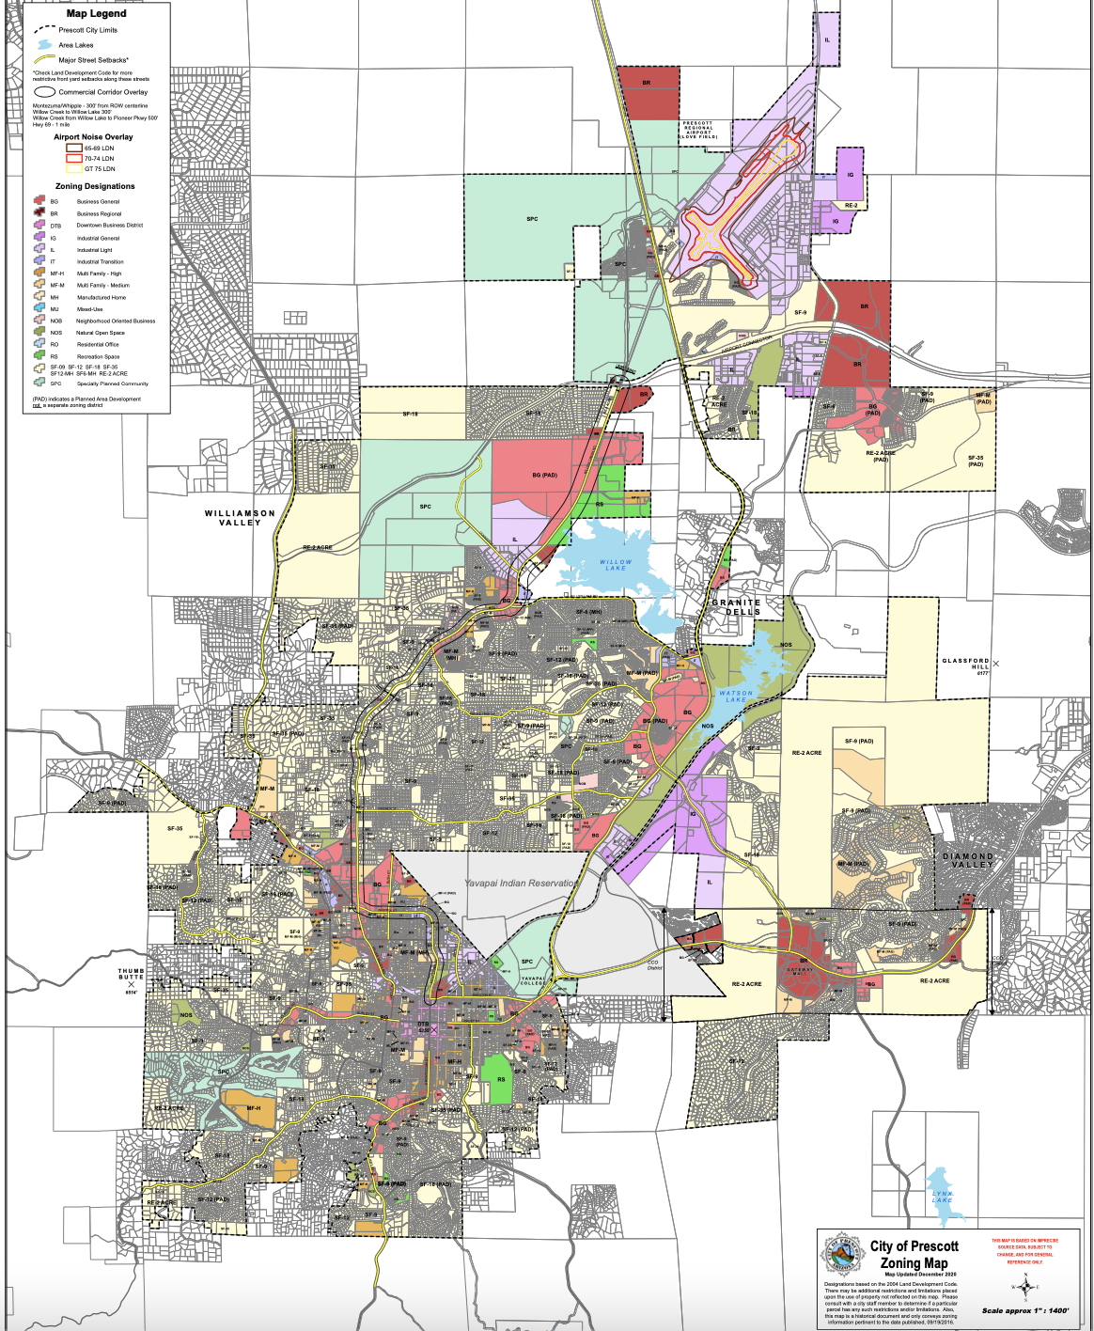
The LDC applies to all development, public and private, within the City of Prescott. All structures, land uses constructed or commenced hereafter and all enlargements of, additions to, changes in, and relocations of, existing structures and uses occurring hereafter shall be subject to this LDC, all Statutes of the State of Arizona, the Building Codes of the City of Prescott, and all other applicable City Codes.
As shown in the diagram below the Airport Noise Overlay (ANO) is one of the zoning districts established by the LDC.
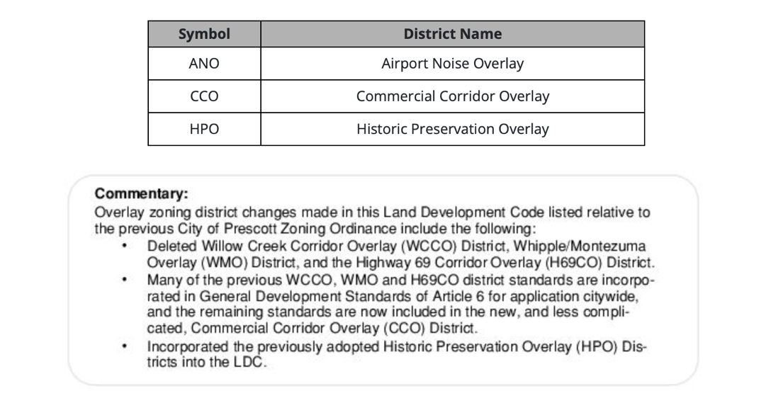
The ANO provides standards for the mitigation of impacts created by aviation related activity at PRC. Uses are allowed in the ANO district in accordance with the following Land Use Compatibility Table.
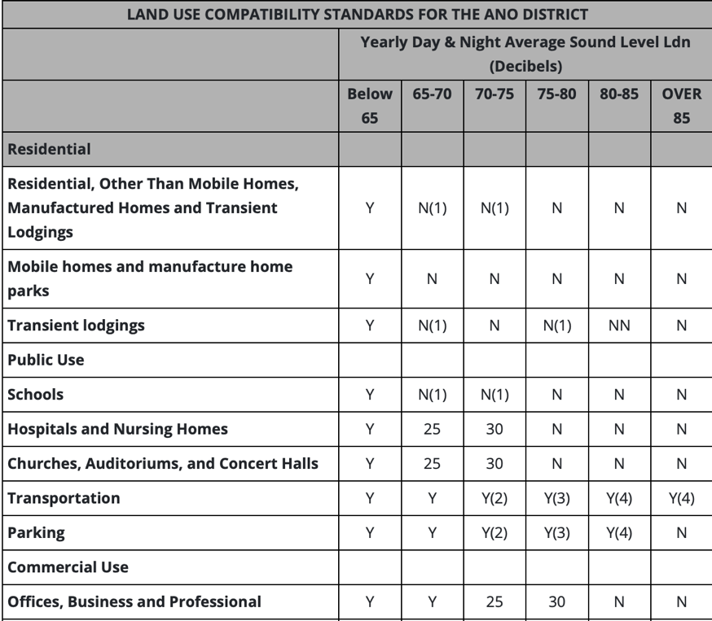
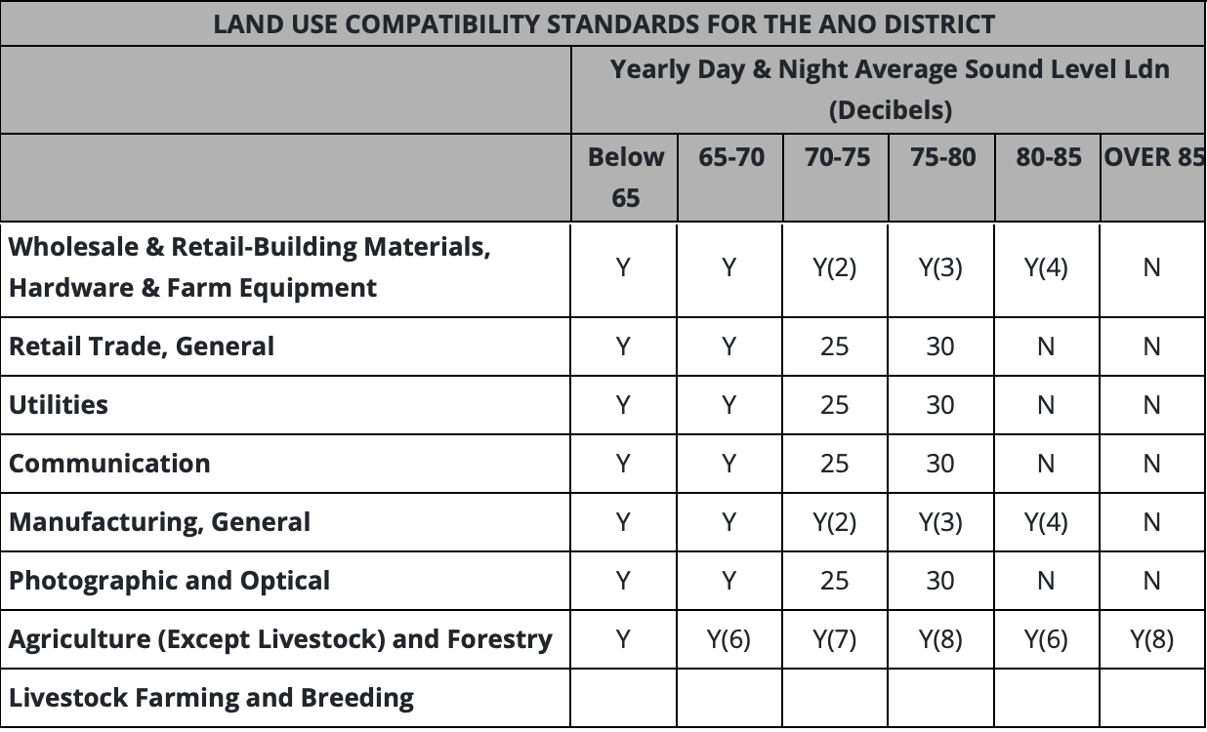
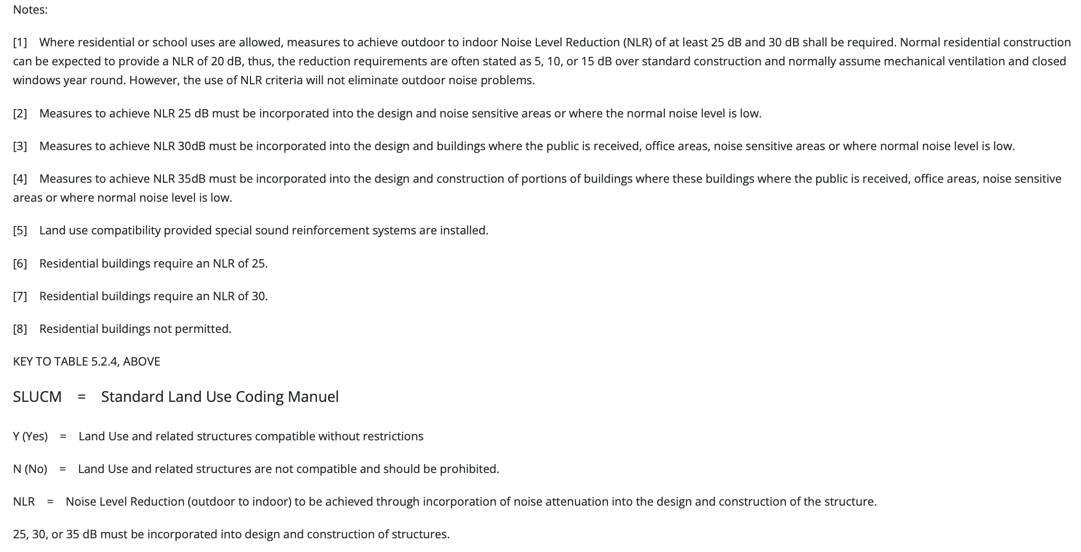
The LDC also requires a Noise and Avigation Easement. Prior to issuance of any building or development permit for property within the noise compatibility zones, the owner of said property shall provide the City of Prescott with an avigation easement over the subject property and release the City of Prescott from all liability for any and all claims for damages including, but not limited to, dust, noise, vibration, fumes, fuel and lubricant particles. The avigation easement and release form shall be available from the City of Prescott. The same avigation easement shall be required within the Airport Influence Area, as authorized by the City, and shown in the table below. The Airport Influence Area is described to include the following parcels.
Parcel | Description
1 | All of Sections 1, 2, and 3, Township 14 North, Range 02 West, Gila and Salt River Base and Meridian, Yavapai County, Arizona
2 | All of Sections 5 and 6, Township 14 North, Range 01 West, Gila and Salt River Base and Meridian, Yavapai County, Arizona
3 | All of Sections 13, 14, 15, 22, 23, 24, 25, 26, 27, 34, 35, and 36, Township 15 North, Range 02 West, Gila and Salt River Base and Meridian, Yavapai County, Arizona
4 | All of Sections 8, 9, 16, 17, 18, 19, 20, 29, 30, 31, and 32, Township 15 North, Range 01 West, Gila and Salt River Base and Meridian, Yavapai County, Arizona

This paper addressed some of the growing pains around PRC. It began with an overview of how funding for the airport has been, and continues to be, obtained from the FAA in the form of AIP grants including the grant assurances, or strings attached to said grants. Then it presented an overview of the ACIP to provide additional insight. Zooming in from national to state planning, a brief overview of the ADOT Airport Master Plan; and zooming in further, a brief look at local planning and the City of Prescott ASAP. Finally, addressing the land around the airport, a brief look at the zoning map approved by the city and the LDC. Throughout this paper, issues were addressed including, but not limited to, land use zoning, noise, safety, and avigation easements.
In closing, it is important to note that PRC was named ADOT 2020 Airport of the Year. It had received the same award in 2014. ADOT’s Aeronautics Group, part of the agency’s Multimodal Planning Division, decides winners based on accomplishments in aviation advocacy and community relations, airport management, special events and recognition, as well as innovative activities and programs. The Aeronautical Group also works with dozens of airports across Arizona to administer federal and state grants through its Airport Development Program.
Lastly, to allay the complaints that PRC receives for noise daily, it is suggested that a public service campaign be launched to turn the public’s attention to the fact that this airport serves a great need within the air transportation industry, that is to train future airline pilots and military pilots, necessary to our air infrastructure as a nation. Instead of begrudging the number of takeoffs and landings over our roofs one should be proud to be a part of a community dedicated in huge part to ensuring air travel and military freedoms remain the American way!

https://www.faa.gov/airports/aip/
https://www.faa.gov/airports/aip/acip/
https://azdot.gov/airports/ernest-love-field
https://www.prescott-az.gov/wp-content/uploads/2017/11/2017-ASAP-final-plan-2014-DWR-Amend-rev2.pdf
https://www.prescott-az.gov/business-development/planning/land-development-code/
https://www.codepublishing.com/AZ/Prescott/#!/PrescottLDC/PrescottLDCNT.html
https://www.faa.gov/airports/planning_capacity/npias/
https://www.faa.gov/airports/planning_capacity/npias/current/media/NPIAS-2021-2025-Appendix-A.pdf
https://www.faa.gov/airports/planning_capacity/npias/current/media/NPIAS-2021-2025-Appendix-B.pdf
https://www.faa.gov/airports/planning_capacity/npias/current/media/NPIAS-2021-2025-Narrative.pdf
https://www.faa.gov/airports/planning_capacity/npias/current/media/NPIAS-2021-2025-Appendix-A.pdf
https://www.faa.gov/airports/aip/overview/
https://www.faa.gov/airports/planning_capacity/npias/current/media/NPIAS-2021-2025-Appendix-B.pdf
https://www.faa.gov/airports/planning_capacity/npias/current/media/NPIAS-2021-2025-Narrative.pdf
https://www.faa.gov/documentLibrary/media/Order/Order-5090-5-NPIAS-ACIP.pdf
https://www.faa.gov/airports/aip/acip/
https://www.faa.gov/regulations_policies/orders_notices/index.cfm/go/document.current/documentNumber/ 5090.5
https://apps.azdot.gov/files/Airports/ALP_PDF/Prescott/Appendix_One_Land_Use_Access_Plan.pdf
https://apps.azdot.gov/files/Airports/MP_PDF/Prescott/PRC_Final_Master_Plan.pdf
https://apps.azdot.gov/files/Airports/MP_PDF/Prescott/PRC_Final_Master_Plan.pdf
https://prescott.erau.edu/about/fleet
https://flyprescott.com/about/
https://apps.azdot.gov/files/Airports/MP_PDF/Prescott/PRC_Final_Master_Plan.pdf
https://apps.azdot.gov/files/Airports/MP_PDF/Prescott/PRC_Final_Master_Plan.pdf
https://apps.azdot.gov/files/Airports/MP_PDF/Prescott/PRC_Final_Master_Plan.pdf
https://apps.azdot.gov/files/Airports/MP_PDF/Prescott/PRC_Final_Master_Plan.pdf
https://apps.azdot.gov/files/Airports/MP_PDF/Prescott/PRC_Final_Master_Plan.pdf
https://www.faa.gov/air_traffic/flight_info/aeronav/digital_products/dafd/search/advanced/
https://www.faa.gov/about/office_org/headquarters_offices/apl/research/models/inm_model
https://www.faa.gov/regulations_policies/policy_guidance/noise/basics/
https://apps.azdot.gov/files/Airports/MP_PDF/Prescott/PRC_Final_Master_Plan.pdf
https://apps.azdot.gov/files/Airports/MP_PDF/Prescott/PRC_Final_Master_Plan.pdf
https://apps.azdot.gov/files/Airports/MP_PDF/Prescott/PRC_Final_Master_Plan.pdf
https://apps.azdot.gov/files/Airports/MP_PDF/Prescott/PRC_Final_Master_Plan.pdf
https://apps.azdot.gov/files/Airports/MP_PDF/Prescott/PRC_Final_Master_Plan.pdf
https://apps.azdot.gov/files/Airports/MP_PDF/Prescott/PRC_Final_Master_Plan.pdf
https://apps.azdot.gov/files/Airports/MP_PDF/Prescott/PRC_Final_Master_Plan.pdf
https://apps.azdot.gov/files/Airports/MP_PDF/Prescott/PRC_Final_Master_Plan.pdf
https://www.prescott-az.gov/wp-content/uploads/2017/11/2017-ASAP-final-plan-2014-DWR-Amend-rev2.pdf
https://www.prescott-az.gov/wp-content/uploads/2017/11/2017-ASAP-final-plan-2014-DWR-Amend-rev2.pdf
https://www.prescott-az.gov/wp-content/uploads/2017/11/2017-ASAP-final-plan-2014-DWR-Amend-rev2.pdf
https://www.prescott-az.gov/wp-content/uploads/2017/11/2017-ASAP-final-plan-2014-DWR-Amend-rev2.pdf
https://www.prescott-az.gov/wp-content/uploads/2017/11/2017-ASAP-final-plan-2014-DWR-Amend-rev2.pdf
http://prescottaz.iqm2.com/Citizens/FileOpen.aspx?Type=1&ID=1722&Inline=True
https://www.prescott-az.gov/wp-content/uploads/2017/11/2017-ASAP-final-plan-2014-DWR-Amend-rev2.pdf
https://www.prescott-az.gov/wp-content/uploads/2017/11/2017-ASAP-final-plan-2014-DWR-Amend-rev2.pdf
https://www.prescott-az.gov/wp-content/uploads/2017/11/2017-ASAP-final-plan-2014-DWR-Amend-rev2.pdf
https://www.faa.gov/airports/aip/grant_assurances/
https://www.faa.gov/airports/aip/grant_assurances/
https://www.faa.gov/airports/aip/grant_assurances/media/airport-sponsor-assurances-aip-2020.pdf
https://www.faa.gov/airports/resources/publications/orders/compliance_5190_6/
https://www.faa.gov/airports/resources/publications/orders/compliance_5190_6/media/5190_6b_chap4.pdf
https://www.faa.gov/airports/resources/publications/orders/compliance_5190_6/media/5190_6b_chap4.pdf
https://www.faa.gov/airports/resources/publications/orders/compliance_5190_6/media/5190_6b_chap2.pdf
https://www.faa.gov/regulations_policies/orders_notices/index.cfm/go/document.information/documentID/ 8460
https://www.faa.gov/documentLibrary/media/Order/5190.2R.pdf
https://adip.faa.gov/agis/public/#/simpleAirportMap/PRC
https://adip.faa.gov/agis/public/#/airportData/PRC
https://www.faa.gov/airports/aip/2021_aip_grants/media/FY2021_AIP_grants_announced_09212021.pdf
https://www.faa.gov/airports/aip/2021_aip_grants/media/FY2021_AIP_grants_announced_04012021.pdf
https://www.faa.gov/airports/aip/grant_histories/media/FY2020-AIP-grants.pdf
https://www.faa.gov/airports/aip/grant_histories/media/FY2019-AIP-grants.pdf
https://www.faa.gov/airports/aip/grant_histories/media/FY2018-AIP-grants.pdf
https://www.faa.gov/airports/aip/grant_histories/media/grants-2003.pdf
https://www.faa.gov/airports/aip/grant_histories/
https://www.faa.gov/airports/aip/grant_histories/
https://www.faa.gov/airports/aip/grant_histories/
https://www.faa.gov/airports/aip/grant_assurances/media/airport-sponsor-assurances-aip-2020.pdf
https://www.faa.gov/airports/airport_compliance/complaints/
https://part16.airports.faa.gov/pdf/16-09-06b.pdf
https://www.faa.gov/airports/aip/grant_histories/media/FY2017-AIP-grants.pdf
https://www.faa.gov/airports/aip/grant_histories/media/FY2018-AIP-grants.pdf
https://www.faa.gov/airports/aip/grant_histories/media/FY2019-AIP-grants.pdf
https://www.faa.gov/airports/aip/2021_aip_grants/media/FY2021_AIP_grants_announced_07012021.pdf
https://www.faa.gov/airports/aip/2021_aip_grants/media/FY2021_AIP_grants_announced_05132021.pdf
https://part16.airports.faa.gov/pdf/16-13-05b.pdf
https://part16.airports.faa.gov/pdf/16-13-05b.pdf
https://part16.airports.faa.gov/pdf/16-13-05b.pdf
https://part16.airports.faa.gov/pdf/16-12-11.pdf
https://part16.airports.faa.gov/pdf/16-13-05b.pdf
https://www.faa.gov/sites/faa.gov/files/about/office_org/headquarters_offices/apl/V.C.pdf
https://www.faa.gov/airports/central/airports_resources/media/RPZeasement.pdf
https://www.faa.gov/airports/central/aip/sponsor_guide/media/0500.pdf
https://www.codepublishing.com/AZ/Prescott/#!/PrescottLDC/PrescottLDC01.html#1
https://www.prescott-az.gov/business-development/planning/land-development-code/
https://www.codepublishing.com/AZ/Prescott/#!/PrescottLDC/PrescottLDC01.html#1
https://www.codepublishing.com/AZ/Prescott/#!/html/PrescottLDC/PrescottLDC02.html
https://www.codepublishing.com/AZ/Prescott/#!/html/PrescottLDC/PrescottLDC05.html
https://www.codepublishing.com/AZ/Prescott/#!/PrescottLDC/PrescottLDCAX.html#AX-A
https://www.faa.gov/airports/aip/
https://www.faa.gov/airports/aip/acip/
https://azdot.gov/airports/ernest-love-field
https://www.prescott-az.gov/wp-content/uploads/2017/11/2017-ASAP-final-plan-2014-DWR-Amend-rev2.pdf
https://www.prescott-az.gov/business-development/planning/land-development-code/
https://azdot.gov/adot-news/prescott-regional-airport-adot%E2%80%99s-2020-airport-year
https://flyprescott.com/noise-program/

