14 CFR 107
and
49 USC 44809 broken down
in a way
you'll remember these regs...
with humor!

At this time remove my bada$$ pic on my Harley and insert your own pic!

The regulations, 14 CFR 107, 48, 89, and 49 USC 44809, are black, my comments are purple, AC 107-2A is green, AC 91-57C is orange, AC 89-1 is red, AC 89-2 is brown, AC 89-3 is pink, and Flight Standards Information Management System (FSIMS) 8900.1 CHG 625 - VOLUME 16 UNMANNED AIRCRAFT SYSTEMS is blue.

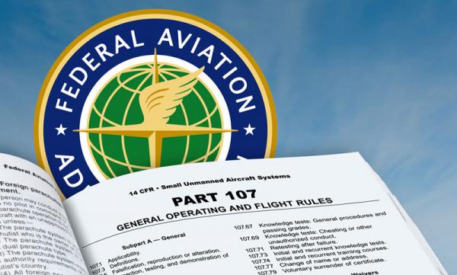

https://www.ecfr.gov/current/title-14/chapter-I/subchapter-F/part-107

Displaying title 14, up to date as of 6/15/2023. Title 14 was last amended 6/15/2023.
Always check the date on the website to ensure you have the most current regs.

PART 107—SMALL UNMANNED AIRCRAFT SYSTEMS
Authority: 49 U.S.C. 106(f), 40101 note, 40103(b), 44701(a)(5), 46105(c), 46110, 44807.
Source: Docket FAA–2015–0150, Amdt. 107–1, 81 FR 42209, June 28, 2016, unless otherwise noted.

Subpart A—General

§ 107.1 Applicability.
(a) Except as provided in paragraph (b) of this section, this part applies to the registration, airman certification, and operation of civil small unmanned aircraft systems within the United States. This part also applies to the eligibility of civil small unmanned aircraft systems to operate over human beings in the United States.
(b) This part does not apply to the following:
(1) Air carrier operations;
(2) Any aircraft subject to the provisions of 49 U.S.C. 44809; more on this later
(3) Any operation that the holder of an exemption under section 333 of Public Law 112–95 or 49 U.S.C. 44807 elects to conduct pursuant to the exemption, unless otherwise specified in the exemption; or
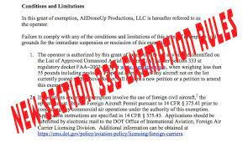
(4) Any operation that a person elects to conduct under part 91 of this chapter with a small unmanned aircraft system that has been issued an airworthiness certificate.
[Amdt. No. 107–8, 86 FR 4381, Jan. 15, 2021]

§ 107.2 Applicability of certification procedures for products and articles.
The provisions of part 21 of this chapter do not apply to small unmanned aircraft systems operated under this part unless the small unmanned aircraft system will operate over human beings in accordance with § 107.140.
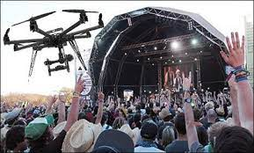
[Amdt. No. 107–8, 86 FR 4381, Jan. 15, 2021]

§ 107.3 Definitions.
The following definitions apply to this part. If there is a conflict between the definitions of this part and definitions specified in § 1.1 of this chapter, the definitions in this part control for purposes of this part:
Definitions of 14 CFR 1.1 v. Definitions of 14 CFR 107

Control station means an interface used by the remote pilot to control the flight path of the small unmanned aircraft.
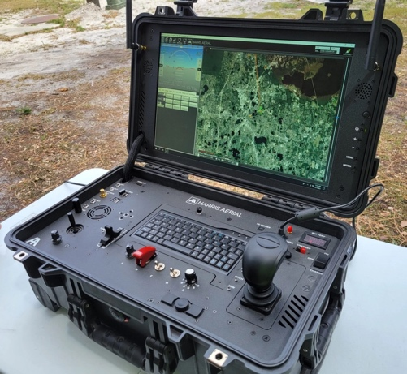
Corrective lenses means spectacles or contact lenses.

Declaration of compliance means a record submitted to the FAA that certifies the small unmanned aircraft conforms to the Category 2 or Category 3 requirements under subpart D of this part.
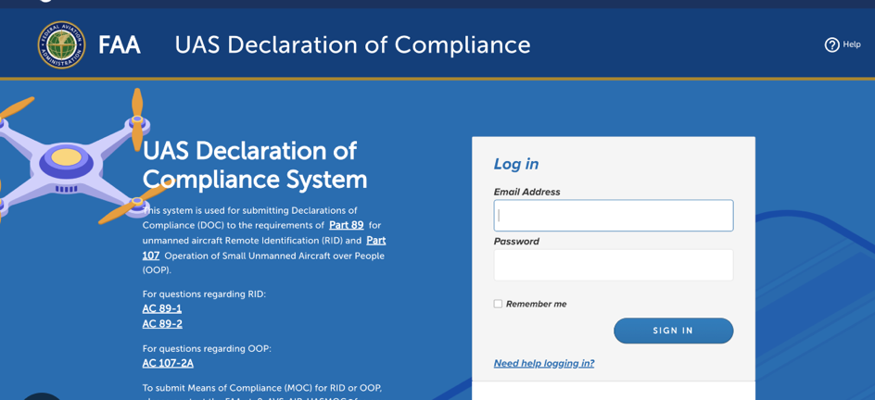

Small unmanned aircraft means an unmanned aircraft weighing less than 55 pounds on takeoff, including everything that is on board or otherwise attached to the aircraft.
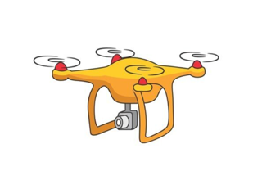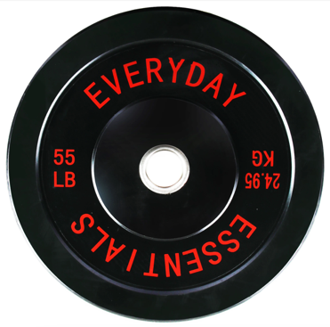
Small unmanned aircraft system (small UAS) means a small unmanned aircraft and its associated elements (including communication links and the components that control the small unmanned aircraft) that are required for the safe and efficient operation of the small unmanned aircraft in the national airspace system.
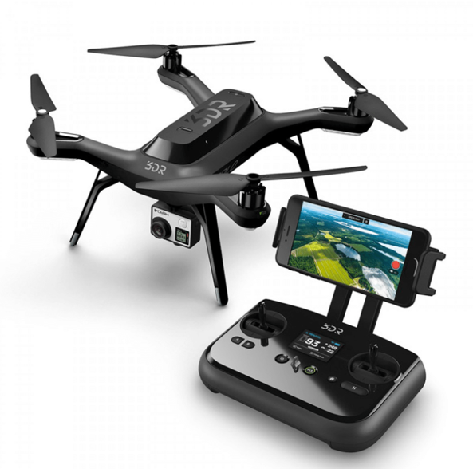

Unmanned aircraft means an aircraft operated without the possibility of direct human intervention from within or on the aircraft.
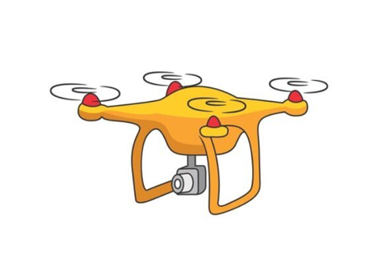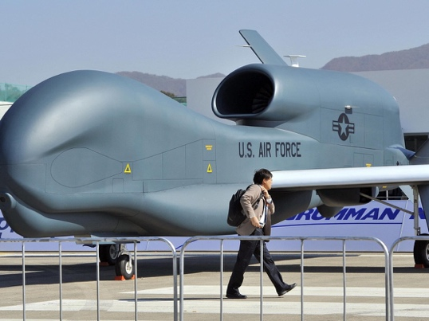

Visual observer means a person who is designated by the remote pilot in command to assist the remote pilot in command and the person manipulating the flight controls of the small UAS to see and avoid other air traffic or objects aloft or on the ground.
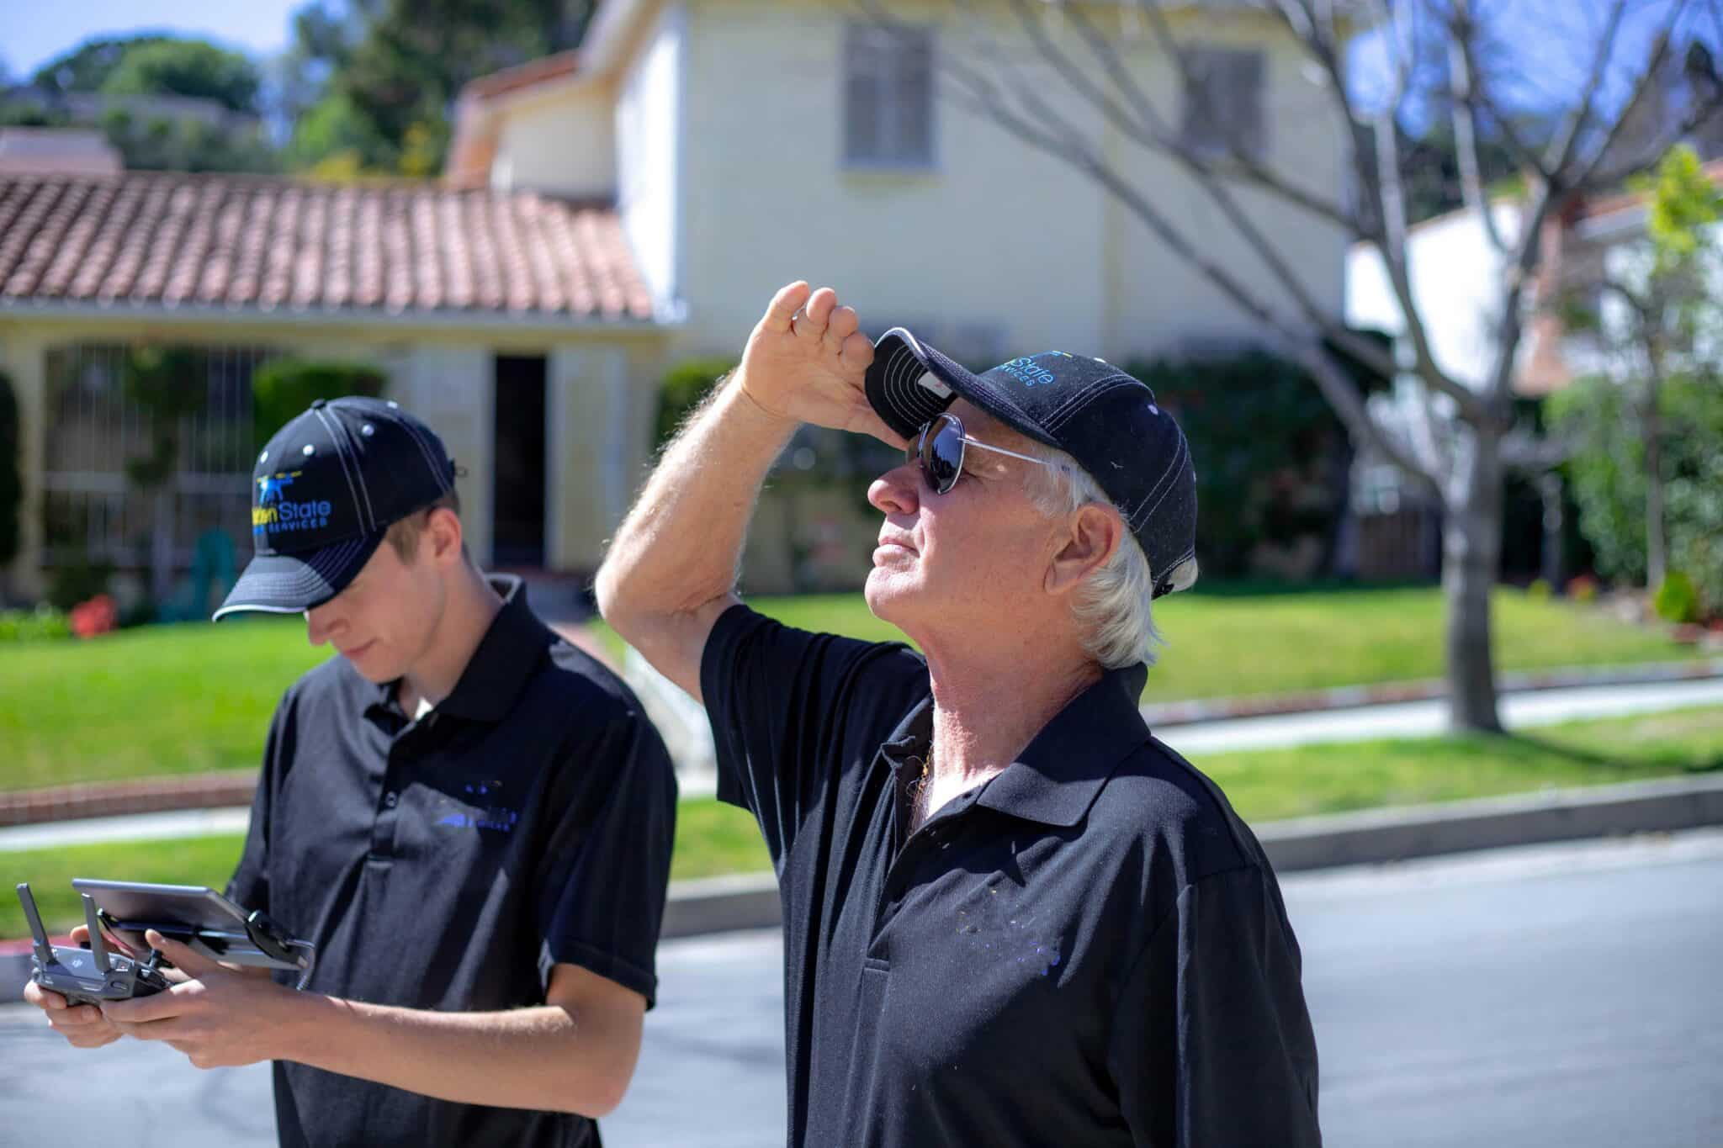
Cool Pilot Dude Visual Observer Dude
[Docket FAA–2015–0150, Amdt. 107–1, 81 FR 42209, June 28, 2016, as amended by Amdt. No. 107–8, 86 FR 4381, Jan. 15, 2021]

§ 107.5 Falsification, reproduction, or alteration.
(a) No person may make or cause to be made—
(1) Any fraudulent or intentionally false record or report that is required to be made, kept, or used to show compliance with any requirement under this part.
(2) Any reproduction or alteration, for fraudulent purpose, of any certificate, rating, authorization, record or report under this part.
(b) The commission by any person of an act prohibited under paragraph (a) of this section is a basis for any of the following:
(1) Denial of an application for a remote pilot certificate or a certificate of waiver;
(2) Denial of a declaration of compliance;
(3) Suspension or revocation of any certificate, waiver, or declaration of compliance issued or accepted by the Administrator under this part and held by that person; or
(4) A civil penalty.
[Docket FAA–2015–0150, Amdt. 107–1, 81 FR 42209, June 28, 2016, as amended by Amdt. No. 107–8, 86 FR 4381, Jan. 15, 2021]

§ 107.7 Inspection, testing, and demonstration of compliance.
(a) A remote pilot in command, owner, or person manipulating the flight controls of a small unmanned aircraft system must—
(1) Have in that person's physical possession and readily accessible the remote pilot certificate with a small UAS rating and identification when exercising the privileges of that remote pilot certificate.
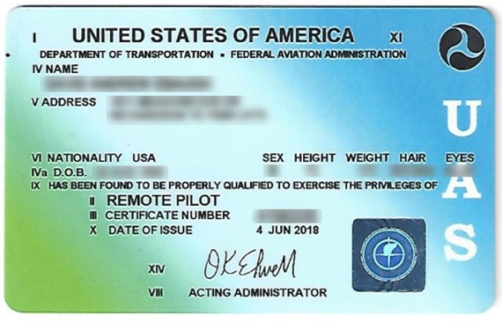
(2) Present his or her remote pilot certificate with a small UAS rating and identification that contains the information listed at § 107.67(b)(1) through (3) for inspection upon a request from—
(i) The Administrator;
(ii) An authorized representative of the National Transportation Safety Board;
(iii) Any Federal, State, or local law enforcement officer; or
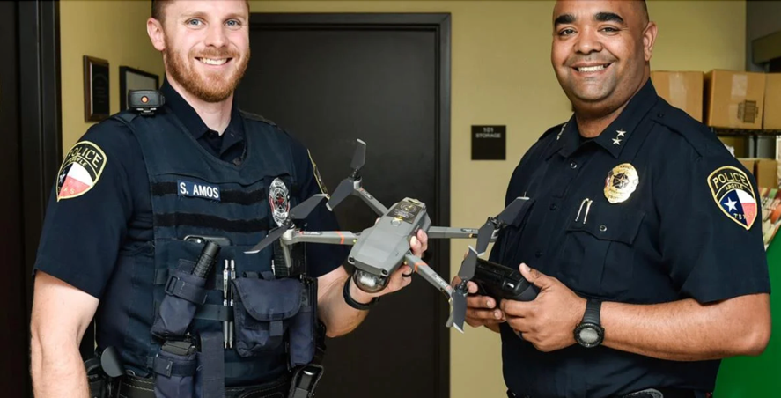
(iv) An authorized representative of the Transportation Security Administration.
(3) Make available, upon request, to the Administrator any document, record, or report required to be kept under the regulations of this chapter.
(b) The remote pilot in command, visual observer, owner, operator, or person manipulating the flight controls of a small unmanned aircraft system must, upon request, allow the Administrator to make any test or inspection of the small unmanned aircraft system, the remote pilot in command, the person manipulating the flight controls of a small unmanned aircraft system, and, if applicable, the visual observer to determine compliance with this part.
(c) Any person holding an FAA-accepted declaration of compliance under subpart D of this part must, upon request, make available to the Administrator:
(1) The declaration of compliance required under subpart D of this part; and
(2) Any other document, record, or report required to be kept under the regulations of this chapter.
(d) Any person holding an FAA-accepted declaration of compliance under subpart D of this part must, upon request, allow the Administrator to inspect its facilities, technical data, and any manufactured small UAS and witness any tests necessary to determine compliance with that subpart.
[Amdt. No. 107–8, 86 FR 4381, Jan. 15, 2021]

§ 107.9 Safety event reporting.
No later than 10 calendar days after an operation that meets the criteria of either paragraph (a) or (b) of this section, a remote pilot in command must report to the FAA, in a manner acceptable to the Administrator, any operation of the small unmanned aircraft involving at least:
(a) Serious injury to any person or any loss of consciousness; or
(b) Damage to any property, other than the small unmanned aircraft, unless one of the following conditions is satisfied:
(1) The cost of repair (including materials and labor) does not exceed $500; or
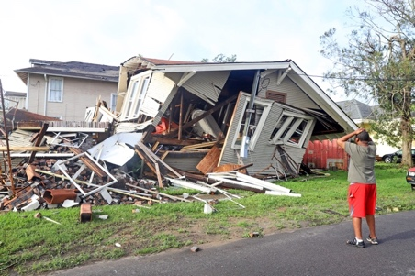
(2) The fair market value of the property does not exceed $500 in the event of total loss.

Subpart B—Operating Rules

§ 107.11 Applicability.
This subpart applies to the operation of all civil small unmanned aircraft systems subject to this part.

§ 107.12 Requirement for a remote pilot certificate with a small UAS rating.
(a) Except as provided in paragraph (c) of this section, no person may manipulate the flight controls of a small unmanned aircraft system unless:
(1) That person has a remote pilot certificate with a small UAS rating issued pursuant to subpart C of this part and satisfies the requirements of § 107.65; or
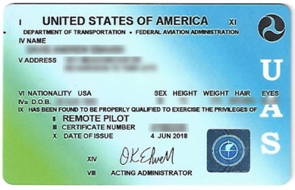
(2) That person is under the direct supervision of a remote pilot in command and the remote pilot in command has the ability to immediately take direct control of the flight of the small unmanned aircraft.
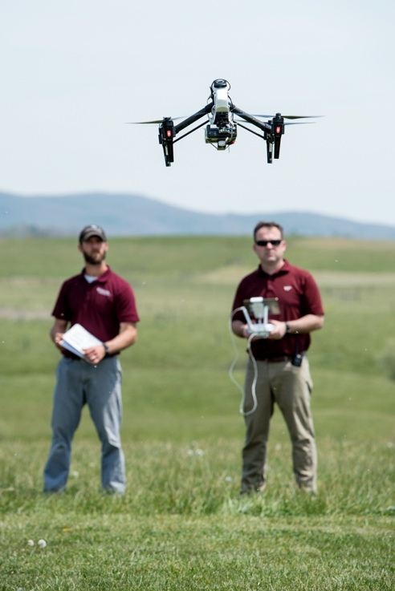
(b) Except as provided in paragraph (c) of this section, no person may act as a remote pilot in command unless that person has a remote pilot certificate with a small UAS rating issued pursuant to Subpart C of this part and satisfies the requirements of § 107.65.
(c) The Administrator may, consistent with international standards, authorize an airman to operate a civil foreign-registered small unmanned aircraft without an FAA-issued remote pilot certificate with a small UAS rating.
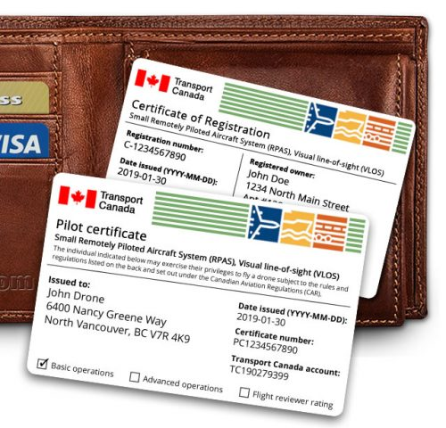

§ 107.13 Registration.
A person operating a civil small unmanned aircraft system for purposes of flight must comply with the provisions of § 91.203(a)(2) of this chapter.
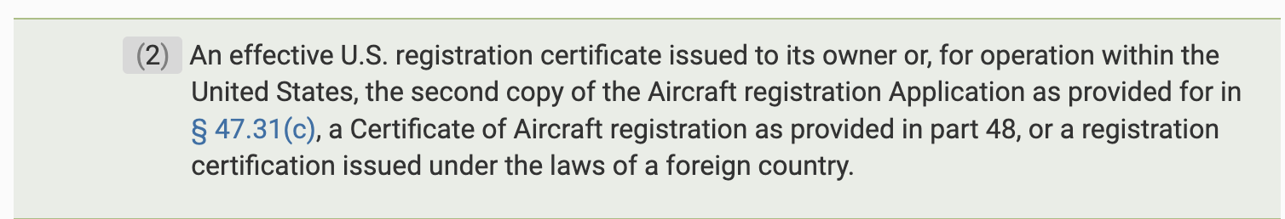

§ 107.15 Condition for safe operation.
(a) No person may operate a civil small unmanned aircraft system unless it is in a condition for safe operation. Prior to each flight, the remote pilot in command must check the small unmanned aircraft system to determine whether it is in a condition for safe operation.
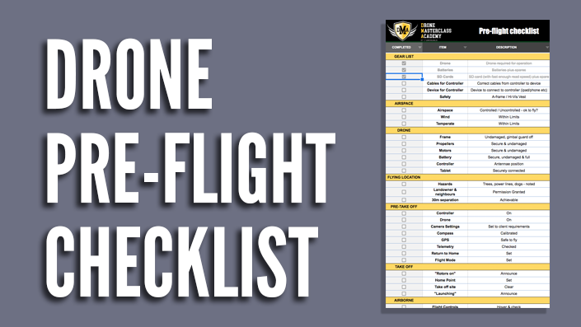
(b) No person may continue flight of the small unmanned aircraft when he or she knows or has reason to know that the small unmanned aircraft system is no longer in a condition for safe operation.
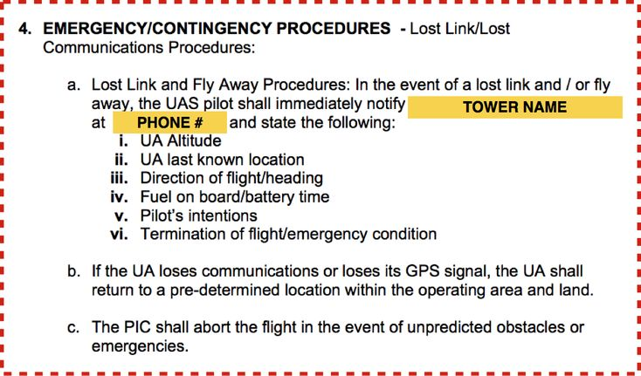

§ 107.17 Medical condition.
No person may manipulate the flight controls of a small unmanned aircraft system or act as a remote pilot in command, visual observer, or direct participant in the operation of the small unmanned aircraft if he or she knows or has reason to know that he or she has a physical or mental condition that would interfere with the safe operation of the small unmanned aircraft system.

§ 107.19 Remote pilot in command.
(a) A remote pilot in command must be designated before or during the flight of the small unmanned aircraft.
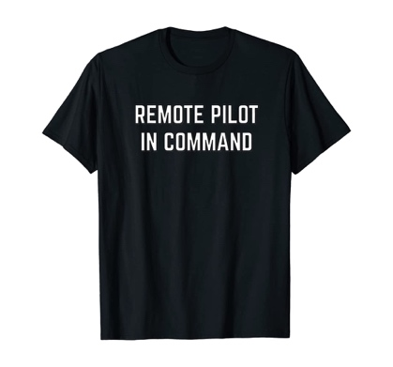
Pick me…. Pick me…
(b) The remote pilot in command is directly responsible for and is the final authority as to the operation of the small unmanned aircraft system.
(c) The remote pilot in command must ensure that the small unmanned aircraft will pose no undue hazard to other people, other aircraft, or other property in the event of a loss of control of the small unmanned aircraft for any reason.
(d) The remote pilot in command must ensure that the small UAS operation complies with all applicable regulations of this chapter.
(e) The remote pilot in command must have the ability to direct the small unmanned aircraft to ensure compliance with the applicable provisions of this chapter.
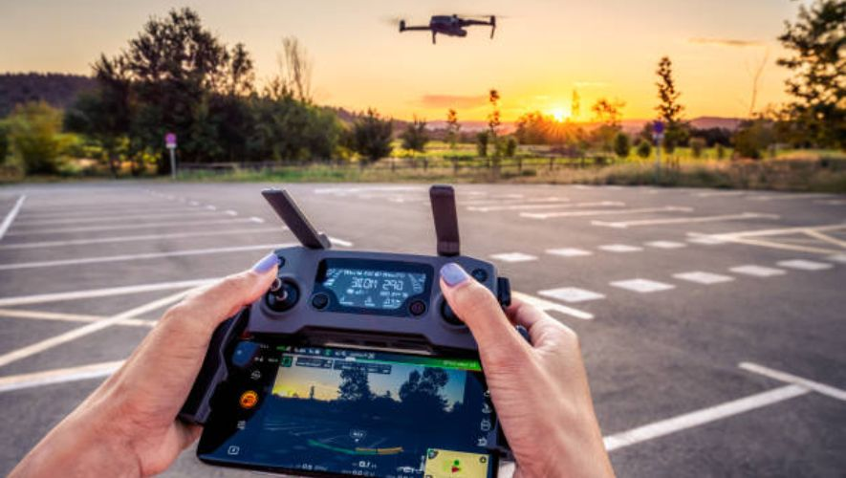
[Docket FAA–2015–0150, Amdt. 107–1, 81 FR 42209, June 28, 2016, as amended by Amdt. No. 107–8, 86 FR 4382, Jan. 15, 2021]

§ 107.21 In-flight emergency.
(a) In an in-flight emergency requiring immediate action, the remote pilot in command may deviate from any rule of this part to the extent necessary to meet that emergency.
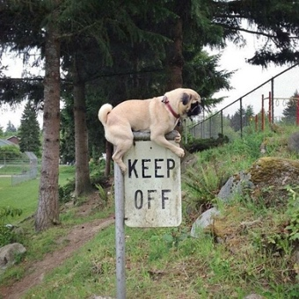
(b) Each remote pilot in command who deviates from a rule under paragraph (a) of this section must, upon request of the Administrator, send a written report of that deviation to the Administrator.

§ 107.23 Hazardous operation.
No person may:
(a) Operate a small unmanned aircraft system in a careless or reckless manner so as to endanger the life or property of another; or
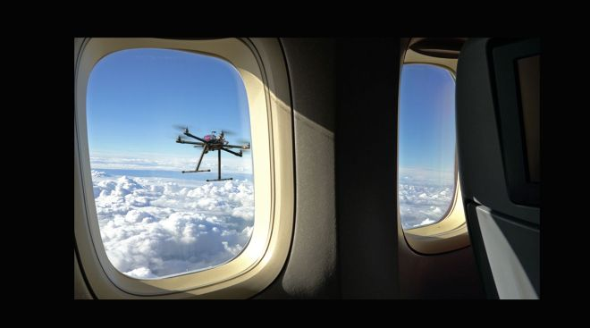

(b) Allow an object to be dropped from a small unmanned aircraft in a manner that creates an undue hazard to persons or property.
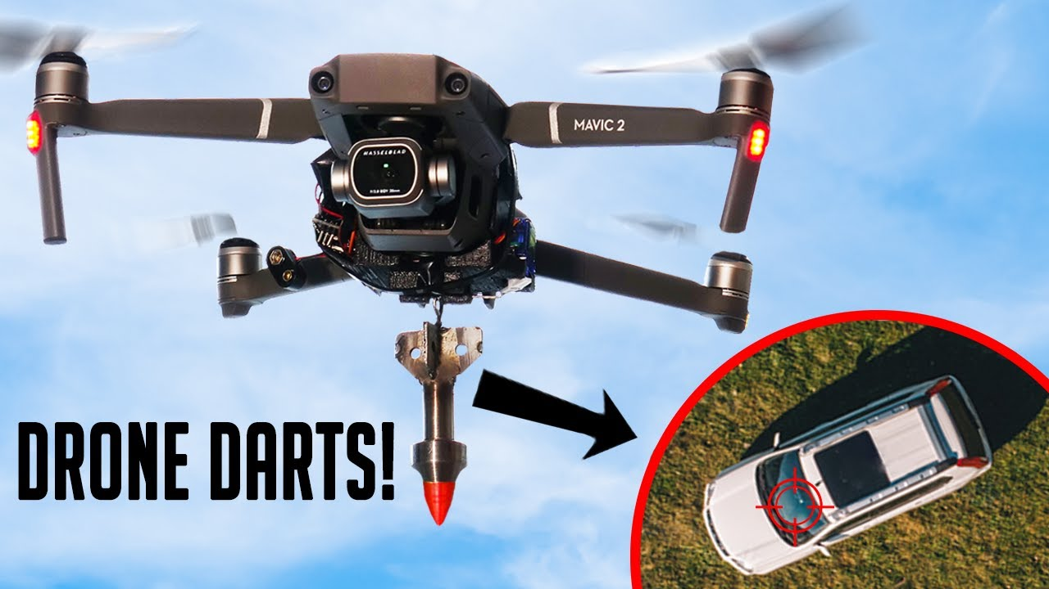

§ 107.25 Operation from a moving vehicle or aircraft.
No person may operate a small unmanned aircraft system—
(a) From a moving aircraft; or
(b) From a moving land or water-borne vehicle unless the small unmanned aircraft is flown over a sparsely populated area and is not transporting another person's property for compensation or hire.
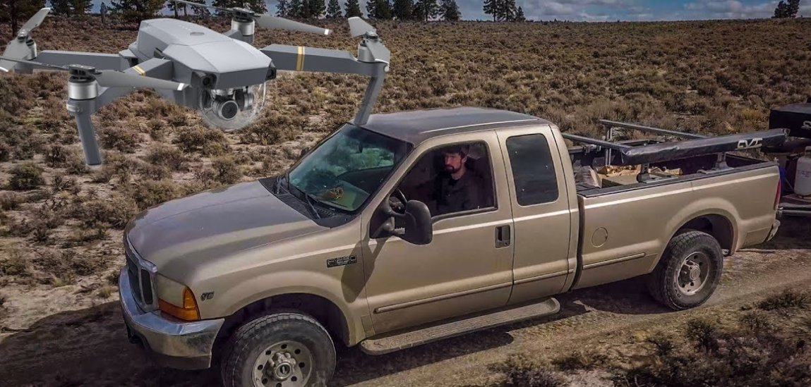

What is the definition of “sparsely populated” you ask?
In a 2010 legal interpretation, the FAA cited Mickalich v. United States, 2007 WL 1041202 (E.D. Mich.) for a discussion of what constitutes a sparsely populated area. The court found that twenty people on a ten-acre site would be considered sparsely populated under 14 CFR 91.119(c). Additionally, in other legal opinions by the FAA, the agency has emphasized that it would adopt a case-by-case analysis in determining when a pilot violates § 91.119, which includes determining when an area is ‘‘sparsely populated.’’
https://www.govinfo.gov/content/pkg/FR-2016-06-28/pdf/2016-15079.pdf

§ 107.27 Alcohol or drugs.
A person manipulating the flight controls of a small unmanned aircraft system or acting as a remote pilot in command or visual observer must comply with the provisions of §§ 91.17 and 91.19 of this chapter.
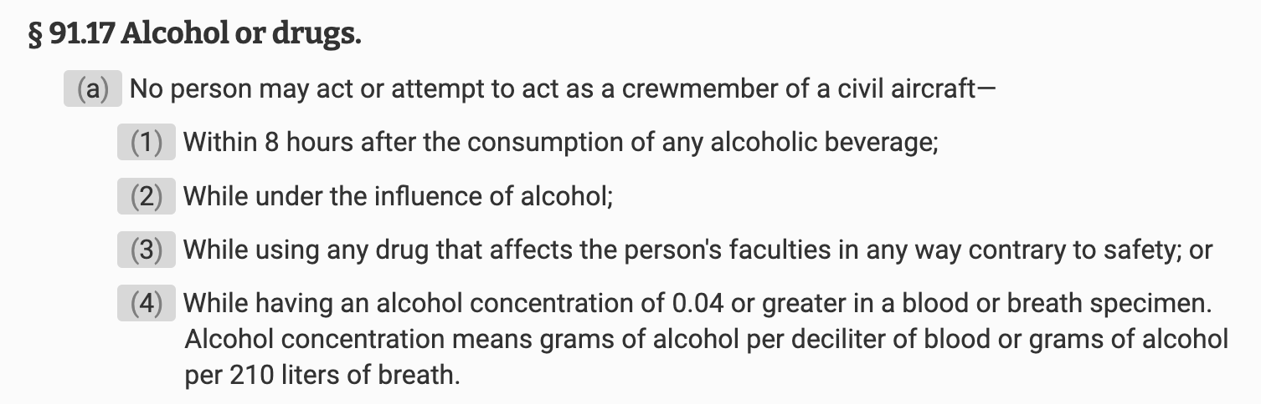

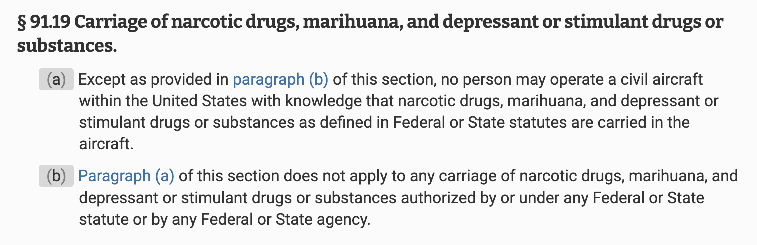

§ 107.29 Operation at night.
(a) Except as provided in paragraph (d) of this section, no person may operate a small unmanned aircraft system at night unless—
(1) The remote pilot in command of the small unmanned aircraft has completed an initial knowledge test or training, as applicable, under § 107.65 after April 6, 2021; and
(2) The small unmanned aircraft has lighted anti-collision lighting visible for at least 3 statute miles that has a flash rate sufficient to avoid a collision. The remote pilot in command may reduce the intensity of, but may not extinguish, the anti-collision lighting if he or she determines that, because of operating conditions, it would be in the interest of safety to do so.
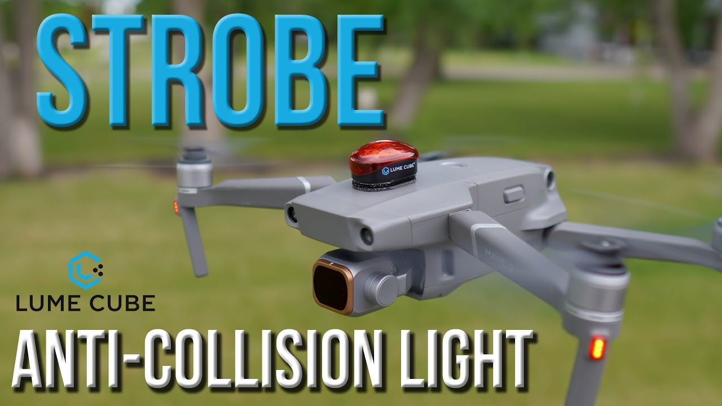
(b) No person may operate a small unmanned aircraft system during periods of civil twilight unless the small unmanned aircraft has lighted anti-collision lighting visible for at least 3 statute miles that has a flash rate sufficient to avoid a collision. The remote pilot in command may reduce the intensity of, but may not extinguish, the anti-collision lighting if he or she determines that, because of operating conditions, it would be in the interest of safety to do so.
(c) For purposes of paragraph (b) of this section, civil twilight refers to the following:
(1) Except for Alaska, a period of time that begins 30 minutes before official sunrise and ends at official sunrise;
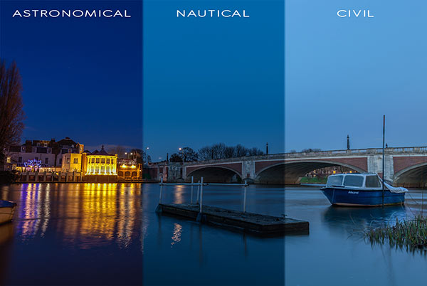
(2) Except for Alaska, a period of time that begins at official sunset and ends 30 minutes after official sunset; and
(3) In Alaska, the period of civil twilight as defined in the Air Almanac.
(d) After May 17, 2021, no person may operate a small unmanned aircraft system at night in accordance with a certificate of waiver issued prior to April 21, 2021 under § 107.200. The certificates of waiver issued prior to March 16, 2021 under § 107.200 that authorize deviation from § 107.29 terminate on May 17, 2021.
[Docket FAA–2015–0150, Amdt. 107–1, 81 FR 42209, June 28, 2016, as amended by Amdt. No. 107–8, 86 FR 4382, Jan. 15, 2021; 86 FR 13631, Mar. 10, 2020]

§ 107.31 Visual line of sight aircraft operation.
(a) With vision that is unaided by any device other than corrective lenses, the remote pilot in command, the visual observer (if one is used), and the person manipulating the flight control of the small unmanned aircraft system must be able to see the unmanned aircraft throughout the entire flight in order to:
(1) Know the unmanned aircraft's location;
(2) Determine the unmanned aircraft's attitude, altitude, and direction of flight;
(3) Observe the airspace for other air traffic or hazards; and
(4) Determine that the unmanned aircraft does not endanger the life or property of another.
(b) Throughout the entire flight of the small unmanned aircraft, the ability described in paragraph (a) of this section must be exercised by either:
(1) The remote pilot in command and the person manipulating the flight controls of the small unmanned aircraft system; or
(2) A visual observer.
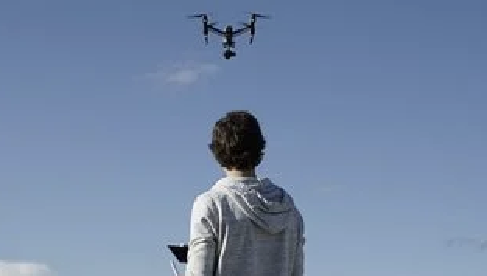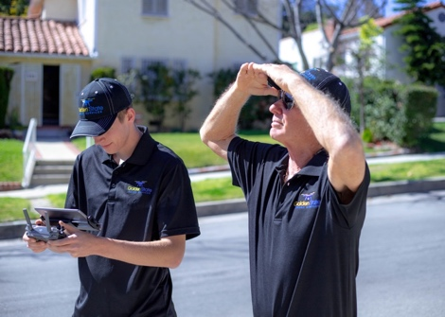

§ 107.33 Visual observer.
If a visual observer is used during the aircraft operation, all of the following requirements must be met:
(a) The remote pilot in command, the person manipulating the flight controls of the small unmanned aircraft system, and the visual observer must maintain effective communication with each other at all times.
(b) The remote pilot in command must ensure that the visual observer is able to see the unmanned aircraft in the manner specified in § 107.31.
(c) The remote pilot in command, the person manipulating the flight controls of the small unmanned aircraft system, and the visual observer must coordinate to do the following:
(1) Scan the airspace where the small unmanned aircraft is operating for any potential collision hazard; and
(2) Maintain awareness of the position of the small unmanned aircraft through direct visual observation.
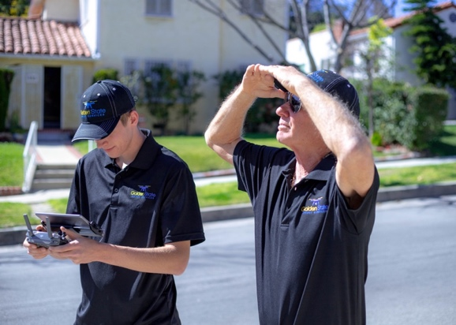

§ 107.35 Operation of multiple small unmanned aircraft.
A person may not manipulate flight controls or act as a remote pilot in command or visual observer in the operation of more than one unmanned aircraft at the same time.
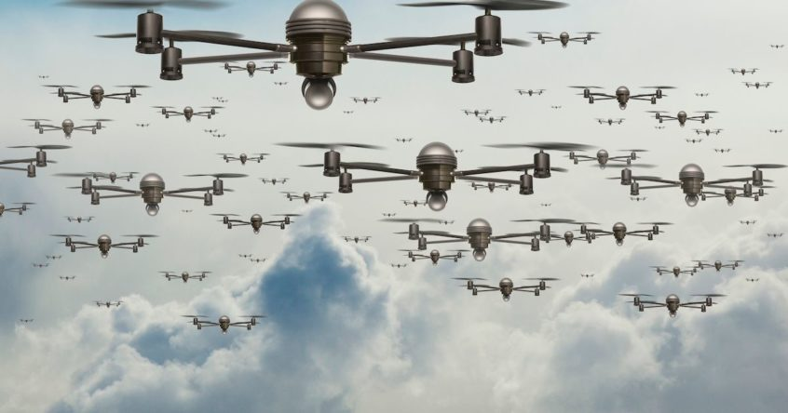
[Amdt. No. 107–8, 86 FR 4382, Jan. 15, 2021]

§ 107.36 Carriage of hazardous material.
A small unmanned aircraft may not carry hazardous material. For purposes of this section, the term hazardous material is defined in 49 CFR 171.8.
This box contains…

§ 107.37 Operation near aircraft; right-of-way rules.
(a) Each small unmanned aircraft must yield the right of way to all aircraft, airborne vehicles, and launch and reentry vehicles. Yielding the right of way means that the small unmanned aircraft must give way to the aircraft or vehicle and may not pass over, under, or ahead of it unless well clear.
(b) No person may operate a small unmanned aircraft so close to another aircraft as to create a collision hazard.
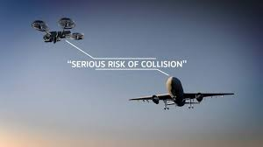

§ 107.39 Operation over human beings.
No person may operate a small unmanned aircraft over a human being unless—
(a) That human being is directly participating in the operation of the small unmanned aircraft;
(b) That human being is located under a covered structure or inside a stationary vehicle that can provide reasonable protection from a falling small unmanned aircraft; or
(c) The operation meets the requirements of at least one of the operational categories specified in subpart D of this part.
[Amdt. No. 107–8, 86 FR 4382, Jan. 15, 2021]
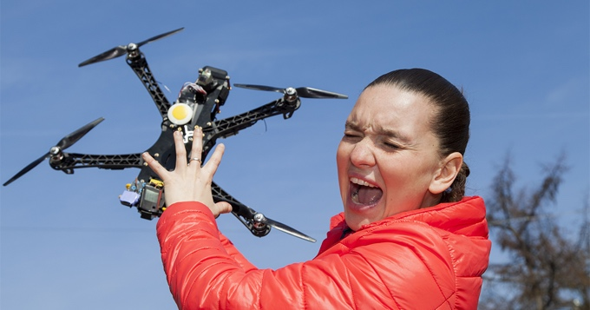

§ 107.41 Operation in certain airspace.
No person may operate a small unmanned aircraft in Class B, Class C, or Class D airspace or within the lateral boundaries of the surface area of Class E airspace designated for an airport unless that person has prior authorization from Air Traffic Control (ATC).
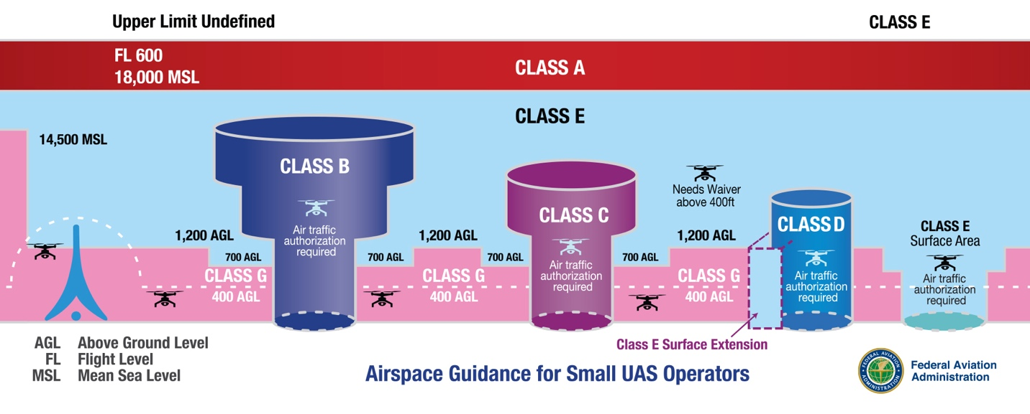

§ 107.43 Operation in the vicinity of airports.
No person may operate a small unmanned aircraft in a manner that interferes with operations and traffic patterns at any airport, heliport, or seaplane base.

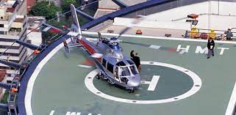

§ 107.45 Operation in prohibited or restricted areas.
No person may operate a small unmanned aircraft in prohibited or restricted areas unless that person has permission from the using or controlling agency, as appropriate.

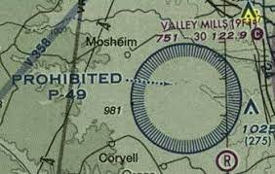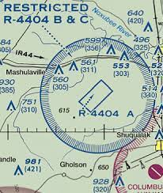

§ 107.47 Flight restrictions in the proximity of certain areas designated by notice to airmen.
A person acting as a remote pilot in command must comply with the provisions of §§ 91.137 through 91.145 and 99.7 of this chapter.
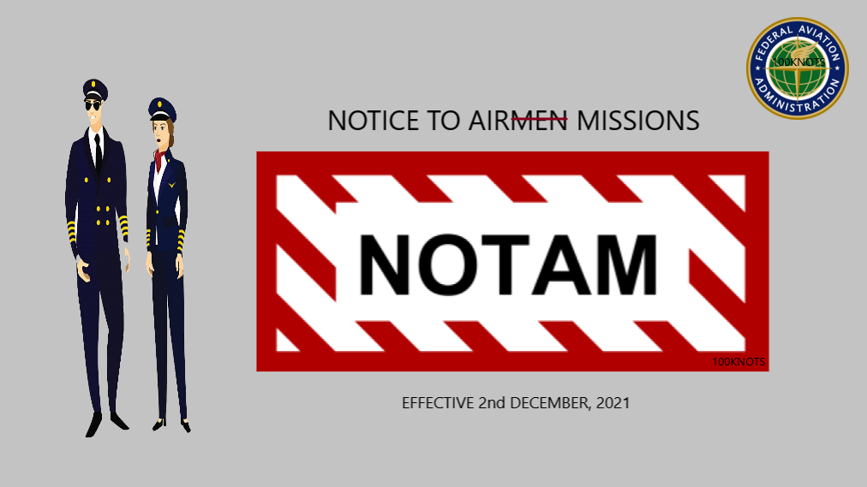

§ 107.49 Preflight familiarization, inspection, and actions for aircraft operation.
Prior to flight, the remote pilot in command must:
(a) Assess the operating environment, considering risks to persons and property in the immediate vicinity both on the surface and in the air. This assessment must include:
(1) Local weather conditions;
(2) Local airspace and any flight restrictions;
(3) The location of persons and property on the surface; and
(4) Other ground hazards.
(b) Ensure that all persons directly participating in the small unmanned aircraft operation are informed about the operating conditions, emergency procedures, contingency procedures, roles and responsibilities, and potential hazards;
(c) Ensure that all control links between ground control station and the small unmanned aircraft are working properly;
(d) If the small unmanned aircraft is powered, ensure that there is enough available power for the small unmanned aircraft system to operate for the intended operational time;
(e) Ensure that any object attached or carried by the small unmanned aircraft is secure and does not adversely affect the flight characteristics or controllability of the aircraft; and
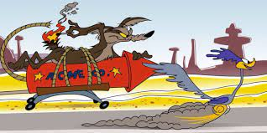
(f) If the operation will be conducted over human beings under subpart D of this part, ensure that the aircraft meets the requirements of § 107.110, § 107.120(a), § 107.130(a), or § 107.140, as applicable.
[Docket FAA–2015–0150, Amdt. 107–1, 81 FR 42209, June 28, 2016, as amended by Amdt. No. 107–8, 86 FR 4382, Jan. 15, 2021]

§ 107.51 Operating limitations for small unmanned aircraft.
A remote pilot in command and the person manipulating the flight controls of the small unmanned aircraft system must comply with all of the following operating limitations when operating a small unmanned aircraft system:
(a) The groundspeed of the small unmanned aircraft may not exceed 87 knots (100 miles per hour).
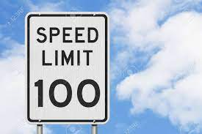
(b) The altitude of the small unmanned aircraft cannot be higher than 400 feet above ground level, unless the small unmanned aircraft:
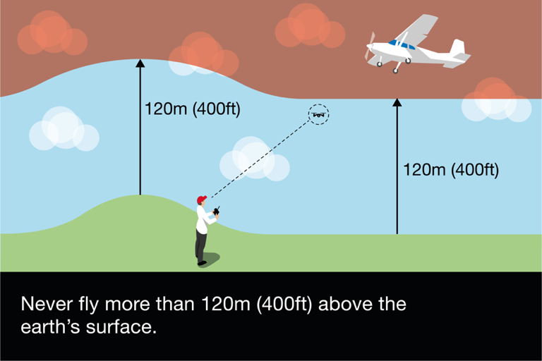
(1) Is flown within a 400-foot radius of a structure; and
(2) Does not fly higher than 400 feet above the structure's immediate uppermost limit.
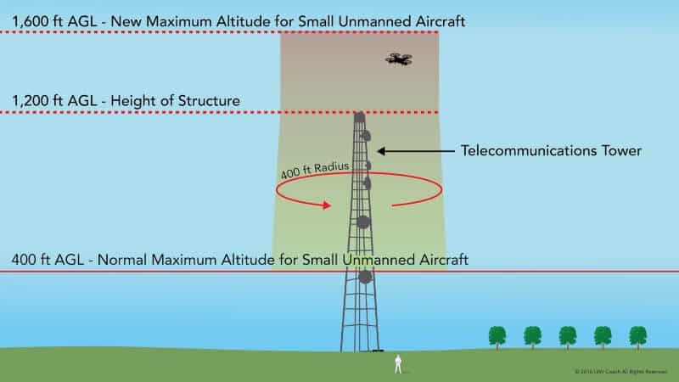
(c) The minimum flight visibility, as observed from the location of the control station must be no less than 3 statute miles. For purposes of this section, flight visibility means the average slant distance from the control station at which prominent unlighted objects may be seen and identified by day and prominent lighted objects may be seen and identified by night.
(d) The minimum distance of the small unmanned aircraft from clouds must be no less than:
(1) 500 feet below the cloud; and
(2) 2,000 feet horizontally from the cloud.
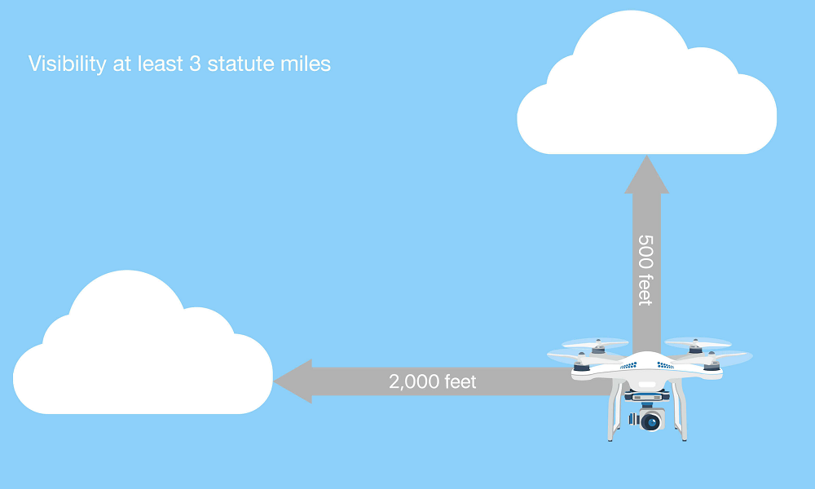

Subpart C—Remote Pilot Certification

§ 107.52 ATC transponder equipment prohibition.
Unless otherwise authorized by the Administrator, no person may operate a small unmanned aircraft system under this part with a transponder on.
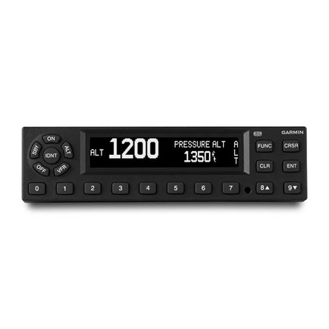
[Amdt. No. 107–7, 86 FR 4513, Jan. 15, 2021]

§ 107.53 Automatic Dependent Surveillance-Broadcast (ADS–B) Out prohibition.
Unless otherwise authorized by the Administrator, no person may operate a small unmanned aircraft system under this part with ADS–B Out equipment in transmit mode.
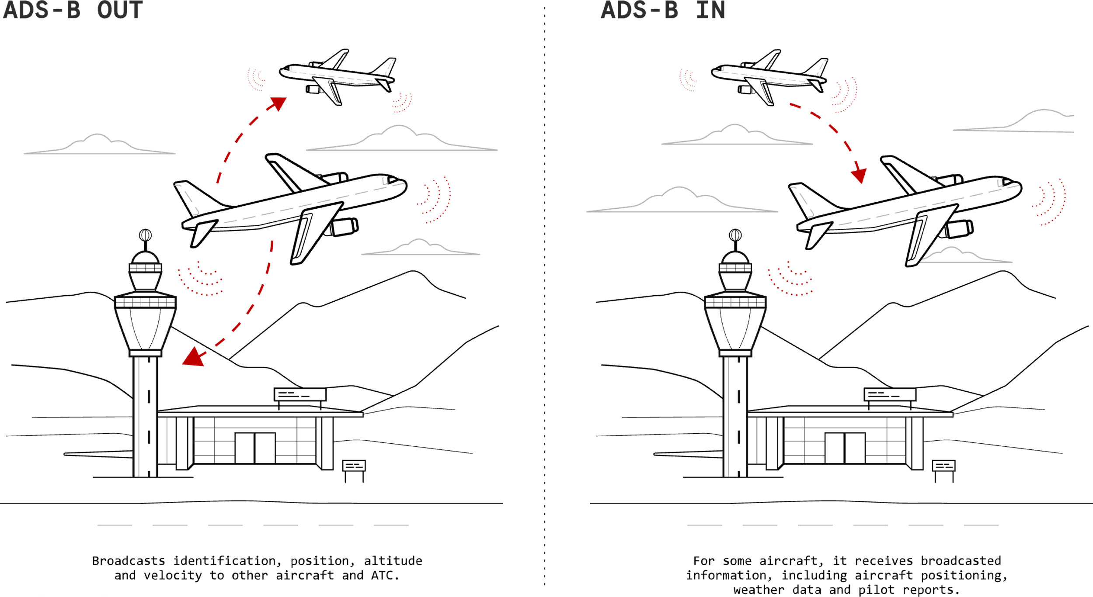
[Amdt. No. 107–7, 86 FR 4513, Jan. 15, 2021]

§ 107.56 Applicability.
This subpart prescribes the requirements for issuing a remote pilot certificate with a small UAS rating.
[ Docket FAA–2015–0150, Amdt. 107–1, 81 FR 42209, June 28, 2016. Redesignated by Amdt. No. 107–7, 86 FR 4513, Jan. 15, 2021]

§ 107.57 Offenses involving alcohol or drugs.
(a) A conviction for the violation of any Federal or State statute relating to the growing, processing, manufacture, sale, disposition, possession, transportation, or importation of narcotic drugs, marijuana, or depressant or stimulant drugs or substances is grounds for:
(1) Denial of an application for a remote pilot certificate with a small UAS rating for a period of up to 1 year after the date of final conviction; or
(2) Suspension or revocation of a remote pilot certificate with a small UAS rating.
(b) Committing an act prohibited by § 91.17(a) or § 91.19(a) of this chapter is grounds for:
(1) Denial of an application for a remote pilot certificate with a small UAS rating for a period of up to 1 year after the date of that act; or
(2) Suspension or revocation of a remote pilot certificate with a small UAS rating

§ 107.59 Refusal to submit to an alcohol test or to furnish test results.
A refusal to submit to a test to indicate the percentage by weight of alcohol in the blood, when requested by a law enforcement officer in accordance with § 91.17(c) of this chapter, or a refusal to furnish or authorize the release of the test results requested by the Administrator in accordance with § 91.17(c) or (d) of this chapter, is grounds for:
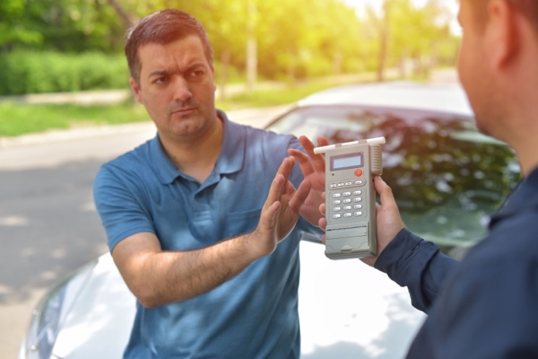
(a) Denial of an application for a remote pilot certificate with a small UAS rating for a period of up to 1 year after the date of that refusal; or
(b) Suspension or revocation of a remote pilot certificate with a small UAS rating.

§ 107.61 Eligibility.
Subject to the provisions of §§ 107.57 and 107.59, in order to be eligible for a remote pilot certificate with a small UAS rating under this subpart, a person must:
(a) Be at least 16 years of age;
(b) Be able to read, speak, write, and understand the English language. If the applicant is unable to meet one of these requirements due to medical reasons, the FAA may place such operating limitations on that applicant's certificate as are necessary for the safe operation of the small unmanned aircraft;
(c) Not know or have reason to know that he or she has a physical or mental condition that would interfere with the safe operation of a small unmanned aircraft system; and
(d) Demonstrate aeronautical knowledge by satisfying one of the following conditions, in a manner acceptable to the Administrator:
(1) Pass an initial aeronautical knowledge test covering the areas of knowledge specified in § 107.73; or
(2) If a person holds a pilot certificate (other than a student pilot certificate) issued under part 61 of this chapter and meets the flight review requirements specified in § 61.56, complete training covering the areas of knowledge specified in § 107.74.
[Docket FAA–2015–0150, Amdt. 107–1, 81 FR 42209, June 28, 2016, as amended by Amdt. No. 107–8, 86 FR 4382, Jan. 15, 2021]

§ 107.63 Issuance of a remote pilot certificate with a small UAS rating.
An applicant for a remote pilot certificate with a small UAS rating under this subpart must make the application in a form and manner acceptable to the Administrator.
(a) The application must include either:
(1) Evidence showing that the applicant passed an initial aeronautical knowledge test. If applying using a paper application, this evidence must be an airman knowledge test report showing passage of the knowledge test; or
(2) If a person holds a pilot certificate (other than a student pilot certificate) issued under part 61 of this chapter and meets the flight review requirements specified in § 61.56, a certificate of completion of an initial training course under this part that covers the areas of knowledge specified in § 107.74.
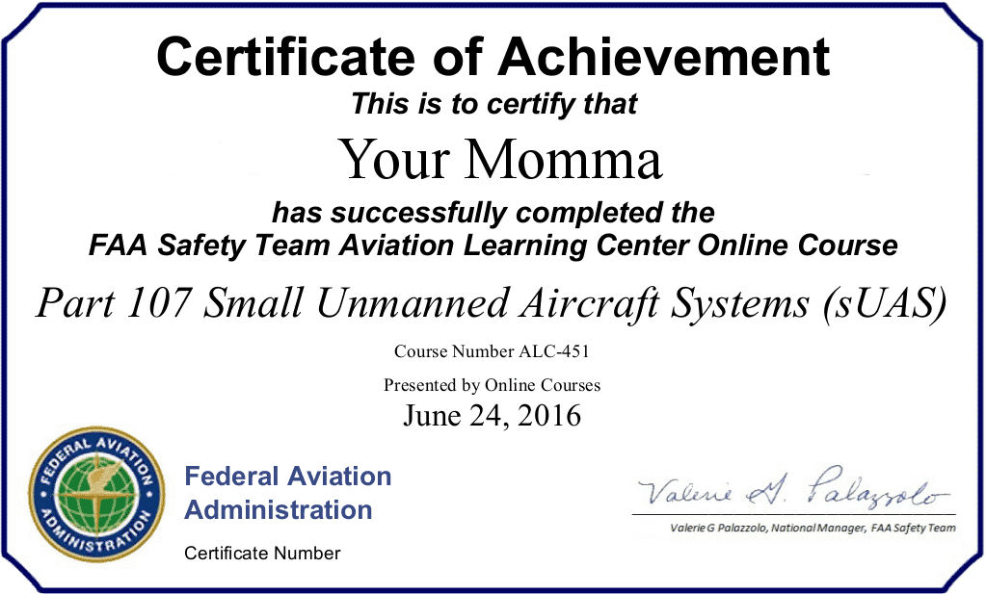
(b) If the application is being made pursuant to paragraph (a)(2) of this section:
(1) The application must be submitted to the responsible Flight Standards office, a designated pilot examiner, an airman certification representative for a pilot school, a certificated flight instructor, or other person authorized by the Administrator;
(2) The person accepting the application submission must verify the identity of the applicant in a manner acceptable to the Administrator; and
(3) The person making the application must, by logbook endorsement or other manner acceptable to the Administrator, show the applicant meets the flight review requirements specified in § 61.56 of this chapter.
[Docket FAA–2015–0150, Amdt. 107–1, 81 FR 42209, June 28, 2016, as amended by Docket FAA–2018–0119, Amdt. 107–2, 83 FR 9172, Mar. 5, 2018; Amdt. No. 107–8, 86 FR 4382, Jan. 15, 2021] ]

§ 107.64 Temporary certificate.
(a) A temporary remote pilot certificate with a small UAS rating is issued for up to 120 calendar days, at which time a permanent certificate will be issued to a person whom the Administrator finds qualified under this part.
(b) A temporary remote pilot certificate with a small UAS rating expires:
(1) On the expiration date shown on the certificate;
(2) Upon receipt of the permanent certificate; or
(3) Upon receipt of a notice that the certificate sought is denied or revoked.
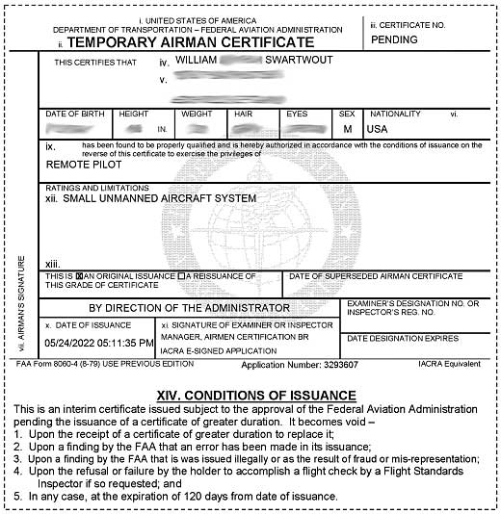

§ 107.65 Aeronautical knowledge recency.
A person may not exercise the privileges of a remote pilot in command with small UAS rating unless that person has accomplished one of the following in a manner acceptable to the Administrator within the previous 24 calendar months:
(a) Passed an initial aeronautical knowledge test covering the areas of knowledge specified in § 107.73;
(b) Completed recurrent training covering the areas of knowledge specified in § 107.73; or
(c) If a person holds a pilot certificate (other than a student pilot certificate) issued under part 61 of this chapter and meets the flight review requirements specified in § 61.56, completed training covering the areas of knowledge specified in § 107.74.
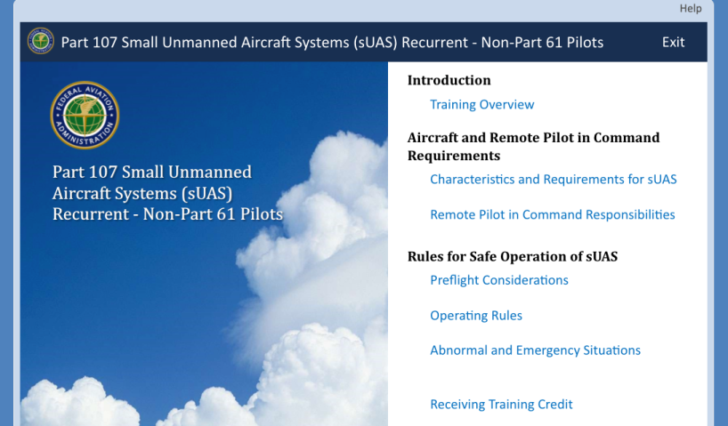
(d) A person who has passed a recurrent aeronautical knowledge test in a manner acceptable to the Administrator or who has satisfied the training requirement of paragraph (c) of this section prior to April 6, 2021 within the previous 24 calendar months is considered to be in compliance with the requirement of paragraph (b) or (c) of this section, as applicable.
[Amdt. No. 107–8, 86 FR 4382, Jan. 15, 2021; 86 FR 13631, Mar. 10, 2021]

§ 107.67 Knowledge tests: General procedures and passing grades.
(a) Knowledge tests prescribed by or under this part are given by persons and in the manner designated by the Administrator.
(b) An applicant for a knowledge test must have proper identification at the time of application that contains the applicant's:
(1) Photograph;
(2) Signature;
(3) Date of birth, which shows the applicant meets or will meet the age requirements of this part for the certificate and rating sought before the expiration date of the airman knowledge test report; and
(4) Permanent mailing address. If the applicant's permanent mailing address is a post office box number, then the applicant must also provide a current residential address.
(c) The minimum passing grade for the knowledge test will be specified by the Administrator.

§ 107.69 Knowledge tests: Cheating or other unauthorized conduct.
(a) An applicant for a knowledge test may not:
(1) Copy or intentionally remove any knowledge test;
(2) Give to another applicant or receive from another applicant any part or copy of a knowledge test;
(3) Give or receive assistance on a knowledge test during the period that test is being given;
(4) Take any part of a knowledge test on behalf of another person;
(5) Be represented by, or represent, another person for a knowledge test;
(6) Use any material or aid during the period that the test is being given, unless specifically authorized to do so by the Administrator; and
(7) Intentionally cause, assist, or participate in any act prohibited by this paragraph.
(b) An applicant who the Administrator finds has committed an act prohibited by paragraph (a) of this section is prohibited, for 1 year after the date of committing that act, from:
(1) Applying for any certificate, rating, or authorization issued under this chapter; and
(2) Applying for and taking any test under this chapter.
(c) Any certificate or rating held by an applicant may be suspended or revoked if the Administrator finds that person has committed an act prohibited by paragraph (a) of this section.

§ 107.71 Retesting after failure.
An applicant for a knowledge test who fails that test may not reapply for the test for 14 calendar days after failing the test.
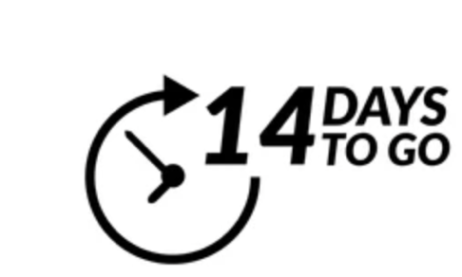

§ 107.73 Knowledge and training.
An initial aeronautical knowledge test and recurrent training covers the following areas of knowledge:
(a) Applicable regulations relating to small unmanned aircraft system rating privileges, limitations, and flight operation;
(b) Airspace classification, operating requirements, and flight restrictions affecting small unmanned aircraft operation;
(c) Aviation weather sources and effects of weather on small unmanned aircraft performance;
(d) Small unmanned aircraft loading;
(e) Emergency procedures;
(f) Crew resource management;
(g) Radio communication procedures;
(h) Determining the performance of the small unmanned aircraft;
(i) Physiological effects of drugs and alcohol;
(j) Aeronautical decision-making and judgment;
(k) Airport operations;
(l) Maintenance and preflight inspection procedures; and
(m) Operation at night.
[Amdt. No. 107–8, 86 FR 4383, Jan. 15, 2021]

§ 107.74 Small unmanned aircraft system training.
Training for pilots who hold a pilot certificate (other than a student pilot certificate) issued under part 61 of this chapter and meet the flight review requirements specified in § 61.56 covers the following areas of knowledge:
(a) Applicable regulations relating to small unmanned aircraft system rating privileges, limitations, and flight operation;
(b) Effects of weather on small unmanned aircraft performance;
(c) Small unmanned aircraft loading;
(d) Emergency procedures;
(e) Crew resource management;
(f) Determining the performance of the small unmanned aircraft;
(g) Maintenance and preflight inspection procedures; and
(h) Operation at night.
[Amdt. No. 107–8, 86 FR 4383, Jan. 15, 2021]

§ 107.77 Change of name or address.
(a) Change of name. An application to change the name on a certificate issued under this subpart must be accompanied by the applicant's:
(1) Remote pilot certificate with small UAS rating; and
(2) A copy of the marriage license, court order, or other document verifying the name change.
(b) The documents in paragraph (a) of this section will be returned to the applicant after inspection.
(c) Change of address. The holder of a remote pilot certificate with small UAS rating issued under this subpart who has made a change in permanent mailing address may not, after 30 days from that date, exercise the privileges of the certificate unless the holder has notified the FAA of the change in address using one of the following methods:
(1) By letter to the FAA Airman Certification Branch, P.O. Box 25082, Oklahoma City, OK 73125 providing the new permanent mailing address, or if the permanent mailing address includes a post office box number, then the holder's current residential address; or
(2) By using the FAA Web site portal at www.faa.gov providing the new permanent mailing address, or if the permanent mailing address includes a post office box number, then the holder's current residential address.

§ 107.79 Voluntary surrender of certificate.
(a) The holder of a certificate issued under this subpart may voluntarily surrender it for cancellation.
(b) Any request made under paragraph (a) of this section must include the following signed statement or its equivalent: “I voluntarily surrender my remote pilot certificate with a small UAS rating for cancellation. This request is made for my own reasons, with full knowledge that my certificate will not be reissued to me unless I again complete the requirements specified in §§ 107.61 and 107.63.”

Subpart D—Operations Over Human Beings
Source: Amdt. No. 107–8, 86 FR 4382, Jan. 15, 2021

§ 107.100 Applicability.
This subpart prescribes the eligibility and operating requirements for civil small unmanned aircraft to operate over human beings or over moving vehicles in the United States, in addition to those operations permitted by § 107.39(a) and (b).

§ 107.105 Limitations on operations over human beings.
Except as provided in §§ 107.39(a) and (b) and 107.145, a remote pilot in command may conduct operations over human beings only in accordance with the following, as applicable: § 107.110 for Category 1 operations; §§ 107.115 and 107.120for Category 2 operations; §§ 107.125 and 107.130 for Category 3 operations; or § 107.140 for Category 4 operations.

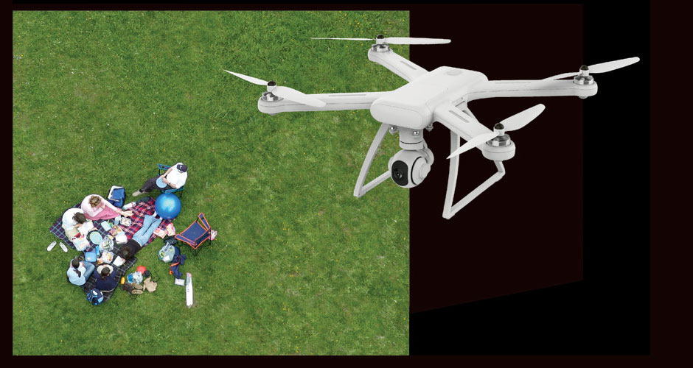

§ 107.110 Category 1 operations.
To conduct Category 1 operations—
(a) A remote pilot in command must use a small unmanned aircraft that—
(1) Weighs 0.55 pounds or less on takeoff and throughout the duration of each operation under Category 1, including everything that is on board or otherwise attached to the aircraft; and
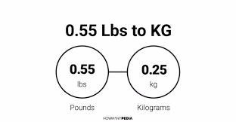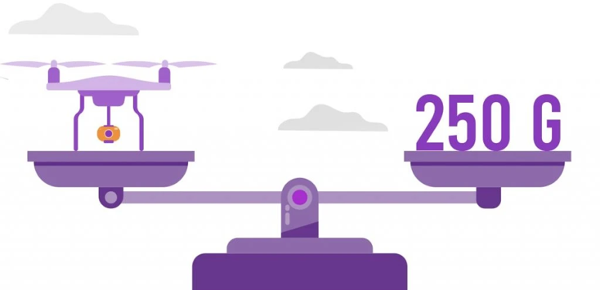
(2) Does not contain any exposed rotating parts that would lacerate human skin upon impact with a human being.
(b) No remote pilot in command may operate a small unmanned aircraft in sustained flight over open-air assemblies of human beings unless the operation meets the requirements of either § 89.110 or § 89.115(a) of this chapter.
[Amdt. No. 107–8, 86 FR 4382, Jan. 15, 2021, as amended by 86 FR 62473, Nov. 10, 2021]

§ 107.115 Category 2 operations: Operating requirements.
To conduct Category 2 operations—
(a) A remote pilot in command must use a small unmanned aircraft that—
(1) Is eligible for Category 2 operations pursuant to § 107.120(a);
(2) Is listed on an FAA-accepted declaration of compliance as eligible for Category 2 operations in accordance with § 107.160; and
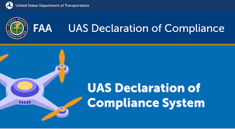
(3) Is labeled as eligible to conduct Category 2 operations in accordance with § 107.120(b)(1).
(b) No remote pilot in command may operate a small unmanned aircraft in sustained flight over open-air assemblies of human beings unless the operation meets the requirements of either § 89.110 or § 89.115(a) of this chapter.

§ 107.120 Category 2 operations: Eligibility of small unmanned aircraft and other applicant requirements.
(a) To be eligible for use in Category 2 operations, the small unmanned aircraft must be designed, produced, or modified such that it—
(1) Will not cause injury to a human being that is equivalent to or greater than the severity of injury caused by a transfer of 11 foot-pounds of kinetic energy upon impact from a rigid object;
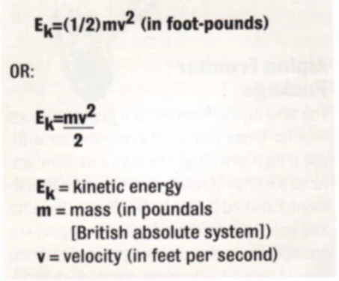
(2) Does not contain any exposed rotating parts that would lacerate human skin upon impact with a human being; and
(3) Does not contain any safety defects.
(b) The applicant for a declaration of compliance for a small unmanned aircraft that is eligible for use in Category 2 operations in accordance with paragraph (a) of this section, must meet all of the following requirements for the applicant's unmanned aircraft to be used in Category 2 operations:
(1) Display a label on the small unmanned aircraft indicating eligibility to conduct Category 2 operations. The label must be in English and be legible, prominent, and permanently affixed to the small unmanned aircraft.
(2) Have remote pilot operating instructions that apply to the operation of the small unmanned aircraft system. The applicant for a declaration of compliance must make available these instructions upon sale or transfer of the aircraft or use of the aircraft by someone other than the applicant who submitted a declaration of compliance pursuant to § 107.160. Such instructions must address, at a minimum—
(i) A system description that includes the required small unmanned aircraft system components, any system limitations, and the declared category or categories of operation;
(ii) Modifications that will not change the ability of the small unmanned aircraft system to meet the requirements for the category or categories of operation the small unmanned aircraft system is eligible to conduct; and
(iii) Instructions for how to verify and change the mode or configuration of the small unmanned aircraft system, if they are variable.
(3) Maintain a product support and notification process. The applicant for a declaration of compliance must maintain product support and notification procedures to notify the public and the FAA of—
(i) Any defect or condition that causes the small unmanned aircraft to no longer meet the requirements of this subpart; and
(ii) Any identified safety defect that causes the small unmanned aircraft to exceed a low probability of casualty.

§ 107.125 Category 3 operations: Operating requirements.
To conduct Category 3 operations, a remote pilot in command—
(a) Must use a small unmanned aircraft that—
(1) Is eligible for Category 3 operations pursuant to § 107.130(a);
(2) Is listed on an FAA-accepted declaration of compliance as eligible for Category 3 operations in accordance with § 107.160; and
(3) Is labeled as eligible for Category 3 operations in accordance with § 107.130(b)(1);
(b) Must not operate the small unmanned aircraft over open-air assemblies of human beings; and
(c) May only operate the small unmanned aircraft above any human being if operation meets one of the following conditions:
(1) The operation is within or over a closed- or restricted-access site and all human beings located within the closed- or restricted-access site must be on notice that a small unmanned aircraft may fly over them; or
(2) The small unmanned aircraft does not maintain sustained flight over any human being unless that human being is—
(i) Directly participating in the operation of the small unmanned aircraft; or
(ii) Located under a covered structure or inside a stationary vehicle that can provide reasonable protection from a falling small unmanned aircraft.

[Amdt. No. 107–8, 86 FR 4382, Jan. 15, 2021, as amended by 86 FR 62473, Nov. 10, 2021]

§ 107.130 Category 3 operations: Eligibility of small unmanned aircraft and other applicant requirements.
(a) To be eligible for use in Category 3 operations, the small unmanned aircraft must be designed, produced, or modified such that it—
(1) Will not cause injury to a human being that is equivalent to or greater than the severity of the injury caused by a transfer of 25 foot-pounds of kinetic energy upon impact from a rigid object;
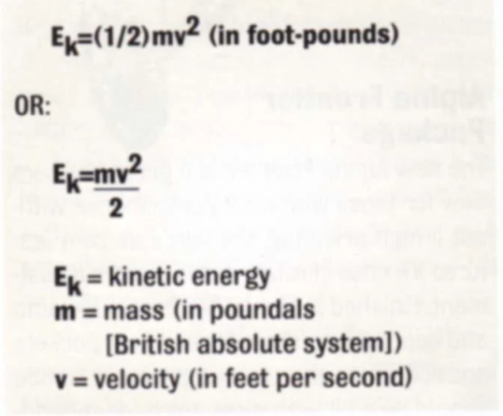
(2) Does not contain any exposed rotating parts that would lacerate human skin upon impact with a human being; and
(3) Does not contain any safety defects.
(b) The applicant for a declaration of compliance for a small unmanned aircraft that is eligible for use in Category 3 operations in accordance with paragraph (a) of this section, must meet all of the following requirements for the applicant's small unmanned aircraft to be used in Category 3 operations:
(1) Display a label on the small unmanned aircraft indicating eligibility to conduct Category 3 operations. The label must be in English and be legible, prominent, and permanently affixed to the small unmanned aircraft.
(2) Have remote pilot operating instructions that apply to the operation of the small unmanned aircraft system. The applicant for a declaration of compliance must make available these instructions upon sale or transfer of the aircraft or use of the aircraft by someone other than the applicant who submitted a declaration of compliance pursuant to § 107.160. Such instructions must address, at a minimum—
(i) A system description that includes the required small unmanned aircraft system components, any system limitations, and the declared category or categories of operation;
(ii) Modifications that will not change the ability of the small unmanned aircraft system to meet the requirements for the category or categories of operation the small unmanned aircraft system is eligible to conduct; and
(iii) Instructions for how to verify and change the mode or configuration of the small unmanned aircraft system, if they are variable.
(3) Maintain a product support and notification process. The applicant for a declaration of compliance must maintain product support and notification procedures to notify the public and the FAA of—
(i) Any defect or condition that causes the small unmanned aircraft to no longer meet the requirements of this subpart; and
(ii) Any identified safety defect that causes the small unmanned aircraft to exceed a low probability of fatality.

§ 107.135 Labeling by remote pilot in command for Category 2 and 3 operations.
If a Category 2 or Category 3 label affixed to a small unmanned aircraft is damaged, destroyed, or missing, a remote pilot in command must label the aircraft in English such that the label is legible, prominent, and will remain on the small unmanned aircraft for the duration of the operation before conducting operations over human beings. The label must correctly identify the category or categories of operation over human beings that the small unmanned aircraft is qualified to conduct in accordance with this subpart.

§ 107.140 Category 4 operations.
(a) Remote pilot in command requirements. To conduct Category 4 operations—
(1) A remote pilot in command—
(i) Must use a small unmanned aircraft that is eligible for Category 4 operations pursuant to paragraph (b) of this section; and
(ii) Must operate the small unmanned aircraft in accordance with all operating limitations that apply to the small unmanned aircraft, as specified by the Administrator.
(2) No remote pilot in command may operate a small unmanned aircraft in sustained flight over open-air assemblies of human beings unless the operation meets the requirements of either § 89.110 or § 89.115(a) of this chapter.
(b) Small unmanned aircraft requirements for Category 4. To be eligible to operate over human beings under this section, the small unmanned aircraft must—
(1) Have an airworthiness certificate issued under part 21 of this chapter.
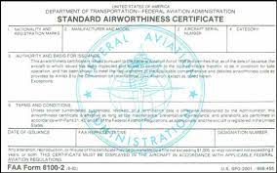
(2) Be operated in accordance with the operating limitations specified in the approved Flight Manual or as otherwise specified by the Administrator. The operating limitations must not prohibit operations over human beings.
(3) Have maintenance, preventive maintenance, alterations, or inspections performed in accordance with paragraph (c)(1) of this section.
(c) Maintenance requirements for Category 4. The owner must (unless the owner enters into an agreement with an operator to meet the requirements of this paragraph (c), then the operator must) meet the requirements of this paragraph (c):
(1) Ensure the person performing any maintenance, preventive maintenance, alterations, or inspections:
(i) Uses the methods, techniques, and practices prescribed in the manufacturer's current maintenance manual or Instructions for Continued Airworthiness that are acceptable to the Administrator, or other methods, techniques, and practices acceptable to the Administrator;
(ii) Has the knowledge, skill, and appropriate equipment to perform the work;
(iii) Performs the maintenance, preventive maintenance, or alterations on the small unmanned aircraft in a manner using the methods, techniques, and practices prescribed in the manufacturer's current maintenance manual or Instructions for Continued Airworthiness prepared by its manufacturer, or other methods, techniques, and practices acceptable to the Administrator;
(iv) Inspects the small unmanned aircraft in accordance with the manufacturer's instructions or other instructions acceptable to the Administrator; and
(v) Performs the maintenance, preventive maintenance, or alterations using parts of such a quality that the condition of the aircraft will be at least equal to its original or properly altered condition.
(2) Maintain all records of maintenance, preventive maintenance, and alterations performed on the aircraft and ensure the records are documented in a manner acceptable to the Administrator. The records must contain the description of the work performed, the date the work was completed, and the name of the person who performed the work.
(3) Maintain all records containing—
(i) The status of life-limited parts that are installed on, or part of, the small unmanned aircraft;
(ii) The inspection status of the aircraft; and
(iii) The status of applicable airworthiness directives including the method of compliance, the airworthiness directive number, and revision date. If the airworthiness directive involves recurring action, the record must contain the time and date of the next required action.
(4) Retain the records required under paragraphs (c)(2) and (3) of this section, as follows:
(i) The records documenting maintenance, preventive maintenance, or alterations performed must be retained for 1 year from when the work is completed or until the maintenance is repeated or superseded by other work.
(ii) The records documenting the status of life-limited parts, compliance with airworthiness directives, and inspection status of the small unmanned aircraft must be retained and transferred with the aircraft upon change in ownership.
(5) Ensure all records under paragraphs (c)(2) and (3) of this section are available for inspection upon request from the Administrator or any authorized representative of the National Transportation Safety Board (NTSB).
(d) Compliance with parts 43 and 91 of this chapter. Compliance with part 43 and part 91, subpart E, of this chapter fulfills the requirements in paragraphs (b)(3) and (c) of this section.
[Amdt. No. 107–8, 86 FR 4383, Jan. 15, 2021; 86 FR 13633, Mar. 10, 2021]

§ 107.145 Operations over moving vehicles.
No person may operate a small unmanned aircraft over a human being located inside a moving vehicle unless the following conditions are met:
(a) The operation occurs in accordance with § 107.110 for Category 1 operations; § 107.115 for Category 2 operations; § 107.125 for Category 3 operations; or § 107.140 for Category 4 operations.
(b) For an operation under Category 1, Category 2, or Category 3, the small unmanned aircraft, throughout the operation—
(1) Must remain within or over a closed- or restricted-access site, and all human beings located inside a moving vehicle within the closed- or restricted-access site must be on notice that a small unmanned aircraft may fly over them; or
(2) Must not maintain sustained flight over moving vehicles.
(c) For a Category 4 operation, the small unmanned aircraft must—
(1) Have an airworthiness certificate issued under part 21 of this chapter.
(2) Be operated in accordance with the operating limitations specified in the approved Flight Manual or as otherwise specified by the Administrator. The operating limitations must not prohibit operations over human beings located inside moving vehicles.

§ 107.150 Variable mode and variable configuration of small unmanned aircraft systems.
A small unmanned aircraft system may be eligible for one or more categories of operation over human beings under this subpart, as long as a remote pilot in command cannot inadvertently switch between modes or configurations.

§ 107.155 Means of compliance.
(a) Establishment of compliance. To meet the requirements of § 107.120(a) for operations in Category 2, or the requirements of § 107.130(a) for operations in Category 3, the means of compliance must consist of test, analysis, or inspection.
(b) Required information. An applicant requesting FAA acceptance of a means of compliance must submit the following information to the FAA in a manner specified by the Administrator:
(1) Procedures. Detailed description of the means of compliance, including applicable test, analysis, or inspection procedures to demonstrate how the small unmanned aircraft meets the requirements of § 107.120(a) for operations in Category 2 or the requirements of § 107.130(a) for operations in Category 3. The description should include conditions, environments, and methods, as applicable.
(2) Compliance explanation. Explanation of how application of the means of compliance fulfills the requirements of § 107.120(a) for operations in Category 2 or the requirements of § 107.130(a) for operations in Category 3.
(c) FAA acceptance. If the FAA determines the applicant has demonstrated compliance with paragraphs (a) and (b) of this section, it will notify the applicant that it has accepted the means of compliance.
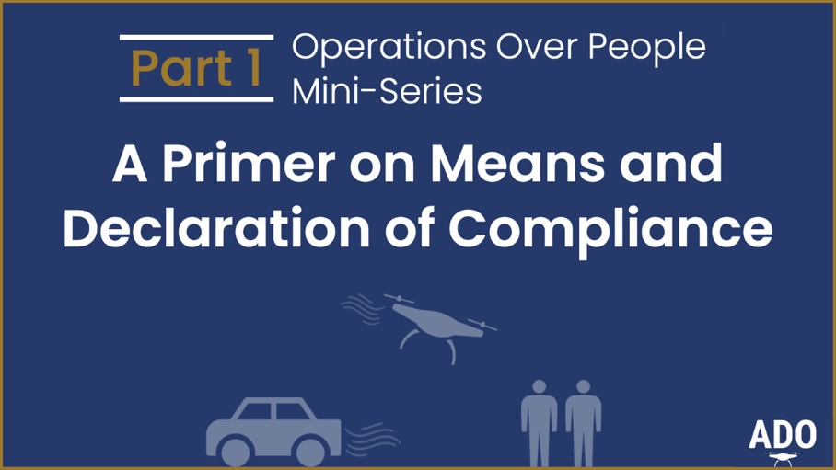
(d) Rescission.
(1) A means of compliance is subject to ongoing review by the Administrator. The Administrator may rescind its acceptance of a means of compliance if the Administrator determines that a means of compliance does not meet any or all of the requirements of this subpart.
(2) The Administrator will publish a notice of rescission in the Federal Register.
(e) Inapplicability of part 13, subpart D, of this chapter. Part 13, subpart D, of this chapter does not apply to the procedures of paragraph (a) of this section.

§ 107.160 Declaration of compliance.
(a) Required information. In order for an applicant to declare a small unmanned aircraft is compliant with the requirements of this subpart for Category 2 or Category 3 operations, an applicant must submit a declaration of compliance for acceptance by the FAA, in a manner specified by the Administrator, that includes the following information:
(1) Applicant's name;
(2) Applicant's physical address;
(3) Applicant's email address;
(4) The small unmanned aircraft make and model name, and series, if applicable;
(5) The small unmanned aircraft serial number or range of serial numbers that are the subject of the declaration of compliance;
(6) Whether the declaration of compliance is an initial declaration or an amended declaration;
(7) If the declaration of compliance is an amended declaration, the reason for the re-submittal;
(8) The accepted means of compliance the applicant used to fulfill requirements of § 107.120(a) or § 107.130(a) or both;
(9) A declaration that the applicant—
(i) Has demonstrated that the small unmanned aircraft, or specific configurations of that aircraft, satisfies § 107.120(a) or § 107.130(a) or both, through the accepted means of compliance identified in paragraph (a)(8) of this section;
(ii) Has verified that the unmanned aircraft does not contain any safety defects;
(iii) Has satisfied § 107.120(b)(3) or § 107.130(b)(3), or both; and
(iv) Will, upon request, allow the Administrator to inspect its facilities, technical data, and any manufactured small unmanned aircraft and witness any tests necessary to determine compliance with this subpart; and
(10) Other information as required by the Administrator.
(b) FAA acceptance. If the FAA determines the applicant has demonstrated compliance with the requirements of this subpart, it will notify the applicant that it has accepted the declaration of compliance.
(c) Notification of a safety issue. Prior to initiating rescission proceedings pursuant to paragraphs (d)(1) through (3) of this section, the FAA will notify the applicant if a safety issue has been identified for the declaration of compliance.
(d) Rescission.
(1) No person may operate a small unmanned aircraft identified on a declaration of compliance that the FAA has rescinded pursuant to this subpart while that declaration of compliance is rescinded.
(2) The FAA may rescind a declaration of compliance if any of the following conditions occur:
(i) A small unmanned aircraft for which a declaration of compliance was accepted no longer complies with § 107.120(a) or § 107.130(a);
(ii) The FAA finds a declaration of compliance is in violation of § 107.5(a); or
(iii) The Administrator determines an emergency exists related to safety in accordance with the authority in 49 U.S.C. 46105.
(3) If a safety issue identified under paragraph (c) of this section has not been resolved, the FAA may rescind the declaration of compliance as follows:
(i) The FAA will issue a notice proposing to rescind the declaration of compliance. The notice will set forth the Agency's basis for the proposed rescission and provide the holder of the declaration of compliance with 30 calendar days from the date of issuance of the proposed notice to submit evidentiary information to refute the proposed notice.
(ii) The holder of the declaration of compliance must submit information demonstrating how the small unmanned aircraft meets the requirements of this subpart within 30 calendar days from the date of issuance of the proposed notice.
(iii) If the FAA does not receive the information required by paragraph (d)(3)(ii) of this section within 30 calendar days from the date of the issuance of the proposed notice, the FAA will issue a notice rescinding the declaration of compliance.
(4) If the Administrator determines that an emergency exists in accordance with paragraph (d)(2)(iii) of this section, the FAA will exercise its authority under 49 U.S.C. 46105(c) to issue an order rescinding a declaration of compliance without initiating the process in paragraph (d)(3) of this section.
(e) Petition to reconsider the rescission of a declaration of compliance. A person subject to an order of rescission under paragraph (d)(3) of this section may petition the FAA to reconsider the rescission of a declaration of compliance by submitting a request to the FAA in a manner specified by the Administrator within 60 days of the date of issuance of the rescission.
(1) A petition to reconsider the rescission of a declaration of compliance must demonstrate at least one of the following:
(i) A material fact that was not present in the original response to the notification of the safety issue and an explanation for why it was not present in the original response;
(ii) The FAA made a material factual error in the decision to rescind the declaration of compliance; or
(iii) The FAA did not correctly interpret a law, regulation, or precedent.
(2) Upon consideration of the information submitted under paragraph (e)(1) of this section, the FAA will issue a notice either affirming the rescission or withdrawing the rescission.
(f) Inapplicability of part 13, subpart D, of this chapter. Part 13, subpart D, of this chapter does not apply to the procedures of paragraphs (d) and (e) of this section.

§ 107.165 Record retention.
(a) A person who submits a declaration of compliance under this subpart must retain and make available to the Administrator, upon request, the information described in paragraph (a)(1) of this section for the period of time described in paragraph (a)(2) of this section.
(1) All supporting information used to demonstrate the small unmanned aircraft meets the requirements of §§ 107.120(a), for operations in Category 2, and 107.130(a), for operations in Category 3.
(2) The following time periods apply:
(i) If the person who submits a declaration of compliance produces a small unmanned aircraft, that person must retain the information described in paragraph (a)(1) of this section for two years after the cessation of production of the small unmanned aircraft system for which the person declared compliance.
(ii) If the person who submits a declaration of compliance designs or modifies a small unmanned aircraft, that person must retain the information described in paragraph (a)(1) of this section for two years after the person submitted the declaration of compliance.
(b) A person who submits a means of compliance under this subpart must retain and make available to the Administrator, upon request, and for as long as the means of compliance remains accepted, the detailed description of the means of compliance and justification showing how the means of compliance meets the requirements of §§ 107.120(a), for operations in Category 2, and 107.130(a), for operations in Category 3.

Subpart E—Waivers

§ 107.200 Waiver policy and requirements.
(a) The Administrator may issue a certificate of waiver authorizing a deviation from any regulation specified in § 107.205 if the Administrator finds that a proposed small UAS operation can safely be conducted under the terms of that certificate of waiver.
(b) A request for a certificate of waiver must contain a complete description of the proposed operation and justification that establishes that the operation can safely be conducted under the terms of a certificate of waiver.
(c) The Administrator may prescribe additional limitations that the Administrator considers necessary.
(d) A person who receives a certificate of waiver issued under this section:
(1) May deviate from the regulations of this part to the extent specified in the certificate of waiver; and
(2) Must comply with any conditions or limitations that are specified in the certificate of waiver.

§ 107.205 List of regulations subject to waiver.
A certificate of waiver issued pursuant to § 107.200 may authorize a deviation from the following regulations of this part:
(a) Section 107.25—Operation from a moving vehicle or aircraft. However, no waiver of this provision will be issued to allow the carriage of property of another by aircraft for compensation or hire.
(b) Section 107.29(a)(2) and (b)—Anti-collision light required for operations at night and during periods of civil twilight.
(c) Section 107.31—Visual line of sight aircraft operation. However, no waiver of this provision will be issued to allow the carriage of property of another by aircraft for compensation or hire.
(d) Section 107.33—Visual observer.
(e) Section 107.35—Operation of multiple small unmanned aircraft systems.
(f) Section 107.37(a)—Yielding the right of way.
(g) Section 107.39—Operation over people.
(h) Section 107.41—Operation in certain airspace.
(i) Section 107.51—Operating limitations for small unmanned aircraft.
(j) Section 107.145—Operations over moving vehicles.
[Docket FAA–2015–0150, Amdt. 107–1, 81 FR 42209, June 28, 2016, as amended by Amdt. No. 107–8, 86 FR 4387, Jan. 15, 2021]

We still have recreational rules under 49 USC 44809!

https://uscode.house.gov/view.xhtml?req=granuleid:USC-prelim-title49-section44809&num=0&edition=prelim

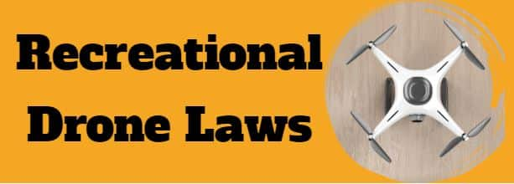

The rule for operating UAS or drones under 55 pounds in the NAS is 14 CFR Part 107, referred to as the Small UAS Rule. However, if you want to fly a drone for purely recreational purposes, there is a limited statutory exception ("carve out") that provides a basic set of requirements.
Many people assume that a recreational flight simply means not flying for a business or being compensated. But that's not always the case. Compensation, or the lack of it, is not what determines if a flight was recreational or not. Before you fly your drone, you need to know which regulations apply to your flight.
The default regulation for drones weighing under 55 pounds is Part 107. Almost all non-recreational drone flying is regulated by Part 107.
Note: Non-recreational drone flying include things like taking photos to help sell a property or service, roof inspections, or taking pictures of a high school football game for the school's website. Goodwill can also be considered non-recreational. This would include things like volunteering to use your drone to survey coastlines on behalf of a non-profit organization.
Remember, if you’re not sure which rules apply to your flight, fly under Part 107.
Congress created the Exception for Limited Recreational Operations of Unmanned Aircraft to allow those flying drones purely for fun or personal enjoyment to operate without complying with Part 107. People flying under this Exception are required to comply will all rules for recreational flyers.

§44809. Exception for limited recreational operations of unmanned aircraft

(a) In General.-
Except as provided in subsection (e), and notwithstanding chapter 447 of title 49, United States Code, a person may operate a small unmanned aircraft without specific certification or operating authority from the Federal Aviation Administration if the operation adheres to all of the following limitations:

(1) The aircraft is flown strictly for recreational purposes.

(2) The aircraft is operated in accordance with or within the programming of a community-based organization's set of safety guidelines that are developed in coordination with the Federal Aviation Administration.
https://www.faa.gov/uas/recreationalfliers/faa-recognized-community-based-organizations

(3) The aircraft is flown within the visual line of sight of the person operating the aircraft or a visual observer co-located and in direct communication with the operator.
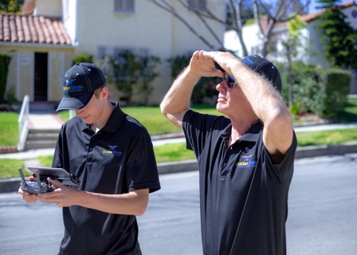

(4) The aircraft is operated in a manner that does not interfere with and gives way to any manned aircraft.

(5) In Class B, Class C, or Class D airspace or within the lateral boundaries of the surface area of Class E airspace designated for an airport, the operator obtains prior authorization from the Administrator or designee before operating and complies with all airspace restrictions and prohibitions.

(6) In Class G airspace, the aircraft is flown from the surface to not more than 400 feet above ground level and complies with all airspace restrictions and prohibitions.

(7) The operator has passed an aeronautical knowledge and safety test described in subsection (g) and maintains proof of test passage to be made available to the Administrator or law enforcement upon request.

(8) The aircraft is registered and marked in accordance with chapter 441 of this title and proof of registration is made available to the Administrator or a designee of the Administrator or law enforcement upon request.

(b) Other Operations.-Unmanned aircraft operations that do not conform to the limitations in subsection (a) must comply with all statutes and regulations generally applicable to unmanned aircraft and unmanned aircraft systems.

(c) Operations at Fixed Sites.-
(1) Operating procedure required.-Persons operating unmanned aircraft under subsection (a) from a fixed site within Class B, Class C, or Class D airspace or within the lateral boundaries of the surface area of Class E airspace designated for an airport, or a community-based organization conducting a sanctioned event within such airspace, shall make the location of the fixed site known to the Administrator and shall establish a mutually agreed upon operating procedure with the air traffic control facility.
https://udds-faa.opendata.arcgis.com/datasets/9eeda285b99842698528f1e35a7d2368_0/explore

(2) Unmanned aircraft weighing more than 55 pounds.-A person may operate an unmanned aircraft weighing more than 55 pounds, including the weight of anything attached to or carried by the aircraft, under subsection (a) if-
(A) the unmanned aircraft complies with standards and limitations developed by a community-based organization and approved by the Administrator; and
(B) the aircraft is operated from a fixed site as described in paragraph (1).

(d) Updates.-
(1) In general.-The Administrator, in consultation with government, stakeholders, and community-based organizations, shall initiate a process to periodically update the operational parameters under subsection (a), as appropriate.

(2) Considerations.-In updating an operational parameter under paragraph (1), the Administrator shall consider-
(A) appropriate operational limitations to mitigate risks to aviation safety and national security, including risk to the uninvolved public and critical infrastructure;
(B) operations outside the membership, guidelines, and programming of a community-based organization;
(C) physical characteristics, technical standards, and classes of aircraft operating under this section;
(D) trends in use, enforcement, or incidents involving unmanned aircraft systems;
(E) ensuring, to the greatest extent practicable, that updates to the operational parameters correspond to, and leverage, advances in technology; and
(F) equipage requirements that facilitate safe, efficient, and secure operations and further integrate all unmanned aircraft into the national airspace system.

(3) Savings clause.-Nothing in this subsection shall be construed as expanding the authority of the Administrator to require a person operating an unmanned aircraft under this section to seek permissive authority of the Administrator, beyond that required in subsection (a) of this section, prior to operation in the national airspace system.

(e) Statutory Construction.-Nothing in this section shall be construed to limit the authority of the Administrator to pursue an enforcement action against a person operating any unmanned aircraft who endangers the safety of the national airspace system.

(f) Exceptions.-Nothing in this section prohibits the Administrator from promulgating rules generally applicable to unmanned aircraft, including those unmanned aircraft eligible for the exception set forth in this section, relating to-
(1) updates to the operational parameters for unmanned aircraft in subsection (a);
(2) the registration and marking of unmanned aircraft;
(3) the standards for remotely identifying owners and operators of unmanned aircraft systems and associated unmanned aircraft; and
(4) other standards consistent with maintaining the safety and security of the national airspace system.

(g) Aeronautical Knowledge and Safety Test.-
(1) In general.-Not later than 180 days after the date of enactment of this section, the Administrator, in consultation with manufacturers of unmanned aircraft systems, other industry stakeholders, and community-based organizations, shall develop an aeronautical knowledge and safety test, which can then be administered electronically by the Administrator, a community-based organization, or a person designated by the Administrator.
(2) Requirements.-The Administrator shall ensure the aeronautical knowledge and safety test is designed to adequately demonstrate an operator's-
(A) understanding of aeronautical safety knowledge; and
(B) knowledge of Federal Aviation Administration regulations and requirements pertaining to the operation of an unmanned aircraft system in the national airspace system.

(h) Community-based Organization Defined.-In this section, the term "community-based organization" means a membership-based association entity that-
(1) is described in section 501(c)(3) of the Internal Revenue Code of 1986;
(2) is exempt from tax under section 501(a) of the Internal Revenue Code of 1986;
(3) the mission of which is demonstrably the furtherance of model aviation;
(4) provides a comprehensive set of safety guidelines for all aspects of model aviation addressing the assembly and operation of model aircraft and that emphasize safe aeromodelling operations within the national airspace system and the protection and safety of individuals and property on the ground, and may provide a comprehensive set of safety rules and programming for the operation of unmanned aircraft that have the advanced flight capabilities enabling active, sustained, and controlled navigation of the aircraft beyond visual line of sight of the operator;
(5) provides programming and support for any local charter organizations, affiliates, or clubs; and
(6) provides assistance and support in the development and operation of locally designated model aircraft flying sites.

(i) Recognition of Community-based Organizations.-In collaboration with aeromodelling stakeholders, the Administrator shall publish an advisory circular within 180 days of the date of enactment of this section that identifies the criteria and process required for recognition of community-based organizations.

https://www.faa.gov/uas/recreationalfliers/faa-recognized-community-based-organizations

The Recreational UAS Safety Test or TRUST is available! Recreational flyers are encouraged to take and pass TRUST at their earliest opportunity and carry proof of passage when flying.

https://www.faa.gov/uas/recreational_flyers
The Exception for Limited Recreational Operations of Unmanned Aircraft (USC 44809) is the law that describes how, when, and where you can fly drones for recreational purposes. Following these rules helps keep people, your drone and our airspace safe:
- Fly only for recreational purposes (personal enjoyment).
- Follow the safety guidelines of an FAA-recognized Community Based Organization (CBO).
For more information on how to become an FAA-recognized CBO, read Advisory Circular 91-57C.
- Keep your drone within the visual line of sight or use a visual observer who is co-located (physically next to) and in direct communication with you.
- Give way to and do not interfere with other aircraft.
- Fly at or below FAA-authorized altitudes in controlled airspace (Class B, C, D, and surface Class E designated for an airport) only with prior FAA authorization by using LAANC or DroneZone.
- Fly at or below 400 feet in Class G (uncontrolled) airspace.
Note: Flying drones in restricted airspace is not allowed. Drone pilots should always check for airspace restrictions prior to flight on our B4UFLY app or the UAS Facility Maps webpage.
- Take The Recreational UAS Safety Test (TRUST) and carry proof of test passage when flying.
- Have a current FAA registration, mark (PDF) your drones on the outside with the registration number, and carry proof of registration with you when flying.
Note: Beginning September 16, 2023, if your drone requires an FAA registration number it will be also required to broadcast Remote ID information. For more information on drone registration, visit How to Register Your Drone.
- Do not operate your drone in a manner that endangers the safety of the national airspace system.
Individuals violating any of these rules, and/or operating in a dangerous manner, may be subject to FAA enforcement action.
For more information, read Advisory Circular 91-57C.
September 2023 - FAA Extends Remote ID Enforcement Date Six Months
Drone pilots who are unable to comply with the broadcast requirement of the Remote ID Rule will now have until March 16, 2024, to equip their aircraft. After that date, operators could face fines and suspension or revocation of pilot certificates. In making this decision, the FAA recognizes the unanticipated issues that some operators are experiencing finding some remote identification broadcast modules.

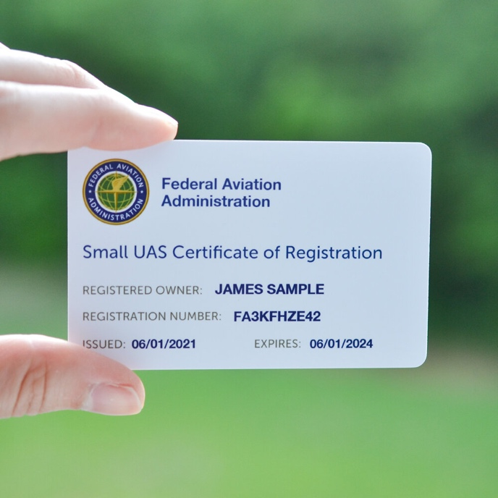
https://www.ecfr.gov/current/title-14/chapter-I/subchapter-C/part-48
PART 48—REGISTRATION AND MARKING REQUIREMENTS FOR SMALL UNMANNED AIRCRAFT
Authority: 49 U.S.C. 106(f), 106(g), 40101, 40103, 40113–40114, 41703, 44101–44103, 44105–44106, 44110–44113, 44809(f), 45302, 45305, 46104, 46301, 46306.
Source: Doc. No. FAA–2015–7396; Amdt. No. 48–1; 80 FR 78645, Dec. 16, 2015, unless otherwise noted.

Subpart A—General

§ 48.1 Applicability.
(a) This part provides registration and identification requirements for small unmanned aircraft that are part of a small unmanned aircraft system as defined in § 1.1 of this chapter.
(b) Small unmanned aircraft eligible for registration in the United States must be registered and identified in accordance with either:
(1) The registration and identification requirements in this part; or
(2) The registration requirements in part 47 and the identification and registration marking requirements in subparts A and C of part 45.
(c) Small unmanned aircraft intended to be operated outside of the territorial airspace of the United States, or registered through a trust or voting trust, must be registered in accordance with subparts A and B of part 47 and satisfy the identification and registration marking requirements of subparts A and C of part 45.

§ 48.10 Definitions.
For purposes of this part, the following definitions apply:
Citizen of the United States or U.S. citizen means one of the following:
(1) An individual who is a citizen of the United States or one of its possessions.
(2) A partnership each of whose partners is an individual who is a citizen of the United States.
(3) A corporation or association organized under the laws of the United States or a State, the District of Columbia, or a territory or possession of the United States, of which the president and at least two-thirds of the board of directors and other managing officers are citizens of the United States, which is under the actual control of citizens of the United States, and in which at least 75 percent of the voting interest is owned or controlled by persons that are citizens of the United States.
Registry means the FAA, Civil Aviation Registry, Aircraft Registration Branch.
Resident alien means an individual citizen of a foreign country lawfully admitted for permanent residence in the United States as an immigrant in conformity with the regulations of the Department of Homeland Security (8 CFR Chapter 1).

§ 48.15 Requirement to register.
No person may operate a small unmanned aircraft that is eligible for registration under 49 U.S.C. 44101–44103 unless one of the following criteria has been satisfied:
(a) The owner has registered and marked the aircraft in accordance with this part;
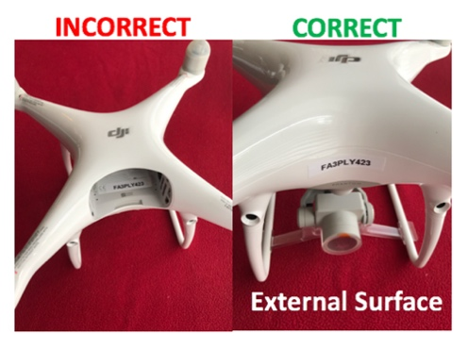
(b) The aircraft is operated exclusively in compliance with 49 U.S.C. 44809 and weighs 0.55 pounds or less on takeoff, including everything that is on board or otherwise attached to the aircraft; or
(c) The aircraft is an aircraft of the Armed Forces of the United States.
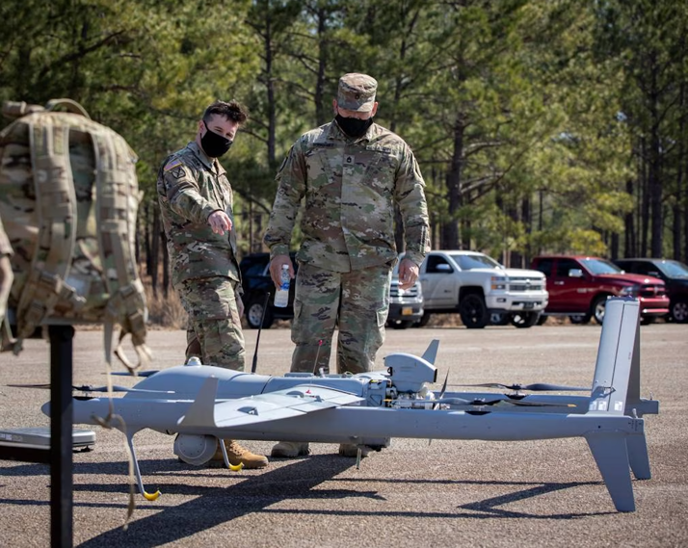
[Doc. No. FAA–2015–7396; Amdt. No. 48–1; 80 FR 78645, Dec. 16, 2015, as amended by Doc. No. FAA–2019–1100; Amdt. No. 48–3; 86 FR 4504, Jan. 15, 2021]

§ 48.20 Eligibility for registration.
A small unmanned aircraft may be registered under 49 U.S.C. 44103 and under this part only when the aircraft is not registered under the laws of a foreign country and is—
(a) Owned by a U.S. citizen;
(b) Owned by an individual citizen of a foreign country lawfully admitted for permanent residence in the United States;
(c) Owned by a corporation not a citizen of the United States when the corporation is organized and doing business under the laws of the United States or a State within the United States, and the aircraft is based and primarily used in the United States; or
(d) An aircraft of—
(1) The United States Government; or
(2) A State, the District of Columbia, a territory or possession of the United States, or a political subdivision of a State, territory, or possession.

§ 48.25 Applicants.
(a) To register a small unmanned aircraft in the United States under this part, a person must provide the information required by § 48.110 to the Registry in a form and manner prescribed by the Administrator. Upon submission of this information, the FAA issues a Certificate of Aircraft Registration to that person.
(b) A small unmanned aircraft must be registered by its owner using the legal name of its owner, unless the owner is less than 13 years of age. If the owner is less than 13 years of age, then the small unmanned aircraft must be registered by a person who is at least 13 years of age.
(c) In accordance with 49 U.S.C. 44103(c), registration is not evidence of aircraft ownership in any proceeding in which ownership of an unmanned aircraft by a particular person is in issue.
(d) In this part, “owner” includes a buyer in possession, a bailee, a lessee of a small unmanned aircraft under a contract of conditional sale, and the assignee of that person.
[Doc. No. FAA–2015–7396; Amdt. No. 48–1; 80 FR 78645, Dec. 16, 2015, as amended by Doc. No. FAA–2019–1100; Amdt. No. 48–3; 86 FR 4504, Jan. 15, 2021]

§ 48.30 Fees.
(a) The fee for issuing or renewing a Certificate of Aircraft Registration as described in § 48.100 is $5.00 per aircraft.
(b) The fee for issuing or renewing a Certificate of Aircraft Registration as described in § 48.105 is $5.00 per certificate.
(c) Each application for and renewal of a Certificate of Aircraft Registration must be accompanied by the fee described in paragraphs (a) and (b), as applicable, paid to the Federal Aviation Administration through the web-based aircraft registration system, or in another manner if prescribed by the Administrator.
[Doc. No. FAA–2015–7396; Amdt. No. 48–1; 80 FR 78645, Dec. 16, 2015, as amended by Doc. No. FAA–2019–1100; Amdt. No. 48–3; 86 FR 4504, Jan. 15, 2021]

Subpart B—Certificates of Aircraft Registration for Small Unmanned Aircraft

§ 48.100 Registration: Small unmanned aircraft operated for any purpose other than exclusively limited recreational operations.
(a) Certificate of Aircraft Registration. A Certificate of Aircraft Registration issued in accordance with § 48.110 to a small unmanned aircraft used for any purpose other than operating exclusively in compliance with 49 U.S.C. 44809 constitutes registration for the small unmanned aircraft identified on the application.
(b) Effective date of registration. An aircraft is registered when the applicant receives a Certificate of Aircraft Registration for the specific aircraft. The effective date of registration is shown by the date of issue on the Certificate of Aircraft Registration issued for the aircraft.
(c) Registration renewal. A Certificate of Aircraft registration issued under this part expires 3 years after the date of issue unless it is renewed.
(1) The holder of a Certificate of Aircraft Registration must renew the Certificate by verifying, in a form and manner prescribed by the Administrator, that the information provided in accordance with § 48.110 is accurate and if it is not, provide updated information. The verification may take place at any time within the six months preceding the month in which the Certificate of Aircraft registration expires.
(2) A certificate issued under this paragraph expires three years from the expiration date of the previous certificate.
(d) Other events affecting effectiveness of Certificate. Each Certificate of Aircraft Registration issued by the FAA under this subpart is effective, unless registration has ended by reason of having been revoked, canceled, expired, or the ownership is transferred, until the date upon which one of the following events occurs:
(1) Subject to the Convention on the International Recognition of Rights in Aircraft when applicable, the aircraft is registered under the laws of a foreign country.
(2) The small unmanned aircraft is totally destroyed or scrapped.
(3) The holder of the Certificate of Aircraft Registration loses U.S. citizenship.
(4) Thirty days have elapsed since the death of the holder of the Certificate of Aircraft Registration.
(5) The owner, if an individual who is not a citizen of the United States, loses status as a resident alien, unless that person becomes a citizen of the United States at the same time.
(6) The owner is a corporation other than a corporation which is a citizen of the United States and one of the following events occurs:
(i) The corporation ceases to be lawfully organized and doing business under the laws of the United States or any State thereof; or
(ii) The aircraft was not operated exclusively within the United States during the period of registration under this part.
[Doc. No. FAA–2015–7396; Amdt. No. 48–1; 80 FR 78645, Dec. 16, 2015. Redesignated and amended by Doc. No. FAA–2019–1100; Amdt. No. 48–3, 86 FR 4504, Jan. 15, 2021]

§ 48.105 Registration: Small unmanned aircraft intended exclusively for limited recreational operations.
(a) Certificate of Aircraft Registration. A Certificate of Aircraft Registration issued in accordance with § 48.110 for small unmanned aircraft to be operated exclusively in compliance with 49 U.S.C. 44809 constitutes registration for all the small unmanned aircraft used exclusively for operations in compliance with 49 U.S.C. 44809 owned by the individual identified on the application.
(b) Effective date of registration. An aircraft is registered when the applicant receives a Certificate of Aircraft Registration. The effective date of registration is shown by the date of issue on the Certificate of Aircraft Registration issued under this part.
(c) Registration renewal. A Certificate of Aircraft registration issued under this part expires 3 years after the date of issue unless it is renewed.
(1) The holder of a Certificate of Aircraft Registration must renew the Certificate by verifying, in a form and manner prescribed by the Administrator, that the information provided in accordance with § 48.110 is accurate and if it is not, provide updated information. The verification may take place at any time within the six months preceding the month in which the Certificate of Aircraft registration expires.
(2) A certificate issued under this paragraph expires three years from the expiration date of the previous certificate.
(d) Other events affecting effectiveness of Certificate. Each Certificate of Aircraft Registration issued by the FAA under this part is effective, unless registration has ended by reason of having been revoked, canceled or expired, or until the date upon which one of the following events occurs:
(1) The holder of the Certificate of Aircraft Registration loses U.S. citizenship.
(2) Thirty days have elapsed since the death of the holder of the Certificate of Aircraft Registration.
(3) The owner, if an individual who is not a citizen of the United States, loses status as a resident alien, unless that person becomes a citizen of the United States at the same time.
[Doc. No. FAA–2015–7396; Amdt. No. 48–1; 80 FR 78645, Dec. 16, 2015. Redesignated and amended by Doc. No. FAA–2019–1100; Amdt. No. 48–3, 86 FR 4504, Jan. 15, 2021]

§ 48.110 Application.
(a) Required information. Each applicant for a Certificate of Aircraft Registration issued under this part must submit all of the following information to the Registry:
(1) Applicant's name and, for an applicant other than an individual, the name of the authorized representative applying for a Certificate of Aircraft Registration.
(2) Applicant's physical address and, for an applicant other than an individual, the physical address of the authorized representative. If the applicant or authorized representative cannot receive mail at a physical address, then provide a mailing address.
(3) Applicant's email address or, for applicants other than individuals, the email address of the authorized representative.
(4) Applicant's telephone number(s) and, for an applicant other than an individual, the telephone number(s) of the authorized representative.
(5) The aircraft manufacturer and model name.
(6) For any standard remote identification unmanned aircraft, the serial number issued by the manufacturer of the unmanned aircraft in accordance with the design and production requirements of part 89 of this chapter. The serial number provided in this application must not be listed on more than one Certificate of Aircraft Registration at the same time.
(7) For any unmanned aircraft equipped with a remote identification broadcast module, the serial number issued by the manufacturer of the remote identification broadcast module in accordance with the design and production requirements of part 89 of this chapter. An applicant may submit the serial number of more than one remote identification broadcast module as part of the application for aircraft registration under § 48.105. The serial number of a remote identification broadcast module provided in this application must not be listed on more than one Certificate of Aircraft Registration at the same time.
(8) Other information as required by the Administrator.
(b) Provision of information. The information identified in paragraph (a) of this section must be submitted to the Registry through the web-based small unmanned aircraft registration system in a form and manner prescribed by the Administrator.
(c) Issuance of Certificate of Aircraft Registration. The FAA will issue a Certificate of Aircraft Registration upon completion of the application requirements provided in paragraph (a) of this section.
[Doc. No. FAA–2015–7396; Amdt. No. 48–1; 80 FR 78645, Dec. 16, 2015. Redesignated and amended by Doc. No. FAA–2019–1100; Amdt. No. 48–3, 86 FR 4504, Jan. 15, 2021]

§ 48.115 Requirement to maintain current information.
(a) The holder of a Certificate of Aircraft Registration must ensure that the information provided under § 48.110 remains accurate.
(b) The holder of a Certificate of Aircraft Registration must update the information using the web-based small unmanned aircraft registration system within 14 calendar days of the following:
(1) A change in the information provided under § 48.110.
(2) When aircraft registration requires cancellation for any reason including sale or transfer, destruction, or export.
[Doc. No. FAA–2015–7396; Amdt. No. 48–1; 80 FR 78645, Dec. 16, 2015. Redesignated and amended by Doc. No. FAA–2019–1100; Amdt. No. 48–3, 86 FR 4504, Jan. 15, 2021]

§ 48.120 Invalid registration.
The registration of a small unmanned aircraft is invalid if, at the time it is made—
(a) The aircraft is registered in a foreign country;
(b) The applicant is not the owner, except when the applicant registers on behalf of an owner who is under 13 years of age;
(c) The applicant is not eligible to submit an application under this part; or
(d) The interest of the applicant in the aircraft was created by a transaction that was not entered into in good faith, but rather was made to avoid (with or without the owner's knowledge) compliance with 49 U.S.C. 44101–44103.

§ 48.125 Foreign civil aircraft.
Except for corporations eligible to register under § 48.20(c), the FAA will issue a recognition of ownership to persons required to comply with the provisions of this part pursuant to an authorization to operate issued under part 375 of this title. The recognition of ownership does not have the effect of U.S. aircraft registration.

Subpart C—Aircraft Marking

§ 48.200 General.
(a) No person may operate a small unmanned aircraft registered in accordance with this part unless the aircraft displays a unique identifier in accordance with the requirements of § 48.205 of this subpart.
(b) A unique identifier is one of the following:
(1) The registration number issued to an individual or the registration number issued to the aircraft by the Registry upon completion of the registration process provided by this part; or
(2) If authorized by the Administrator, the small unmanned aircraft serial number provided with the application for Certificate of Aircraft Registration under § 48.110(a).
[Doc. No. FAA–2015–7396; Amdt. No. 48–1; 80 FR 78645, Dec. 16, 2015. Redesignated and amended by Doc. No. FAA–2019–1100; Amdt. No. 48–3, 86 FR 4504, Jan. 15, 2021]

§ 48.205 Display and location of unique identifier.
(a) The unique identifier must be maintained in a condition that is legible.
(b) The unique identifier must be affixed to the small unmanned aircraft by any means necessary to ensure that it will remain affixed for the duration of each operation.
(c) The unique identifier must be legibly displayed on an external surface of the small unmanned aircraft.
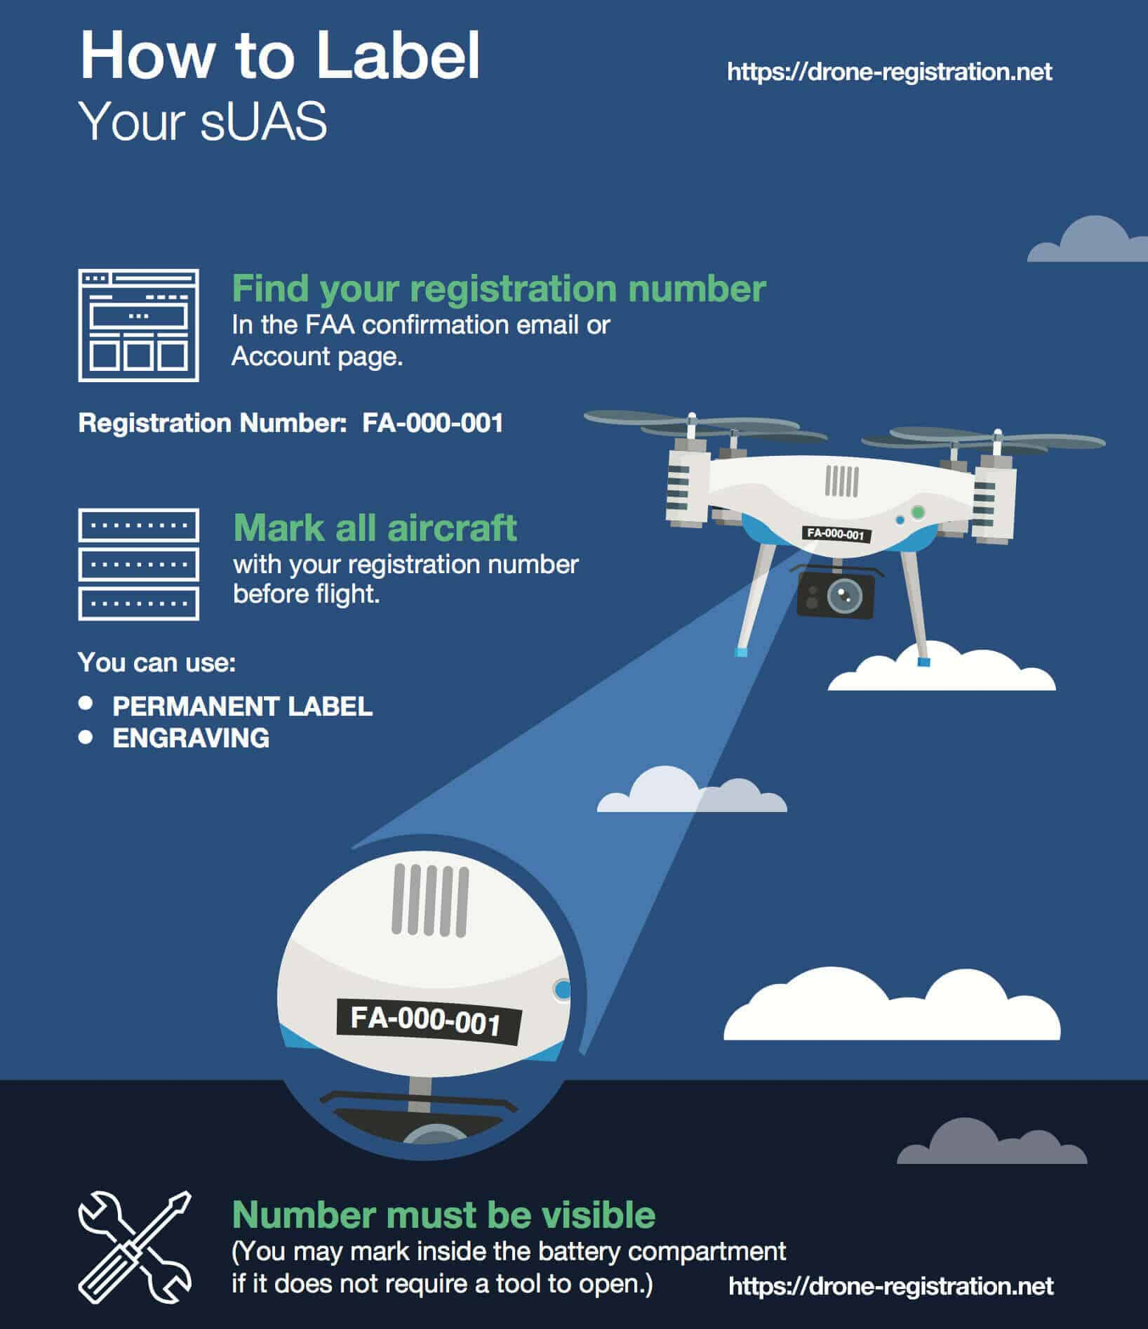
[Doc. No. FAA–2015–7396; Amdt. No. 48–1; 80 FR 78645, Dec. 16, 2015, as amended by Doc. No. FAA–2018–1084, 84 FR 3673, Feb. 13, 2019]

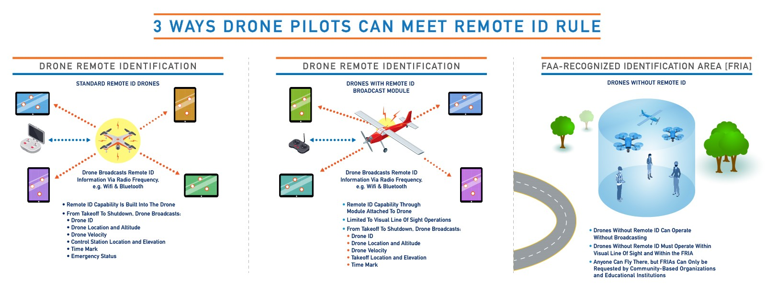
PART 89—REMOTE IDENTIFICATION OF UNMANNED AIRCRAFT
Authority: 49 U.S.C. 106(f), 106(g), 40101(d), 40103(b), 44701, 44805, 44809(f); Section 2202 of Pub. L. 114–190, 130 Stat. 629.
Source: Amdt. No. 89–1, 86 FR 4505, Jan. 15, 2021, unless otherwise noted.

Subpart A—General

§ 89.1 Definitions.
The following definitions apply to this part.
Declaration of compliance means a record submitted to the FAA by the producer of a standard remote identification unmanned aircraft or remote identification broadcast module to attest that all the requirements of subpart F of this part have been met.
Home-built unmanned aircraft means an unmanned aircraft that an individual built solely for education or recreation.

§ 89.5 Falsification, reproduction, alteration, or omission.
(a) No person may make or cause to be made any of the following:
(1) Any fraudulent or intentionally false statement in any document related to any acceptance, application, approval, authorization, certificate, declaration, designation, qualification, record, report, request for reconsideration, or similar, submitted under this part.
(2) Any fraudulent or intentionally false statement in any document required to be developed, provided, kept, or used to show compliance with any requirement under this part.
(3) Any reproduction or alteration, for fraudulent purpose, of any document related to any acceptance, application, approval, authorization, certificate, declaration, designation, qualification, record, report, request for reconsideration, or similar, submitted or granted under this part.
(b) No person may, by omission, knowingly conceal or cause to be concealed, a material fact in—
(1) Any document related to any acceptance, application, approval, authorization, certificate, declaration, designation, qualification, record, report, request for reconsideration, or similar, submitted under this part; or
(2) Any document required to be developed, provided, kept, or used to show compliance with any requirement under this part.
(c) The commission by any person of an act prohibited under paragraph (a) or (b) of this section is a basis for—
(1) Denial, suspension, rescission, or revocation of any acceptance, application, approval, authorization, certificate, declaration, declaration of compliance, designation, document, filing, qualification, means of compliance, record, report, request for reconsideration, or similar instrument issued or granted by the Administrator and held by that person; or
(2) A civil penalty.

Subpart B—Operating Requirement

§ 89.101 Applicability.
(a) Except as provided in paragraph (b) of this section, this subpart applies to the following:
(1) Persons operating unmanned aircraft registered or required to be registered under part 47 or 48 of this chapter.
(2) Persons operating foreign civil unmanned aircraft in the United States.
(b) This subpart does not apply to unmanned aircraft operations under part 91 of this chapter that are transmitting ADS–B Out pursuant to § 91.225.

§ 89.105 Remote identification requirement.
Except as otherwise authorized by the Administrator or as provided in § 89.120, after September 16, 2023, no person may operate an unmanned aircraft within the airspace of the United States unless the operation meets the requirements of § 89.110 or § 89.115.
September 2023 - FAA Extends Remote ID Enforcement Date Six Months
Drone pilots who are unable to comply with the broadcast requirement of the Remote ID Rule will now have until March 16, 2024, to equip their aircraft. After that date, operators could face fines and suspension or revocation of pilot certificates. In making this decision, the FAA recognizes the unanticipated issues that some operators are experiencing finding some remote identification broadcast modules.

§ 89.110 Operation of standard remote identification unmanned aircraft.
Unless otherwise authorized by the Administrator, a person may comply with the remote identification requirement of § 89.105 by operating a standard remote identification unmanned aircraft under the following conditions:
(a) Operational requirements. A person may operate a standard remote identification unmanned aircraft only if the person operating the standard remote identification unmanned aircraft ensures that all of the following conditions are met:
(1) From takeoff to shutdown, the standard remote identification unmanned aircraft must broadcast the message elements of § 89.305.
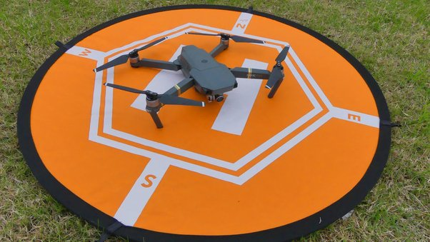
(2) The person manipulating the flight controls of the unmanned aircraft system must land the unmanned aircraft as soon as practicable if the standard remote identification unmanned aircraft is no longer broadcasting the message elements of § 89.305.
(b) Standard remote identification unmanned aircraft requirements. A person may operate a standard remote identification unmanned aircraft only if the unmanned aircraft meets all of the following requirements:
(1) Its serial number is listed on an FAA-accepted declaration of compliance, or the standard remote identification unmanned aircraft is covered by a design approval or production approval issued under part 21 of this chapter and meets the requirements of subpart F of this part.
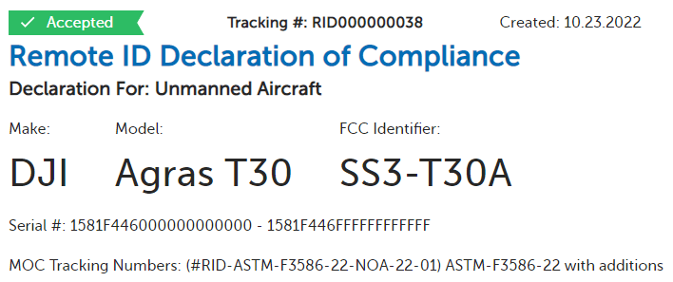
(2) Its remote identification equipment is functional and complies with the requirements of this part from takeoff to shutdown.
(3) Its remote identification equipment and functionality have not been disabled.
(4) The Certificate of Aircraft Registration of the unmanned aircraft used in the operation must include the serial number of the unmanned aircraft, as per applicable requirements of parts 47 and 48 of this chapter, or the serial number of the unmanned aircraft must be provided to the FAA in a notice of identification pursuant to § 89.130 prior to the operation.

§ 89.115 Alternative remote identification.
A person operating an unmanned aircraft that is not a standard remote identification unmanned aircraft may comply with the remote identification requirement of § 89.105 by meeting all of the requirements of either paragraph (a) or (b) of this section.
(a) Remote identification broadcast modules. Unless otherwise authorized by the Administrator, a person may operate an unmanned aircraft that is not a standard remote identification unmanned aircraft if all of the following conditions are met:
(1) Equipage.
(i) The unmanned aircraft used in the operation must be equipped with a remote identification broadcast module that meets the requirements of § 89.320 and the serial number of the remote identification broadcast module must be listed on an FAA-accepted declaration of compliance.
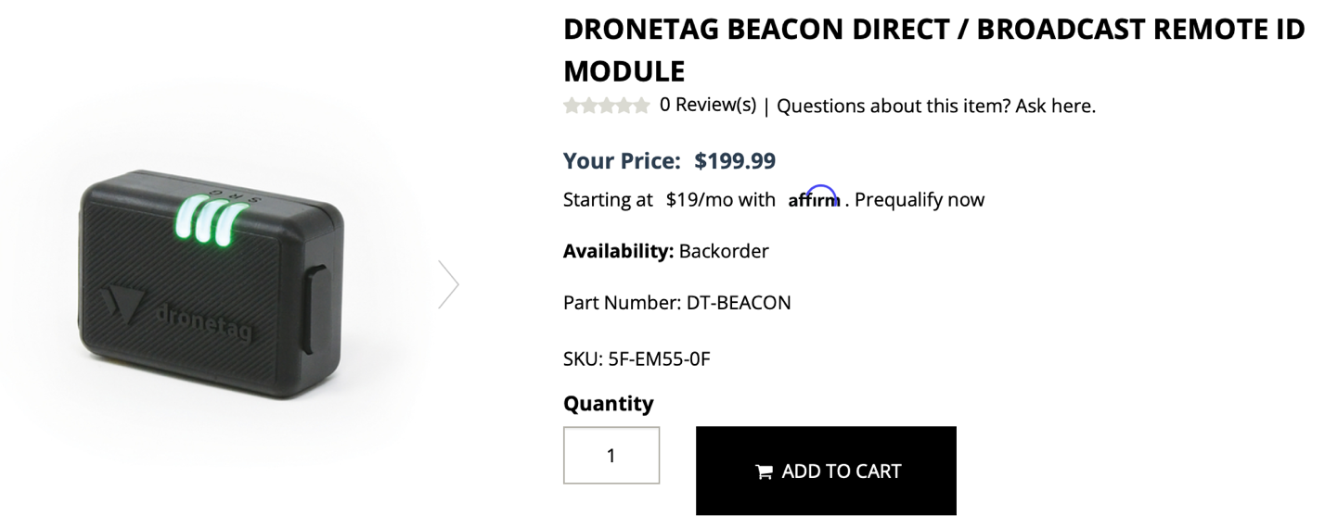
(ii) The Certificate of Aircraft Registration of the unmanned aircraft used in the operation must include the serial number of the remote identification broadcast module, as per applicable requirements of parts 47 and 48 of this chapter, or the serial number of the unmanned aircraft must be provided to the FAA in a notice of identification pursuant to § 89.130 prior to the operation.
(2) Remote identification operating requirements. Unless otherwise authorized by the Administrator, a person may operate an unmanned aircraft under this paragraph (a) only if all of the following conditions are met:
(i) From takeoff to shutdown, the person operating the unmanned aircraft must ensure that the remote identification broadcast module broadcasts the remote identification message elements of § 89.315 directly from the unmanned aircraft.
(ii) The person manipulating the flight controls of the unmanned aircraft system must be able to see the unmanned aircraft at all times throughout the operation.
(3) Pre-flight requirement. Prior to takeoff, the person manipulating the flight controls of the unmanned aircraft system must ensure the remote identification broadcast module is functioning in accordance with this subpart.
(4) In-flight loss of remote identification broadcast. The person manipulating the flight controls of the unmanned aircraft system must land the unmanned aircraft as soon as practicable if the unmanned aircraft is no longer broadcasting the message elements of § 89.315.
(b) Operations at FAA-recognized identification areas. Unless otherwise authorized by the Administrator, a person may operate an unmanned aircraft without remote identification equipment only if all of the following conditions are met:
(1) The unmanned aircraft and the person manipulating the flight controls of the unmanned aircraft system remain within the boundaries of an FAA-recognized identification area throughout the operation; and
(2) The person manipulating the flight controls of the unmanned aircraft system must be able to see the unmanned aircraft at all times throughout the operation.
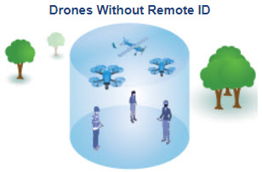

§ 89.120 Operations for aeronautical research or to show compliance with regulations.
The Administrator may authorize operations without remote identification where the operation is solely for the purpose of aeronautical research or to show compliance with regulations.

§ 89.125 Automatic Dependent Surveillance-Broadcast (ADS–B) Out prohibition.
Automatic Dependent Surveillance-Broadcast (ADS–B) Out equipment cannot be used to comply with the remote identification requirements of this part.
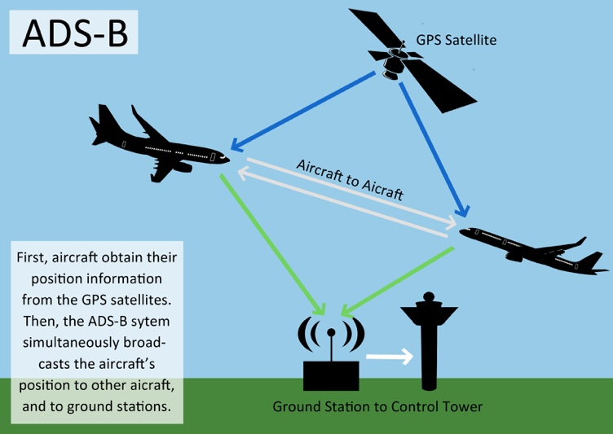

§ 89.130 Confirmation of identification.
(a) Notification requirement. No person may operate a foreign registered civil unmanned aircraft with remote identification in the airspace of the United States unless, prior to the operation, the person submits a notice of identification in a form and manner acceptable to the Administrator. The notice of identification must include all of the following:
(1) The name of the person operating the foreign registered civil unmanned aircraft in the United States, and, if applicable, the person's authorized representative.
(2) The physical address of the person operating the foreign registered civil unmanned aircraft in the United States, and, if applicable, the physical address for the person's authorized representative. If the operator or authorized representative does not receive mail at the physical address, a mailing address must also be provided.
(3) The telephone number(s) where the person operating the foreign registered civil unmanned aircraft in the United States, and, if applicable, the person's authorized representative can be reached while in the United States.
(4) The email address of the person operating the foreign registered civil unmanned aircraft in the United States, and, if applicable, the email address of the person's authorized representative.
(5) The unmanned aircraft manufacturer and model name.
(6) The serial number of the unmanned aircraft or remote identification broadcast module.
(7) The country of registration of the unmanned aircraft.
(8) The registration number.
(b) Issuance of a Confirmation of Identification.
(1) The FAA will issue a Confirmation of Identification upon completion of the notification requirements provided in paragraph (a) of this section.
(2) The filing of a notification under paragraph (a) of this section and the Confirmation of Identification issued under paragraph (b)(1) of this section do not have the effect of United States aircraft registration.
(c) Proof of notification. No person may operate a foreign registered civil unmanned aircraft with remote identification in the United States unless the person obtains a Confirmation of Identification under paragraph (b)(1) of this section, maintains such Confirmation of Identification at the unmanned aircraft's control station, and produces the Confirmation of Identification when requested by the FAA or a law enforcement officer.
(d) Requirement to maintain current information. The holder of a Confirmation of Identification must ensure that the information provided under paragraph (a) of this section remains accurate and must update the information prior to operating a foreign registered civil unmanned aircraft in the United States.

Subpart C—FAA-Recognized Identification Areas
Source: Amdt. No. 89–1, 86 FR 4511, Jan. 15, 2021, unless otherwise noted.

§ 89.201 Applicability.
This subpart prescribes procedural requirements to establish an FAA-recognized identification area.

§ 89.205 Eligibility.
Only the following persons are eligible to apply for the establishment of an FAA-recognized identification area under this subpart:
(a) A community-based organization recognized by the Administrator.
(b) An educational institution, including primary and secondary educational institutions, trade schools, colleges, and universities.

§ 89.210 Requests for establishment of an FAA-recognized identification area.
(a) Application. An eligible person requesting the establishment of an FAA-recognized identification area under this subpart may submit an application in a form and manner acceptable to the Administrator.
(b) Required documentation. A request under this subpart must contain all of the following information:
(1) The name of the eligible person under § 89.205.
(2) The name of the individual making the request on behalf of the eligible person.
(3) A declaration that the individual making the request has the authority to act on behalf of the community-based organization or educational institution.
(4) The name and contact information of the primary point of contact for communications with the FAA.
(5) The physical address of the proposed FAA-recognized identification area.
(6) The location of the proposed FAA-recognized identification area in a form and manner prescribed by the Administrator.
(7) If applicable, a copy of any existing letter of agreement regarding the flying site.
(8) Description of the intended purpose of the FAA-recognized identification area and why the proposed FAA-recognized identification area is necessary for that purpose.
(9) Any other information required by the Administrator.

§ 89.215 Approval of FAA-recognized identification areas.
The Administrator will assess applications for FAA-recognized identification areas and may require additional information or documentation, as needed, to supplement an application. The Administrator will approve or deny an application, and may take into consideration matters such as, but not limited to:
(a) The existence of any FAA established flight or airspace restriction limiting the operation of unmanned aircraft systems, such as special use airspace designations under part 73 of this chapter, temporary flight restrictions issued under part 91 of this chapter, or any other special flight rule, restriction or regulation in this chapter limiting the operation of unmanned aircraft systems in the interest of safety, efficiency, national security and/or homeland security, which overlaps with the proposed FAA-recognized identification area.
(b) The safe and efficient use of airspace by other aircraft.
(c) The safety and security of persons or property on the ground.
(d) The need for an FAA-recognized identification area in the proposed location and proximity of other FAA-recognized identification areas.

§ 89.220 Amendment.
(a) From the time of application until expiration or termination of an FAA-recognized identification area, any change to the information submitted in the application including but not limited to a change to the point of contact for the FAA-recognized identification area or a change to the FAA-recognized identification area's organizational affiliation must be submitted to the FAA within 10 calendar days of the change.
(b) If the person who has been granted an FAA-recognized identification area wishes to change the geographic boundaries of the FAA-recognized identification area, the person must submit a request describing the change to the FAA for review. The geographic boundaries of the FAA-recognized identification area will not change unless the requested change is approved in accordance with § 89.215.
(c) The establishment of an FAA-recognized identification area is subject to ongoing review in accordance with § 89.215 by the Administrator that may result in the termination of the FAA-recognized identification area pursuant to § 89.230 or modification of the FAA-recognized identification area.

§ 89.225 Duration of an FAA-recognized identification area.
(a) Duration. Except as otherwise provided in this subpart, an FAA-recognized identification area will be in effect for 48 calendar months after the date the FAA approves the request for establishment of an FAA-recognized identification area.
(b) Renewal. A person wishing to renew an FAA-recognized identification area must submit a request for renewal no later than 120 days prior to the expiration of the FAA-recognized identification area in a form and manner acceptable to the Administrator. The Administrator may deny requests submitted after that deadline or requests submitted after the expiration.

§ 89.230 Expiration and termination.
(a) Expiration. Unless renewed, an FAA-recognized identification area issued under this subpart will expire automatically and will have no further force or effect as of the day that immediately follows the date of expiration.
(b) Termination prior to expiration —
(1) Termination by request. An individual identified as the point of contact for an approved FAA-recognized identification area may submit a request to the Administrator to terminate that FAA-recognized identification area.
(2) Termination by FAA.
(i) The FAA may terminate an FAA-recognized identification area upon a finding that—
(A) The FAA-recognized identification area may pose a risk to aviation safety, public safety, homeland security, or national security;
(B) The FAA-recognized identification area is no longer associated with a person eligible for an FAA-recognized identification area; or
(C) The person who submitted a request for establishment of an FAA-recognized identification area provided false or misleading information during the submission, amendment, or renewal process.
(ii) The Administrator will notify the primary point of contact of the decision to terminate the FAA-recognized identification area and the reasons for the termination. Except as provided in paragraph (c) of this section, if the FAA terminates an FAA-recognized identification area based upon a finding that the FAA-recognized identification area may pose a risk to aviation safety, public safety, homeland security, or national security, that area will no longer be eligible to be an FAA-recognized identification area for as long as those conditions remain in effect.
(c) Petition to reconsider the FAA's decision to terminate an FAA-recognized identification area. No later than 30 calendar days after the termination of an FAA-recognized identification area, a person may petition the Administrator for reconsideration of the decision. The petition must state the reasons justifying the request for reconsideration and include any supporting documentation. Upon consideration of the information submitted by the petitioner, the Administrator will notify the petitioner of the decision on the request for reconsideration.
(d) Inapplicability of part 13, subpart D, of this chapter. Part 13, subpart D, of this chapter does not apply to the procedures of paragraphs (b) and (c) of this section.

Subpart D—Requirements for Standard Remote Identification Unmanned Aircraft and Remote Identification Broadcast Modules

§ 89.301 Applicability.
This subpart prescribes the minimum message element set and minimum performance requirements for standard remote identification unmanned aircraft and remote identification broadcast modules.
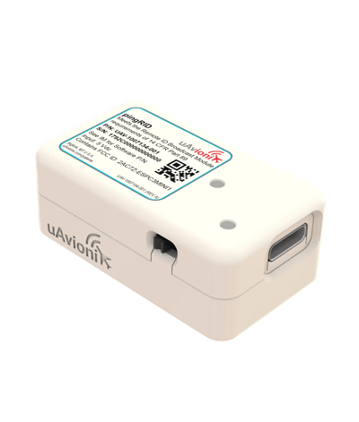

§ 89.305 Minimum message elements broadcast by standard remote identification unmanned aircraft.
A standard remote identification unmanned aircraft must be capable of broadcasting the following remote identification message elements:
(a) The identity of the unmanned aircraft, consisting of:
(1) A serial number assigned to the unmanned aircraft by the person responsible for the production of the standard remote identification unmanned aircraft; or
(2) A session ID.
(b) An indication of the latitude and longitude of the control station.
(c) An indication of the geometric altitude of the control station.
(d) An indication of the latitude and longitude of the unmanned aircraft.
(e) An indication of the geometric altitude of the unmanned aircraft.
(f) An indication of the velocity of the unmanned aircraft.
(g) A time mark identifying the Coordinated Universal Time (UTC) time of applicability of a position source output.
(h) An indication of the emergency status of the unmanned aircraft.
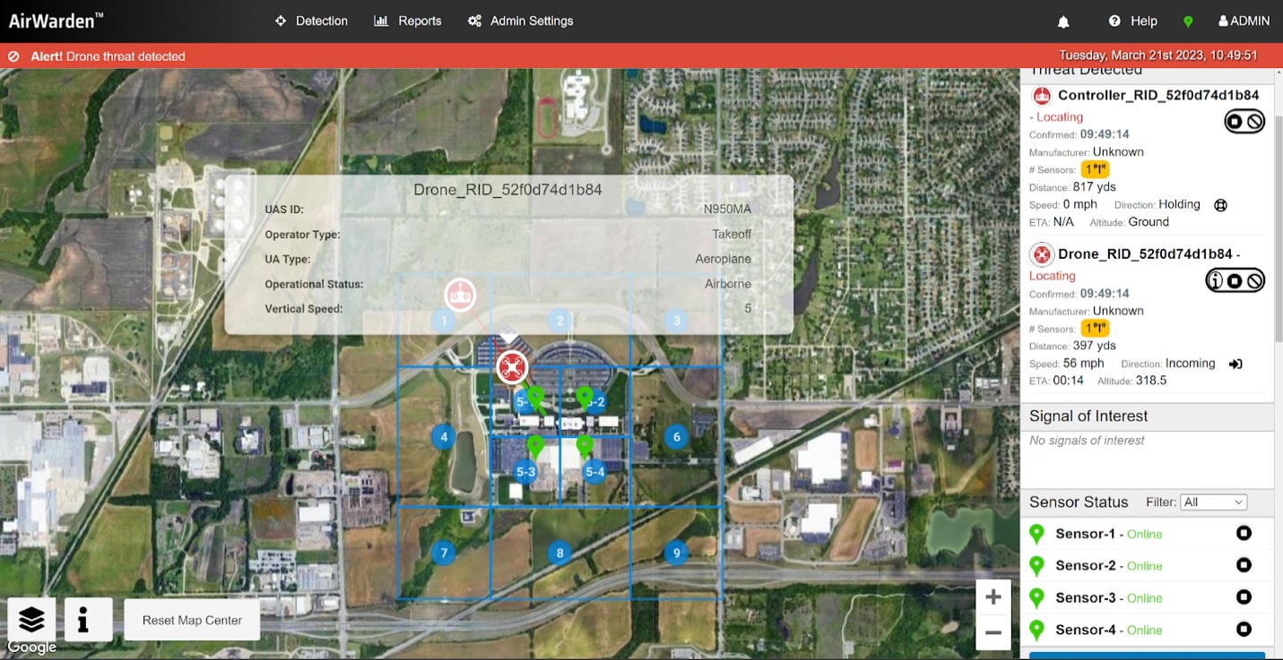

§ 89.310 Minimum performance requirements for standard remote identification unmanned aircraft.
A standard remote identification unmanned aircraft must meet the following minimum performance requirements:
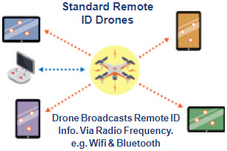
(a) Control station location. The location of the control station of the unmanned aircraft must be generated and encoded into the message elements and must correspond to the location of the person manipulating the flight controls of the unmanned aircraft system.
(b) Time mark. The time mark message element must be synchronized with all other remote identification message elements.
(c) Self-testing and monitoring.
(1) Prior to takeoff, the unmanned aircraft must automatically test the remote identification functionality and notify the person manipulating the flight controls of the unmanned aircraft system of the result of the test.
(2) The unmanned aircraft must not be able to take off if the remote identification equipment is not functional.
(3) The unmanned aircraft must continuously monitor the remote identification functionality from takeoff to shutdown and must provide notification of malfunction or failure to the person manipulating the flight controls of the unmanned aircraft system.
(d) Tamper resistance. The unmanned aircraft must be designed and produced in a way that reduces the ability of a person to tamper with the remote identification functionality.
(e) Error correction. The remote identification equipment must incorporate error correction in the broadcast of the message elements in § 89.305.
(f) Interference considerations. The remote identification equipment must not interfere with other systems or equipment installed on the unmanned aircraft, and other systems or equipment installed on the unmanned aircraft must not interfere with the remote identification equipment.
(g) Message broadcast.
(1) The unmanned aircraft must be capable of broadcasting the message elements in § 89.305 using a non-proprietary broadcast specification and using radio frequency spectrum compatible with personal wireless devices in accordance with 47 CFR part 15, where operations may occur without an FCC individual license.
(2) Any broadcasting device used to meet the requirements of this section must be integrated into the unmanned aircraft without modification to its authorized radio frequency parameters and designed to maximize the range at which the broadcast can be received, while complying with 47 CFR part 15 and any other applicable laws in effect as of the date the declaration of compliance is submitted to the FAA for acceptance.
(h) Message elements performance requirements.
(1) The reported geometric position of the unmanned aircraft and the control station must be accurate to within 100 feet of the true position, with 95 percent probability.
(2) The reported geometric altitude of the control station must be accurate to within 15 feet of the true geometric altitude, with 95 percent probability.
(3) The reported geometric altitude of the unmanned aircraft must be accurate to within 150 feet of the true geometric altitude, with 95 percent probability.
(4) The unmanned aircraft must broadcast the latitude, longitude, and geometric altitude of the unmanned aircraft and its control station no later than 1.0 seconds from the time of measurement to the time of broadcast.
(5) The unmanned aircraft must broadcast the message elements at a rate of at least 1 message per second.
(i) Take-off limitation. The unmanned aircraft must not be able to take off unless it is broadcasting the message elements in § 89.305.

§ 89.315 Minimum message elements broadcast by remote identification broadcast modules.
Remote identification broadcast modules must be capable of broadcasting the following remote identification message elements:
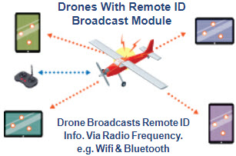
(a) The identity of the unmanned aircraft, consisting of the serial number assigned to the remote identification broadcast module by the person responsible for the production of the remote identification broadcast module.
(b) An indication of the latitude and longitude of the unmanned aircraft.
(c) An indication of the geometric altitude of the unmanned aircraft.
(d) An indication of the velocity of the unmanned aircraft.
(e) An indication of the latitude and longitude of the take-off location of the unmanned aircraft.
(f) An indication of the geometric altitude of the take-off location of the unmanned aircraft.
(g) A time mark identifying the Coordinated Universal Time (UTC) time of applicability of a position source output.

§ 89.320 Minimum performance requirements for remote identification broadcast modules.
Remote identification broadcast modules must meet the following minimum performance requirements:
(a) Take-off location. The remote identification broadcast module must be capable of determining the take-off location of the unmanned aircraft.
(b) Time mark. The time mark message element must be synchronized with all other remote identification message elements.
(c) Self-testing and monitoring.
(1) Prior to take-off, the remote identification broadcast module must automatically test the remote identification functionality and notify the person manipulating the flight controls of the unmanned aircraft system of the result of the test.
(2) The remote identification broadcast module must continuously monitor the remote identification functionality from takeoff to shutdown and must provide notification of malfunction or failure to the person manipulating the flight controls of the unmanned aircraft system.
(d) Tamper resistance. The remote identification broadcast module must be designed and produced in a way that reduces the ability of a person to tamper with the remote identification functionality.
(e) Error correction. The remote identification broadcast module must incorporate error correction in the broadcast of the message elements in § 89.315.
(f) Interference considerations. The remote identification broadcast module must not interfere with other systems or equipment installed on compatible unmanned aircraft, and other systems or equipment installed on compatible unmanned aircraft must not interfere with the remote identification equipment.
(g) Message broadcast.
(1) The remote identification broadcast module must be capable of broadcasting the message elements in § 89.315 using a non-proprietary broadcast specification and using radio frequency spectrum compatible with personal wireless devices in accordance with 47 CFR part 15, where operations may occur without an FCC individual license.
(2) The remote identification broadcast module must be designed to maximize the range at which the broadcast can be received, while complying with 47 CFR part 15 and any other applicable laws in effect as of the date the declaration of compliance is submitted to the FAA for acceptance.
(h) Message elements performance requirements.
(1) The reported geometric position of the unmanned aircraft must be accurate to within 100 feet of the true position, with 95 percent probability.
(2) The reported geometric altitude of the unmanned aircraft must be accurate to within 150 feet of the true geometric altitude, with 95 percent probability.
(3) The reported geometric position of the take-off location must be accurate to within 100 feet of the true geometric position, with 95 percent probability.
(4) The reported geometric altitude of the take-off location must be accurate to within 150 feet of the true geometric altitude, with 95 percent probability.
(5) The remote identification broadcast module must broadcast the latitude, longitude, and geometric altitude of the unmanned aircraft no later than 1.0 seconds from the time of measurement to the time of broadcast.
(6) The remote identification broadcast module must broadcast the message elements at a rate of at least 1 message per second.

Subpart E—Means of Compliance

§ 89.401 Applicability.
This subpart prescribes—
(a) Requirements for means of compliance with subpart D of this part.
(b) Procedural requirements for the submission and acceptance of means of compliance used in the design and production of standard remote identification unmanned aircraft or remote identification broadcast modules to ensure they meet the minimum performance requirements of this part.
(c) Rules governing persons submitting means of compliance for FAA acceptance.

§ 89.405 Submission of a means of compliance for FAA acceptance.
(a) Eligibility. Any person may submit a means of compliance for acceptance by the FAA.
(b) Required information. A person requesting acceptance of a means of compliance must submit the following information to the FAA in a form and manner acceptable to the Administrator:
(1) The name of the person or entity submitting the means of compliance, the name of the main point of contact for communications with the FAA, the physical address, email address, and other contact information.
(2) A detailed description of the means of compliance.
(3) An explanation of how the means of compliance addresses all of the minimum performance requirements established in subpart D of this part so that any standard remote identification unmanned aircraft or remote identification broadcast module designed and produced in accordance with such means of compliance meets the remote identification requirements of this part.
(4) Any substantiating material the person wishes the FAA to consider as part of the request.
(c) Testing and validation. A means of compliance submitted for acceptance by the FAA must include testing and validation procedures for persons responsible for the production of standard remote identification unmanned aircraft or remote identification broadcast modules to demonstrate through analysis, ground test, or flight test, as appropriate, how the standard remote identification unmanned aircraft or the remote identification broadcast module performs its intended functions and meets the requirements in subpart D of this part, including any applicable FAA performance requirements for radio station operation.

§ 89.410 Acceptance of a means of compliance.
(a) A person requesting acceptance of a means of compliance must demonstrate to the Administrator that the means of compliance addresses all of the requirements of subparts D and E of this part, and that any standard remote identification unmanned aircraft or remote identification broadcast module designed and produced in accordance with such means of compliance would meet the performance requirements of subpart D of this part.
(b) The Administrator will evaluate a means of compliance that is submitted to the FAA and may request additional information or documentation, as needed, to supplement the submission.
(c) If the Administrator determines the person has demonstrated that the means of compliance meets the requirements of subparts D and E of this part, the FAA will notify the person that the Administrator has accepted the means of compliance.

§ 89.415 Rescission.
(a) Rescission of an FAA-accepted means of compliance.
(1) A means of compliance is subject to ongoing review by the Administrator. The Administrator may rescind acceptance of a means of compliance if the Administrator determines that a means of compliance does not meet any or all of the requirements of subpart D or E of this part.
(2) The Administrator will publish a notice of rescission in the Federal Register.
(b) Inapplicability of part 13, subpart D, of this chapter. Part 13, subpart D, of this chapter does not apply to the procedures of paragraph (a) of this section.

§ 89.420 Record retention.
A person who submits a means of compliance that is accepted by the Administrator under this subpart must retain the following information for as long as the means of compliance is accepted plus an additional 24 calendar months, and must make available for inspection by the Administrator the following:
(a) All documentation and substantiating data submitted to the FAA for acceptance of the means of compliance.
(b) Records of all test procedures, methodology, and other procedures, as applicable.
(c) Any other information necessary to justify and substantiate how the means of compliance enables compliance with the remote identification requirements of this part.

Subpart F— Remote Identification Design and Production

§ 89.501 Applicability.
(a) This subpart prescribes—
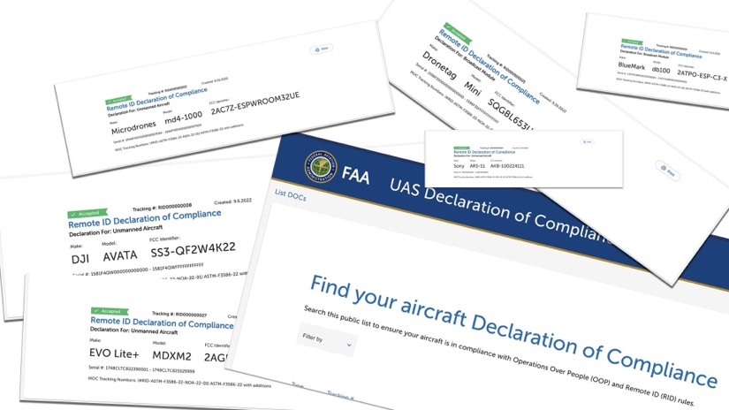
(1) Requirements for the design and production of unmanned aircraft with remote identification produced for operation in the airspace of the United States.
(2) Requirements for the design and production of remote identification broadcast modules.
(3) Procedural requirements for the submission, acceptance, and rescission of declarations of compliance.
(4) Rules governing persons submitting declarations of compliance for FAA acceptance under this part.
(b) Except as provided in paragraph (c) of this section, this subpart applies to the design and production of all unmanned aircraft operated in the airspace of the United States.
(c) Except for unmanned aircraft designed and produced to be standard remote identification unmanned aircraft, this subpart does not apply to the design or production of:
(1) Home-built unmanned aircraft.
(2) Unmanned aircraft of the United States Government.
(3) Unmanned aircraft that weigh 0.55 pounds or less on takeoff, including everything that is on board or otherwise attached to the aircraft.
(4) Unmanned aircraft designed or produced exclusively for the purpose of aeronautical research or to show compliance with regulations.

§ 89.505 Serial numbers.
No person may produce a standard remote identification unmanned aircraft under § 89.510 or § 89.515 or a remote identification broadcast module under § 89.520, unless the producer assigns to the unmanned aircraft or remote identification broadcast module a serial number that complies with ANSI/CTA–2063–A. ANSI/CTA–2063–A, Small Unmanned Aerial Systems Serial Numbers (September 2019) is incorporated by reference into this section with the approval of the Director of the Office of the Federal Register under 5 U.S.C. 552(a) and 1 CFR part 51. All approved material is available for inspection at the FAA's Office of Rulemaking (ARM–1), 800 Independence Avenue SW, Washington, DC 20590 (telephone 202–267–9677) and is available from Consumer Technology Association (CTA), 1919 South Eads Street, Arlington, VA 22202, CTA@CTA.tech, 703–907–7600 or at https://www.cta.tech. It is also available for inspection at the National Archives and Records Administration (NARA). For information on the availability of this material at NARA, email fedreg.legal@nara.gov, or go to www.archives.gov/federal-register/cfr/ibr-locations.html.
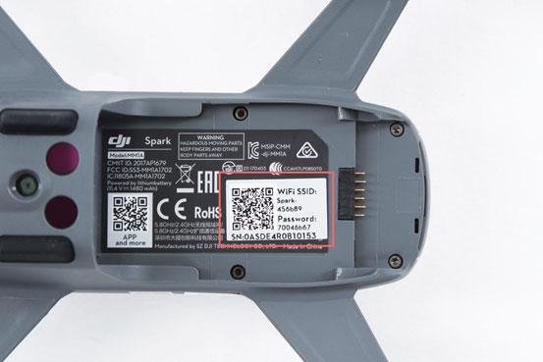

§ 89.510 Production requirements for unmanned aircraft produced under a design approval or production approval issued under part 21 of this chapter.
After September 16, 2022, no person may produce an unmanned aircraft for operation in the airspace of the United States under a design approval or production approval issued under part 21 of this chapter unless:
(a) All applicable requirements of part 21 of this chapter are met; and
(b) The unmanned aircraft is—
(1) Designed and produced to meet the minimum performance requirements for standard remote identification unmanned aircraft established in § 89.310 in accordance with an FAA-accepted means of compliance; or
(2) Equipped with Automatic Dependent Surveillance-Broadcast (ADS–B) Out equipment that meets the requirements of § 91.225 of this chapter.

§ 89.515 Production requirements for unmanned aircraft without design approval or production approval issued under part 21 of this chapter.
Except as provided in § 89.510, after September 16, 2022, no person may produce an unmanned aircraft for operation in the airspace of the United States unless—
(a) The unmanned aircraft is designed and produced to meet the minimum performance requirements for standard remote identification unmanned aircraft established in § 89.310 in accordance with an FAA-accepted means of compliance; and
(b) All of the following conditions are met:
(1) Inspection requirements for production of standard unmanned aircraft. A person responsible for the production of standard remote identification unmanned aircraft must, upon request, allow the Administrator to inspect the person's facilities, technical data, and any standard remote identification unmanned aircraft the person produces, and to witness any tests necessary to determine compliance with this subpart.
(2) Audit requirements. A person responsible for the production of standard remote identification unmanned aircraft must cause independent audits to be performed on a recurring basis, and additionally whenever the FAA provides notice of noncompliance or potential noncompliance, to demonstrate the unmanned aircraft listed under a declaration of compliance meet the requirements of this subpart. The person responsible for the production of standard remote identification unmanned aircraft must provide the results of all such audits to the FAA upon request.
(3) Product support and notification. A person responsible for the production of standard remote identification unmanned aircraft must maintain product support and notification procedures to notify the public and the FAA of any defect or condition that causes an unmanned aircraft to no longer meet the requirements of this subpart, within 15 calendar days of the date the person becomes aware of the defect or condition.

§ 89.520 Production requirements for remote identification broadcast modules.
After April 21, 2021, no person may produce remote identification broadcast modules unless:
(a) The remote identification broadcast module is designed and produced to meet the minimum performance requirements for remote identification broadcast modules established in § 89.320 in accordance with an FAA-accepted means of compliance; and
(b) All of the following conditions are met:
(1) Inspection requirements for production of remote identification broadcast modules. A person responsible for the production of remote identification broadcast modules must, upon request, allow the Administrator to inspect the person's facilities, technical data, and any remote identification broadcast modules the person produces, and to witness any tests necessary to determine compliance with this subpart.
(2) Audit requirements. A person responsible for the production of remote identification broadcast modules must cause independent audits to be performed on a recurring basis, and additionally whenever the FAA provides notice of noncompliance or potential noncompliance, to demonstrate the remote identification broadcast modules listed under a declaration of compliance meet the requirements of this subpart. The person responsible for the production of remote identification broadcast modules must provide the results of all such audits to the FAA upon request.
(3) Product support and notification. A person responsible for the production of remote identification broadcast modules must maintain product support and notification procedures to notify the public and the FAA of any defect or condition that causes the remote identification broadcast module to no longer meet the requirements of this subpart, within 15 calendar days of the date the person becomes aware of the defect or condition.
(4) Instructions. A person responsible for the production of a remote identification broadcast module must make available instructions for installing and operating the remote identification broadcast module to any person operating an unmanned aircraft with the remote identification broadcast module.
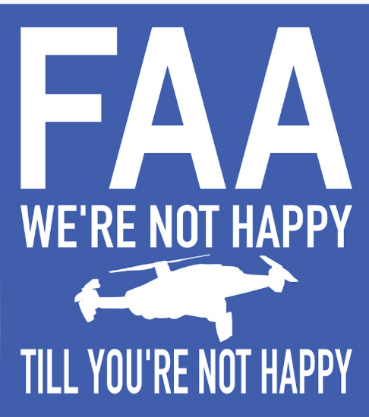
[Amdt. No. 89–1, 86 FR 4505, Jan. 15, 2021; 86 FR 13630, Mar. 10, 2021]

§ 89.525 Labeling.
(a) No person may produce a standard remote identification unmanned aircraft under § 89.515 unless it displays a label indicating that the unmanned aircraft meets the requirements of this part. The label must be in English and be legible, prominent, and permanently affixed to the unmanned aircraft.
(b) No person may produce a remote identification broadcast module under § 89.520 unless it displays a label indicating that the equipment meets the requirements of this part. The label must be in English and be legible, prominent, and permanently affixed to the broadcast module.
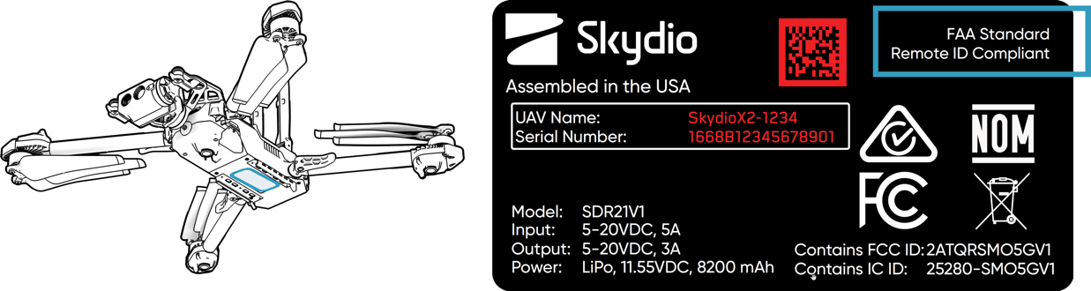

§ 89.530 Submission of a declaration of compliance for FAA acceptance.
(a) Eligibility. A person responsible for the production of a standard remote identification unmanned aircraft under § 89.515 or a remote identification broadcast module under § 89.520 must submit a declaration of compliance for acceptance by the FAA.
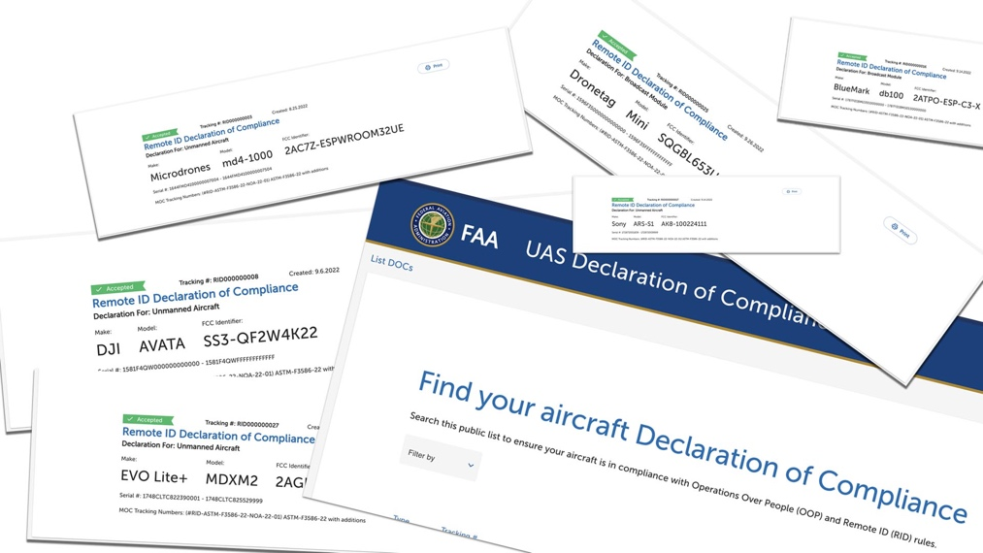
(b) Required information for standard remote identification unmanned aircraft. The person responsible for the production of a standard remote identification unmanned aircraft requesting acceptance of a declaration of compliance must declare that the unmanned aircraft complies with the requirements of this subpart by submitting a declaration of compliance to the FAA in a form and manner acceptable to the Administrator. The declaration must include at a minimum the following information:
(1) The name, physical address, telephone number, and email address of the person responsible for production of the unmanned aircraft.
(2) The unmanned aircraft's make and model.
(3) The unmanned aircraft's serial number, or the range of serial numbers for which the person responsible for production is declaring compliance.
(4) The FCC Identifier of the 47 CFR part 15-compliant radio frequency equipment used and integrated into the unmanned aircraft.
(5) The means of compliance used in the design and production of the unmanned aircraft.
(6) Whether the declaration of compliance is an initial declaration or an amended declaration, and if the declaration of compliance is an amended declaration, the reason for the amendment.
(7) A declaration that the person responsible for the production of the unmanned aircraft:
(i) Can demonstrate that the unmanned aircraft was designed and produced to meet the minimum performance requirements of § 89.310 by using an FAA-accepted means of compliance.
(ii) Complies with the requirements of § 89.515(b).
(8) A statement that 47 CFR part 15-compliant radio frequency equipment is used and is integrated into the unmanned aircraft without modification to its authorized radio frequency parameters.
(c) Required information for remote identification broadcast modules. The person responsible for the production of a remote identification broadcast module under § 89.520 that is requesting acceptance of a declaration of compliance must declare that the remote identification broadcast module complies with the requirements of this subpart by submitting a declaration of compliance to the FAA in a form and manner acceptable to the Administrator. The declaration must include at a minimum the following information:
(1) The name, physical address, telephone number, and email address of the person responsible for production of the remote identification broadcast module.
(2) The remote identification broadcast module's make and model.
(3) The remote identification broadcast module's serial number, or the range of serial numbers for which the person responsible for production is declaring compliance.
(4) The FCC Identifier of the 47 CFR part 15-compliant radio frequency equipment used and integrated into the remote identification broadcast module.
(5) The means of compliance used in the design and production of the remote identification broadcast module.
(6) Whether the declaration of compliance is an initial declaration or an amended declaration, and if the declaration of compliance is an amended declaration, the reason for the amendment.
(7) A declaration that the person responsible for the production of the remote identification broadcast module:
(i) Can demonstrate that the remote identification broadcast module was designed and produced to meet the minimum performance requirements of § 89.320 by using an FAA-accepted means of compliance.
(ii) Complies with the requirements of § 89.520(b).
(8) A statement that 47 CFR part 15-compliant radio frequency equipment is used and is integrated into the remote identification broadcast module without modification to its authorized radio frequency parameters, and a statement that instructions have been provided for installation of 47 CFR part 15-compliant remote identification broadcast module without modification to the broadcast module's authorized radio frequency parameters.

§ 89.535 Acceptance of a declaration of compliance.
(a) The Administrator will evaluate a declaration of compliance that is submitted to the FAA and may request additional information or documentation, as needed, to supplement the declaration of compliance.
(b) If the Administrator determines that the submitter has demonstrated compliance with the requirements of this subpart, the FAA will notify the submitter that the Administrator has accepted the declaration of compliance.

§ 89.540 Rescission and reconsideration.
(a) Rescission of the FAA's acceptance of a declaration of compliance.
(1) A declaration of compliance is subject to ongoing review by the Administrator. The Administrator may rescind acceptance of a declaration of compliance under circumstances including but not limited to the following:
(i) A standard remote identification unmanned aircraft or remote identification broadcast module listed under an accepted declaration of compliance does not meet the minimum performance requirements of § 89.310 or § 89.320.
(ii) A previously FAA-accepted declaration of compliance does not meet a requirement of this subpart; or
(iii) The FAA rescinds acceptance of the means of compliance listed in an FAA-accepted declaration of compliance.
(2) The Administrator will notify the person who submitted the FAA-accepted declaration of compliance of any issue of noncompliance.
(3) If the Administrator determines that it is in the public interest, prior to rescinding acceptance of a declaration of compliance, the Administrator may provide a reasonable period of time for the person who submitted the declaration of compliance to remediate the noncompliance. A failure to remediate the noncompliance constitutes cause for rescission of the FAA's acceptance of the declaration of compliance.
(4) The Administrator will notify the person who submitted the declaration of compliance of the decision to rescind acceptance of the declaration of compliance by publishing a notice of rescission in the Federal Register.
(b) Petition to reconsider the FAA's decision to rescind acceptance of a declaration of compliance.
(1) The person who submitted the FAA-accepted declaration of compliance or any person adversely affected by the rescission of the Administrator's acceptance of a declaration of compliance may petition for a reconsideration of the decision by submitting a request to the FAA in a form and manner acceptable to the Administrator within 60 calendar days of the date of publication in the Federal Register of notification of rescission.
(2) A petition to reconsider the rescission of the Administrator's acceptance of a declaration of compliance must show that the petitioner is an interested party and has been adversely affected by the decision of the FAA. The petition must also demonstrate at least one of the following:
(i) The petitioner adduces a significant additional fact not previously presented to the FAA.
(ii) The Administrator made a material error of fact in the decision to rescind acceptance of the declaration of compliance.
(iii) The Administrator did not correctly interpret a law, regulation, or precedent.
(3) Upon consideration of the information submitted by the petitioner, the Administrator will notify the petitioner and the person who submitted the declaration of compliance (if different) of the decision on whether to reinstate the Administrator's acceptance of the declaration of compliance.
(c) Inapplicability of part 13, subpart D, of this chapter. Part 13, subpart D, of this chapter does not apply to the procedures of paragraphs (a) and (b) of this section.

§ 89.545 Record retention.
A person who submits a declaration of compliance under this subpart that is accepted by the Administrator must retain the following information for as long as the standard remote identification unmanned aircraft or remote identification broadcast module listed on that declaration of compliance is produced plus an additional 24 calendar months, and must make available for inspection by the Administrator the following:
(a) The means of compliance, all documentation, and substantiating data related to the means of compliance used.
(b) Records of all test results.
(c) Any other information necessary to demonstrate compliance with the means of compliance so that the standard remote identification unmanned aircraft or remote identification broadcast module meets the remote identification requirements and the design and production requirements of this part.

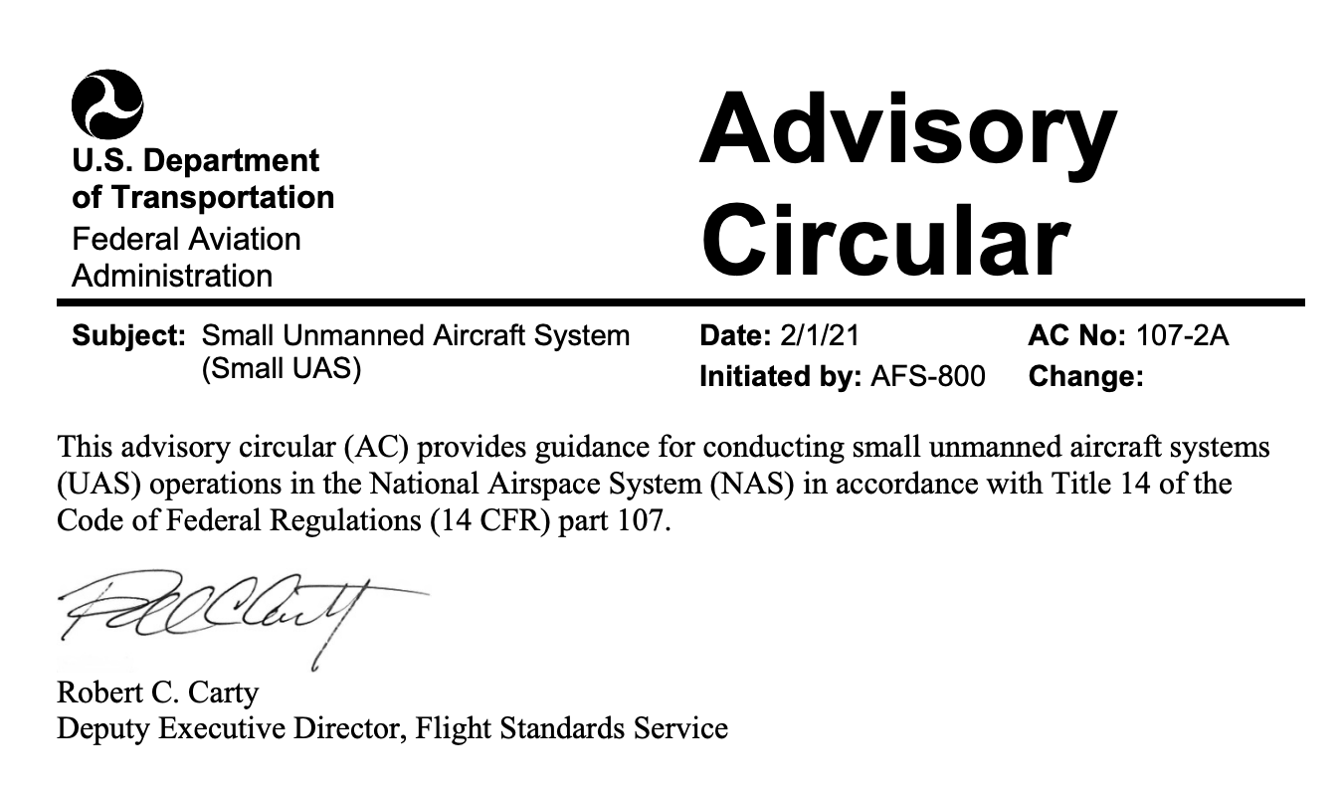
CHAPTER 1. GENERAL
1.1 Purpose of This Advisory Circular (AC). This AC provides guidance in the areas of airman (remote pilot) certification, aircraft registration and marking, aircraft airworthiness, and the operation of small Unmanned Aircraft Systems (UAS) in the National Airspace System (NAS) to promote compliance with the requirements of Title 14 of the Code of Federal Regulations (14 CFR) part 107.
1.1.1 Effects of Guidance. The contents of this document do not have the force and effect of law and are not meant to bind the public in any way. This document is intended only to provide clarity to the public regarding existing requirements under the law or agency policies. It does not provide, nor is it intended to provide, a legal interpretation of the regulations. This AC uses mandatory terms, such as “must,” when the language is describing an established statutory or regulatory requirement. This AC does not change, add to, or delete regulatory requirements or authorize deviations from regulatory requirements or restrictions.
1.1.2 Part 107 Provisions. This AC is not intended to cover every provision of part 107. Rather, this AC is intended to provide guidance on those provisions of part 107 where additional information may be helpful. The Federal Aviation Administration (FAA) emphasizes, however, that persons subject to part 107 are responsible for complying with every applicable provision of part 107, regardless of whether the provision is discussed in this AC.
1.1.3 Privacy-Related Laws. Part 107 operators should be aware that State and local authorities may enact privacy-related laws specific to UAS operations. The FAA encourages small UAS operators to review those laws prior to operating their UAS. The National Telecommunications and Information Administration (NTIA) has also published the Voluntary Best Practices for UAS Privacy, Transparency, and Accountability (dated May 18, 2016), available at https://www.ntia.doc.gov/files/ntia/publications/uas_privacy_ best_practices_6-21-16.pdf.
This document outlines and describes voluntary best practices that small UAS operators could take to advance UAS privacy, transparency, and accountability for the private and commercial use of UAS.
1.2 Where You Can Find This AC. You can find this AC on the FAA’s website at https://www.faa.gov/regulations_policies/advisory_circulars.
1.3 What This AC Cancels. AC 107-2, Small Unmanned Aircraft Systems (sUAS), dated June 21, 2016, is canceled.
1.4 Request for Information. Direct comments and suggestions for improving this publication to: Federal Aviation Administration General Aviation and Commercial Division (AFS-800) 55 M Street SE, 8th Floor, Zone 1 Washington, DC 20003
1.5 AC Feedback Form. For your convenience, the AC Feedback Form is the last page of this AC. Note any deficiencies found, clarifications needed, or suggested improvements regarding the contents of this AC on the Feedback Form.
CHAPTER 2. REFERENCES

2.1 Related Code of Federal Regulations (CFR) Parts. The following regulations and parts can be found at https://www.faa.gov/regulations_policies/faa_regulations/.

2.1.1 Title 14 CFR.
• Part 1, Definitions and Abbreviations.
• Part 43, Maintenance, Preventive Maintenance, Rebuilding, and Alteration.
• Part 47, Aircraft Registration.
• Part 48, Registration and Marking Requirements for Small Unmanned Aircraft.
• Part 71, Designation of Class A, B, C, D, and E Airspace Areas; Air Traffic Service Routes; and Reporting Points.
• Part 73, Special Use Airspace.
• Part 89, Remote Identification of Unmanned Aircraft.
• Part 91, General Operating and Flight Rules.
• Part 93, Special Air Traffic Rules.
• Part 99, Security Control of Air Traffic.
• Part 107, Small Unmanned Aircraft Systems.

2.1.2 Title 47 CFR. Part 87, Aviation Services.

2.1.3 Title 49 CFR. Part 830, Notification and Reporting of Aircraft Accidents or Incidents and Overdue Aircraft, and Preservation of Aircraft Wreckage, Mail, Cargo, and Records.

2.2 Notices to Air Missions (NOTAM). Information on how to obtain NOTAMs can be found at https://pilotweb.nas.faa.gov/PilotWeb/.

2.2.1 Additional resources to create NOTAMs, check weather, and prepare flight plans can be found at https://www.1800wxbrief.com/.

2.3 Related Reading Material. The following listed reference materials contain additional information necessary to ensure safe operations in the NAS. A small UAS operator may want to consider seeking out additional publications to supplement the lists below.

2.3.1 FAA ACs and Directives (current editions). You can find the current editions of the following publications on the FAA websites https://www.faa.gov/regulations_policies/advisory_circulars/ and https://www.faa.gov/regulations_policies/orders_notices/.
• AC 00-6, Aviation Weather.
• AC 00-45, Aviation Weather Services.
• AC 60-28, FAA English Language Standard for an FAA Certificate Issued Under 14 CFR Parts 61, 63, 65, and 107.
• AC 61-141, Flight Instructors as Certifying Officials for Student Pilot and Remote Pilot Applicants.
• AC 120-92, Safety Management Systems for Aviation Service Providers.
• FAA Order JO 7110.10, Air Traffic Organization Policy, Flight Services.
• FAA Order JO 7110.65, Air Traffic Organization Policy, Air Traffic Control.
• FAA Order JO 7200.23, Air Traffic Organization Policy, Processing of Unmanned Aircraft Systems Requests.
• FAA Order JO 7210.3, Air Traffic Organization Policy, Facility Operation and Administration. • FAA Order JO 7400.11, Air Traffic Organization Policy, Airspace Designations and Reporting Points.
• FAA Order 8130.34, Airworthiness Certification of Unmanned Aircraft Systems and Optionally Piloted Aircraft.
• FAA Order 8900.1, Volume 16, Unmanned Aircraft Systems. 2.3.2 Additional FAA Online/Mobile Sources.
• UAS website: https://www.faa.gov/uas/.
• UAS Registration website: https://faadronezone.faa.gov/.
• B4UFLY mobile app.
• UAS Flight Planning, NOTAMs, temporary flight restrictions (TFR): https://www.1800wxbrief.com/ and https://tfr.faa.gov.
• FAA Safety website: https://www.faasafety.gov.
• FAA UAS Data Delivery System website: https://udds-faa.opendata.arcgis.com/.
• FAA Waiver Safety Explanation Guidelines for Part 107 Waiver Applications: https://www.faa.gov/uas/commercial_operators/part_107_waivers/waiver_safety_explanation_guidelines/.
• FAA Integrated Airman Certification and Rating Application (IACRA): https://iacra.faa.gov/iacra.
• Airman Certificate Testing Service (ACTS): https://www.faa.gov/training_testing/testing/ACTS/.
• Flight Standards District Offices (FSDO): https://www.faa.gov/about/office_org/field_offices/fsdo.
2.3.3 FAA Handbooks, Manuals, and Other Publications.
You can find the following handbooks, manuals, and other publications on the FAA website at https://www.faa.gov/regulations_policies/handbooks_manuals/.
• Aeronautical Information Manual (AIM): https://www.faa.gov/air_traffic/publications/.
• Aeronautical Charts (Digital): https://www.faa.gov/air_traffic/flight_info/aeronav/digital_products/.
• Pilot/Controller Glossary: https://www.faa.gov/air_traffic/publications/.
• Pilot’s Handbook of Aeronautical Knowledge: https://www.faa.gov/regulations_policies/handbooks_manuals/aviation/phak/.
• Risk Management Handbook: https://www.faa.gov/sites/faa.gov/files/regulations_policies/handbooks_manuals/aviat ion/risk_management_hb_change_1.pdf.
• Remote Pilot – Small Unmanned Aircraft Systems Airman Certification Standards (ACS): https://www.faa.gov/training_testing/testing/acs/media/uas_acs.pdf.
• Unmanned Aircraft Systems Operating Handbook: https://www.faa.gov/about/office_org/headquarters_offices/avs/offices/afx/afs/afs600 /afs630/.

2.3.4 Statutory Resources.
• Public Law (PL) 112-95 (Feb. 14, 2012), Title III, Subtitle B—Unmanned Aircraft Systems.
• PL 114-190 (July 15, 2016), Title II, Subtitle B—UAS Safety.
• PL 115-254 (Oct. 5, 2018), Title III, Subtitle B—Unmanned Aircraft Systems.
CHAPTER 3. BACKGROUND
3.1 PL 112-95, Title III, Subtitle B. In 2012, Congress passed the FAA Modernization and Reform Act of 2012, PL 112-95. Section 333 of PL 112-95 directed the Secretary of Transportation to determine whether UAS operations posing the least amount of public risk and no threat to national security could safely be operated in the NAS and, if so, to establish requirements for the safe operation of these systems in the NAS. As part of its ongoing efforts to integrate UAS operations in the NAS and in accordance with Section 333, in June 2016, the FAA issued a final rule adding part 107, integrating civil small UAS into the NAS. Part 107 allows small UAS operations for many different purposes without requiring airworthiness certification, exemption, or a Certificate of Waiver or Authorization (COA).
3.2 Organization of Part 107. The FAA addresses aviation safety in three key areas: personnel, equipment, and operations. The FAA assesses each of these areas both independently to meet current regulations and standards, as well as collectively to ensure no conflicts exist overall that would create an unsafe condition. This approach allows the FAA to be flexible in responding to the needs of the aviation community while still being able to establish standards for future growth and development. To that end, part 107 contains subparts that focus on each of these key aviation safety areas specific to small UAS, and the chapters in this AC are organized in the same manner.
CHAPTER 4. PART 107 SUBPART A, GENERAL
4.1 Applicability. This chapter provides guidance regarding the applicability of part 107 to civil small unmanned aircraft operations conducted within the NAS. However, part 107 does not apply to the following:
1. Limited recreational operations of UAS that occur in accordance with Title 49 of the United States Code (49 U.S.C.) § 44809; (Title 49 U.S.C. § 44809(a) states that a person may operate a small unmanned aircraft without specific certification or operating authority from the FAA if the operation adheres to all of the following limitations:
(1) the aircraft is flown strictly for recreational purposes;
(2) the aircraft is operated in accordance with or within the programming of a community-based organization’s set of safety guidelines that are developed in coordination with the FAA;
(3) the aircraft is flown within Visual Line of Sight (VLOS) of the person operating the aircraft or a visual observer (VO) co-located and in direct communication with the operator;
(4) the aircraft is operated in a manner that does not interfere with and gives way to any manned aircraft;
(5) in Class B, Class C, or Class D airspace or within the lateral boundaries of the surface area of Class E airspace designated for an airport, the operator obtains prior authorization from the Administrator or designee before operating and complies with all airspace restrictions and prohibitions;
(6) in Class G airspace, the aircraft is flown from the surface to not more than 400 feet above ground level (AGL) and complies with all airspace restrictions and prohibitions;
(7) the operator has passed an aeronautical knowledge and safety test described in § 44809(g) and maintains proof of test passage to be made available to the Administrator or law enforcement upon request; and
(8) the aircraft is registered and marked in accordance with 49 U.S.C. chapter 441 and proof of registration is made available to the Administrator or a designee of the Administrator or law enforcement upon request.)
2. Operations conducted outside the United States;
3. Amateur rockets;
4. Moored balloons;
5. Unmanned free balloons;
6. Kites;
7. Public aircraft operations; and
8. Air carrier operations.
4.2 Definitions. The following defined terms are used throughout this AC:
4.2.1 Applicant. A person who submits a declaration of compliance (DOC) to the FAA for review and acceptance. An applicant may be anyone who designs, produces, or modifies a small unmanned aircraft.
4.2.2 Control Station (CS). An interface used by the remote pilot or the person manipulating the controls to control the flightpath of the small unmanned aircraft.
4.2.3 Corrective Lenses. Spectacles or contact lenses.
4.2.4 Declaration of Compliance (DOC). A record submitted to the FAA that certifies the small unmanned aircraft conforms to the Category 2 or Category 3 requirements under part 107 subpart D, as described in Chapter 8, Small Unmanned Aircraft Over People.
4.2.5 Means of Compliance (MOC). The method an applicant uses to show its small UAS would not exceed the applicable injury severity limit upon impact with a human being, does not contain any exposed rotating parts that would cause lacerations, and does not have any safety defects.
4.2.6 Person Manipulating the Controls. A person other than the remote pilot in command (PIC) who is controlling the flight of a small unmanned aircraft under the supervision of the remote PIC.
4.2.7 Remote Pilot in Command (Remote PIC or Remote Pilot). A person who holds a Remote Pilot Certificate with a small UAS rating and has the final authority and responsibility for the operation and safety of a small unmanned aircraft operation conducted under part 107.
4.2.8 Small Unmanned Aircraft. A small unmanned aircraft weighing less than 55 pounds, including everything that is on board or otherwise attached to the aircraft, and can be flown without the possibility of direct human intervention from within or on the aircraft.
4.2.9 Small Unmanned Aircraft System (small UAS). A small unmanned aircraft and its associated elements (including communication links and the components that control the small unmanned aircraft) that are required for the safe and efficient operation of the small unmanned aircraft in the NAS.
4.2.10 Unmanned Aircraft. An aircraft operated without the possibility of direct human intervention from within or on the aircraft (part 1, § 1.1).
4.2.11 Visual Observer (VO). A person the remote PIC designates as a crewmember who assists the small unmanned aircraft remote PIC and the person manipulating the controls to see and avoid other air traffic or objects aloft or on the ground (part 107, § 107.3).
4.2.12 Voluntary Consensus Standards Body. Voluntary consensus standards bodies are domestic or international organizations that plan, develop, establish, or coordinate voluntary standards using agreed-upon procedures. A voluntary consensus standards body observes principles such as openness, balance of interest, and due process. These bodies may include nonprofit organizations, industry associations, accredited standards developers, professional and technical societies, committees, task forces, or working groups.
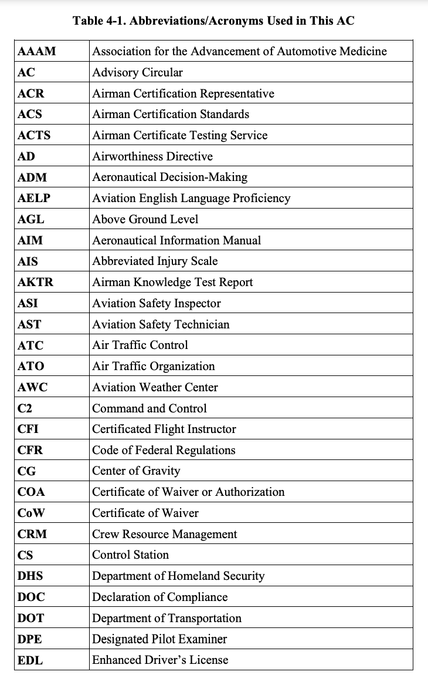
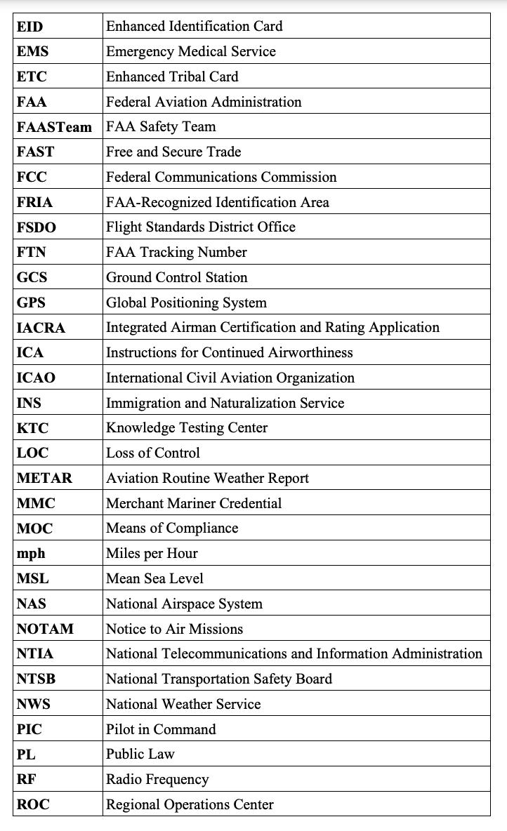
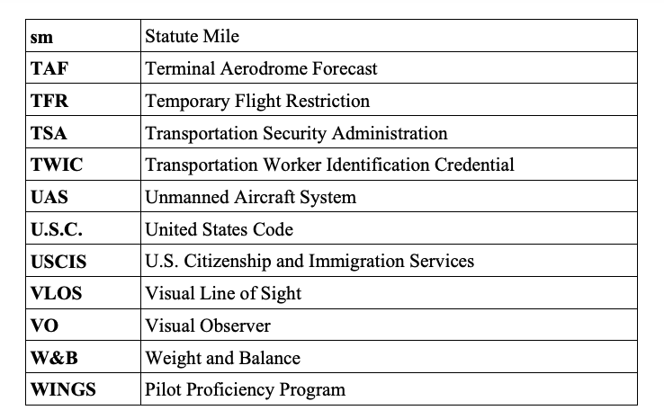

4.3 Falsification, Reproduction, or Alteration. The FAA relies on information provided by owners and remote pilots of small UAS when it authorizes operations or when it has to make a compliance determination. Accordingly, the United States government may take appropriate action against a small UAS owner, operator, remote PIC, applicant for a DOC, or anyone else who fraudulently or knowingly provides false records or reports, or otherwise reproduces or alters any records, reports, or other information for fraudulent purposes. Such action could include the FAA’s imposition of civil sanctions and the suspension or revocation of a certificate or waiver (§ 107.5).

4.4 Accident Reporting. The remote PIC of the small unmanned aircraft is required to report an accident to the FAA within 10 days if it meets any of the following thresholds:
1. At least serious injury to any person or any loss of consciousness. A serious injury is an injury that qualifies as Level 3 or higher on the Abbreviated Injury Scale (AIS) of the Association for the Advancement of Automotive Medicine (AAAM). The AIS is an anatomical scoring system that provides a means of ranking the severity of an injury and is widely used by emergency medical personnel. The FAA currently uses serious injury (AIS Level 3) as an injury threshold in other FAA regulations. AIS 3 Example: A person requires hospitalization, but the injury can fully heal (including, but not limited to, head trauma, broken bone(s), or laceration(s) to the skin that requires suturing).
2. Damage to any property, other than the small unmanned aircraft, if the cost is greater than $500 to repair or replace the property (whichever is lower). Example: A small unmanned aircraft damages a property with a fair market value of $200, and it would cost $600 to repair the damage. Because the fair market value is below $500, this accident is not required to be reported. Similarly, if the aircraft causes $200 worth of damage to property with a fair market value of $600, that accident is also not required to be reported because the repair cost is below $500 (§ 107.9).

4.4.1 Submitting the Report. The accident report must be made within 10 calendar-days of the operation that created the injury or damage. The report may be submitted to the appropriate FAA Regional Operations Center (ROC) electronically or by telephone. Electronic reporting can be completed at https://www.faa.gov/uas/. To make a report by phone, see Figure 4-1, FAA Regional Operations Centers Telephone List. Reports may also be made to the responsible Flight Standards office (refer to https://www.faa.gov/about/office_org/field_offices/fsdo/). The report should include the following information:
1. Small UAS remote PIC’s name and contact information;
2. Small UAS remote PIC’s FAA airman certificate number;
3. Small UAS registration number issued to the aircraft (FAA registration number);
4. Location of the accident;
5. Date of the accident;
6. Local time of the accident;
7. Whether any serious injury or fatality occurred;
8. Property damaged and extent of damage, if any or known; and
9. Description of what happened.

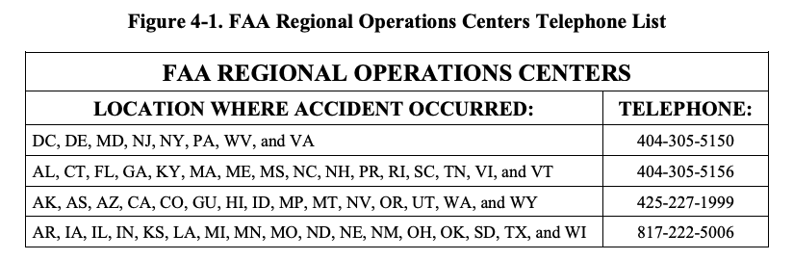

4.4.2 National Transportation Safety Board (NTSB) Reporting. In addition to the report submitted to the ROC, and in accordance with the criteria established by the NTSB, certain small unmanned aircraft accidents must also be reported to the NTSB. NTSB’s regulations, codified at 49 CFR part 830, require immediate notification when an aircraft accident occurs. NTSB regulations define an “unmanned aircraft accident” as an occurrence associated with the operation of any public or civil UAS that takes place between the time that the system is activated with the purpose of flight and the time that the system is deactivated at the conclusion of its mission, in which any person suffers death or serious injury, or the aircraft has a maximum gross takeoff weight of 300 pounds or greater and sustains substantial damage. NTSB regulations contain specific definitions for “serious injury” and “substantial damage” (49 CFR part 830, § 830.2). For more information, visit https://www.ntsb.gov.

CHAPTER 5. PART 107 SUBPART B, OPERATING RULES (SMALL UAS)

5.1 Applicability. This chapter provides guidance regarding small unmanned aircraft operating limitations and the responsibilities of the remote pilot in command (PIC), person manipulating the controls, visual observer (VO), and anyone else who may directly participate in the small UAS operation. A person is a direct participant in the small UAS operation if their involvement is necessary for the safe operation of the small UAS.

5.2 Aircraft Operation. Just like a manned-aircraft PIC, the remote PIC of a small unmanned aircraft is directly responsible for and is the final authority for the safe operation of the small unmanned aircraft (§ 107.19). Additionally, a person manipulating the controls (who is not the remote PIC) can participate in flight operations under certain conditions. It is important to note that a person may not operate or act as a remote PIC or VO in the operation of more than one small unmanned aircraft at the same time (§ 107.35). The following items describe the requirements for both a remote PIC and a person manipulating the controls.

5.2.1 Remote PIC. A person acting as a remote PIC of a small UAS under part 107 must obtain a Remote Pilot Certificate with a small UAS rating issued by the FAA prior to small UAS operation (§ 107.12). The remote PIC must have, in that person’s physical possession and readily accessible, this certificate and personal identification during flight operations (§§ 107.7 and 107.67(b)(1) through (3)). Guidance regarding remote pilot certification is found in Chapter 6, Part 107 Subpart C, Remote Pilot Certification.

5.2.1.1 Part 107 permits transfer of control of a small UAS between certificated remote pilots. Two or more certificated remote pilots transferring operational control (i.e., the remote PIC designation) to each other may do so only if they are both capable of maintaining Visual Line of Sight (VLOS) of the small unmanned aircraft without loss of control (LOC). One remote pilot may be designated the remote PIC at the beginning of the operation, and at some point in the operation another remote pilot may take over as remote PIC by positively communicating the transfer of control. The remote PIC assuming control of the small UAS maintains responsibility for the safe operation of the small UAS.

5.2.2 Person Manipulating the Flight Controls. A person who does not hold a Remote Pilot Certificate or a remote pilot who has not met the recurrent training requirements of part 107 may operate the small UAS under part 107, as long as they are directly supervised by a remote PIC and the remote PIC has the ability to take immediate, direct control of the small UAS. This ability is necessary to ensure the remote PIC can quickly address any hazardous situation. The ability of the remote PIC to take over the flight controls immediately could be achieved by using a number of different methods. The operation could involve a “buddy box” type system that uses two control stations (CS): one for the person manipulating the flight controls and one for the remote PIC that allows the remote PIC to override the other CS and immediately take direct control of the small unmanned aircraft (§ 107.19). Another method could involve the remote PIC standing close enough to the person manipulating the flight controls so that they would be able to physically take over the CS from the other person. Another method could employ the use of an automation system where the remote PIC could immediately engage that system to put the small unmanned aircraft in a pre-programmed “safe” mode such as a hover, a holding pattern, or “return home.”

5.2.3 Automated Operations. An automated operation is generally considered an operation in which the remote pilot inputs a flight plan into the CS, which sends the flight plan to the autopilot on board the small unmanned aircraft. During automated flight, flight control inputs are made by components on board the aircraft, not from a CS. If the remote PIC loses the control link to the small unmanned aircraft, the aircraft would continue to fly the programmed mission/return home to land. During automated flight, the remote PIC must have the ability to change routing/altitude or command the aircraft to land immediately. The ability to direct the small unmanned aircraft may be through manual manipulation of the flight controls or through commands using automation.

5.2.3.1 The remote PIC must retain the ability to direct the small unmanned aircraft to ensure compliance with the requirements of part 107. The remote PIC may transmit a command for the automated aircraft to climb, descend, land now, proceed to a new waypoint, enter an orbit pattern, or return to home. Any of these methods may be used to avoid a hazard or give right-of-way.

5.2.3.2 The use of automation does not allow a person to operate more than one small unmanned aircraft simultaneously (§ 107.35).

5.3 Aeronautical Decision-Making (ADM) and Crew Resource Management (CRM). ADM is a systematic approach to the mental process used by pilots to determine consistently the best course of action in response to a given set of circumstances. A remote PIC uses many different resources to safely operate a small unmanned aircraft and needs to be able to manage these resources effectively. CRM is a component of ADM, in which the pilot of a small unmanned aircraft makes effective use of all available resources: human resources, hardware, and information. Many remote pilots operating under part 107 may use a VO, oversee other persons manipulating the controls of the small UAS, or any other person with whom the remote PIC may interact to ensure safe operations. Therefore, a remote PIC must be able to function in a team environment and maximize team performance. This skill set includes situational awareness, proper allocation of tasks to individuals, avoidance of work overloads for themselves and in others, and effectively communicating with other members of the crew, such as VOs and persons manipulating the controls of a small unmanned aircraft. Appendix A, Risk Assessment Tools, contains expanded information on ADM and CRM, as well as sample risk assessment tools to aid in identifying hazards and mitigating risks.

5.4 Aircraft Registration. A small unmanned aircraft must be registered, in accordance with part 47 or part 48, prior to operating under part 107. Part 48 is the regulation that establishes the streamlined online registration option for small unmanned aircraft that will be operated only within the territorial limits of the United States. The online registration website is https://faadronezone.faa.gov/. Guidance regarding small unmanned aircraft registration and marking may be found at https://www.faa.gov/licenses_certificates/aircraft_certification/aircraft_registry/. Alternatively, small unmanned aircraft owners or operators can elect to register under part 47 in the same manner as manned aircraft.

5.4.1 Registration and Permit for Foreign-Owned and Operated Small UAS. If small UAS operations involve the use of foreign civil aircraft, the operator would need to obtain a Foreign Aircraft Permit pursuant to 14 CFR part 375, as described in § 375.41, before conducting any commercial air operations under this authority. Foreign civil aircraft means (a) an aircraft of foreign registry that is not part of the armed forces of a foreign nation, or (b) a U.S.-registered aircraft owned, controlled, or operated by persons who are not citizens or permanent residents of the United States. Application instructions are specified in § 375.43. Applications should be submitted by electronic mail to the Department of Transportation (DOT) Office of International Aviation, Foreign Air Carrier Licensing Division at https://cms.dot.gov/policy/aviation-policy/licensing/foreign-carriers. Foreign-owned and operated small UAS must be registered, as provided for under part 47 or part 48, including submission of an Affidavit of Ownership for Unmanned Aircraft, if necessary. Additional information can be obtained at https://www.faa.gov/licenses_certificates/aircraft_certification/aircraft_registry/UA/. (Refer to Title 49 of the United States Code (49 U.S.C.) § 44101(b)(1) for exceptions.)

5.5 Small Unmanned Aircraft Maintenance, Inspections, and Condition for Safe Operation. A small unmanned aircraft must be maintained in a condition for safe operation. Prior to flight, the remote PIC is responsible for conducting a check of the small unmanned aircraft to verify it is actually in a condition for safe operation (§ 107.15). Guidance regarding how to determine that a small unmanned aircraft is in a condition for safe operation is found in Chapter 7, Small Unmanned Aircraft Maintenance and Inspection.

5.6 Medical Condition. Being able to operate the small unmanned aircraft safely relies on, among other things, the physical and mental capabilities of the remote PIC, person manipulating the controls, VO, and any other direct participant in the small UAS operation. Though the person manipulating the controls of a small unmanned aircraft and VO are not required to obtain an airman medical certificate, they cannot participate in the operation of a small UAS if they know or have reason to know that they have a physical or mental condition that could interfere with the safe operation of the small UAS (§ 107.17).

5.6.1 Physical or Mental Incapacitations. Obvious examples of physical or mental incapacitations that could render a remote PIC, person manipulating the controls, or VO incapable of performing their small UAS operational duties include, but are not limited to, such things as:
1. The temporary or permanent loss of the dexterity necessary to operate the CS to control the small unmanned aircraft safely.
2. The inability to maintain the required “see and avoid” vigilance due to blurred vision.
3. The inability to maintain proper situational awareness of the small unmanned aircraft operations due to illness and/or medication(s), such as after taking medications that caution against driving or operating heavy machinery.
4. A debilitating physical condition, such as a migraine headache or moderate or severe body ache(s) or pain(s) that would render the remote PIC, person manipulating the controls, or VO unable to perform small UAS operational duties.
5. A hearing or speaking impairment that would inhibit the remote PIC, person manipulating the controls, or VO from effectively communicating with each other. In such a situation, the remote PIC must ensure they implement an alternative means of effective communication. For example, a person who is hearing impaired may be able to use sign language to communicate effectively.

5.7 Civil Twilight and Operations at Night. Night is defined in § 1.1 as the time between the end of evening civil twilight and the beginning of morning civil twilight, as published in The Air Almanac, converted to local time. In the continental United States, evening civil twilight is the period of sunset until 30 minutes after sunset and morning civil twilight is the period of 30 minutes prior to sunrise until sunrise. In Alaska, the definition of civil twilight differs and is described in The Air Almanac. The Air Almanac provides tables to determine sunrise and sunset at various latitudes. These tables can also be downloaded from the Naval Observatory and customized for a particular location. The link for the Naval Observatory is https://www.usno.navy.mil/search?SearchableText=air+ almanac+.

5.7.1 Civil Twilight Operations. When small UAS operations occur during civil twilight, the small unmanned aircraft must be equipped with anti-collision lighting visible for at least 3 statute miles (sm). However, the remote PIC may reduce the visible distance of the lighting to less than 3 sm during flight if they have determined that it would be in the interest of safety to do so. For more information on this determination, see paragraph 5.7.2.2.

5.7.2 Operations at Night. Small UAS operations at night may occur only under the two risk mitigation measures listed in § 107.29. First, the remote PIC must have completed either an initial knowledge test or recurrent training that have been updated to include night operations. Second, the small unmanned aircraft must have lighted anti-collision lighting that is visible for at least 3 sm. The remote pilot may rely upon manufacturer statements indicating the anti-collision lighting is visible for 3 sm. However, the remote pilot ultimately remains responsible for verifying that anti-collision lighting is operational, visible for 3 sm, and has a flash rate sufficient to avoid a collision at the operating location.

5.7.2.1 A certificated remote pilot receives night operations privileges and may operate at night only after completing either a knowledge test that contains questions on night physiology and night visual illusions, or through completion of recurrent training. The recurrent training contains the topics of night physiology and night visual illusions. Chapter 6 provides a detailed explanation of both paths for night operations privileges.

5.7.2.2 As is the case for civil twilight operations, the small unmanned aircraft must be equipped with anti-collision lighting that is visible for at least 3 sm. However, the remote PIC may reduce the intensity of the light if the remote PIC determines it is in the interest of safety to do so. For example, a bright light or a bright strobe light on the small unmanned aircraft in very close proximity to the remote pilot could cause the remote pilot to lose the ability to observe the small unmanned aircraft’s location, speed, attitude, or altitude with accuracy. The remote pilot maintains the discretion to reduce the intensity of the anti-collision lighting when they determine it would be in the best interest of safety to do so. Discretion is an important component of § 107.19, which states that the remote PIC is directly responsible for the operation of the small unmanned aircraft. The remote PIC must ensure the operation of the small unmanned aircraft complies with all regulations of part 107. This includes the requirement to maintain the capability of visually observing the small unmanned aircraft. Section 107.29 does not require small unmanned aircraft operating during the day to have illuminated small unmanned aircraft anti-collision lighting. Lighting is generally not effective for mitigating risk of collision during daytime operations. Remote pilots may exercise their discretion, however, and elect to have lighting on during all daytime operations.

5.7.2.3 A remote PIC or operator may request a waiver of the anti-collision lighting requirement for operations at night and during civil twilight. The process for requesting a waiver is two-fold: the requester must (1) fully describe the proposed operation, and (2) establish the operation can be safely conducted under the terms of a Certificate of Waiver (CoW). Paragraph 5.20 below describes the application process for waivers.

5.8 Operations Over Open-Air Assemblies of Persons. Remote pilots are prohibited from operating a small unmanned aircraft as a Category 1, 2, or 4 operation in sustained flight over open-air assemblies, unless the operation meets the requirements of 14 CFR part 89, § 89.110 or § 89.115(a). Category 3 operations are not allowed over an open-air assembly of persons. Note: See paragraphs 8.3.2 and 8.3.6.4 for more information regarding open-air assemblies of persons.

5.9 VLOS Aircraft Operation. The remote PIC and person manipulating the controls must be able to see the small unmanned aircraft at all times during flight (§ 107.31). The small unmanned aircraft must be operated closely enough to ensure visibility requirements are met during small UAS operations. This requirement also applies to the VO, if used, during the aircraft operation. The person maintaining VLOS may have brief moments in which they are not looking directly at or cannot see the small unmanned aircraft, but still retain the capability to see the small unmanned aircraft or quickly maneuver it back to VLOS. These moments may be necessary for the remote PIC to look at the controller to determine remaining battery life or for operational awareness. Should the remote PIC or person manipulating the controls lose VLOS of the small unmanned aircraft, they must regain VLOS as soon as practicable. Even though the remote PIC may briefly lose sight of the small unmanned aircraft, the remote PIC always has the see-and-avoid responsibilities set out in §§ 107.31 and 107.37. The circumstances that may prevent a remote PIC from fulfilling those responsibilities will vary, depending on factors such as the type of small UAS, the operational environment, and distance between the remote PIC and the small unmanned aircraft. For this reason, no specific time interval exists in which interruption of VLOS is permissible, as it would have the effect of potentially allowing a hazardous interruption of the operation. If the remote PIC cannot regain VLOS, the remote PIC or person manipulating the controls should follow pre-determined procedures for the loss of VLOS. The capabilities of the small UAS will govern the remote PIC’s determination as to the appropriate course of action. For example, the remote PIC may need to land the small unmanned aircraft immediately, enter hover mode, or employ a return-to-home sequence. The VLOS requirement does not prohibit actions such as scanning the airspace or briefly looking down at the small unmanned aircraft CS.

5.9.1 Unaided Vision. VLOS must be accomplished and maintained by unaided vision, except vision that is corrected by the use of eyeglasses (spectacles) or contact lenses. Vision aids, such as binoculars, may be used only momentarily to enhance situational awareness. For example, the remote PIC, person manipulating the controls, or VO may use vision aids to avoid inadvertently flying over persons or conflicting with other aircraft. First person view devices may be used during operations, but do not satisfy the VLOS requirement.

5.9.2 VO. The use of a VO is optional. The remote PIC may choose to use a VO to supplement situational awareness and VLOS. Although the remote PIC and person manipulating the controls must maintain the capability to see the small unmanned aircraft, using one or more VOs allows the remote PIC and person manipulating the controls to conduct other mission-critical duties (such as checking displays) while still ensuring situational awareness of the small unmanned aircraft. The VO must be able to communicate effectively with regard to the following:
• The small unmanned aircraft location, attitude, altitude, and direction of flight;
• The position of other aircraft or hazards in the airspace; and
• The determination that the small unmanned aircraft does not endanger the life or property of another (§ 107.33).

5.9.2.1 To ensure the VO can carry out their duties, the remote PIC must ensure the VO is positioned in a location where the VO is able to see the small unmanned aircraft sufficiently to maintain VLOS. The remote PIC can do this by specifying the location of the VO. The FAA also requires the remote PIC and VO coordinate to (1) scan the airspace where the small unmanned aircraft is operating for any potential collision hazard, and (2) maintain awareness of the position of the small unmanned aircraft through direct visual observation (§ 107.33). The remote PIC and VO would accomplish this by the VO communicating to the remote PIC and person manipulating the controls the flight status of the small unmanned aircraft and any collision hazards which may enter the area of operation, so that the remote PIC or person manipulating the controls can take appropriate action. The VO’s visual observation of the small unmanned aircraft and surrounding airspace would enable the VO to inform the remote PIC of the status.

5.9.2.2 To make this communication possible, the remote PIC, person manipulating the controls, and VO must work out a method of effective communication that does not create a distraction. Such a means of communication entails the constant ability to understand one another. The communication method must be determined prior to operation. Effective communication would permit the use of communication-assisting devices, such as a handheld radio, to facilitate communication from a distance.

5.9.3 VLOS at Night. Prior to a small UAS operation at night, the remote PIC should ensure they will be able to keep the small unmanned aircraft within the intended area of operation and within VLOS for the duration of the operation. In almost all cases involving operations at night, the remote PIC may need to restrict the operational area of the small unmanned aircraft. Reduced lighting and contrast at night may make it difficult for remote pilots to fulfill the requirements of § 107.31(a), requiring remote pilots to maintain the capability of visually discerning the location, attitude, altitude, and direction of the flight of the aircraft. A remote pilot cannot solely rely on the small unmanned aircraft’s anti-collision lighting, Ground Control Station (GCS) telemetry data displays, or a combination of the two for compliance with § 107.31.

5.10 Operation Near Airports, in Certain Airspace, in Prohibited or Restricted Areas, or in the Proximity of Certain Areas Designated by a Notice to Air Missions (NOTAM). Small unmanned aircraft may operate in controlled or uncontrolled airspace. Operations in Class B, Class C, or Class D airspace, or within the lateral boundaries of the surface area of Class E airspace designated for an airport, are not permitted unless that person has prior authorization from air traffic control (ATC) (§ 107.41). Information concerning the current authorization process is available at https://www.faa.gov/uas/. The remote PIC must understand airspace classifications and requirements. Failure to do so could be contrary to part 107 regulations and may potentially have an adverse effect on the safety of operations. Small UAS operating under part 107 may not be subject to part 91 requirements, because the equipage and communications requirements outlined in part 91 were designed to provide safety and efficiency in the National Airspace System (NAS). ATC authorizations may depend on operational parameters similar to those found in part 91. The FAA has the authority to approve or deny aircraft operations based on traffic density, controller workload, communication issues, or any other type of operation that could potentially impact the safe and expeditious flow of air traffic in that airspace.

5.10.1 Small Unmanned Aircraft Operations Near an Airport—Notification and Permissions. Unless the flight is conducted within controlled airspace, no notification or authorization is necessary to operate a small unmanned aircraft at or near an airport. When operating in the vicinity of an airport, the remote PIC must be aware of and avoid all traffic patterns and approach corridors to runways and landing areas. The remote PIC must avoid operating in any area in which the presence of the small UAS may interfere with operations at the airport, such as approach corridors, taxiways, runways, or helipads (§ 107.43). The remote PIC must yield right-of-way to all other aircraft, including aircraft operating on the surface of the airport (§ 107.43).

5.10.1.1 Remote PICs are prohibited from operating a small unmanned aircraft in a manner that interferes with operations and traffic patterns at airports, heliports, and seaplane bases (§ 107.43). Small unmanned aircraft must always yield right-of-way to a manned aircraft. A manned aircraft may alter its flightpath, delay its landing, or take off in order to avoid a small unmanned aircraft that may present a potential conflict or otherwise affect the safe outcome of the flight. A small unmanned aircraft hovering 200 feet above a runway may cause a manned aircraft holding short of the runway to delay takeoff, or a manned aircraft on the downwind leg of the pattern to delay landing. While the small unmanned aircraft in this scenario would not present an immediate traffic conflict to the aircraft on the downwind leg of the traffic pattern or to the aircraft intending to take off, nor would it violate the right-of-way provision of § 107.37(a), the small unmanned aircraft would have interfered with the operations of the traffic pattern at an airport.

5.10.1.2 In order to avoid interfering with operations in a traffic pattern, remote PICs should avoid operating in the traffic pattern or published approach corridors used by manned aircraft. When operational necessity requires the remote PIC to operate at an airport in uncontrolled airspace, the remote PIC should operate the small unmanned aircraft in such a way that the manned aircraft pilot does not need to alter their flightpath in the traffic pattern or on a published instrument approach in order to avoid a potential collision.

5.10.2 Air Traffic Organization (ATO). When receiving requests for authorization to operate in controlled airspace, ATO does not approve or deny small unmanned aircraft operations on the basis of equipage that exceeds the part 107 requirements. Additional equipage and technologies, such as geo-fencing, have not been certificated by the FAA and need to be examined on a case-by-case basis in order for the FAA to determine their reliability and functionality. Additionally, requiring staff from ATO to review equipage would place a burden on ATO and detract from other duties. Instead of seeking an authorization, a remote pilot who wishes to operate in controlled airspace because the remote pilot can demonstrate mitigations through equipage may do so by applying for a CoW (see paragraph 5.20).

5.10.3 Temporary Flight Restrictions (TFR). Certain TFRs may be imposed by way of a NOTAM. Refer to https://www.1800wxbrief.com. The remote PIC must check for NOTAMs before each flight to determine whether any airspace restrictions apply to the operation.
5.10.4 Type of Airspace. Remote PICs must also be aware of the type of airspace in which they will be operating their small unmanned aircraft. Referring to the B4UFly app or a current aeronautical chart (refer to https://www.faa.gov/air_traffic/flight_info/aeronav/digital_pro ducts/) of the intended operating area will aid the small unmanned aircraft remote PIC’s decision making regarding operations in the NAS.

5.11 Preflight Familiarization, Inspection, and Actions for Aircraft Operation. The remote PIC must complete a preflight familiarization, inspection, and other actions, such as crewmember briefings, prior to beginning flight operations (§ 107.49). The FAA has produced many publications providing in-depth information on topics such as aviation weather, aircraft loading and performance, emergency procedures, risk mitigation, ADM, and airspace, which should all be considered prior to operations (see Appendix E, Sample Preflight Assessment and Inspection Checklist). Additionally, all remote pilots are encouraged to review FAA publications (see paragraph 2.3).

5.11.1 Prior to Flight. The remote PIC must:
1. Conduct an assessment of the operating environment. The assessment must include at least the following:
• Local weather conditions;
• Local airspace and any flight restrictions;
• The location of persons and moving vehicles not directly participating in the operation, and property on the surface;
• If conducting operations over people or moving vehicles, ensure their small unmanned aircraft is eligible for the category or categories of operations (see Chapter 8);
• Consider the potential for persons and moving vehicles not directly participating in operations entering the operational area for the duration of the operation;
• Consider whether the operation will be conducted over an open-air assembly of persons; and
• Other ground hazards.

Note: Remote pilots are prohibited from operating a small unmanned aircraft as a Category 1, 2, or 4 operation in sustained flight over open-air assemblies unless the operation meets the requirements of § 89.110 or § 89.115(a).

2. Ensure all persons directly participating in the small UAS operation are informed about the following:
• Operating conditions;
• Emergency procedures;
• Contingency procedures, including those for persons or moving vehicles not directly participating in the operation that enter the operational area;
• Roles and responsibilities of each person participating in the operation; and
• Potential hazards.

3. Ensure all control links between the CS and the small unmanned aircraft are working properly. Before each flight, the remote PIC must determine the small unmanned aircraft flight control surfaces necessary for the safety of flight are moving correctly through the manipulation of the small unmanned aircraft CS. If the remote PIC observes that one or more of the control surfaces are not responding correctly to CS inputs, then the remote PIC may not conduct flight operations until correct movement of all flight control surface(s) is established.

4. Ensure sufficient power exists to continue controlled flight operations to a normal landing. This can be accomplished by following the small UAS manufacturer’s operating manual power consumption tables. Another method would be to include a system on the small UAS that detects power levels and alerts the remote pilot when remaining aircraft power is diminishing to a level that is inadequate for continued flight operation.

5. Ensure the small unmanned aircraft anti-collision light(s) function(s) properly prior to any flight that will occur during civil twilight or at night. The remote PIC must also consider, during their preflight check, whether the anti-collision light(s) could reduce the amount of power available to the small unmanned aircraft. The remote PIC may need to reduce the planned duration of the small unmanned aircraft operation to ensure sufficient power exists to maintain the illuminated anti-collision light(s) and to ensure sufficient power exists for the small unmanned aircraft to proceed to a normal landing.

6. Ensure any object attached or carried by the small unmanned aircraft is secure and does not adversely affect the flight characteristics or controllability of the aircraft.

7. Ensure all necessary documentation is available for inspection, including the remote PIC’s Remote Pilot Certificate, identification, aircraft registration, and CoW, if applicable (§ 107.7).

5.11.2 Safety Risk Assessment. These preflight familiarizations, inspections, and actions can be accomplished as part of an overall safety risk assessment. The FAA encourages the remote PIC to conduct the overall safety risk assessment as a method of compliance with the restriction on operating over any person who is not directly involved in the operation, unless the small unmanned aircraft is eligible for an operation over people in accordance with part 107 subpart D. The safety risk assessment also assists with ensuring the small unmanned aircraft will remain clear of other aircraft. Appendix A provides additional guidance on how to conduct an overall safety risk assessment.

5.12 Operating Limitations for Small Unmanned Aircraft. Operations of the small unmanned aircraft must comply with the following limitations:
• Cannot be flown faster than a groundspeed of 87 knots (100 miles per hour (mph));
• Cannot be flown higher than 400 feet above ground level (AGL), unless flown within a 400-foot radius of a structure and does not fly higher than 400 feet above the structure’s immediate uppermost limit;
• Minimum visibility, as observed from the location of the CS, may not be less than 3 sm; and
• Minimum distance from clouds being no less than 500 feet below a cloud and no less than 2,000 feet horizontally from the cloud (§ 107.51).

Note: These operating limitations are intended, among other things, to support the remote pilot’s ability to identify hazardous conditions relating to encroaching aircraft or persons on the ground, and to take appropriate actions to maintain safety.

5.12.1 Determining Groundspeed. Many different types of small unmanned aircraft and different ways to determine groundspeed exist. This guidance will only touch on some of the possible means for the remote PIC to ensure the small unmanned aircraft does not exceed a groundspeed of 87 knots during flight operations. Examples of methods to ensure compliance with this limitation are:
• Installing a Global Positioning System (GPS) device on the small unmanned aircraft that reports groundspeed information to the remote pilot, allowing the remote pilot to determine the wind direction and speed and calculate the small unmanned aircraft airspeed for a given direction of flight;
• Timing the groundspeed of the small unmanned aircraft when it is flown between two or more fixed points, considering wind speed and direction between each point, then noting the power settings of the small unmanned aircraft to operate at or less than 87 knots groundspeed; or
• Using the small unmanned aircraft’s manufacturer design limitations (e.g., installed groundspeed limiters).

5.12.2 Determining Altitude. In order to comply with the maximum altitude requirements of part 107, a remote pilot may determine altitude by:
• Installing a calibrated altitude reporting device on the small unmanned aircraft that reports the small unmanned aircraft altitude above mean sea level (MSL) to the remote pilot, who subtracts the MSL elevation of the CS from the small unmanned aircraft reported MSL altitude to determine the small unmanned aircraft AGL altitude above the terrain or structure;
• Installing a GPS device on the small unmanned aircraft that has the capability of reporting MSL altitude to the remote pilot;
• Having the remote pilot and VO pace off 400 feet from the small unmanned aircraft while it is on the ground to get a visual perspective of distance so that the remote pilot and VO can recognize and maintain that visual perspective (or closer) when the small unmanned aircraft is in flight; or
• Using the known height of local rising terrain and/or structures as a reference.

5.12.3 Visibility and Distance from Clouds. The remote PIC must determine that the visibility from the CS is at least 3 sm and that the small unmanned aircraft maintains at least 500 feet below clouds and at least 2,000 feet horizontally from clouds. Obtaining local aviation weather reports that include current and forecast weather conditions is one means of determining visibility and cloud clearance. If there is more than one local aviation reporting station near the operating area, the remote PIC should choose the closest one that is most representative of the terrain surrounding the operating area. If local aviation weather reports are not available, the remote PIC cannot operate the small unmanned aircraft until they are able to determine the required visibility and cloud clearances by other reliable means. The small unmanned aircraft cannot be operated above any cloud, and there cannot be obstructions to visibility, such as smoke or a cloud, between the small unmanned aircraft and the remote PIC (§ 107.39).

5.13 Remaining Clear of Other Aircraft. A remote PIC has a responsibility to operate the small unmanned aircraft so that it remains clear of and yields to all other aircraft (§ 107.37). This is traditionally referred to as “see and avoid.” To satisfy this responsibility, the remote PIC must know the location and flightpath of their small unmanned aircraft at all times. The remote PIC must be aware of other aircraft, persons, and property in the vicinity of the operating area, and maneuver the small unmanned aircraft to avoid collision. The remote PIC must take action to ensure other aircraft will not need to maneuver to avoid colliding with the small unmanned aircraft.

5.14 Operations from Moving Vehicles. Part 107 permits operation of a small unmanned aircraft from a moving land or water-borne vehicle over a sparsely-populated area. However, operation from a moving aircraft is prohibited. Additionally, small unmanned aircraft transporting another person’s property for compensation or hire may not be operated from any moving vehicle (§ 107.25).

5.14.1 Waiving the Sparsely-Populated Area Provision. Although the regulation states that operations from a moving vehicle may only be conducted over a sparsely-populated area, this provision may be waived (§§ 107.200 and 107.205). The operation is subject to the same restrictions that apply to all other part 107 operations. The remote PIC operating from a moving vehicle is still required to maintain VLOS. The remote PIC is also responsible for ensuring that no person is subject to undue risk as a result of LOC of the small unmanned aircraft for any reason. If a VO is not located in the same vehicle as the remote PIC, the VO and remote PIC must still maintain effective communication.

5.14.2 Applicable Laws. Other laws, such as State and local traffic laws, may apply to a person driving a vehicle and operating an unmanned aircraft from the vehicle. When operating a small UAS from a moving vehicle, the FAA emphasizes that people involved in the operation are responsible for complying with applicable State and local laws as well as FAA regulations.

5.15 Transportation of Property. Part 107 permits transportation of property by small unmanned aircraft for compensation or hire. These operations must be conducted within a confined area and in compliance with the operating restrictions of part 107. When transporting property, the transport must occur wholly within the bounds of a single State.

5.15.1 Limitations. As with other operations in part 107, small UAS operations involving the transport of property must be conducted within VLOS of the remote pilot. While the VLOS limitation can be waived for some operations under the rule, it cannot for transportation of property. Additionally, part 107 does not allow the operation of a small UAS from a moving vehicle or aircraft if the small unmanned aircraft is being used to transport property for compensation or hire. This limitation cannot be waived. The maximum total weight of the small unmanned aircraft (including any property being transported) is limited to under 55 pounds. Other provisions of part 107 require the remote pilot to know the small unmanned aircraft’s location; to determine the small unmanned aircraft’s attitude, altitude, and direction; to yield the right-of-way to other aircraft; and to maintain the ability to see and avoid other aircraft.

5.15.2 Hazardous Materials. Section 107.36 prohibits the carriage of hazardous materials by small unmanned aircraft. The carriage of any hazardous material on a small unmanned aircraft may only occur if the operator holds an exemption that permits such carriage. Title 14 CFR part 11 applies to petitions for exemption.

5.16 Operations While Impaired. Part 107 does not allow operation of a small UAS if the remote PIC, person manipulating the controls, or VO is unable to carry out their responsibilities safely (§ 107.27). It is the remote PIC’s responsibility to ensure all crewmembers are not impaired while participating in the operation. While drug and alcohol use are known to impair judgment, certain over-the-counter medications and medical conditions could also affect the ability to operate a small unmanned aircraft safely. For example, certain antihistamines and decongestants may cause drowsiness. Additionally, part 107 prohibits a person from serving as a remote PIC, VO, or other crewmember, or manipulating the controls, if they:
• Consumed any alcoholic beverage within the preceding 8 hours;
• Are under the influence of alcohol;
• Have a blood alcohol concentration of .04 percent or greater; or
• Are using a drug that affects the person’s mental or physical capabilities (§ 91.17).

5.16.1 Medical Conditions. Certain medical conditions, such as epilepsy, may also create a risk to operations. It is the responsibility of remote PICs to determine that their medical condition is under control and they can safely conduct a small UAS operation.

5.17 Remote Identification of Unmanned Aircraft Systems. Remote identification requirements are contained in part 89. The information contained in this AC covers the remote identification operational requirements that are relevant to all part 107 operators. Additional information related to remote identification is available in the following ACs:
• AC 89-1, Means of Compliance Process for Remote Identification of Unmanned Aircraft.
• AC 89-2, Declaration of Compliance Process for Remote Identification of Unmanned Aircraft.

5.17.1 After September 16, 2023, most small unmanned aircraft that are registered or required to be registered must comply with remote identification requirements. The serial number of a standard remote identification unmanned aircraft, or of the remote identification broadcast module, if one is installed on the unmanned aircraft, must be listed on the Certificate of Aircraft Registration. The serial number may only be listed on one Certificate of Aircraft Registration at a time. The remote identification broadcast module may be moved from one unmanned aircraft operated under part 107 to another, but the serial number must also be moved from the first aircraft’s Certificate of Aircraft Registration to the second aircraft’s certificate prior to operation. Small unmanned aircraft that are not required to be registered under part 48, such as those where the unmanned aircraft weighs 0.55 pounds or less, must comply with remote identification requirements when operated under any operating part for which registration is required. Remote identification provides data regarding the location and identification of small unmanned aircraft operating in the NAS. It also provides airspace awareness to the FAA, national security agencies, and law enforcement entities, which can be used to distinguish compliant airspace users from those potentially posing a safety or security risk. A list of unmanned aircraft by make and model that are compliant with remote identification will be found at https://www.faa.gov/uas, when developed.

5.17.2 Standard remote identification unmanned aircraft broadcast certain message elements over radio frequency (RF) spectrum. These message elements include: Unmanned Aircraft Identification (either the unmanned aircraft’s serial number or session ID); latitude, longitude, and geometric altitude of both the CS and the unmanned aircraft; the velocity of the unmanned aircraft (including horizontal and vertical speed and direction); a time mark; and an emergency status code (§ 89.110).

5.17.3 Small unmanned aircraft without remote identification. Small unmanned aircraft that are not standard remote identification unmanned aircraft may operate in one of two ways: the small unmanned aircraft may be equipped with a remote identification broadcast module, or the small unmanned aircraft may be operated within an FAA-recognized identification area (FRIA) (§ 89.115).

5.17.3.1 Unmanned aircraft equipped with remote identification modules may be integrated by the manufacturer (e.g., if a manufacturer upgraded or retrofit the aircraft) or a standalone broadcast module installed by the user secured to the unmanned aircraft prior to takeoff. The remote identification broadcast module broadcasts certain message elements directly from the unmanned aircraft over RF spectrum. These message elements include: the Unmanned Aircraft Identification, the unmanned aircraft’s serial number; latitude, longitude, and geometric altitude of the unmanned aircraft; latitude, longitude, and geometric altitude of the takeoff location; the velocity of the unmanned aircraft (including horizontal and vertical speed and direction); and a time mark. Small unmanned aircraft using a remote identification broadcast module must be operated within VLOS (§ 89.115(a)).

5.17.3.2 A person operating a small unmanned aircraft that is not a standard remote identification unmanned aircraft may also operate within VLOS within a FRIA, regardless of the type of operation conducted (e.g., part 91, 107, or other). You will be able to access a list of FRIAs at https://www.faa.gov/uas when available (§ 89.115).

5.18 In-Flight Emergency. An in-flight emergency is an unexpected and unforeseen serious occurrence or situation that requires urgent, prompt action. In the case of an in-flight emergency, the remote PIC is permitted to deviate from any rule of part 107 to the extent necessary to respond to that emergency. A remote PIC who exercises this emergency power is required, upon the FAA’s request, to send a written report to the FAA explaining the deviation. Emergency action should be taken in such a way as to minimize injury or damage to property (§ 107.21).

5.19 Careless or Reckless Operation. As with manned aircraft, remote PICs are prohibited from engaging in a careless or reckless operation (§ 107.23). Because small UAS have additional operating considerations that are not present in manned aircraft operations, additional activity may amount to careless or reckless operation if conducted using a small UAS. For example, careless or reckless operation may consist of failure to consider weather conditions near structures, trees, or rolling terrain when operating in a densely populated area.

5.20 Certificate of Waiver. Part 107 includes the option to apply for a CoW. This CoW will allow a small UAS operation to deviate from certain provisions of part 107 if the Administrator finds that the proposed operation can be safely conducted under the terms of that CoW (§ 107.200). A list of the sections of part 107 subject to waiver are listed below:
• Section 107.25: Operation from a moving vehicle or aircraft.
• Section 107.29(a)(2) and (b): Anti-collision light required for operations at night and during periods of civil twilight.
• Section 107.31: Visual line of sight aircraft operation. However, no waiver of this provision will be issued to allow the carriage of property of another by aircraft for compensation or hire.
• Section 107.33: Visual observer.
• Section 107.35: Operation of multiple small unmanned aircraft systems.
• Section 107.37(a): Yielding the right-of-way.
• Section 107.39: Operation over people.
• Section 107.41: Operation in certain airspace.
• Section 107.51: Operating limitations for small unmanned aircraft.
• Section 107.145: Operations over moving vehicles.

5.20.1 Applying for a CoW. A CoW can be requested by following the instructions and submitting an application at https://www.faa.gov/uas/.

5.20.2 Application Process. The application must contain a complete description of the proposed operation and a justification, including supporting data and documentation (as necessary), that establishes the proposed operation can safely be conducted under the terms of a CoW. A complete listing of Waiver Safety Explanation Guidelines is posted to the FAA’s website to assist waiver applicants in preparing their proposals and justifications for applications for waiver. They can be found at https://www.faa.gov/uas/commercial_operators/part_107_waivers/waiver_safety_explanation_guidelines/. Although not required by part 107, the FAA encourages waiver applicants to submit their application at least 90 days prior to the start of the proposed operation. The FAA will strive to complete review and adjudication of waivers within 90 days; however, the time required for the FAA to make a determination regarding waiver requests will vary based on the complexity of the request. The amount of data and analysis required as part of the application will be proportional to the specific relief that is requested. For example, a request to waive several sections of part 107 for an operation that takes place in a congested metropolitan area with heavy air traffic will likely require significantly more data and analyses than a request to waive a single section for an operation that takes place in a sparsely-populated area with minimal air traffic. If a CoW is granted, that certificate may include specific special provisions designed to ensure the small UAS operation may be conducted as safely as one conducted under the provisions of part 107. A listing of standard special provisions for part 107 waivers is available on the FAA’s website at https://www.faa.gov/uas/.

5.21 Supplemental Operational Information. Appendix B, Supplemental Operational Information, contains expanded information regarding operational topics that should be considered prior to operations.

CHAPTER 6. PART 107 SUBPART C, REMOTE PILOT CERTIFICATION

6.1 Applicability. This chapter provides guidance regarding the airman certification requirements and procedures for persons acting as remote pilot in command (PIC) of a small UAS operated in the National Airspace System (NAS). In the aviation context, the FAA typically refers to “licensing” as “certification.”

6.2 Remote Pilot Certification. An individual exercising the authority of PIC in compliance with part 107 is considered a “remote PIC.” As such, prior to acting as remote PIC, an individual must obtain a Remote Pilot Certificate with a small UAS rating (§ 107.12).

6.3 Eligibility. Pursuant to the requirements of § 107.61, an individual applying for a Remote Pilot Certificate with a small UAS rating must meet the following eligibility requirements, as applicable:
• Be at least 16 years of age.
• Be able to read, speak, write, and understand the English language.
Note: Please refer to § 107.17 for small UAS operating prohibitions for an individual with known medical conditions.
• Be in a physical and mental condition that would not interfere with the safe operation of a small UAS.
• Pass the initial aeronautical knowledge test at an FAA-approved Knowledge Testing Center (KTC). However, an individual who already holds a pilot certificate issued under 14 CFR part 61, other than a student pilot certificate, and meets the flight review requirements specified in part 61, § 61.56 is only required to complete successfully a part 107 online training, found at https://www.faasafety.gov. For more information concerning aeronautical knowledge tests and training, see paragraphs 6.7 and 6.8.

6.4 Application Process. This paragraph provides guidance on how an individual can apply for a Remote Pilot Certificate (§ 107.63).

6.4.1 Remote Pilot Applicants Without Part 61 Certificates. An individual who does not hold a part 61 pilot certificate or a part 61 certificate holder who does not meet the flight review requirements specified in § 61.56 must use the following process. A part 61 pilot who meets the flight review requirements specified in § 61.56 may elect to use this process.
1. Pass an initial aeronautical knowledge test administered at a KTC (see paragraphs 6.7 and 6.8).
2. Complete and submit the Remote Pilot Certificate and/or Rating Application for a Remote Pilot Certificate (FAA Form 8710-13).

• Option 1 (Online Form): This is the fastest and simplest method. The FAA Form 8710-13 application should be completed online using the electronic FAA Integrated Airmen Certificate and Rating Application (IACRA) system (https://iacra.faa.gov/iacra/). An applicant seeking a Remote Pilot Certificate must have already passed an initial Remote Pilot aeronautical knowledge test. Once registered with IACRA, the applicant will log in with their username and password. Click on “Start New Application” and (1) Application Type: “Pilot,” (2) Certifications: “Initial Remote Pilot,” (3) “Other Path Information,” and (4) “Start Application.” Continue through the application process and, when prompted, the applicant may select the knowledge test information provided or enter the 17-digit Knowledge Test Exam ID from the knowledge test in IACRA. Knowledge Test Reports upload immediately to the IACRA system. This allows processing the application for certification without any delay after passing the test. The KTC test proctor verifies the identity of the applicant. Once the applicant completes the online application in IACRA, the applicant signs the application electronically and submits it to the Airman Registry for processing. No FAA representative will be required to sign the application if the applicant was able to self-certify. Note: When an applicant seeking a Remote Pilot Certificate uses this online option, the application transmits electronically from the applicant to the Airman Registry. The only electronic signature reflected on the IACRA application will be the applicant’s. The Registry confirms basic airman information with the Transportation Security Administration (TSA) prior to generating a Temporary Airman Certificate. Once completed, the applicant receives a confirmation email allowing the applicant to log into the IACRA system and print a copy of the temporary certificate.

• Option 2 (Paper Application): An applicant seeking a Remote Pilot Certificate could also submit a paper application. If the applicant chooses the paper method, the original Remote Pilot initial aeronautical knowledge test report must be mailed with the application to the following address: DOT/FAA Airmen Certification Branch (AFB-720) P.O. Box 25082 Oklahoma City, OK 73125 Note: A Temporary Airman Certificate will not be provided to the remote pilot applicant if the applicant does not hold a part 61 certificate. For this reason, it would be in the applicant’s best interest to utilize Option 1 (IACRA system) instead of the paper method, in order to receive a Temporary Airman Certificate once the application has completed the TSA vetting process.

3. Receive permanent Remote Pilot Certificate once all other FAA internal processing is complete.

6.4.2 Applicants with Part 61 Certificates. Instead of the process described above, an individual who holds a part 61 pilot certificate, other than a student pilot certificate, and meets the flight review requirements specified in § 61.56 may elect to apply using the following process:
1. Complete the online Part 107 Small Unmanned Aircraft Systems (small UAS) training located within the FAA Safety Team (FAASTeam) website (https://www.faasafety.gov) and receive a completion certificate.
2. Complete the Remote Pilot Certificate and/or Rating Application for a Remote Pilot Certificate (FAA Form 8710-13).

• Option 1 (Online Application): In almost all cases, the application should be completed online using the electronic FAA IACRA system (https://iacra.faa.gov/iacra/). The applicant must include verification that the applicant completed the online training or passed an initial aeronautical knowledge test. The applicable official document(s) must be uploaded into IACRA either by the applicant or the certifying official.

• Option 2 (Paper): The application may be completed on paper. Using this method, the certificate of completion for the online training must be included with the application. A part 61 pilot, who also meets the requirements of § 61.56, may also take the knowledge test for initial certification. If a part 61 pilot decides to take the knowledge test, the pilot must also include the knowledge test report with their paper application. Please note that the processing time will be increased if a paper application is used.

3. Contact a certifying official such as the local Flight Standards District Office (FSDO), FAA Designated Pilot Examiner (DPE), an Airman Certification Representative (ACR), or a certificated flight instructor (CFI) to make an appointment to validate the applicant’s identification. The applicant must present the completed FAA Form 8710-13 along with the online training completion certificate or knowledge test report (as applicable) and proof of meeting the flight review requirements specified in § 61.56. The FAA Form 8710-13 application will be signed by the applicant after the certifying official examines the applicant’s photo identification and verifies the applicant’s identity. The FAA representative will then sign the application. The identification presented must include a photograph of the applicant, the applicant’s signature, and the applicant’s actual residential address (if different from the mailing address). This information may be presented in more than one form of identification. Acceptable methods of identification include, but are not limited to U.S. drivers’ licenses, government identification cards, passports, and military identification cards (see Appendix D, Remote Pilot Certification and Applicant Identity Verification). If using paper or IACRA method, an appropriate FSDO representative, a DPE, or an ACR will issue the applicant a Temporary Airman Certificate. Note: A CFI is not authorized to issue a temporary certificate. The applicant can print their own Temporary Airman Certificate after receiving an email from the FAA notifying the applicant that it is available. The FSDO signs and mails the application to AFB-720 for the issuance of the permanent certificate. Flight instructors may refer to AC 61-141.

6.5 Security Disqualification. After the FAA receives the application, the TSA will vet the applicant prior to issuance of a temporary Remote Pilot Certificate. If the vetting is successful, the FAA will issue a permanent Remote Pilot Certificate. If the vetting is not successful, the applicant will be disqualified and a temporary or permanent pilot certificate will not be issued. Individuals who believe they improperly failed a security threat assessment may appeal the decision to the TSA.

6.6 FAA Tracking Number (FTN) Requirement. Beginning January 13, 2020, all applicants must establish an FTN within IACRA before taking any FAA airman knowledge test.
• This identification number will be printed on the applicant’s Airman Knowledge Test Report (AKTR) in replacement of the Applicant ID number.
• To register for an FTN in IACRA, applicants will need to visit the IACRA website and follow the instructions provided.
• You can access IACRA at https://iacra.faa.gov/iacra/.
• Once you have your FTN, you can register to take your FAA Airman Knowledge Test by going to the following registration and scheduling website operated by PSI Services LLC: https://faa.psiexams.com/FAA/login.
• You can find FTN Frequently Asked Questions (and Answers) at https://www.faa.gov/training_testing/testing/acts/media/ftn_faqs.pdf.
• You can find a video about the registration process for an FTN in IACRA at https://www.youtube.com/watch?v=ETLsH8BruBM&feature=youtu.be.

6.7 Aeronautical Knowledge Test. The FAA publishes the Remote Pilot – Small Unmanned Aircraft Systems Airman Certification Standards (ACS) (https://www.faa.gov/training_te sting/testing/acs/) that provides the standards for the Knowledge Test. Materials helpful for preparation are available at https://www.faa.gov/about/office_org/headquarters_office s/avs/offices/afx/afs/afs600/afs630/.
Chapter 2, References, lists FAA publications and online resources that will assist in preparing for remote pilot certification.
Note: The following information regarding the knowledge test applies to individuals who do not hold a current part 61 airman certificate.

6.7.1 Knowledge Test. As described in paragraph 6.4, an individual applying for a Remote Pilot Certificate with a small UAS rating must pass an initial aeronautical knowledge test given at an FAA-approved KTC. In order to take an aeronautical knowledge test, an applicant must schedule an appointment with the KTC. On the day of scheduled testing, the applicant must provide proper government-issued photo identification to KTC. The location of the closest KTC can be found at https://faa.psiexams.com/FAA/login. The knowledge test will cover the aeronautical knowledge areas listed below:
1. Applicable regulations relating to small UAS rating privileges, limitations, and flight operation;
2. Airspace classification, operating requirements, and flight restrictions affecting small unmanned aircraft operations;
3. Aviation weather sources and effects of weather on small unmanned aircraft performance;
4. Small unmanned aircraft loading;
5. Emergency procedures;
6. Crew Resource Management (CRM);
7. Radio communication procedures;
8. Determining the performance of the small unmanned aircraft;
9. Physiological effects of drugs and alcohol;
10. Aeronautical decision-making (ADM) and judgment;
11. Airport operations;
12. Maintenance and preflight inspection procedures; and
13. Operation at night.

6.7.1.1 A part 61 certificate holder who meets the flight review requirements specified in § 61.56 may complete training instead of taking the knowledge test (see paragraph 6.7). This training includes the following topics:
1. Applicable regulations relating to small UAS rating privileges, limitations, and flight operation;
2. Effects of weather on small unmanned aircraft performance;
3. Small unmanned aircraft loading;
4. Emergency procedures;
5. CRM;
6. Determining the performance of small unmanned aircraft;
7. Maintenance and preflight inspection procedures; and
8. Operation at night.

6.7.2 Recurrent Training. After an individual receives a Remote Pilot Certificate with a small UAS rating, that individual must retain the level of knowledge required to safely operate a small UAS in the NAS. To continue exercising the privileges of a Remote Pilot Certificate, the certificate holder must successfully complete recurrent training within 24 calendar-months of passing either an initial knowledge test or initial knowledge training. Figure 6-1, Recurrent Training Cycle Examples, illustrates an individual’s potential renewal cycles.

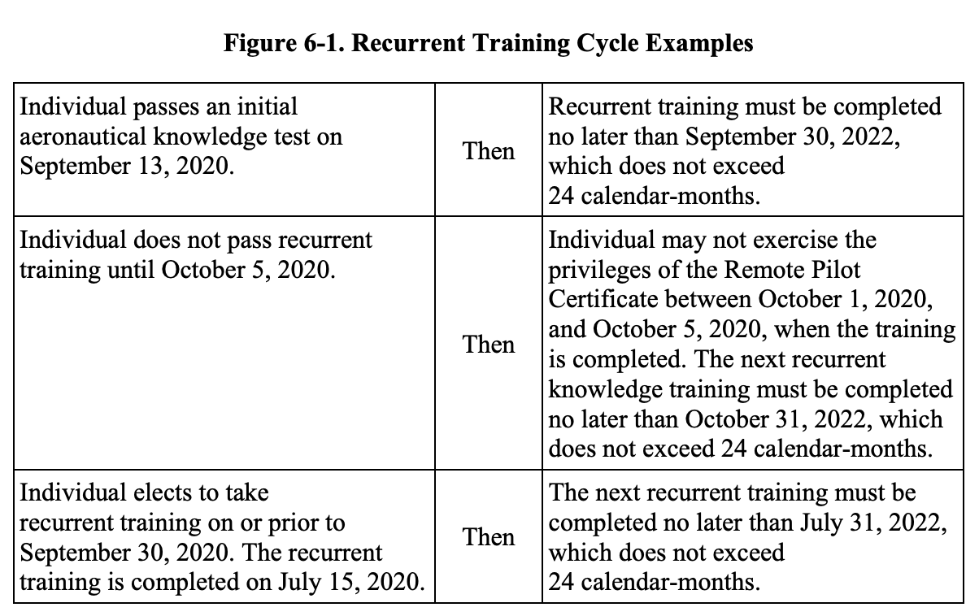

6.8 Aeronautical Knowledge Training. This paragraph is applicable to individuals who hold a part 61 airman certificate, other than a student pilot certificate, and meet the flight review requirements specified in § 61.56.

6.8.1 Training. As described in paragraph 6.7, an individual who holds a part 61 airman certificate, other than a student pilot certificate, and meets the flight review requirements specified in § 61.56 may complete training instead of the initial knowledge test. The training can be taken online at https://www.faasafety.gov. The FAA offers options for training completion in addition to those available on https://www.faasafety.gov. Other options include completion of special pilot proficiency programs, such as an FAA-provided WINGS course specific to small UAS operations. These programs will offer tools and resources to strengthen decision-making skills and enable the remote pilot to continue to ensure they operate safely within the bounds of part 107.

CHAPTER 7. SMALL UAS MAINTENANCE AND INSPECTION

7.1 Applicability. Section 107.15 requires the remote PIC to perform checks of the small unmanned aircraft prior to each flight to determine whether the small UAS is in a condition for safe operation. This chapter provides guidance on how to inspect and maintain a small UAS. Additionally, Appendix C, Small UAS Maintenance and Inspection Best Practices, contains expanded information and best practices for small UAS maintenance and inspection.

7.2 Maintenance. Small UAS maintenance includes scheduled and unscheduled overhaul, repair, inspection, modification, replacement, and system software upgrades of the small UAS and its components necessary for flight. Whenever possible, the operator should maintain the small UAS and its components in accordance with manufacturer’s instructions. The aircraft manufacturer may provide the maintenance program, or, if one is not provided, the applicant may choose to develop one. See paragraph 7.3.5 for suggested benefits of recordkeeping. (See paragraph 8.3.7.4 for Category 4 maintenance requirements. See paragraph 8.3.7.4.1 for Category 4 record retention requirements and owner and operator responsibilities.)

7.2.1 Scheduled Maintenance. The small UAS manufacturer may provide documentation for scheduled maintenance of the entire small unmanned aircraft and associated system equipment. The manufacturer may identify components of the small UAS that should undergo scheduled periodic maintenance or replacement based on time-in-service limits (such as flight hours, cycles, and/or the calendar-days). Operators should adhere to the manufacturer’s recommended schedule for such maintenance, in the interest of achieving the longest and safest service life of the small UAS.

7.2.1.1 If the small UAS manufacturer or component manufacturer does not provide scheduled maintenance instructions, the operator should establish a scheduled maintenance protocol. Such protocol could entail documenting any repair, modification, overhaul, or replacement of a system component resulting from normal flight operations, and recording the time-in-service for that component at the time of the maintenance procedure. Over time, the operator should then be able to establish a reliable maintenance schedule for the small UAS and its components.

7.2.2 Unscheduled Maintenance. During the course of a preflight inspection, the remote PIC may discover a small UAS component is in need of servicing (such as lubrication), repair, modification, overhaul, or replacement outside of the scheduled maintenance period as a result of normal flight operations or resulting from a mishap. In addition, the small UAS manufacturer or component manufacturer may require an unscheduled system software update to correct a problem. In the event such a condition is found, flight operations should not occur until the issue is corrected.

7.2.3 Performing Maintenance. In some instances, the small UAS or component manufacturer may require completion of certain maintenance tasks by the manufacturer or by a person or facility (personnel) the manufacturer specifies. Maintenance should occur in accordance with the manufacturer’s instructions. However, if the operator declines to use the manufacturer or personnel the manufacturer recommends are unable to perform the required maintenance, the operator should consider the expertise of maintenance personnel familiar with the specific small UAS and its components.

7.2.3.1 If the operator or other maintenance personnel are unable to repair, modify, or overhaul a small UAS or component back to its safe operational specification, the operator should replace the small UAS or component with one that is in a condition for safe operation. All required maintenance should be completed before each flight, and preferably in accordance with the manufacturer’s instructions or, in lieu of that, within known industry best practices.

7.3 Preflight Inspection. Pursuant to the requirements of § 107.49, in addition to assessing the intended area of operation and planning the operation as described above in paragraph 5.10, the remote PIC must inspect the small UAS to ensure that it is in a condition for safe operation prior to each flight. This inspection includes examining the small UAS for equipment damage or malfunction(s). This preflight inspection should be conducted in accordance with the small UAS manufacturer’s inspection procedures when available (usually found in the manufacturer’s owner or maintenance manual) and/or an inspection procedure developed by the small UAS owner or operator.

7.3.1 Creating an Inspection Program. As an option, small UAS owners or operators may wish to create an inspection program for their small UAS. The person creating such an inspection program may find sufficient details to assist in the development of a suitable inspection program tailored to a specific small UAS in a variety of industry programs.

7.3.2 Scalable Preflight Inspection. The preflight check as part of the inspection program should include an appropriate small UAS preflight inspection that is scalable to the small UAS, program, and operation that the remote PIC performs prior to each flight. An appropriate preflight inspection should encompass the entire system in order to determine a continued condition for safe operation prior to flight.

7.3.3 Title 14 CFR Part 43 Appendix D Guidelines. Another option and best practice may include opting to comply with the portions of part 43 appendix D. Although part 43 appendix D is technically a maintenance inspection checklist and not a preflight inspection checklist, it provides a logical and systematic approach to performing an inspection by dividing the aircraft into subgroups. It details inspection of the airframe, then the flight controls, then the batteries, then the engine, etc. Unlike manned aircraft that require significant disassembly, most small UAS inspection items are visible without necessitating the need for disassembly. In the absence of a manufacturer’s instructions, an operator may use part 43 appendix D as a guide to develop their own inspection program, but it is not comprehensive, as it does not address unique UAS features like datalinks or support equipment. An operator would need to identify those items not covered and include them in their inspection program.

7.3.4 Preflight Inspection Items. Even if the small UAS manufacturer has a written preflight inspection procedure, the FAA recommends the remote PIC ensure the following inspection items be incorporated into the remote PIC’s preflight inspection procedure. Such a practice will ensure the remote PIC accurately determines that the small UAS is in a condition for safe operation. The preflight inspection should include a visual or functional check of the following items.
1. Visual condition inspection of the small UAS components;
2. Airframe structure (including undercarriage), all flight control surfaces, and linkages;
3. Registration markings, for proper display and legibility (part 48, § 48.205);
4. Moveable control surface(s), including airframe attachment point(s);
5. Servo motor(s), including attachment point(s);
6. Propulsion system, including powerplant(s), propeller(s), rotor(s), ducted fan(s), etc.;
7. Check fuel for correct type and quantity;
8. Check that any equipment, such as a camera, is securely attached;
9. Check that control link connectivity is established between the aircraft and the CS;
10. Verify communication with small unmanned aircraft and that the small UAS has acquired GPS location from the minimum number of satellites specified by the manufacturer;
11. Verify all systems (e.g., aircraft and control unit) have an adequate power supply for the intended operation and are functioning properly;
12. Verify correct indications from avionics, including control link transceiver, communication/navigation equipment, and antenna(s);
13. Display panel, if used, is functioning properly;
14. Check ground support equipment, including takeoff and landing systems, for proper operation;
15. Verify adequate communication between CS and small unmanned aircraft exists; check to ensure the small UAS has acquired GPS location from the minimum number of satellites specified by the manufacturer;
16. Check for correct movement of control surfaces using the CS;
17. Check flight termination system, if applicable;
18. Check that the anti-collision light is functioning (if operating during civil twilight and night);
19. Calibrate small UAS compass prior to any flight;
20. Verify controller operation for heading and altitude;
21. Start the small UAS propellers to inspect for any imbalance or irregular operation;
22. At a controlled low altitude, fly within range of any interference and recheck all controls and stability; and
23. Check battery levels for the aircraft and CS

7.3.5 Benefits of Recordkeeping. Small UAS owners and operators may find recordkeeping to be beneficial. This may be done by documenting any repair, modification, overhaul, or replacement of a system component resulting from normal flight operations, and recording the time-in-service for that component at the time of the maintenance procedure. The operator would then be able to establish a reliable maintenance schedule for the small UAS and its components. The use of hardcopy and/or electronic logbook format for recordkeeping, inclusive of all periodic inspections, maintenance, preventative maintenance, repairs, and alterations performed on the small UAS, is useful in documenting the history of the small UAS. Recordkeeping would include all components of the small UAS, including:
small unmanned aircraft,
CS,
launch and recovery equipment,
Command and Control (C2) link equipment,
payload, and
any other components required to safely operate the small UAS.
Recordkeeping of documented maintenance and inspection events reinforces owner/operator responsibility through a systematic means to determine that the small UAS is in a condition for safe flight. Maintenance and inspection recordkeeping provides retrievable evidence of vital safety assessment data defining the condition of safety-critical systems and components supporting the decision to launch. For operators that rapidly accumulate flight operational hours/cycles, recordkeeping of a small UAS may provide an essential safety support. Methodical maintenance and inspection data collection can prove to be very helpful in the tracking of small UAS component service life, as well as systemic component, equipage, and structural failure events.

CHAPTER 8. SMALL UNMANNED AIRCRAFT OVER PEOPLE

8.1 Applicability. This chapter provides guidance concerning small unmanned aircraft eligibility requirements and remote pilot responsibilities for small unmanned aircraft operations over people.

8.2 Category of Operations. Part 107 establishes four categories of permissible operations over people. Category 1 is limited to a maximum weight of 0.55 pounds, including everything that is on board or otherwise attached to the aircraft at the time of takeoff and throughout the duration of each operation. In addition, the small unmanned aircraft must not contain any exposed rotating parts that would lacerate human skin upon impact with a human being. Category 2 or 3 operations may only be conducted with small unmanned aircraft that fulfill performance-based safety requirements, which limit the risk and severity of injuries based on potential hazards. Category 4 allows small unmanned aircraft issued an airworthiness certificate under 14 CFR part 21 to operate over people in accordance with part 107, so long as the operating limitations specified in the FAA-approved Flight Manual, or as otherwise specified by the Administrator, do not prohibit operations over people.

8.3 Operations Over People. Section 107.39 prohibits operations of a small unmanned aircraft over a person who is not under a safe cover, such as a protective structure or a stationary vehicle, unless the operation is conducted in accordance with one of the four categories listed in part 107 subpart D. A remote pilot may operate a small unmanned aircraft over a person who is directly participating in the operation of the small unmanned aircraft. Direct participants include the remote pilot in command (PIC), another person who may be manipulating the controls, a visual observer (VO), or crewmembers necessary for the safety of the small unmanned aircraft operation. A direct participant should be directly involved in the small unmanned aircraft flight operation. The remote pilot assigns and briefs the direct participants in preparation for the operation. The remote pilot may comply with the requirements prohibiting operation over people in several ways. For example:
• Selecting an operational location where there are no people and none are expected to be present for the duration of the operation. If the remote pilot selects a location where people are present, the remote pilot should have a plan of action to ensure human beings remain clear of the operating area. The remote pilot may be able to direct people to remain indoors or remain under safe cover until the small unmanned aircraft flight operation has ended. Safe cover is a structure or stationary vehicle that protects a person from harm if the small unmanned aircraft impacts that structure or vehicle.
• Maintaining a safe distance from people who are not directly participating in the operation of the small unmanned aircraft.
• Ensuring the small unmanned aircraft will not be operated over any moving vehicles.
Note: The remote pilot should consider risk mitigations, and needs to take into account the small unmanned aircraft’s course, speed, and trajectory, including the possibility of a failure, to determine whether the small unmanned aircraft would go over or strike a person who is not directly participating in the flight operation.

8.3.1 Minimum Distances from a Person. Part 107 does not impose a specific stand-off distance requirement from people when operating a small unmanned aircraft. The remote pilot may elect to observe a minimum stand-off distance to ensure the safety of the operation. When determining an appropriate stand-off distance, the remote pilot should consider the following factors:
• The small unmanned aircraft’s performance, to include course, speed, trajectory, and maneuverability.
• Environmental conditions such as wind, including gusts, precipitation, and visibility.
• Operational area conditions such as the location and movement of people, vessels, or vehicles, as well as terrain features, including structures or any other item that could affect the operational area where the small unmanned aircraft is being maneuvered.
• Probable failures and the ability to perform emergency maneuvers, including emergency landings.
• The remote pilot’s familiarity with and ability to maneuver the small unmanned aircraft.
Note: When conducting the small unmanned aircraft operation, the remote pilot should evaluate and make adjustments to this minimum distance from people as conditions change.

8.3.2 Operations Over Open-Air Assemblies of Persons. Remote pilots are prohibited from operating a small unmanned aircraft as a Category 1, 2, or 4 operation in sustained flight over open-air assemblies, unless the operation meets the requirements of § 89.110 or § 89.115(a). This prohibition is subject to waiver.

8.3.2.1 “Sustained flight” over an open-air assembly of persons in a Category 1, 2, or 4 operation does not include a brief, one-time transiting over a portion of the assembled gathering where the transit is merely incidental to a point-to-point operation unrelated to the assembly.

8.3.2.2 Category 3 operations are not allowed over an open-air assembly of persons.

8.3.3 Operations Over Moving Vehicles. Part 107 allows small unmanned aircraft operations over people inside moving vehicles with a small unmanned aircraft that meets the eligibility requirements for a Category 1, 2, 3, or 4 operation subject to one of the following conditions:

8.3.3.1 For Categories 1, 2, and 3 small unmanned aircraft, the operation must be conducted within or over a closed- or restricted-access site. Any person located inside a moving vehicle within the closed- or restricted-access site must be on notice that a small unmanned aircraft may fly over them; or

8.3.3.2 If the operation is not conducted within or over a closed- or restricted-access site, the small unmanned aircraft must not maintain sustained flight over any moving vehicle.

Note: Category 4 small unmanned aircraft may be eligible to operate over moving vehicles as long as the operating limitations specified in the FAA-approved Flight Manual, or as otherwise specified by the Administrator, do not prohibit such operation.

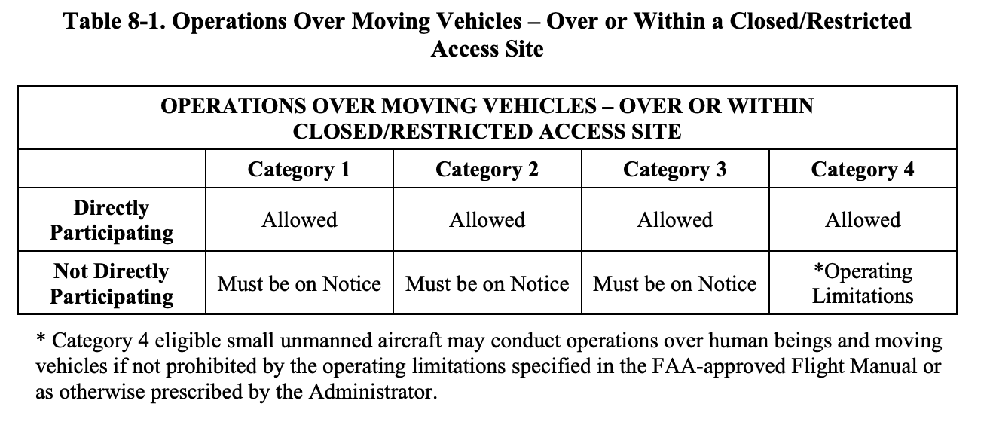

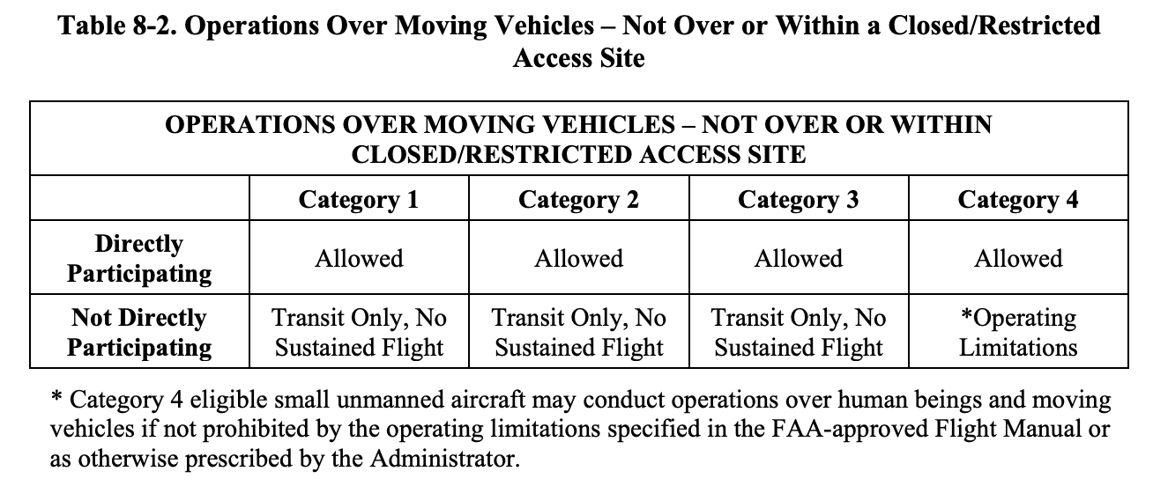

8.3.4 Category 1 Operations. Part 107 establishes a category of operations over people using small unmanned aircraft that weigh 0.55 pounds (250 grams) or less on takeoff and throughout the duration of flight, including everything that is on board or otherwise attached to the aircraft. In addition to weight limits, Category 1 small unmanned aircraft must not contain any exposed rotating parts that would lacerate human skin upon impact. Remote pilots are prohibited from operating as a Category 1 operation in sustained flight over open-air assemblies unless the operation meets the requirements of § 89.110 or § 89.115(a). This prohibition is subject to waiver.

8.3.4.1 The remote pilot is responsible for determining that the small unmanned aircraft does not exceed the weight threshold and must ensure that the small unmanned aircraft does not contain any exposed rotating parts that would lacerate human skin. These requirements are in addition to the already existing pilot requirements of part 107, such as the preflight responsibilities listed in § 107.49 (see paragraph 8.11.1). 8.3.4.2 There are no applicant requirements for Category 1.

8.3.5 Category 2 Operations. To conduct Category 2 operations over people, the small unmanned aircraft must meet the requirements of § 107.120. To confirm such eligibility, the small unmanned aircraft must be listed on an FAA-accepted declaration of compliance (DOC).

8.3.5.1 It is the remote pilot’s responsibility to ensure that the small unmanned aircraft is listed on an FAA-accepted DOC as eligible for Category 2 operations and labeled as eligible to conduct Category 2 operations. A remote pilot can accomplish these things by checking the FAA’s DOC Portal at https://uasdoc.faa.gov to see if the DOC is valid and by visually inspecting the aircraft to ensure a label identifying the aircraft as Category 2 is affixed to the aircraft. These requirements are in addition to the already existing pilot requirements of part 107, such as the preflight responsibilities listed in § 107.49.

8.3.5.2 Additionally, the small unmanned aircraft must display a label indicating eligibility to conduct Category 2 operations; have current remote pilot operating instructions that apply to the operation of the small unmanned aircraft, which are described below in paragraph 8.12; and be subject to a product support and notification process. (The applicant must submit the DOC containing specific information to affirm that the aircraft meets the safety requirements through an FAA-accepted means of compliance (MOC). See paragraph 8.9 for a detailed description of the DOC and the process for submitting the DOC.)

8.3.5.3 Remote pilots are prohibited from operating as a Category 2 operation in sustained flight over open-air assemblies unless the operation meets the requirements of § 89.110 or § 89.115(a). This prohibition is subject to waiver.

8.3.6 Category 3 Operations. To conduct Category 3 operations over people, a small unmanned aircraft must meet the safety requirements of § 107.130. To confirm such eligibility, the small unmanned aircraft must be listed on an FAA-accepted DOC.

8.3.6.1 It is the remote pilot’s responsibility to ensure the small unmanned aircraft is listed on an FAA-accepted DOC and labeled as eligible to conduct Category 3 operations. A remote pilot can accomplish these things by checking online at https://uasdoc.faa.gov to see if the DOC is valid and by visually inspecting the aircraft to ensure a label identifying the aircraft as Category 3 is affixed to the aircraft. These requirements are in addition to the already existing pilot requirements of part 107, such as the preflight responsibilities listed in § 107.49.

8.3.6.2 Additionally, the small unmanned aircraft must display a label identifying eligibility to conduct Category 3 operations; have current remote pilot operating instructions that apply to the operation of the small unmanned aircraft, which are described below in paragraph 8.12; and be subject to a product support and notification process. (The applicant must submit the DOC containing specific information to affirm that the aircraft meets the safety requirements through an FAA-accepted MOC. See paragraph 8.9 for a detailed description of the DOC and the process for submitting the DOC.)

8.3.6.3 Location Requirements and Restrictions. Category 3 operations are allowed under the following conditions:
• The operation is conducted over a closed- or restricted-access site and everyone located within the site must be on notice that a small unmanned aircraft may fly over them.
• The operation is not conducted within a closed- or restricted-access site, and the small unmanned aircraft does not sustain flight over any person unless that person is directly participating in the operation or located under a covered structure or inside a stationary vehicle that can provide reasonable protection from a falling small unmanned aircraft.

8.3.6.4 No Operations Over Open-Air Assemblies of People. Category 3 operations are not allowed over an open-air assembly of persons. While the FAA does not define open-air assembly by regulation, it employs a case-by-case approach in determining how to apply the term. Open-air assembly has to do with the density of people who are not directly participating in the operation of the small unmanned aircraft and the size of the operational area. An open-air assembly is generally understood as dense gatherings of people in the open, usually associated with concert venues, sporting events, parks, and beaches during certain events. Such assemblies are usually associated with public spaces. The FAA considers that some potential examples of open-air assemblies may include sporting events, concerts, parades, protests, political rallies, community festivals, or parks and beaches during certain events. Some potential examples that are less likely to be considered open-air assemblies include individual persons or families exiting a shopping center, persons participating in casual sports in an open area without spectators, individuals or small groups taking leisure in a park or on a beach, or individuals walking or riding a bike along a bike path. Whether an open-air assembly exists depends on a case-by-case determination based on the facts and circumstances of each case. The remote pilot must assess whether the operational area would be considered an open-air assembly prior to conducting flight operations.

8.3.6.5 Modifications. The remote pilot operating instructions may contain details concerning allowable modifications of the small unmanned aircraft. Modifications not allowed by the remote pilot operating instructions may render the small unmanned aircraft ineligible for operations over people. Such modifications would require submission of a new DOC. Additionally, the small unmanned aircraft may need to be relabeled to reflect the category of operations it is eligible to conduct. In the case of the sale or transfer of the small unmanned aircraft, or use of the aircraft by someone other than the applicant, the applicant must provide remote pilot operating instructions that reflect the aircraft’s eligible category and acceptable modifications. Therefore, the FAA encourages manufacturers of small unmanned aircraft to keep track of modifications that would require an update to the remote pilot operating instructions.

8.3.6.6 Closed- or Restricted-Access Sites. Category 3 operations may take place over or within closed- or restricted-access sites where everyone located within the site must be on notice that a small unmanned aircraft may fly over them, as long as the operational area is not considered an open-air assembly. People who are not directly participating in the operation of the small unmanned aircraft but who are performing functions at the closed- or restricted-access site must be on notice of potential small unmanned aircraft operations, and should be advised of precautions or other recommended actions to take, if necessary. Remote pilots are responsible for ensuring no inadvertent or unauthorized access to the site occur. Adequate assurance could include physical barriers such as barricading and fencing or monitoring personnel to ensure inadvertent or unauthorized access to the site does not occur. Geographical boundaries, such as rivers, canals, cliffs, and heavily wooded areas may serve as effective barriers to restrict access.

8.3.6.7 No Sustained Flight Over People. In addition to closed- or restricted-access sites, Category 3 operations may take place outside of a closed- or restricted-access site as long as the small unmanned aircraft does not sustain flight over people not participating in the operation of the small unmanned aircraft. This allows the remote pilot to operate over people, but only for a brief period. The intent of the requirement is momentary exposure, without sustained exposure over one or more persons. Sustained flight includes hovering above any person’s head, flying back and forth over a person, or circling above an uninvolved person in such a way that the small unmanned aircraft remains above some part of that person. The remote pilot should adjust the flightpath of the small unmanned aircraft to ensure minimal exposure of the aircraft over people, and may need to discontinue the operation if the flightpaths would require sustained flight over people.

8.3.7 Category 4 Operations. Certification is how the FAA manages risk through safety assurance. It provides the FAA confidence that a proposed product or operation will meet FAA safety expectations to protect the public. Eligible Category 4 small unmanned aircraft must have an airworthiness certificate issued by the FAA under part 21 and must be operated in accordance with the operating limitations specified in the FAA-approved Flight Manual or as otherwise specified by the Administrator. The airworthiness certificate allows small unmanned aircraft operations for compensation and hire.

8.3.7.1 The remote pilot conducting Category 4 operations over people must use an eligible small unmanned aircraft. To operate over people in accordance with § 107.140 and over moving vehicles in accordance with § 107.145(c), the remote pilot must operate the small unmanned aircraft in accordance with all operating limitations that apply to the small unmanned aircraft, as specified by the Administrator. These operating limitations must not prohibit operations over people.

8.3.7.2 Remote pilots are prohibited from operating as a Category 4 operation in sustained flight over open-air assemblies unless the operation meets the requirements of § 89.110 or § 89.115(a). This prohibition is subject to waiver.

8.3.7.3 Category 4 Maintenance. In order to preserve the continued airworthiness of the small unmanned aircraft and continue to meet a level of reliability that the FAA finds acceptable for flying over people in accordance with Category 4, the requirements of § 107.140(c) apply. Eligible Category 4 small unmanned aircraft must have maintenance, preventive maintenance, or alterations performed in a manner using the methods, techniques, and practices prescribed in the manufacturer’s current maintenance manual or instructions for continued airworthiness (ICA) prepared by its manufacturer, or other methods, techniques, and practices acceptable to the Administrator. Additionally, Category 4 small unmanned aircraft must be inspected in accordance with the manufacturer’s instructions or other instructions acceptable to the Administrator and have maintenance, preventive maintenance, or alterations performed using parts of such a quality that the condition of the aircraft will be at least equal to its original or properly altered condition.

8.3.7.3.1 The person performing any maintenance, preventive maintenance, or alterations must use the methods, techniques, and practices prescribed in the manufacturer’s current maintenance manual or ICA (Instructions for Continued Airworthiness) that are acceptable to the Administrator, or other methods, techniques, and practices acceptable to the Administrator. The person who inspects the small unmanned aircraft must do so in accordance with the manufacturer’s instructions or other instructions acceptable to the Administrator. Additionally, the person must have the knowledge, skill, and appropriate equipment to perform the work. The person performing the maintenance, preventive maintenance, or alterations must use parts of such a quality that the condition of the aircraft will be at least equal to its original or properly altered condition.

8.3.7.3.2 The owner or operator must maintain records of maintenance performed on the aircraft as well as records documenting the status of life-limited parts, compliance with Airworthiness Directives (AD), and inspection compliance of the small unmanned aircraft. Owner and operator responsibilities are discussed in paragraph 8.3.7.4.1.

8.3.7.4 Applicability of Maintenance and Record Retention Requirements. When a remote pilot operates a small unmanned aircraft in accordance with part 107, having an FAA-issued airworthiness certificate under part 21, the requirements of parts 43 and 91 do not apply. However, a small unmanned aircraft issued an airworthiness certificate may be eligible to operate under part 91, under certain circumstances. Part 107 contains necessary updates to the regulatory text to reflect the applicability of operating rules. Category 4 does not prescribe as many maintenance and record retention requirements as are required by parts 43 and 91, respectively. Therefore, it may be difficult for an owner or operator to switch between operating rules. A small unmanned aircraft operated and maintained in accordance with part 107 may find it difficult to show compliance with the requirements of part 43 and 91. To address this concern, an owner or operator can elect to comply with the relevant parts 43 and 91 requirements, even while operating in accordance with part 107. Under these circumstances, electing to comply with the relevant parts 43 and 91 requirements may help facilitate moving back and forth between operational parts, if desired, because the requirements of parts 43 and 91 are more stringent than those of § 107.140 with regard to maintenance and airworthiness.

8.3.7.4.1 Consistent with other regulatory frameworks, such as parts 91 and 135, the owner is responsible for maintaining the small unmanned aircraft in accordance with the requirements of § 107.140(c). However, if the owner enters into an agreement with another entity to operate the small unmanned aircraft, the operator is responsible for the maintenance and records retention requirements for small unmanned aircraft operated in accordance with Category 4 under part 107. The FAA expects most operators of Category 4 small unmanned aircraft operating under part 107 will also be the owner, or operating under direction of the owner. In this case, the owner is responsible for compliance with the Category 4 small unmanned aircraft maintenance and records retention requirements. To maintain flexibility for those owners of Category 4 small unmanned aircraft who wish to enter into an agreement with another entity for the operation of their small unmanned aircraft without the owner’s intervention or control, § 107.140(c) provides the means for the responsibility of maintenance requirements and retention of records to be clearly defined in such an agreement. If so specified in the agreement, the FAA would hold the operator responsible for compliance with the Category 4 small unmanned aircraft maintenance and records retention requirements. An agreement between an owner and an operator may be in the form of a written lease or contract, verbal agreement, or other agreement. If any agreement is found invalid or unenforceable, then the owner has the responsibility to meet these requirements. The provisions of any agreement should address, at a minimum, the requirements of § 107.140(c).

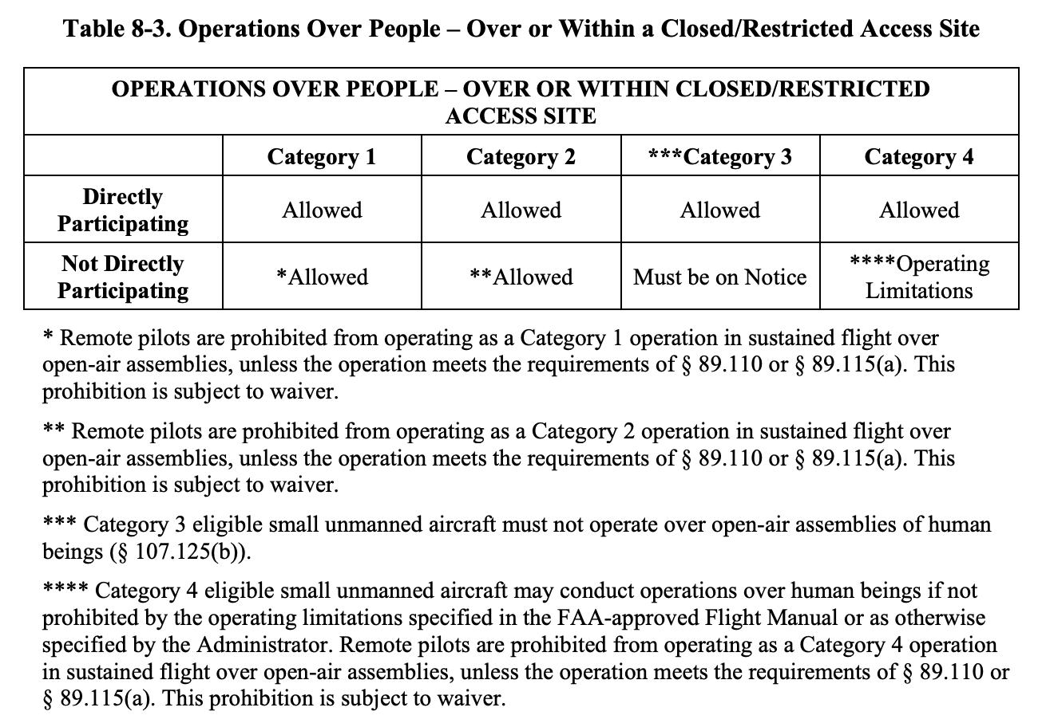
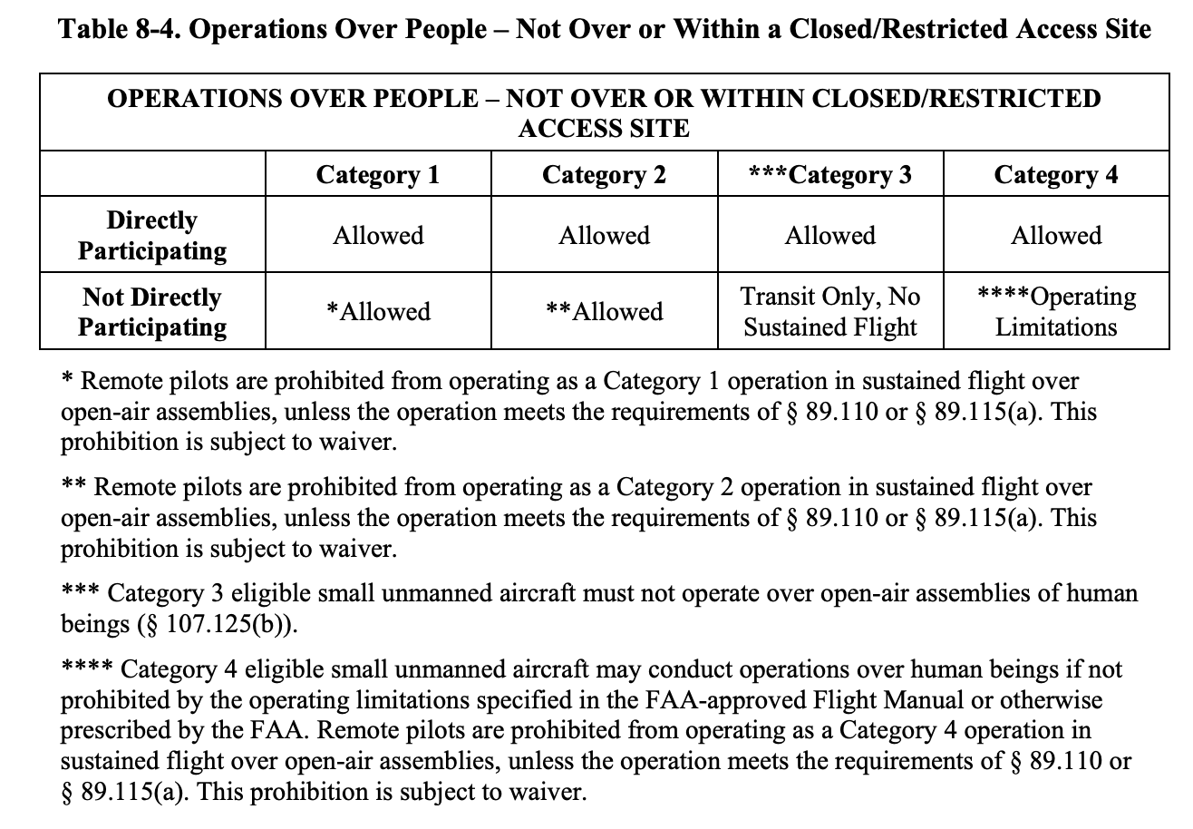

8.4 Applicant. An applicant includes any person who produces, designs, or modifies a small unmanned aircraft eligible to operate over people within the United States. An applicant may produce many small unmanned aircraft, sell kits from which to build small unmanned aircraft, or modify a small unmanned aircraft in a way that affects the eligibility of the small unmanned aircraft to conduct a different category of operations over people than it was previously eligible.

8.4.1 An applicant who manufactures and sells a kit that contains all the components and parts from which to build an operable small unmanned aircraft must comply with the requirements of part 107 subpart D, if the aircraft is intended for operations over people. The kit must contain all the components necessary to build an operable small unmanned aircraft, and would not require the owner to purchase any additional materials. Before the kit is sold, the applicant must ensure that the completely assembled small unmanned aircraft, not only its individual component parts, complies with the performance-based safety requirements to determine eligibility using an FAA-accepted MOC and declare compliance. This will ensure that the small unmanned aircraft meets the requirements of part 107 subpart D.

8.4.2 Someone who builds a small unmanned aircraft from separate components and parts not from a kit is an applicant. For example, someone may purchase the parts of a small unmanned aircraft separately, and build the small unmanned aircraft. An applicant is required to submit a DOC in order to conduct Category 2 or 3 operations.

8.4.3 An applicant may be a person who modifies a small unmanned aircraft listed on an existing DOC, resulting in noncompliance with the original declaration. A noncompliance means the small unmanned aircraft has been altered and is no longer in the same configuration as originally declared. If the small unmanned aircraft is changed so that it is no longer eligible for operations over people, a new DOC must be submitted prior to conducting operations over people or moving vehicles within that category. An applicant should specify allowable modifications in the remote pilot operating instructions (please see paragraph 8.12 below for information concerning remote pilot operating instructions). This ensures a remote pilot who may replace parts or otherwise modify the small unmanned aircraft is aware of which modifications would be allowable for the category of operation. An applicant may develop updates for a small unmanned aircraft after the remote pilot takes possession of it, such as a software update or hardware update. To communicate these updates to the remote pilots, the manufacturer should make operating instructions for the new capabilities of the small unmanned aircraft available.

8.4.4 Any person who makes a modification not permissible by the remote pilot operating instructions to a small unmanned aircraft eligible for Category 2 or Category 3 operations over people renders that small unmanned aircraft ineligible. If the person making the modification intends to conduct Category 2 or Category 3 operations over people with the modified small unmanned aircraft, that person is required to take on the responsibilities of an applicant. In this case, the applicant is required to determine the modified small unmanned aircraft meets the performance-based safety requirements for either Category 2 or Category 3, or both, using an FAA-accepted MOC and submit a new DOC. This principle applies to any person who modifies an existing ineligible small unmanned aircraft with the intention of conducting Category 2 or Category 3, or both, operations over people.

8.4.5 Maintenance actions performed on an eligible Category 2 or Category 3 aircraft that do not change the configuration or characteristics of the aircraft would not require a new DOC to be submitted. For example, if replacing propellers is listed as an allowed modification in the remote pilot operating instructions, a new DOC would not be required. However, replacing propellers not covered in the remote pilot operating instructions requires submission of a new DOC to conduct Category 2 or Category 3 operations over people. Remote pilot operating instructions should include a list of allowed modifications for the small unmanned aircraft to remain eligible.
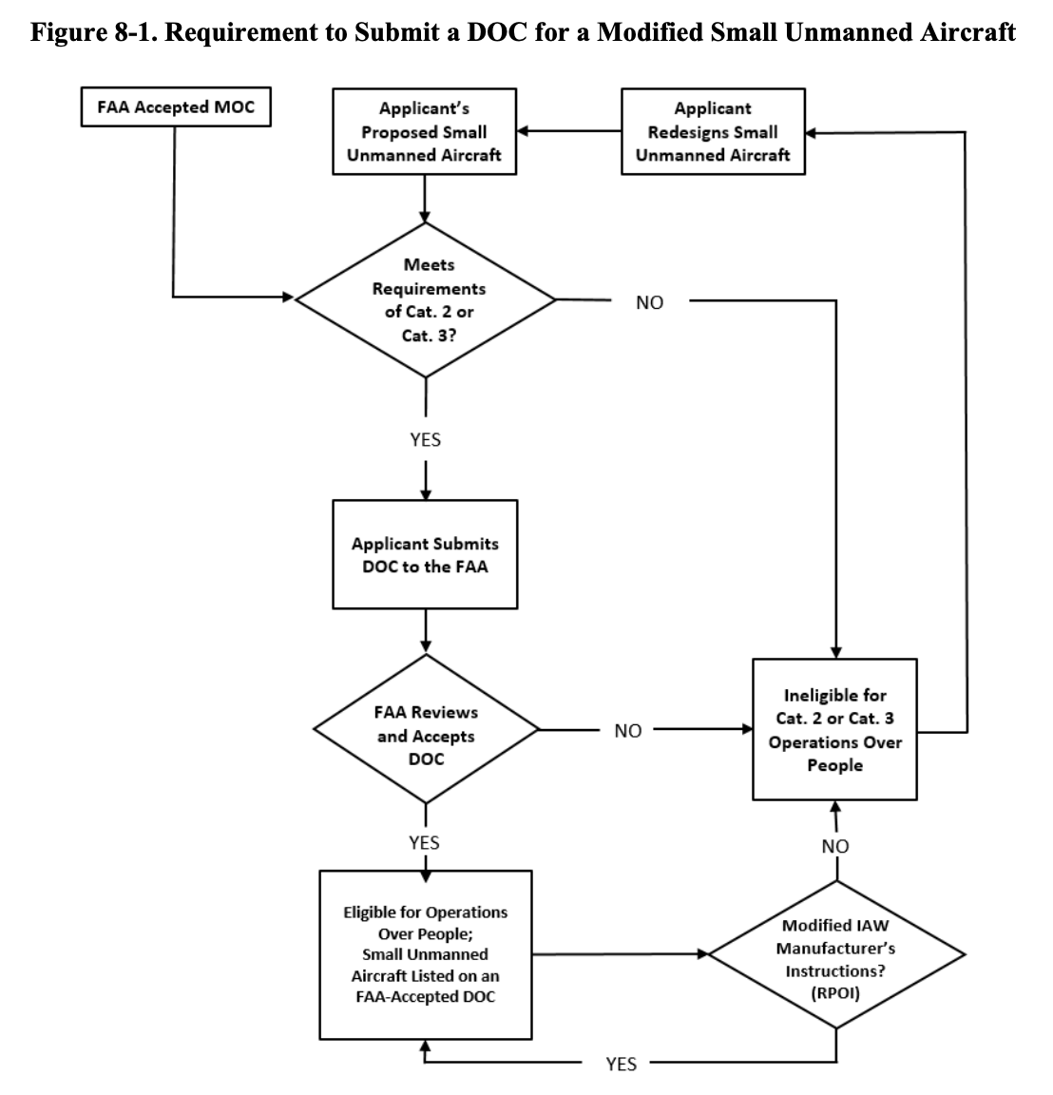
8.5 Means of Compliance—General Information. An MOC is a method to show that a small unmanned aircraft does not exceed the applicable injury severity limit upon impact with a human being, does not contain any exposed rotating parts that would lacerate human skin, and does not contain any safety defects. An MOC must be accepted by the FAA before an applicant can rely on it to declare compliance with the safety requirements for operations over people. Anyone may submit an MOC to the FAA for acceptance if it fulfills Category 2 or Category 3 safety requirements. An individual or a voluntary consensus standards body (e.g., ASTM International or SAE) could develop an acceptable MOC. The MOC must demonstrate through test, analysis, or inspection that the small unmanned aircraft is eligible for operations over people in Category 2, Category 3, or both. The MOC may include consensus standards. Once the FAA accepts an MOC, any person submitting a DOC could use it to establish that a small unmanned aircraft fulfills the requirements of the rule. An applicant requesting FAA acceptance of an MOC must submit certain information to the FAA in a manner the Administrator specifies. When reviewing an MOC, the FAA will utilize a comprehensive set of criteria. The FAA will determine whether the testing, analysis, or inspection described in the MOC demonstrates that a small unmanned aircraft meets the appropriate regulatory requirements. An MOC must address the injury severity limits, the prohibition on exposed rotating parts that would cause lacerations, and verification that there are no safety defects. The FAA will determine whether the proposed MOC aligns with accepted methods used by the medical industry, consumer safety groups, or other peer-reviewed test methods. In addition, the FAA will consider whether the proposed MOC relies on mitigations that require exceptional remote pilot skill or excessive workload to satisfy the requirements.

8.5.1 The FAA must accept an MOC before an applicant can rely on it to demonstrate compliance with the performance-based safety requirements for operations over human beings. An FAA-accepted MOC is subject to an ongoing review by the FAA to ensure the MOC remains valid. If the FAA determines the MOC no longer meets any or all of the requirements to demonstrate compliance with part 107 subpart D, the FAA may rescind acceptance of an MOC. If the FAA elects to rescind an MOC, it will publish a notice of rescission in the Federal Register.

8.5.2 The MOC options an applicant may use are:
1. The FAA-provided MOC, discussed in this AC.
2. An FAA-accepted MOC developed by a voluntary consensus standards body or other entity, or an FAA-accepted MOC developed independent of the FAA. An MOC developed by an individual applicant requires the same level of FAA review as an MOC developed by a voluntary consensus standards body. The FAA generally works with voluntary consensus standards bodies in the development of these standards. As a result, any MOC based on these standards will already have gone through a comprehensive review process during development.

8.6 FAA-Provided MOC. Without prejudice to any other MOC that an applicant may propose and the FAA may accept, the FAA offers one already accepted MOC for both the impact kinetic energy and exposed rotating parts requirements provided at §§ 107.120(a)(1) and (2) (Category 2) and 107.130(a)(1) and (2) (Category 3). The FAA-provided MOC for the injury severity limitations is developed through an applicant’s calculation of the small unmanned aircraft’s maximum kinetic energy. This MOC does not account for impact dynamics or other factors, but consists of using only the formula the FAA describes to calculate the small unmanned aircraft’s maximum kinetic energy. This FAA-accepted MOC provides manufacturers with at least one method to demonstrate their small unmanned aircraft would meet the requirements to operate over people. As a result, the MOC involves confirming
(1) the impact of a small unmanned aircraft does not exceed a certain kinetic energy limit,
(2) the small unmanned aircraft does not contain any exposed rotating parts, and
(3) does not contain any safety defects.

8.6.1 Impact Kinetic Energy. An applicant may use the FAA-provided MOC to satisfy the impact kinetic energy requirements by confirming the impact of the small unmanned aircraft does not exceed the applicable injury severity limits during a typical failure mode at the aircraft’s maximum performance capabilities. To test a small unmanned aircraft using this MOC, an applicant would first determine the maximum forward airspeed that the small unmanned aircraft is capable of attaining at full power in level flight. This would be done using a reliable and accurate airspeed measurement method under typical environmental conditions. For example, an applicant could measure the maximum speed using a Global Positioning System (GPS) groundspeed indicator, a radar gun, or tape measure and stop watch. Note that small unmanned aircraft operated under part 107 may not exceed the speed limitations in part 107 unless authorized under a Certificate of Waiver (CoW) or an exemption (§ 107.51(a)).

8.6.1.1 Next, an applicant would determine the ground impact speed resulting from an unpowered free-fall from the highest altitude the small unmanned aircraft is capable of attaining at full power. Note that aircraft operating under part 107 may not exceed the altitude limitations of that rule unless authorized under a CoW or an exemption (§ 107.51(b)). The ground impact speed could be determined by performing a drop test from the altitude determined in the previous step using a reliable and accurate vertical speed measurement method under typical environmental conditions.

8.6.1.2 If an applicant determines it is unreasonable to perform a drop test from the highest attainable altitude, then the applicant can perform a drop test from a lower altitude. The lower altitude must be sufficient to determine the small unmanned aircraft free-fall aerodynamic characteristics, such as the coefficient of drag and terminal velocity, to accurately calculate the ground impact speed from a free-fall from the highest attainable altitude. The manufacturer would state in the supporting data the applicant submits pursuant to § 107.155 the environmental conditions under which the applicant determined the maximum speeds. The applicant would also describe any unique test conditions for both the level flight and free-fall scenarios.

8.6.1.3 The above tests account for speeds a small unmanned aircraft could reach prior to or during a typical failure mode, such as losing power and falling with both a vertical and horizontal speed component. The tests do not take into account small unmanned aircraft failure modes or pilot actions that would cause the small unmanned aircraft to exceed the speeds determined in the previous steps. One example is a powered descent in which the ground impact speed of the small unmanned aircraft exceeds its unpowered free-fall ground impact speed. The FAA assumes these types of failure modes or pilot actions are not typical, and while possible, have a low likelihood of occurring. If an applicant determines these types of failure modes or pilot actions could typically occur and result in speeds greater than those determined in the previous steps, then the applicant should use the higher speeds to determine the maximum impact kinetic energy.

8.6.1.4 Once the applicant determines the maximum speeds associated with a horizontal and vertical impact, the applicant would determine the highest combination of these speeds the aircraft could achieve as a result of a typical failure in order to determine the maximum impact kinetic energy. The applicant should identify and assess typical failures caused by system or equipment loss of function or malfunction as well as those that could be caused by pilot error.

8.6.1.5 In consideration of the maximum speeds and typical failures described above, the applicant should determine the maximum impact kinetic energy using the following equation:
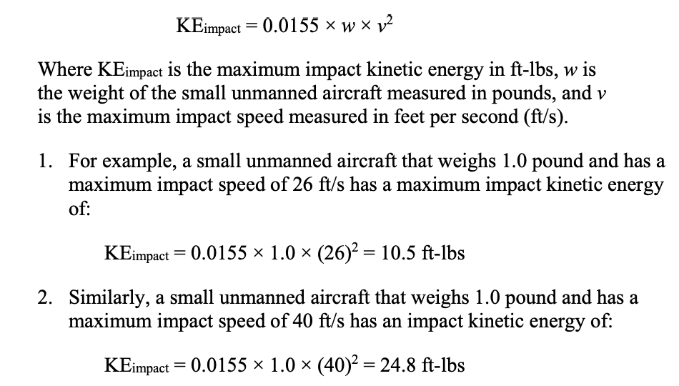

8.6.1.6 The two tables below provide examples of maximum impact speeds, rounded to whole numbers, associated with the impact kinetic energy thresholds of the different categories and the weight of the small unmanned aircraft. One table provides speeds in feet per second and the other table provides speeds in miles per hour (mph). Applicants may use these tables when following this MOC based on the maximum performance of the small unmanned aircraft. These tables do not consider any energy absorbing characteristics of a small unmanned aircraft that may reduce the amount of energy that is transferred to a person during a collision.
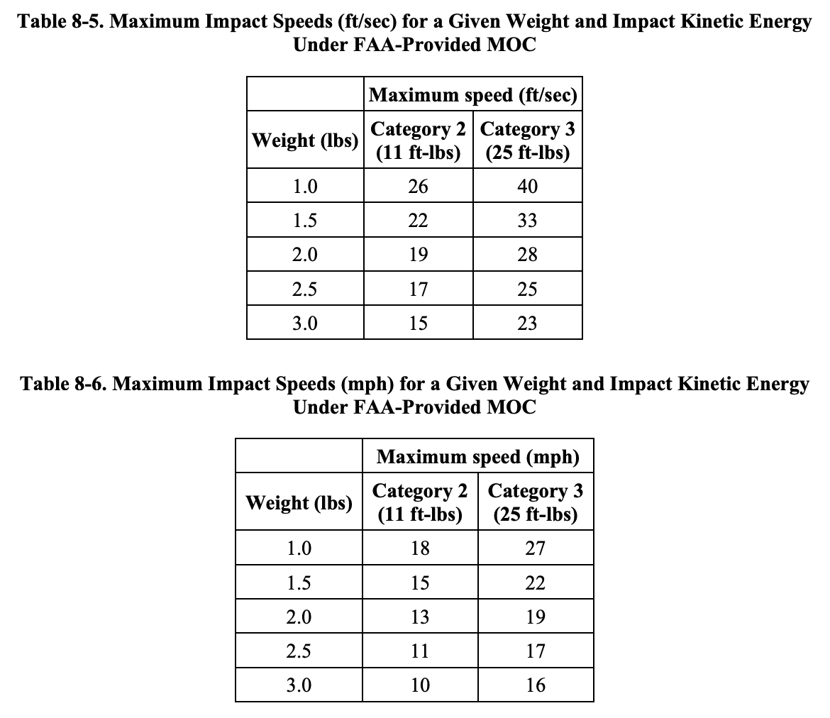

8.6.1.7 If the small unmanned aircraft incorporates airspeed or altitude limiting systems or equipment that, when installed or enabled, restrict its forward airspeed or altitude in order to meet an impact kinetic energy requirement, then those systems or equipment should be installed or enabled when performing the tests described above. If compliance with the impact kinetic energy requirement depends on the proper function of those systems or equipment, then the applicant should provide in the remote pilot operating instructions information on the proper use of those systems or equipment, as well as any restrictions. The FAA anticipates applicants will implement these types of systems or equipment through hardware, software, or a combination of both. If the small unmanned aircraft can be operated with or without these systems or equipment enabled or installed, such as in a variable-mode small unmanned aircraft, then the applicant should provide information in the remote pilot operating instructions to ensure pilots understand any restrictions or limitations associated with the different modes.

8.6.1.8 This MOC does not account for the use or testing of design features such as parachutes, ballistic recovery systems, or other deployable devices that once deployed, reduce impact velocity. Such features can establish that a small unmanned aircraft would impact a person with a reduced amount of kinetic energy. Such design features will require the FAA’s review to determine whether they assist in achieving compliance with injury severity limitations. Outside the scope of the FAA-provided MOC, an applicant may choose to demonstrate compliance with the injury severity limitations using deployable devices, as long as the applicant describes how the devices are used to meet the safety requirements in the proposed MOC.

8.6.1.9 The MOC detailed above does not take into account the effect of the small unmanned aircraft’s structural configuration or materials of construction during an impact with a person. It assumes that the total kinetic energy of the small unmanned aircraft would be transferred to the person upon impact. In reality, a small unmanned aircraft’s structural configuration, materials of construction, or other design features may reduce the amount of the total kinetic energy that is transferred to a person during an impact. The use of energy absorbing materials, or an energy absorbing protective cage, may reduce the transfer of kinetic energy during an impact with a person. Under these circumstances, an applicant may wish to establish the amount of kinetic energy transferred to a person during an impact based on the impact absorbing characteristics of the small unmanned aircraft. If an applicant shows the aircraft does not transfer more than the kinetic energy limit to a person upon impact, the aircraft may be eligible for Category 2 or 3 operations over people. This demonstration would require an MOC that is not provided in this AC.

8.6.1.10 The FAA acknowledges limitations associated with the FAA-provided MOC. The FAA intended with this FAA-provided MOC to provide a test method that applicants could use to show compliance with the injury severity limitations, with the anticipation that industry can and will develop more flexible MOC through a voluntary consensus standards body or otherwise. The FAA expects these industry standards to consider that small unmanned aircraft often have non-rigid structures, which can reduce the kinetic energy transferred to a person upon impact. The FAA encourages the development of such MOC. Please see paragraphs 8.7 and 8.8 below for information concerning other MOC.

8.6.2 Exposed Rotating Parts. One means, but not the only means, of complying with the requirement would be to manufacture the small unmanned aircraft so that it does not contain any exposed rotating parts. For example, if the propellers that provide lift and thrust for the small unmanned aircraft are internal to the unmanned aircraft, such as in a ducted fan configuration, and would not make contact with a person as a result of a typical impact, then the parts would not be exposed. Therefore, the small unmanned aircraft would satisfy this requirement. Testing and analysis may be required to determine that the rotating parts could not become exposed as a result of a typical impact with a person. If the forces on the small unmanned aircraft during an impact with a person are likely to cause structural failures that cause the rotating parts to become exposed, then that design would not satisfy this requirement.

8.7 Voluntary Consensus Standards Body MOC. A voluntary consensus standards body incorporates openness, balance, due process, appeals process, and consensus. These characteristics result in a peer review of voluntary consensus standards. Voluntary consensus standards bodies are composed of a wide selection of industry participants, often including the FAA.

8.7.1 The FAA encourages industry stakeholders to develop additional test methods and analyses to provide multiple ways for applicants to comply with the applicable safety requirements. Two potential approaches for industry to consider are provided in the following paragraphs.

8.7.2 A person may develop a standard for small unmanned aircraft having rotating parts that are protected by safety features, such as propeller guards. The standard could require testing by the applicant to support the determination that the protective safety features accomplish their intended function of preventing rotating parts from contacting a person during impact. If the applicant has tested those safety features and demonstrated they would remain intact during impact, this could be one means of demonstrating that exposed rotating parts would not be capable of lacerating human skin upon impact.

8.7.3 If a small unmanned aircraft has rotating parts that are exposed without any protective safety features, it may be shown through testing and analysis that the rotating parts would not lacerate human skin upon impact. By analyzing test data that evaluates the size, shape, rotational speed, material, and orientation of the rotating parts, and the severity of injuries that would be caused by these parts under any impact scenarios, it can be determined that the rotating parts would not lacerate human skin upon impact.

8.7.4 The method of analysis or testing should be commensurate with the applicant’s means of compliance. If a small unmanned aircraft has propellers made out of flexible material, an applicant would likely not need to perform sophisticated analysis or testing to demonstrate that the exposed rotating parts would not cause lacerations to human skin upon impact. If an applicant chooses to design a small unmanned aircraft with exposed propellers with sharp leading edges made of a rigid material, such as a carbon fiber composite that are driven by high torque motors, that applicant would likely have to perform a more sophisticated analysis or testing. The objective of the analysis or testing is to demonstrate that the propellers would not cause lacerations upon impact. This testing standard requires the applicant to demonstrate it across a range of typical human encounters and unmanned aircraft operational scenarios. Categories 2 and 3 require the manufacturer to show the unmanned aircraft would not cause lacerations (emphasis added). Therefore, the FAA does not expect applications to test for every human encounter, merely the ones that are typical.

8.7.5 The unmanned aircraft may also have a rotor that does not have sufficient momentum to lacerate normal human skin, and may implement technology to stop the exposed rotating part before it would lacerate skin. Another example of how an aircraft could comply with the prohibition on exposed rotating parts that would cause lacerations would be to use materials that are incapable of lacerating human skin. An example of this would be to use or design rotors or propellers with properties that break away or flex upon impact to eliminate lacerations without the use of guards or shrouds. For Categories 2 and 3, any method an applicant chooses to use to comply with the exposed rotating parts requirement must be demonstrated through an FAA-accepted MOC.

8.7.6 Exposed rotating parts may pose a significant laceration hazard if they contact human skin, which is unacceptable for the safety of the public. The FAA distinguishes between a laceration to mean a cut that goes all the way through the skin while an abrasion means a superficial injury to the skin. Additionally, the FAA uses the expression “typical human encounter” to describe normal impacts, such as unmanned aircraft impacting a human being due to a loss of control, small unmanned aircraft failures, or remote pilot error.

8.8 Means of Compliance. Any person may propose an MOC to satisfy the safety requirements of § 107.120(a) or § 107.130(a). A person would submit a proposed MOC to the FAA for review and acceptance, showing that its small unmanned aircraft would not exceed the applicable injury severity limit upon impact with a human being, does not contain any exposed rotating parts that would lacerate human skin, and does not contain any safety defects. The FAA must accept an MOC before an applicant can rely on it to declare compliance with the performance-based safety requirements of § 107.120(a) or § 107.130(a), or both.

8.8.1 An applicant requesting FAA acceptance of an MOC should carefully consider the additional time and effort that could be necessary to coordinate an MOC when scheduling its projects. FAA coordination may require the efforts of FAA technical specialists, Chief Scientific Technical Advisors, or other governmental agencies. The use of existing FAA-accepted MOC would be more expeditious because the FAA will already have reviewed such MOC. As with voluntary consensus standards bodies, some developers of an MOC may not be applicants also submitting a DOC to the FAA for acceptance. Guidance for developing and submitting an MOC to the FAA for acceptance is provided below.

8.8.2 An applicant requesting FAA acceptance of an MOC should submit its proposed MOC at https://uasdoc.faa.gov. An acceptable MOC may be used to establish the small unmanned aircraft fulfills the safety requirements set forth in § 107.120(a) or § 107.130(a). The MOC must show, through test, analyses, inspection, or any combination of these options that the small unmanned aircraft meets the safety requirements for the respective category of operation over people. The proposed MOC must include a detailed description of the MOC and an explanation of how applying the MOC fulfills the safety requirements of § 107.120(a) or § 107.130(a), or both. The FAA will evaluate the testing procedure and substantiation documents on a case-by-case basis.

8.8.3 When reviewing an MOC, the FAA will utilize criteria that include, but are not limited to, the following:

8.8.3.1 To evaluate compliance with the appropriate safety requirements, the FAA will determine whether the applicant’s methods demonstrate the applicant has properly mitigated the severity of human injury that could occur to an acceptable safety level, as defined in the appropriate aircraft category.

8.8.3.2 The FAA will also determine whether the tests or analyses are performed in accordance with accepted methods used by the medical industry, consumer safety groups, or other peer-reviewed test methods.

8.8.3.3 In addition, the FAA will determine whether the proposed MOC requires unreasonable skill on behalf of the remote pilot or incorporation of mitigations to meet the requirements.

8.8.3.4 The FAA will determine whether the MOC addresses design features such as deployable devices (i.e., parachutes) or other features independent of the small unmanned aircraft to determine whether they assist in fulfilling the safety requirements.

8.8.4 The FAA will indicate acceptance of an MOC by publishing a Notice of Availability in the Federal Register identifying the MOC as accepted and notifying the applicant.

8.8.5 An MOC accepted by the FAA is considered valid whether it comes from a consensus standards body or a person. If a proposed MOC is not accepted by the FAA, the FAA will notify the applicant requesting acceptance of an MOC of any issues with the proposed MOC.

8.9 Declarations of Compliance. For a small unmanned aircraft to be eligible to conduct Category 2 or 3 operations over people, the person who designs, produces, or modifies the small unmanned aircraft must declare compliance with the appropriate performance-based safety requirements through use of an FAA-accepted MOC. The FAA will receive such DOCs via an electronic form available on the FAA’s website https://uasdoc.faa.gov. Submission of a DOC involves the applicant declaring the following information:
• The applicant has demonstrated that the small unmanned aircraft meets the performance-based safety requirements for the category or categories of operation through an FAA-accepted MOC;
• The applicant maintains a process to notify owners of small unmanned aircraft and the FAA of any unsafe conditions that render those small unmanned aircraft noncompliant with part 107 subpart D;
• The applicant verifies that the small unmanned aircraft does not contain any safety defects; and
• The applicant will allow the FAA access to its facilities and technical documents, records, or reports required or witness any test necessary to determine compliance with the DOC.

8.9.1 Contents of a DOC. An applicant intending to promote a small unmanned aircraft as eligible for operations over people in accordance with Category 2 or Category 3 must submit a DOC to the FAA for acceptance. An applicant submits the DOC through the FAA’s website https://uasdoc.faa.gov. A completed DOC will include information the FAA requires for both determining that a small unmanned aircraft complies with the applicable safety requirements and a means of tracking those models of small unmanned aircraft that were declared compliant. In accordance with § 107.160, applicants will declare they have met the requirements of the rule through an FAA-accepted MOC and include the following information:
1. FAA-accepted MOC used.
2. Name of the applicant.
3. Physical address of the applicant.
4. Email address of the applicant (used for correspondence with the FAA).
5. Small unmanned aircraft make and model, and series, if applicable.
6. Serial number or range of serial numbers for the small unmanned aircraft subject to the DOC (open-ended are permitted).
7. Whether the DOC is an initial or an amended DOC, and if amended, the reason for the resubmittal.
8. Declaration that the applicant:
• Has demonstrated the small unmanned aircraft meets the injury severity limits of Category 2, Category 3, or both, and the prohibition on exposed rotating parts that would cause lacerations;
• Has verified the small unmanned aircraft does not have any safety defects;
• Has satisfied the requirement to maintain a product support and notification process; and
• Will, upon request, allow the Administrator to inspect its facilities and its technical data.
9. Any other information as required by the Administrator.

8.9.2 Additionally, if an applicant resubmits an FAA-accepted DOC, the applicant must include the reason for the amendment. For example, the amendment could include additional serial numbers, document the correction of a safety defect, or correct the misspelling of the applicant’s name or an incorrect address. The FAA will maintain a list of FAA-accepted DOCs and make them publicly available on the FAA website. This allows the FAA and the public to determine which makes and models, and series, if applicable, of small unmanned aircraft are eligible to conduct Categories 2 and 3 operations over people.
Note: The Administrative function of the DOC Portal must be used to request a correction to an error or to change certain parts of an applicant’s information, such as a name or email address that is currently listed on the FAA-accepted DOC.

8.9.3 After an applicant declares a specific small unmanned aircraft meets the requirements of a particular category, the applicant should ensure the small unmanned aircraft continues to comply with the applicable requirements. By submitting the DOC to the FAA for acceptance, the applicant attests it meets the requirements for part 107 subpart D, including:

8.9.3.1 The applicant declares it has established and maintains a support and notification process to the public applicable to the small unmanned aircraft that are listed on the DOC. The product support and notification process exists to notify small unmanned aircraft owners, the public, and the FAA of safety issues that result in noncompliance with regulatory requirements. Notification to the small unmanned aircraft owners could take the form of a notice on a website or electronic notification to owners. Owners may register their small unmanned aircraft with the manufacturer under a warranty program, or to update the small unmanned aircraft’s software. Manufacturer registration may be used to advise the remote pilot that the small unmanned aircraft does not fulfill the safety requirements for eligibility in one or more categories of operations over people. The person who holds the FAA-accepted DOC should exercise due diligence to ensure the communications involving potential noncompliant conditions are communicated to the responsible individual. Manufacturers are encouraged to design and utilize a system to facilitate communication between the applicant and the owners of the small unmanned aircraft. Manufacturers should implement their product support and notification system to communicate corrective actions for safety defects. When the manufacturer can confirm that the safety defects have been corrected for specific serial numbers, a new DOC may be submitted. The manufacturer must verify that those serial numbered aircraft have no safety defects prior to submitting a new DOC.

8.9.3.2 The DOC includes an agreement indicating the person who holds the FAA-accepted DOC will allow the Administrator to inspect its facilities, technical data, and any manufactured small unmanned aircraft when a safety issue warrants that level of FAA involvement. Prior to inspecting the facilities, the FAA will coordinate with the holder of the DOC in advance of the FAA visit to explain the safety concerns. Upon receipt of the FAA notification, the responsible person should be prepared to discuss production and safety procedures, including engineering and quality systems, procedures manuals, and handbooks, when practical. The FAA will expect the responsible person who holds the DOC to be prepared to discuss an evaluation of and proposed solution to the safety concerns. This may include a review of:
• Critical processes (including special processes) and critical suppliers.
• Recent design changes.
• Significant changes in manufacturing personnel, procedures, or inspections.
• Quality issues or escapes.
• Witness any tests necessary to determine compliance with part 107 subpart D.
• Any additional relevant correspondence or data pertaining to issues discovered in the course of new product deliveries or acceptance.
• Service history data and service difficulties.
Note: The FAA expects the responsible person to be prepared with any necessary information regarding the items above and other relevant quality data, procedures, or records available to evaluate the safety concern.

8.9.4 FAA Acceptance of a DOC. If the FAA determines the applicant has demonstrated compliance with the requirements of part 107 subpart D, it will notify the applicant that it has accepted the DOC. All FAA-accepted DOCs will be made available on the FAA’s website.

8.9.5 Rescinding a DOC. In determining whether to rescind a DOC, the FAA will consider any safety defect, material, component, or feature on a small unmanned aircraft that increases the likelihood that the small unmanned aircraft could cause a serious injury to a person during an operation over people. If such a condition exists, the FAA will initiate contact with the person who holds the DOC by email notification to discuss resolution of the safety defect. The FAA could rescind a DOC if a small unmanned aircraft is no longer compliant with the applicable safety requirements or the prohibition on exposed rotating parts that would cause lacerations. Additionally, the FAA could rescind a DOC if a small unmanned aircraft contains a safety defect and the applicant is unable or unwilling to correct it or if the FAA finds a DOC is in violation of § 107.5.

8.9.5.1 In a case where a person initially declared a small unmanned aircraft compliant with both Category 2 and Category 3, and the FAA finds it necessary to rescind the DOC for one of the categories, the FAA will take the following actions. First, the FAA will issue a notice to the applicant proposing to rescind the DOC. The notice would set forth the agency’s basis for the proposed rescission and provide the applicant 30 calendar-days to submit information to refute the proposed notice of rescission. If the holder of the DOC does not provide information demonstrating that the small unmanned aircraft meets the applicable safety requirements within 30 calendar-days, the FAA will issue a notice rescinding the DOC. In addition to publishing any final rescission of a DOC on the FAA website, the FAA may publish notification of any applicable safety defects in the Federal Register as a Notice of Availability. Such a notice will inform remote pilots that the identified aircraft are no longer eligible to conduct operations over people.

8.9.5.2 If the FAA rescinds a DOC for a small unmanned aircraft because of a safety issue, a small unmanned aircraft can be modified such that the safety issue is resolved. The person may then seek acceptance of the modified small unmanned aircraft by submitting a new DOC. In a scenario in which the FAA previously rescinded a DOC due to a safety issue, the newly submitted DOC will be subject to review by the FAA. The applicant will receive notification from the FAA once the DOC is accepted.

8.9.5.3 If the FAA rescinds a DOC, the FAA will publish the rescission on the FAA website. If the person resolved the safety issue and submitted a new or amended DOC and the FAA determines the person has corrected the safety issue, the FAA will accept the resubmitted DOC.

8.9.6 Emergency Rescission. Prior to rescission of a DOC, the FAA will engage in the safety issue notification process with the person who holds the DOC. However, if the FAA determines an emergency exists and safety of persons requires an immediate rescission of a DOC, the FAA may rescind a DOC without a prior notification as provided in Title 49 of the United States Code (49 U.S.C.) § 46105(c). This emergency rescission would be a final agency action.

8.9.7 Petition for Reconsideration of a Rescission of a DOC. If the FAA rescinds a DOC due to an unresolved safety issue, the person who holds the DOC has the opportunity to petition the FAA for reconsideration. Within 60 days of the date of issuance of a notice of rescission, the person may seek reconsideration by submitting a request to the FAA. The petition for reconsideration must demonstrate that information was not present in the original response and an explanation for why the information was missing, that the FAA made a factual error in its decision to rescind, or that the FAA did not correctly interpret a law, regulation, or precedent. The FAA will consider this petition and issue a final decision either affirming the rescission or withdrawing the rescission. After the FAA issues its final agency decision, the person whose DOC was the subject of the rescission has the option to appeal the action as provided in 49 U.S.C. § 46110. A remote pilot is required to cease operations over people with a small unmanned aircraft listed on a rescinded DOC until final decision has been made on the appeal.

8.10 Accountability for Holders of DOCs. Any person who holds an FAA-accepted DOC under part 107 subpart D is accountable for the person’s products in several ways. First, applicants must have a way to track their products and to inform the public if their product is deemed unsafe to operate in a particular category for operations over people. Additionally, applicants must allow the FAA access to technical data, as well as facilities, if the FAA determines an operational safety issue warrants that level of involvement. By submitting the DOC, the applicant declares its willingness to abide by these requirements. The FAA may review small unmanned aircraft applicants’ procedures, processes, and facilities to determine compliance with this subpart. If the FAA identifies a safety issue that warrants review of an applicant’s data, records, or facilities, an applicant will be required to grant access to the information. The FAA expects the holder of an accepted DOC to ensure the following:
• The validity of the MOC to ensure that any injury to a human being upon impact with small unmanned aircraft that is the subject of the DOC does not exceed established safety requirements;
• That the construction of the small unmanned aircraft, related safety analysis, and service history do not reveal the existence of any hazardous conditions or safety defects that could result in noncompliance with the safety requirements; and
• Monitor its manufacturing processes, operational usage, and accident and incident data to ensure the small unmanned aircraft continues to comply with the applicable performance-based safety requirements. This monitoring may also take the form of information received from owners and operators of the small unmanned aircraft.

8.10.1 Safety Defects. The FAA requires holders of an FAA-accepted DOC to comply with this rule by correcting safety defects that would cause a small unmanned aircraft to no longer meet the safety requirements for Categories 2 and 3 operations over people. Any defects identified after the DOC has been accepted must be resolved. If the unresolved safety defect results in the FAA rescinding the DOC, the person correcting the safety issue must submit a new DOC prior to being eligible to resume operations over people. Alternatively, if the holder of the DOC does not correct the safety issue, the owner or operator of the aircraft could correct the safety issue and submit a new DOC, if they are capable and willing to satisfy all eligibility requirements of the DOC. Holders of an FAA-accepted DOC are required to establish and maintain a product support and notification process and provide remote pilot operating instructions for the respective small unmanned aircraft.

8.10.1.1 Safety defects may be identified through a variety of means. The safety defects may be identified through owner complaints, industry safety bulletins, or an individual manufacturer’s notification. If the safety defect has been identified by the FAA, we will notify the holder of the FAA-accepted DOC of the defect. The holder will have an opportunity to respond by either correcting the defect or demonstrating the small unmanned aircraft meets the safety requirements. Any rescission of a DOC will be made available on the FAA website. These actions serve to notify remote pilots that the identified aircraft is no longer eligible to conduct operations over people. The rescission of a DOC does not render a small unmanned aircraft inoperable, but rather unsafe and ineligible for operations over people.

8.10.2 Owner and FAA Notification Process. An applicant who seeks FAA acceptance of a DOC will declare on its DOC that it has a process in place to notify owners, the public, and the FAA of any defect of condition that causes the small unmanned aircraft to no longer meet the requirements of the subpart or that it contains any safety defects.

8.10.2.1 If, after submitting and receiving FAA acceptance of a DOC for a particular small unmanned aircraft, the applicant determines that the small unmanned aircraft no longer meets the safety requirements for the category declared, the person must notify the public and the FAA. The notification to the public and owners of the small unmanned aircraft should state that the small unmanned aircraft is not eligible for operations over people until the safety defect has been corrected. The notification to the FAA will describe the nature of the noncompliance and how the applicant will address it. If an applicant chooses to correct the safety defect and submits a new DOC that is reviewed and accepted by the FAA, the applicant should notify the public and owners of that make/model that the small unmanned aircraft is again eligible for operations over people in the respective category or categories.

8.10.2.2 Notification to the public could take several forms, as described in paragraph 8.10.2.1 above. The notice should advise remote pilots that the small unmanned aircraft is no longer eligible to operate over people pursuant to one or more of the specified categories. The FAA expects holders of an FAA-accepted DOC to exercise due diligence to ensure the intended audience receives the communications involving potential unsafe conditions. Applicants should design and utilize a system that facilitates communication with the owners of the small unmanned aircraft. It is important for owners and operators of small unmanned aircraft to be advised that their aircraft may have a safety defect.

8.10.2.3 A holder of an FAA-accepted DOC must notify the FAA of any safety issues it identifies. Although the FAA could use sources other than reports to identify potentially hazardous products, reporting can provide the most timely and effective source of information about small unmanned aircraft. Manufacturers of small unmanned aircraft eligible to conduct operations over people should develop a system for maintaining and reviewing information about their products that might identify when their product has a safety issue that may result in noncompliance for operations over people. This information includes, but is not limited to, consumer complaints, warranty returns, insurance claims or payments, product liability lawsuits, reports of production problems, product testing, or other critical analyses of products. Reporting a safety issue to the FAA would not automatically mean that the FAA would determine that the small unmanned aircraft is no longer eligible to operate over people, or that corrective action is necessary. The FAA would evaluate the report and work with holders of an FAA-accepted DOC to determine if corrective action is appropriate. Holders of an FAA-accepted DOC may notify the FAA of safety issues through the FAA website.

8.10.2.4 As part of the notification to the FAA, the holder of the DOC should include information regarding the nature of the safety issue, and how the manufacturer, the remote pilot, or another party will correct the issue. Once the safety issue is corrected, the applicant will submit a DOC to the FAA for acceptance. Once the DOC has been accepted, the remote pilot may operate that small unmanned aircraft over people in the category or categories for which compliance was declared. If the holder is unable or unwilling to address the safety issue, the FAA may begin the rescission process as described in paragraph 8.9.5. This safety issue may not necessarily render the small unmanned aircraft incapable of operation under part 107; rather, it would only necessarily render the small unmanned aircraft ineligible to conduct Category 2 or 3 operations over people without a waiver, exemption, or corrective action provided by an applicant and accepted by the FAA.

8.10.2.5 If a holder of an FAA-accepted DOC identifies a corrective action to address the safety issue, the holder will provide information to the owners and operators and the FAA regarding how the safety issue may be resolved. If the person implements the corrective action to resolve the safety issue, they must use an FAA-accepted MOC to demonstrate the small unmanned aircraft satisfies the safety requirements to conduct Category 2 or 3 operations over people.

8.10.3 Declaring Compliance for Multiple Small Unmanned Aircraft with the Same Make, Model, and Series (If Applicable). The FAA encourages manufacturers to establish and maintain a production quality system or design configuration control system to provide for consistent repeatability of the small unmanned aircraft as identified on the DOC. A system may provide increased confidence that each small unmanned aircraft meets the safety requirements for the category of operation for which the applicant has declared compliance. With a system, an applicant can avoid testing every unit that it manufactures.

8.10.3.1 The FAA may request access to facilities for validation of compliance with applicable industry consensus standards and FAA regulations, as necessary. As part of the DOC, the applicant who submits the DOC for FAA acceptance agrees to allow unrestricted access to its facilities upon request by the FAA.

8.10.3.2 It is the responsibility of the remote pilot to ensure a small unmanned aircraft is eligible for operations over people for the category declared before conducting such operations. Before conducting operations over people, the remote pilot must determine whether the aircraft is listed on an FAA-accepted DOC appropriate to the category of operations for the intended flight. The remote pilot may accomplish this by visiting the FAA’s website.

8.10.3.3 The FAA will maintain a website listing eligible small unmanned aircraft by make, model, series (if applicable), and category declared that are eligible for operations over people. This FAA website will also indicate those small unmanned aircraft by make, model, series (if applicable), and category that have been found to be in noncompliance with the regulatory requirements through the DOC rescission process. The FAA will publish the final rescission on the FAA website and specify the category of small unmanned aircraft that have been rescinded. If the FAA rescinds a DOC as a result of an unresolved safety issue, the FAA will allow an applicant to petition for reconsideration of the decision or modify the small unmanned aircraft to resolve the safety issue. The applicant could then submit a new DOC that the FAA may accept.

8.10.3.4 The person who holds an FAA-accepted DOC can notify the FAA electronically of a safety issue with the small unmanned aircraft on the FAA’s website. When the FAA receives such notification, the FAA will document receipt and may inform the public. The FAA may provide applicant-included information regarding the nature of the safety issue and any other information the applicant provides relating to the safety issue.

8.10.3.5 As part of the notification, the person holding the FAA-accepted DOC should include information regarding the nature of the safety issue and how the safety issue may be corrected. If the person has not determined a corrective action to address the safety issue, the person should advise the public of the nature of the safety issue and a plan for correcting the safety issue. The holder of the FAA-accepted DOC may advise aircraft owners whether operation over people should be continued with their aircraft due to the nature of the safety issue.

8.10.3.6 If the person who holds an FAA-accepted DOC determines a means to correct the safety issue, that person could provide the corrective action information to the owners and operators through their product support and notification system of how the safety issue can be addressed. The FAA will work with the holder of the DOC to determine if the corrective action is acceptable. After the person addresses the safety issue, they must conduct the tests, analysis, or inspections necessary to satisfy the performance-based safety requirements through an FAA-accepted MOC, verify there are no safety defects, and submit a new DOC. When the FAA receives and accepts the new DOC, the FAA-accepted DOC will be provided on the FAA’s website.

8.10.4 Recordkeeping Requirements. The FAA requires small unmanned aircraft records related to DOCs be maintained for a minimum of 2 years after the small unmanned aircraft has ceased being manufactured, or the applicant who designs or modifies a small unmanned aircraft must retain the records for 2 years after the applicant submitted the DOC. The detailed description of the MOC and justification showing how the MOC meets the safety requirements for Category 2 or 3, or both, must be retained for as long as the MOC remains accepted. In the event of a safety defect, or if the FAA initiated an enforcement action against an applicant, this information is critical to determine the cause, scope, and severity of the defect or noncompliance. A person submitting a DOC who modifies a small unmanned aircraft must retain all supporting information used to demonstrate the small unmanned aircraft meets the safety requirements of Category 2 or 3.

8.10.4.1 The FAA will access the information described above in several situations. For example, if the FAA becomes aware of a potential safety issue, the FAA will require all substantiating data to determine whether a safety issue exists. The FAA would seek supporting data after any modifications have been made.
Note: For DOCs that are resubmitted, the same recordkeeping requirements will apply.

8.10.5 Holders of an FAA-Accepted DOC No Longer Supporting the Small Unmanned Aircraft Design. A DOC remains valid even in the case of discontinued models. Therefore, the small unmanned aircraft may still remain listed on the FAA website as eligible to operate over people in accordance with the original DOC. However, if an unsafe condition is identified, the FAA may rescind the DOC. Any applicant could submit a new DOC with design changes that rectify the unsafe condition, provided the requirements to submit a DOC in accordance with § 107.160 can be satisfied.

8.11 Product Labeling.

8.11.1 Category 1. The FAA does not require labeling of small unmanned aircraft eligible for Category 1 operations. Marking the retail packaging with the weight of the aircraft, or with a general statement that the aircraft weighs 0.55 pounds or less would be helpful to the consumer. The manufacturer may also provide information to assist the pilot in determining that the small unmanned aircraft does not have any exposed rotating parts that would lacerate human skin upon impact. This type of packaging would also serve to promote the aircraft to consumers wishing to buy a small unmanned aircraft that has minimal operating restrictions. The FAA expects applicants to provide this type of information on the packaging of a small unmanned aircraft for easy identification purposes; however, such packaging is not required. It is the responsibility of the remote pilot to ensure the small unmanned aircraft meets the applicable requirements. Before conducting Category 1 operations, the remote pilot must determine that the small unmanned aircraft weighs 0.55 pounds or less, including everything that is on board or otherwise attached to the aircraft at the time of takeoff and throughout the duration of each operation. Additionally, the remote pilot is responsible for determining the small unmanned aircraft does not contain any exposed rotating parts that would lacerate human skin upon impact.

8.11.2 Category 2 and Category 3. To be eligible for operations over people in accordance with Category 2 or Category 3, the small unmanned aircraft must display a label indicating the category or categories for which the small unmanned aircraft is eligible to conduct operations. Because operating limitations apply to operations under Category 3, the label on the small unmanned aircraft indicating eligibility for operations under Category 3 also serves to inform the remote pilot of the operating limitations that they are required to observe (§§ 107.120(b)(1) and 107.130(b)(1)).

8.11.2.1 The FAA does not provide a prescriptive labeling requirement that specifies exactly how an applicant must label an aircraft, what size font to use, specific location, etc. Due to the large variety of small unmanned aircraft models that exist, a prescriptive requirement would be inappropriate. Instead, the FAA allows the small unmanned aircraft to be labeled by any means as long as the label is in English, legible, prominent, and permanently affixed to the aircraft before conducting any operations over people. For example, an applicant may use the following labels: “Category 2,” “Category 3,” “Cat. 2,” or “Cat. 3.”
The label could be painted, etched, or affixed to the aircraft by any permanent means. The label should be located externally, where it can easily be seen. The FAA does not prescribe a specific location for label placement because of the design variations of small unmanned aircraft. In the case of very small unmanned aircraft, an applicant may need to exercise creativity in determining the location best suited to satisfying the labeling requirement. Locating a label on a non-critical surface will likely prevent wear and removal during normal operations.

8.11.2.2 If a Category 2 or Category 3 label affixed to a small unmanned aircraft is damaged, destroyed, or missing, a remote PIC must label the aircraft in English such that the label is legible, prominent, and will remain on the small unmanned aircraft for the duration of the operation before conducting operations over human beings. The label must correctly identify the category or categories of operation over human beings that the small unmanned aircraft is eligible to conduct.

8.11.2.3 In order to comply with labeling requirements, a remote pilot must ensure the small unmanned aircraft is properly labeled before conducting any operations over people. A clear and legible label enables a remote pilot, an inspector, or a member of the public to identify the types of operations a small unmanned aircraft is eligible to conduct. An aircraft without a clearly legible label would not be eligible to operate over people. If a label degrades and is no longer legible or attached to the aircraft, the remote pilot is responsible for providing a new label before operating over people. The labeling requirement applies regardless of whether a small unmanned aircraft is obtained directly from an applicant or as a subsequent transfer. No pilot may operate the small unmanned aircraft unless the pilot verifies that the label meets the requirements of §§ 107.120(b)(1) and 107.130(b)(1), as applicable. If the small unmanned aircraft was manufactured before the effective date of this rule, or the small unmanned aircraft was otherwise not labeled, the remote pilot is responsible for determining whether the small unmanned aircraft is listed on an FAA-accepted DOC. If the small unmanned aircraft is eligible to operate over people, the remote pilot is responsible for labeling the aircraft in accordance with § 107.135.

8.11.2.4 A label will need to be changed if a small unmanned aircraft is modified for operation in a different or additional category. If the small unmanned aircraft has been modified and is no longer eligible to operate in its previously labeled category, the label must identify the category the small unmanned aircraft is eligible to operate within. The person who performed the modification would have to remove or cover the previous label so only the label with the new eligible category is visible on the aircraft.

8.12 Remote Pilot Operating Instructions. The FAA requires applicants to provide remote pilot operating instructions for a small unmanned aircraft eligible to conduct Category 2 or Category 3 operations upon sale or transfer of the small unmanned aircraft, or use of the small unmanned aircraft by someone other than the applicant. In addition, the applicant should keep the instructions up-to-date to account for any changes it makes to a small unmanned aircraft.

8.12.1 The remote pilot operating instructions must include, at a minimum, the following information:

1. General information, system description, and system limitations, including the category or categories of operations over people that the small unmanned aircraft is eligible to conduct. This information must describe whether the small unmanned aircraft must include a specific component on the aircraft in order to fulfill the performance-based safety requirements of Category 2 or Category 3, or both, for which the small unmanned aircraft applicant has declared compliance. For example, if an applicant has designed the small unmanned aircraft to have a parachute system or other device affixed to the aircraft and that component is provided separately, the remote pilot operating instructions must clearly identify the component that must be attached. Similarly, the remote pilot operating instructions must list components that are eligible or necessary for inclusion on the aircraft.

2. A statement describing allowable modifications to the small unmanned aircraft.
a. If modifications are allowed, the remote pilot operating instructions must include a complete description of modifications the applicant has determined do not change the eligibility for the category or categories of operations over people for which the small unmanned aircraft has been declared compliant. Such descriptions of modifications include descriptions of the small unmanned aircraft itself as well as any payload that any person may include on the aircraft.
b. Modifications the applicant describes in the remote pilot operating instructions must be consistent with the basis for the FAA’s acceptance of the DOC. Any person, however, who modifies a small unmanned aircraft in a way that will affect the eligibility of the small unmanned aircraft to operate over people under Category 2 or Category 3 is required to submit a new DOC for FAA acceptance before the small unmanned aircraft is eligible to operate over people.

3. A statement regarding whether the small unmanned aircraft has variable modes or configurations.
a. For a small unmanned aircraft that has such variable modes or configurations, the instructions must describe how a remote pilot can verify what mode or configuration the small unmanned aircraft is in and how to switch between modes or configurations. This information assists the remote pilot in verifying that the small unmanned aircraft is in the correct mode or configuration to conduct a certain category of operations over people.
b. Similarly, if a remote pilot chooses to operate in a different category of operations over people, or in a mode or configuration that is not permitted for operations over people but is permitted under part 107, that person must be able to discern the necessary information from the remote pilot operating instructions. The remote pilot should not be able to inadvertently change the mode or configuration.

8.12.2 The remote pilot operating instructions must be specific to the particular small unmanned aircraft design. An applicant may update existing instructions to include the required information with the small unmanned aircraft, or the applicant may create a new set of instructions that are specific to operations over people.

8.12.2.1 The FAA does not require the applicant to provide the remote pilot operating instructions in a particular format. An applicant could choose to provide the operating instructions as part of the packaging of a small unmanned aircraft, make them available electronically, or by any other means. Regardless of the manner in which the applicant transmits the instructions to remote pilots, the applicant should ensure the instructions remain up-to-date. Remote PICs should be able to discern clearly the set of operating instructions that are in effect at the time of the intended operation of the small unmanned aircraft over people.

8.12.2.2 Information contained in the remote pilot operating instructions should provide enough detail to enable remote pilots to understand clearly how to configure the small unmanned aircraft to ensure compliance with applicable requirements for operating over people. This information informs the remote pilot and aids in decision making. While the remote pilot operating instructions can aid a remote pilot in operating safely, it is ultimately the responsibility of the remote PIC to determine the safe operational parameters for the operation. A description of each of the elements the FAA requires in remote pilot operating instructions follows.

Figure 8-2. Sample Remote Pilot Operating Instructions.
[Small Unmanned Aircraft Make and Model]
TABLE OF CONTENTS
INTRODUCTION
GENERAL INFORMATION
SYSTEM DESCRIPTION
Category 2
Category 3
REQUIRED COMPONENTS
OPTIONAL COMPONENTS
INTRODUCTION
The [small unmanned aircraft make and model] is a high performance aerial imaging aircraft that the FAA has determined is eligible to operate over people. The system comes fully assembled and includes the aircraft, touch screen ground station and 3-axis gimbal camera capable of 16 megapixel still photos and full HD 60 FPS videos. Operating the [small unmanned aircraft make and model], will enable you to capture remarkable photographs and video footage for a wide variety of applications.

GENERAL INFORMATION

IMPORTANT: This small unmanned aircraft is eligible to conduct operations over people in Category 2 and Category 3 provided the remote pilot complies with the modification instructions. Any modification to the small unmanned aircraft not provided for in the remote pilot operating instructions may affect eligibility for operations over people. Please take the time to read this entire instruction manual for more information on operating safety and according to the Federal Aviation Regulations.

NOTE: Before any person may conduct operations of the [small unmanned aircraft make and model], you should create an account online with [manufacturer’s name], at [manufacturer’s website]. This will enable you to receive important updates regarding the small unmanned aircraft and its eligibility to operate over people, as well as updates, bulletins, instructional videos and more.

SYSTEM DESCRIPTION
Selection of the FLIGHT MODE The [small unmanned aircraft make and model] is programmed with three (3) flight modes. The flight mode can be selected via the Flight Mode Control Selection Switch located just above the left-hand control stick.

IMPORTANT: Selection of the flight mode determines the category of operations that the [small unmanned aircraft make and model] may conduct over people. The following selection options are available:
Flight Mode G: Any operation not conducted over people.
Flight Mode 2: Any operation conducted in accordance with category 2 operations over people.
Flight Mode 3: Any operation conducted in accordance with category 3 operations over people.

REQUIRED COMPONENTS
Category 2 Required Components
1) The [small unmanned aircraft make and model] Airframe
2) Transmitter and Ground Station
3) USB to Micro USB Cable
4) USB Interface/Programmer
5) 3400mAh 9.1V LiPo Battery
6) 9.1V LiPo Balance Connector Charge Lead
7) AC to DC Adapter/Power Supply
8) 16GB microSD Card w/Adapter
9) CAT 2 Rotor Blades & Guards Category 3
Required Components
1) The [small unmanned aircraft make and model] Airframe
2) Transmitter and Ground Station
3) USB to Micro USB Cable
4) USB Interface/Programmer
5) 5600mAh 11.1V LiPo Battery
6) 11.1V LiPo Balance Connector Charge Lead
7) AC to DC Adapter/Power Supply
8) 16GB microSD Card w/Adapter
9) CAT 3 Rotor Blades & Guards

OPTIONAL COMPONENTS
The [small unmanned aircraft make and model] is already equipped with a high-definition camera. If you intend to conduct operations over people in accordance with Category 2 or Category 3, you may replace the camera only with a pre-approved camera listed in the remote pilot operating instructions, which may be found on the [manufacturer’s] website. Additionally, for operations over people in accordance with Category 2 or Category 3, you may not affix any other payload to the [small unmanned aircraft make and model] unless it is listed in the remote pilot operating instructions, which may be found on the [manufacturer’s] website. Any permissible payload you affix to the small unmanned aircraft must be securely attached throughout the duration of all operations that occur in accordance with Category 2 or Category 3. Failure to adhere to these requirements will result in the ineligibility of the [small unmanned aircraft make and model] to operate over people in accordance with Category 2 or Category 3.

8.12.2.3 Additional Information. Part 107 currently requires remote pilots to conduct a preflight inspection and ensure that the small unmanned aircraft is in a condition for safe operation. These requirements do not change for operations over people. In fact, a preflight assessment for operations over people should be more complex to account for the additional risk inherent in those operations. For example, the remote PIC should consider:
• The location of the people over whom the small unmanned aircraft would fly.
• The weather and other factors that may play a role in the performance of the small unmanned aircraft.
• The environment and airspace in which the operation is being conducted.
• The remote pilot operating instructions to consider the characteristics of small unmanned aircraft, for example, the expected battery life of the small unmanned aircraft.

8.12.2.4 The FAA anticipates the remote pilot operating instructions, which are required for small unmanned aircraft eligible to operate in Category 2 or 3 of part 107 subpart D, will assist the remote pilot in conducting their preflight check and ensuring that the aircraft is in a condition for safe operation prior to conducting the operation.

8.12.2.5 Although the FAA does not require the remote pilot operating instructions to contain information in addition to the above enumerated items, the FAA encourages small unmanned aircraft manufacturers to provide additional operational information to remote pilots. This information will assist remote pilots in planning operations, decision making throughout the flight, and the overall safe conduct of operations of their small unmanned aircraft by providing valuable operating information about the specific small unmanned aircraft design and capabilities. Manufacturers may wish to develop voluntary standards regarding the information provided in the remote pilot operating instructions. These would provide consistency across small unmanned aircraft remote pilot operating instructions, and the remote pilots would have a clearer understanding of what information would accompany a small unmanned aircraft. Information that a small unmanned aircraft manufacturer may wish to consider providing includes, but is not limited to, the factors in paragraphs 8.12.2.5.1 through 8.12.2.5.3 below.

8.12.2.5.1 Performance, Limitations, and Operating Characteristics:
• Operating temperature limits (high and low limits);
• Weather limitations to include wind, precipitation, and maximum wind gusts;
• Altitude limitations to include maximum operating altitude;
• Range limitations;
• Power source to include endurance, power setting, and consumption levels appropriate to the type of propulsion system (fuel, battery, etc.);
• Airspeed limitations;
• Maximum weights;
• Prohibited maneuvers; and
• Other limitations necessary for safe operations over people.

8.12.2.5.2 Normal, Abnormal, and Emergency Operating Procedures:
• Preflight inspection; and
• Emergency or abnormal procedures.

8.12.2.5.3 Weight and Balance (W&B). Information regarding the W&B of the small unmanned aircraft.

8.13 Remote Pilot Responsibilities When Conducting Operations Over People. The remote pilot has additional responsibilities when conducting small unmanned aircraft operations over people. In addition to the other operational requirements in part 107, the pilot is responsible for determining they are operating a small unmanned aircraft in the appropriate category for the type of operation they will conduct. The remote pilot is also responsible for verifying the small unmanned aircraft is properly labeled and listed on an FAA-accepted DOC. The remote pilot should perform all of the recommended preflight actions for all flights described in previous chapters and appendices of this AC.

8.14 Operations Over People at Night. The categories and their respective restrictions for operations over people do not change due to conditions of night. The test methods, analyses, or manner of inspection an applicant uses for determining that a small unmanned aircraft meets the performance-based safety requirements are time-of-day neutral. The risk mitigation measures apply equally to day and night operations when operating over people, with specific requirements for both the manufacturer of the small unmanned aircraft and the remote pilot.

8.14.1 If the small unmanned aircraft used in an operation at night is eligible to operate in any category for operations over people listed in part 107 subpart D, then the remote pilot may operate the small unmanned aircraft over human beings at night pursuant to the requirements of §§ 107.29 and 107.39. In declaring any small unmanned aircraft as eligible for operations in Category 2 or 3, manufacturers who produce small unmanned aircraft eligible to operate over people at night will most likely need to consider the mass of an anti-collision light in declaring the small unmanned aircraft fulfills the safety requirements set forth in either § 107.120(a) or § 107.130(a).

APPENDIX A. RISK ASSESSMENT TOOLS

A.1 Purpose of This Appendix. The information in this appendix is a presentation of aeronautical decision-making (ADM), Crew Resource Management (CRM), and an example of a viable risk assessment process. This process is used to identify hazards and classify the potential risk that those hazards could present in an operation. It also provides examples of potential criteria for the severity of consequences and likelihood of occurrence that may be used by a small unmanned aircraft remote pilot in command (PIC).

A.2 Aeronautical Decision-Making (ADM). The ADM process addresses all aspects of decision making in a solo or crew environment and identifies the steps involved in good decision making. These steps for good decision making are as follows:

A.2.1 Identifying Personal Attitudes Hazardous to Safe Flight. Hazardous attitudes can affect unmanned operations if the remote PIC is not aware of the hazards, leading to such things as: getting behind the aircraft/situation, operating without adequate fuel/battery reserve, loss of positional or situational awareness, operating outside the envelope, and failure to complete all flight planning tasks, preflight inspections, and checklists. Operational pressure is a contributor to becoming subject to these pitfalls.

A.2.2 Learning Behavior Modification Techniques. Continuing to utilize risk assessment procedures for the operation will assist in identifying risk associated with the operation. Conducting an attitude assessment will identify situations where a hazardous attitude may be present.

A.2.3 Learning How to Recognize and Cope with Stress. Stress is ever present in our lives and you may already be familiar with situations that create stress in aviation. However, small UAS operations may create stressors that differ from manned aviation. Such examples may include: working with an inexperienced crewmember, lack of standard crewmember training, interacting with the public and city officials, and understanding new regulatory requirements. Proper planning for the operation can reduce or eliminate stress, allowing you to focus more clearly on the operation.

A.2.4 Developing Risk Assessment Skills. As with any aviation operation, identifying associated hazards is the first step. Analyzing the likelihood and severity of the hazards occurring establishes the probability of risk. In most cases, steps can be taken to mitigate, even eliminate, those risks. Actions such as using visual observers (VO), completing a thorough preflight inspection, planning for weather, familiarity with the airspace and operational area, proper aircraft loading, and performance planning can mitigate identified risks. Figure A-1, Hazard Identification and Risk Assessment Process Chart, is an example of a risk assessment tool. Others are also available for use.

A.2.5 Using All Available Resources with More Than One Crewmember (CRM). A characteristic of CRM is creating an environment where open communication is encouraged and expected, and involves the entire crew to maximize team performance. Many of the same resources that are available to manned aircraft operations are available to unmanned aircraft operations. For example, remote PICs can take advantage of traditional CRM techniques by utilizing additional crewmembers, such as VOs and other ground crew. These crewmembers can provide information about traffic, airspace, weather, equipment, and aircraft loading and performance. If conducting operations over people or moving vehicles, crewmembers can also provide timely information regarding the presence of those not directly participating in the operation. Examples of good CRM include:

A.2.5.1 Communication Procedures. One way to accomplish this is for the VO to maintain visual contact with the small unmanned aircraft and maintain awareness of the surrounding airspace and operational area, and then communicate flight status and any hazards to the remote PIC and person manipulating the controls so that appropriate action can be taken. Then, as conditions change, the remote PIC should brief the crew on the changes and any needed adjustments to ensure a safe outcome of the operation.

A.2.5.2 Communication Methods. The remote PIC, person manipulating the controls, and VO must work out a method of communication, such as the use of a handheld radio or other effective means that would not create a distraction and allows them to understand each other. The remote PIC should evaluate which method is most appropriate for the operation and should make a determination prior to flight.

A.2.5.3 Task Management. Tasks vary depending on the complexity of the operation. Depending upon the area of the operations, additional crewmembers may be needed to operate the small unmanned aircraft safely. The remote PIC should utilize sufficient crewmembers to ensure no one on the team becomes overloaded. Once a member of the team becomes overworked, a greater possibility of an incident/accident exists.

A.2.5.4 Other Resources. Take advantage of information from a weather briefing, air traffic control (ATC), the FAA, local pilots, and landowners. Technology can aid in decision making and improve situational awareness. Being able to collect the information from these resources and manage the information is key to situational awareness and could have a positive effect on your decision making.

A.2.6 Evaluating the Effectiveness of ADM Skills. Successful decision making is measured by a pilot’s consistent ability to keep themselves, any persons involved in the operation, and the aircraft in good condition regardless of the conditions of any given flight. As with manned operations, complacency and overconfidence can be risks. Several checklists and models exist to assist in the decision-making process. Use the IMSAFE checklist to ensure adequate mental and physical preparation for the flight. Use the DECIDE model to assist in continually evaluating each operation for hazards and analyzing risk. Paragraph A.4.8 and AC 60-22, Aeronautical Decision Making, can provide additional information on these models and others.

A.3 Hazard Identification. Hazards related to the small unmanned aircraft and its operating environment must be identified and controlled. The analysis process used to define hazards needs to consider all components of the system, based on the equipment being used and the environment in which it is operated. The key question to ask during analysis of the small unmanned aircraft and its operation is, “what if?” Small unmanned aircraft remote PICs are expected to exercise due diligence in identifying significant and reasonably foreseeable hazards related to their operations. It is recommended that remote pilots document small unmanned aircraft and operating environment hazards in accordance with the hazard identification process described in Figure A-1.

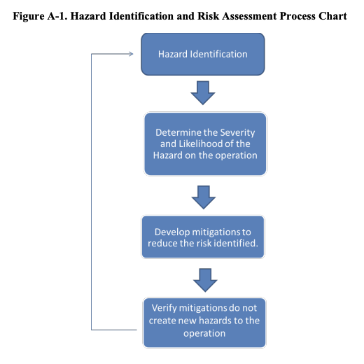

A.4 Safety Risk Assessment and Mitigation Steps. Before flight, the following Safety Risk Assessment and Mitigation steps should be taken. Figure A-2 in this paragraph is an example of a risk assessment plan in table format to accomplish this task. This example should not be considered a required format. It is designed simply to show one way to document a risk assessment and mitigation plan.

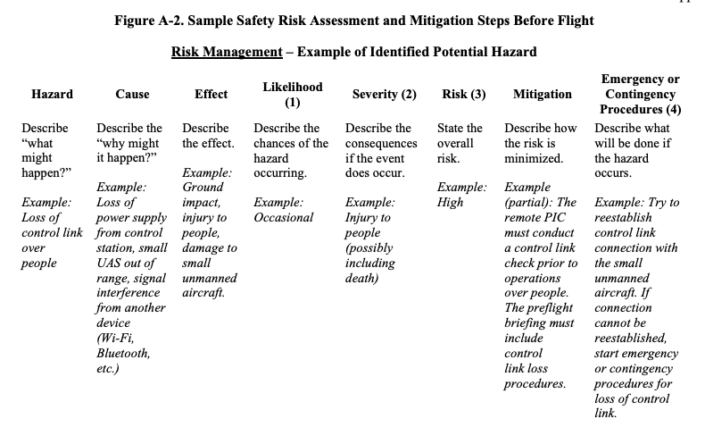

Notes:
(1) Likelihood: Likelihood the risk will occur – Improbable, Remote, Occasional, Probable, or Frequent.
(2) Severity: Consequence if the hazard occurs – No safety effect, Minor, Major, Hazardous, or Catastrophic.
(3) Risk: Combination of Likelihood and Severity – Low, Medium, High, or Avoid (i.e., changes to operation are required for mitigation or the operation should not be conducted). These definitions are used to assign the level of risk prior to consideration of risk mitigation effects.
(4) Emergency or Contingency Procedures: This column is your plan of action if the event still occurs.
(a) In order to identify effectively all potential hazards and their associated risks, you should first begin with a thorough description of the operational environment. This should include (but is not limited to):
1. Current and forecasted weather conditions.
2. Condition of the equipment to be used and associated operational limitations.
3. Remote pilot, observer, and other participants’ fatigue and awareness levels.
4. Terrain and obstacles (such as proximity to power lines, buildings, etc.) in the planned and emergency/contingency flightpath.
5. Identify the hazard(s) associated with flying over people (hazard column above).
6. If the operation will occur at night, identify hazards of flying at night, to include those operations whose mission duration includes portions of day, twilight, and night. Such potential hazards include night vision adaptation when unlit towers and buildings are present in the area of operation. Other potential hazards include current and forecast weather conditions and terrain features that may affect the ability for other aircraft operating in the area to see the anti-collision light for at least 3 statute miles (sm).
7. Identify other hazard(s) present during all small unmanned aircraft flights, such as schedule pressure, health issues, lack of familiarity with equipment, etc. (hazard column above).
(b) Once you have identified the potential hazards, complete the following steps for each hazard.
(c) List the cause(s) of each hazard (cause column above).
(d) List the effect(s) of each hazard (effect column above).
(e) Perform a qualitative risk assessment by:
1. Estimating the likelihood of each hazard occurring (probability column (1) above).
2. Estimating the severity of each hazard, if it occurs (severity column (2) above).
3. Defining the risk of each hazard as a combination of the probability and severity (risk column (3) above).
(f) Describe the mitigation steps for each hazard (mitigation column above). Develop controls to mitigate all risks to an acceptable level. If such development is not possible, the operator should not operate the small unmanned aircraft until the operator can accomplish this.
(g) Describe any procedures to accomplish, including emergency and contingency procedures, should the hazard occur (emergency or contingency procedure column (4) above).

A.4.1 In-Flight Mitigations. During the flight, the following safety risk assessment and mitigation steps should be taken:
1. Properly use the assessment and inspection checklists, including briefing of appropriate safety risk assessment and mitigation steps.
2. Maintain proper configuration of the small unmanned aircraft for the category of the operation.
3. Constantly re-assess risk.
4. Have and follow procedures for making changes to the flight profile, including crewmember notification.

A.4.2 Post-Flight. After the flight, the following steps should be taken:
1. Perform a thorough debriefing.
2. Capture lessons learned and recommendations.

A.4.3 Contributors to Consider When Performing Risk Assessments. The following list contains examples of factors to consider in assigning a risk rating to a specific identified hazard. This is not a comprehensive list, but an initial list of items to consider:
• Workload.
• Configuration (gross weight, center of gravity (CG), etc.).
• Environment (weather, ATC, particular airport conditions, turbulence, etc.).
• Specific small unmanned aircraft limitations as stated by the manufacturer.
• Consequence of failure in technique, system, or structure.

A.4.4 Formulating Mitigations. Mitigate all risks to an acceptable level. Mitigations are actions to minimize, understand, prepare, or respond to causes of the hazards. They are actions the remote pilot, crewmember(s), or other team member(s) have control over. Mitigations will address reducing either the probability of a cause, the severity of the effect, or both. Mitigations should be detailed and specific in nature. The following items should be considered when formulating mitigations. This is not a comprehensive list, but an initial list of items to consider:
• Set limits on flight conditions (e.g., minimum weather, altitude, minimum/maximum speed, etc.).
• Clearly define and brief criteria that could cause the discontinuation of the flight (e.g., items that affect safety of flight) and who will make and execute decisions.
• Review hazards and specify steps to reduce the associated risk(s).
• Review Weight and Balance (W&B) computations.

A.4.5 Emergency and Contingency Procedures. Describe any emergency and contingency procedures to accomplish if the hazard occurs, despite mitigation steps (emergency or contingency procedure column (4) in Figure A-2 above).

A.4.6 Other Risk Assessment Tools for Flight and Operational Risk Management. Other tools can also be used for flight or operational risk assessments and can be developed by the remote PICs themselves. The key consideration is ensuring all potential hazards and risks are identified and appropriate actions are taken to reduce the risk to persons and property not associated with the operations.

A.4.7 Reducing Risk. Risk analyses should concentrate not only on assigning levels of severity and likelihood, but on determining why these particular levels were selected. This is referred to as root cause analysis, and is the first step in developing effective controls to reduce risk to lower levels. In many cases, simple brainstorming sessions among crewmembers is the most effective and affordable method of finding ways to reduce risk. This also has the advantage of involving people who will ultimately be required to implement the controls developed.

A.4.7.1 It is very easy to get quite bogged down in trying to identify all hazards and risks. That is not the purpose of a risk assessment. The focus should be upon those hazards which pose the greatest risks. As stated earlier, by documenting and compiling these processes, a remote PIC can build an arsenal of safety practices that will add to the safety and success of future operations.

A.4.8 Sample Hazard Identification and Risk Assessment.

A.4.8.1 Example. I am the remote PIC of a small unmanned aircraft in the proximity of an accident scene shooting aerial footage. Much like pilots in manned aircraft must adhere to preflight action (14 CFR part 91, § 91.103), I must adhere to preflight familiarization, inspection, and aircraft operations (14 CFR part 107, § 107.49). Let’s say there is an obvious takeoff and landing site that I intend to use. What if, while I am operating, a manned aircraft (emergency medical services (EMS) helicopter) requires use of the same area and I am not left with a suitable landing site? Furthermore, I am running low on power. If I consider this situation prior to flight, I can use the Basic Hazard Identification and Mitigation Process. Through this process, I might determine that an acceptable level of risk can be achieved by also having an alternate landing site and possibly additional sites at which I can sacrifice the small unmanned aircraft to avoid imposing risks to people on the ground or to manned aircraft operations. It is really a simple process: I must consider the hazards presented during this particular operation, determine the risk severity, and then develop a plan to lessen (or mitigate) the risk to an acceptable level. By documenting and compiling these processes, I can build a collection of safety practices that will add to the safety and success of future operations. The following are some proven methods that can help a new remote PIC along the way:

A.4.8.2 Hazard Identification. Using the Personal Minimums (PAVE) Checklist for Risk Management, I will set personal minimums based upon my specific flight experience, health habits, and tolerance for stress, just to name a few. After identifying hazards, I will then input them into the Hazard Identification and Risk Assessment Process Chart (see Figure A-1).
1. Personal:
Am I healthy for flight and what are my personal minimums based upon my experience operating this small unmanned aircraft?
During this step, I will often use the IMSAFE checklist in order to perform a more in-depth evaluation:
• Illness – Am I suffering from any illness or symptom of an illness which might affect me in flight?
• Medication – Am I currently taking any drugs (prescription or over-the-counter)?
• Stress – Am I experiencing any psychological or emotional factors that might affect my performance?
• Alcohol – Have I consumed alcohol within the last 8 to 24 hours?
• Fatigue – Have I received sufficient sleep and rest in the recent past?
• Eating – Am I sufficiently nourished?

2. Aircraft:
Have I conducted a preflight check of my small UAS (aircraft, control station (CS), takeoff and landing equipment, anti-collision light for night operations, etc.)?
Has it been determined to be in a condition for safe operation?
Is the payload properly secured to the aircraft prior to flight?

3. Environment:
What is the weather like?
Am I comfortable and experienced enough to fly in the forecast weather conditions?
Have I considered all of my options and left myself an “out?”
Have I determined alternative landing spots in case of an emergency?
Will I be flying at night and how may that change the way I operate?
What are my associated risks when operating at night?
Will I have the ability to see the anti-collision light for at least 3 sm?
Will other aircraft that may be operating in the area have the ability to see the anti-collision light for at least 3 sm, considering weather and terrain (certain weather phenomena, such as fog, terrain features, and other phenomena, and obstacles such as hills, mountains, and manmade structures, may affect the ability for me and other aircraft to see the anti-collision light for at least 3 sm)?
Is the flash rate sufficient to avoid a collision?
Will I be operating over people, and if so, how will I ensure I do not create any hazards to persons not directly participating in the operation?
Can my operational area be considered an open-air assembly of persons?
Will I be operating over moving vehicles, and if so, how will I ensure I do not create any hazards to vehicles?
Will my operations (landing spots) need to be relocated due to the people?

4. External Pressures:
Am I stressed or anxious?
Is this a flight that will cause me to be stressed or anxious?
Is there pressure to complete the flight operation quickly?
Am I dealing with an unhealthy safety culture?
Am I being honest with myself and others about my personal operational abilities and limitations?

A.4.9 Controlling Risk. After hazards and risks are fully understood through the preceding steps, risk controls must be designed and implemented. These may be additional or changed procedures, additional or modified equipment, the addition of VOs, or any of a number of other changes.

A.4.10 Residual and Substitute Risk. Residual risk is the risk remaining after mitigation has been completed. Often, this is a multistep process, continuing until risk has been mitigated to an acceptable level necessary to begin or continue operation. After these controls are designed but before the operation begins or continues, an assessment must be made of whether the controls are likely to be effective and/or whether they introduce new hazards to the operation. The latter condition, introduction of new hazards, is referred to as substitute risk, a situation in which the resolution is worse than the original issue. The loop seen in Figure A-1 that returns back to the top of the diagram depicts the use of the preceding hazard identification, risk analysis, and risk assessment processes to determine whether the modified operation is acceptable.

A.4.11 Starting the Operation. Once a remote PIC develops and implements appropriate risk controls, the operation can begin.

APPENDIX B. SUPPLEMENTAL OPERATIONAL INFORMATION

B.1 Determining Operational Performance. The manufacturer may provide operational and performance information that contains the operational performance data for the aircraft such as data pertaining to takeoff, climb, range, endurance, descent, and landing. To be able to make practical use of the aircraft’s capabilities and limitations, it is essential to understand the significance of the operational data. The use of this data in flying operations is essential for safe and efficient operation. It should be emphasized that manufacturers’ information regarding performance data is not standardized. If manufacturer-published performance data is unavailable, it is advisable to seek out performance data that may have already been determined and published by other users of the same small UAS manufacturer model and use that data as a starting point.

B.2 Small Unmanned Aircraft Loading and Its Effects on Performance.

B.2.1 Weight and Balance (W&B). Before any flight, the remote PIC should verify the aircraft is correctly loaded by determining the W&B condition of the aircraft. An aircraft’s W&B restrictions established by the manufacturer or the builder should be closely followed. Compliance with the manufacturer’s W&B limits is critical to flight safety. The remote PIC must consider the consequences of an overweight aircraft, as it may result in an unsafe condition.

B.2.1.1 Although a maximum gross takeoff weight may be specified, the aircraft may not always safely take off with this load under all conditions. Conditions that affect takeoff and climb performance, such as high elevations, high air temperatures, and high humidity (high density altitudes) may require a reduction in weight before flight is attempted. Other factors to consider prior to takeoff are runway/launch area length, surface, slope, surface wind, and the presence of obstacles. These factors may require a reduction in weight prior to flight.

B.2.1.2 Weight changes during flight also have a direct effect on aircraft performance. Fuel burn is the most common weight change that takes place during flight. As fuel is used, the aircraft becomes lighter and performance is improved, but this could have a negative effect on balance. In UAS operations, weight change during flight may occur when expendable items are used on board (e.g., a jettisonable load).

B.2.2 Balance, Stability, and Center of Gravity (CG). Adverse balance conditions (i.e., weight distribution) may affect flight characteristics in much the same manner as those mentioned for an excess weight condition. Limits for the location of the CG may be established by the manufacturer. The CG is not a fixed point marked on the aircraft; its location depends on the distribution of aircraft weight. As variable load items are shifted or expended, there may be a resultant shift in CG location. The remote PIC should determine how the CG will shift and the resultant effects on the aircraft. If the CG is not within the allowable limits after loading or does not remain within the allowable limits for safe flight, it will be necessary to relocate or shed some weight before flight is attempted.

B.3 Sources of Weather Information for Small Unmanned Aircraft Operations. Remote PICs are encouraged to obtain weather information prior to flight from Flight Service by using the website https://www.1800wxbrief.com. Remote PICs can create a free account in order to use the briefing service. While Flight Service does offer a telephone-based service, it is intended for manned aircraft pilots only.

B.3.1 National Weather Service (NWS). Remote PICs are also encouraged to visit the NWS’s Aviation Weather Center (AWC) at https://www.aviationweather.gov. This free, web-based service does not require registration and offers all of the weather products important to a remote PIC, such as Aviation Routine Weather Reports (METAR) and Terminal Aerodrome Forecast (TAF). While reviewing the weather for your intended operation, it is also critical that the remote PIC review any TFRs at the FAA’s TFR website, which can be found at https://tfr.faa.gov.

B.4 Weather and the Effects on Performance. Weather is an important factor that influences aircraft performance and flying safety. Atmospheric pressure and density, wind, and uneven surface heating are factors that affect small unmanned aircraft performance and must be considered prior to flight.

B.4.1 Wind. Wind speed and direction are important as they affect takeoff, landing, and cruise of flight operations. Geological features, trees, structures, and other anomalies can affect the wind direction and speed close to the ground. In particular, ground topography, trees, and buildings can break up the flow of the wind and create wind gusts that change rapidly in direction and speed. The remote PIC should be vigilant when operating small unmanned aircraft near large buildings or other man-made structures and natural obstructions, such as mountains, bluffs, or canyons. The intensity of the turbulence associated with ground obstructions depends on the size of the obstacle and the primary velocity of the wind. This same condition is even more noticeable when flying in mountainous regions. While the wind flows smoothly up the windward side of the mountain and the upward currents help to carry an aircraft over the peak of the mountain, the wind on the leeward side does not act in a similar manner. As the air flows down the leeward side of the mountain, the air follows the contour of the terrain and is increasingly turbulent. This tends to push an aircraft into the side of a mountain. The stronger the wind, the greater the downward pressure and turbulence become. Due to the effect terrain has on the wind in valleys or canyons, downdrafts can be severe.

B.4.2 Surface Heat. Different surfaces radiate heat in varying amounts. Plowed ground, rocks, sand, and barren land give off a larger amount of heat, whereas water, trees, and other areas of vegetation tend to absorb and retain heat. The resulting uneven heating of the air creates small areas of local circulation called convective currents, which creates bumpy, turbulent air. Convective currents, with their rising and sinking air can adversely affect the controllability of the small unmanned aircraft.

B.5 Battery Fires. Lithium-based batteries are highly flammable and capable of ignition. A battery fire could cause an in-flight emergency by causing a LOC of the small unmanned aircraft. Lithium battery fires can be caused when a battery short-circuits, is improperly charged, is heated to extreme temperatures, is damaged as a result of a crash, is mishandled, or is simply defective. The remote PIC should consider following the manufacturer’s recommendations, when available, to help ensure safe battery handling and usage.

B.6 Small UAS Frequency Utilization. A small UAS typically uses RFs for the communication link between the CS and the small unmanned aircraft.

B.6.1 Frequency Spectrum (RF) Basics. The 2.4 GHz and 5.8 GHz systems are the unlicensed band RFs that most small UAS use for the connection between the CS and the small unmanned aircraft. Note the frequencies are also used for computer wireless networks and the interference can cause problems when operating an unmanned aircraft in an area (e.g., dense housing and office buildings) that has many wireless signals. LOC and flyaways are some of the reported problems with small UAS frequency implications.

B.6.1.1 To avoid frequency interference, many modern small UAS operate using a 5.8 GHz system to control the small unmanned aircraft and a 2.4 GHz system to transmit video and photos to the ground. Consult the small UAS operating manual and manufacturer’s recommended procedures before conducting small UAS operations.

B.6.1.2 It should be noted that both RF bands (2.4 GHz and 5.8 GHz) are considered line of sight and the command and control link between the CS and the small unmanned aircraft will not work properly when barriers are between the CS and the unmanned aircraft. Part 107 requires the remote PIC or person manipulating the controls to be able to see the unmanned aircraft at all times, which should also help prevent obstructions from interfering with the line of sight frequency spectrum.

B.6.2 Spectrum Authorization. Frequency spectrum used for small unmanned aircraft operations are regulated by the Federal Communications Commission (FCC). Radio transmissions, such as those used to control an unmanned aircraft and to downlink real-time video, must use frequency bands that are approved for use by the operating agency. The FCC authorizes civil operations. Some operating frequencies are unlicensed and can be used freely (e.g., 900 MHz, 2.4 GHz, and 5.8 GHz) without FCC approval. All other frequencies require a user-specific license for all civil users, except Federal agencies, to be obtained from the FCC. For further information, visit https://www.fcc.gov/licensing-databases/licensing

APPENDIX C. SMALL UAS MAINTENANCE AND INSPECTION BEST PRACTICES

C.1 In the interest of assisting operators with varying background levels of small UAS knowledge and skill, below is a chart offering conditions that, if noticed during a preflight inspection or check, may support a determination that the small unmanned aircraft is not in a condition for safe operation. Further inspection to identify the scope of damage and extent of possible repair needed to remedy the unsafe condition may be necessary prior to flight.

C.2 For Category 4 maintenance requirements for operating in accordance with 14 CFR part 107, see Chapter 8, paragraph 8.3.7.4.

C.3 For Category 4 record retention requirements, see Chapter 8, paragraph 8.3.7.4.1.

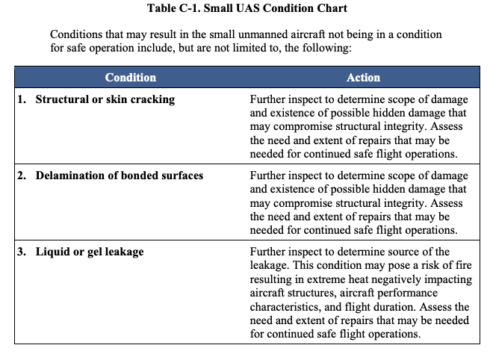
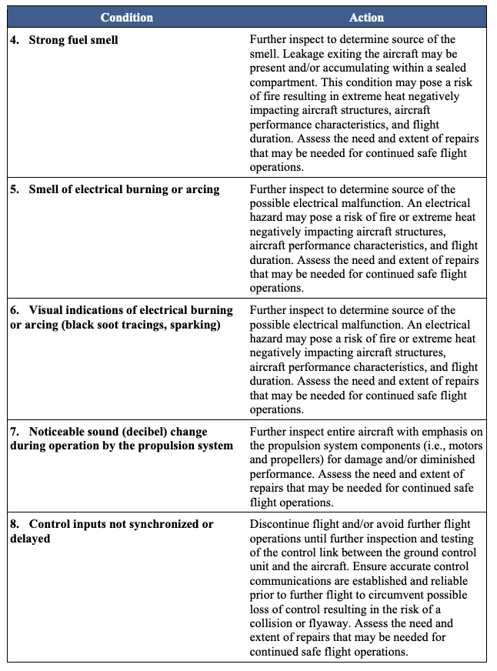
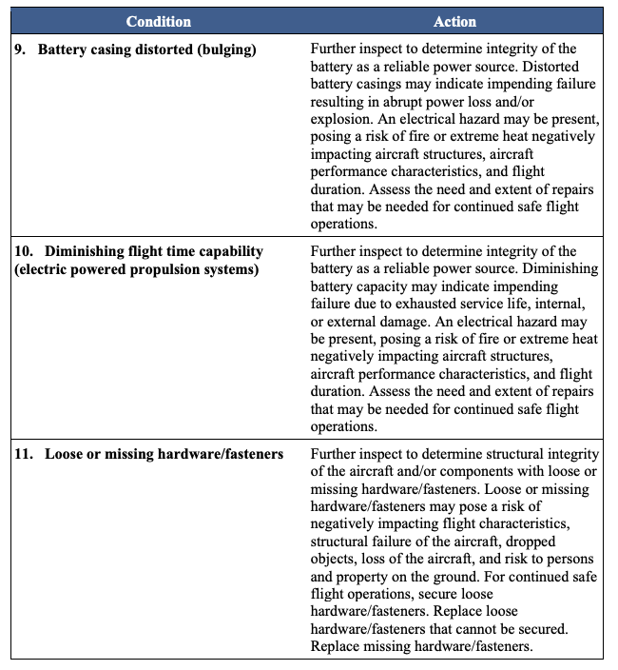

APPENDIX D. REMOTE PILOT CERTIFICATION AND APPLICANT IDENTITY VERIFICATION

D.1 Remote Pilot Certification. Specific knowledge requirements for the Remote Pilot Certificate are located in 14 CFR part 107 subpart C.

D.1.1 A person may apply for a Remote Pilot Certificate with one of the following certifying official: a CFI, a DPE, through an FAA aviation safety inspector (ASI) or aviation safety technician (AST), or with an Airman Certification Representative (ACR) associated with a 14 CFR part 141 pilot school. All Remote Pilot Certificates will be issued by the Civil Aviation Registry Division (AFB-700) on a high quality plastic card stock containing tamper- and counterfeit-resistant features.

D.1.2 Additional information on the eligibility requirements for remote pilots can be found at part 107, § 107.61. Note: If an applicant has a known medical issue that would require a limitation on the Remote Pilot Certificate, refer that applicant to the responsible Flight Standards office to ensure the application is processed with the correct limitations.

D.2 Acceptance of a Remote Pilot Application. Certifying officials may accept an individual’s application for an FAA Remote Pilot Certificate by utilizing the FAA’s IACRA or the paper FAA Form 8710-13, Remote Pilot Certificate and/or Rating Application.

D.3 IACRA. Authorized individuals are encouraged to utilize IACRA for the purpose of accepting a remote pilot application. IACRA is a web-based certification/rating application system that guides the user through the FAA’s application process. IACRA may be accessed at https://iacra.faa.gov/iacra/. The website also contains an instruction manual for additional assistance.

D.4 CFI Registration Process for Accepting an Application for a Remote Pilot Certificate. In order for a CFI to accept a remote pilot application, the CFI must be registered in IACRA as the role of “Recommending Instructor.” Even though the instructor is utilizing the role of a certifying officer, their signature will be reflected in the “Instructor Action” section of FAA Form 8710-13.

D.5 Establishing Eligibility. Before processing an application for a Remote Pilot Certificate, the certifying official must ensure the applicant meets the eligibility requirements of § 107.61, meets the flight review requirements specified in 14 CFR part 61, § 61.56, and verifies the applicant’s identity. The certifying official should refer to AC 60-28, FAA English Language Standard for an FAA Certificate Issued Under 14 CFR Parts 61, 63, 65, and 107, and the International Civil Aviation Organization (ICAO) website to prepare for the assessment. The AC outlines the required procedures to ensure the applicant meets the FAA Aviation English Language Proficiency (AELP) standards. The ICAO website can be found at http://cfapp.icao.int/rssta/RSSTA.cfm. After conducting an assessment of the applicant’s English language proficiency, in accordance with AC 60-28, if it is determined the applicant does not meet the FAA standard, process the application by:

D.5.1 When utilizing IACRA, answer the questions concerning FAA AELP. The system will recognize whether the applicant has met the FAA AELP and process the application as necessary. No additional paperwork will be required to be mailed to the responsible Flight Standards office.

D.5.2 When utilizing a paper FAA Form 8710-13, if the applicant does not meet the eligibility requirements of § 107.61, the certifying official will check the “Application Rejected” box in the appropriate section of the Submitting Official’s Report and specify the reason for rejection. The authorized individual will also check the “No” box after the statement “Applicant meets FAA Aviation English Language Proficiency.” After verifying the application is complete, forward this application to the responsible Flight Standards office for data entry and processing, even if the applicant does not meet the eligibility requirements. The address and contact information for the responsible Flight Standards office can be found at https://www.faa.gov/about/office_org/field_offices/fsdo/. Note: If the applicant does not meet the eligibility requirements of § 107.61, do not check the “Application Accepted” box. This box should only be checked once it is determined the applicant meets the eligibility requirements. Check the “Application Rejected” box and continue processing the application. The terms “accept” and “reject” are used to notify AFB-700 of whether the applicant meets the requirements for the issuance of a Remote Pilot Certificate.

D.6 Application Process Utilizing IACRA. A person who meets the eligibility requirements of a Remote Pilot Certificate may register as an applicant through IACRA, which stores FAA Form 8710-13 electronically until a certifying official accesses the form. FAA Form 8710-13 may be accessed by a certifying official by searching for the person’s unique FAA tracking number (FTN) assigned by an FAA internal system after the person has completed the required items on the remote pilot application form. The certifying official will verify that the applicant meets the regulatory eligibility requirements and that the application has been completed properly. Additionally, the certifying official will verify the applicant’s identity and input the photograph identification data into IACRA when prompted. Once the authorized individual has completed the application through IACRA, it will be transmitted electronically to AFB-700 for processing.

D.7 Application Process Utilizing Paper FAA Form 8710-13. Applicants have the ability to apply for a Remote Pilot Certificate in paper format on the FAA Form 8710-13 to ensure all applicants have the uninterrupted ability to apply for an FAA Remote Pilot Certificate. The same information captured on the paper FAA Form 8710-13 is captured within IACRA. Once it is verified the applicant meets the eligibility requirements of § 107.61, the certifying official will check the “Application Accepted” box in the Submitting Official’s Report section. The certifying official will also select the “Yes” box after the statement “Applicant meets FAA Aviation English Language Proficiency.” Once the authorized individual has verified that the application was completed in accordance with the form’s instructions, the certifying official will send the completed remote pilot application to their responsible Flight Standards office for data entry. The address and contact information for the responsible Flight Standards office can be found at https://www.faa.gov/about/office_org/field_offices/fsdo/. Once the data is captured, the FSDO will mail the application file to AFB-700 via first-class mail to the following address: DOT/FAA, Airmen Certification Branch, AFB-720, P.O. Box 25082, Oklahoma City, OK 73125. The FAA notes that the submittal of a paper FAA Form 8710-13 may delay the issuance of a Remote Pilot Certificate because of mailing time to AFB-700.

D.8 Documentation of Identification on Paper FAA Form 8710-13. The certifying official accepting an individual’s application for a Remote Pilot Certificate should review the person’s photo identification presented at the time of application to confirm it is current and valid. The flight instructor should document the type of identification and number submitted (e.g., Virginia driver’s license number A12345678 and expiration date xx/xx/xxxx) on the FAA Form 8710-13 “Airman’s Identification” section in accordance with the following guidelines.

D.9 Pilot Certificate Applicant Identity Verification.

D.9.1 General Identity Document Review Guidelines:

D.9.1.1 Applicant must present a government-issued photo identification (refer to suggested list below).

D.9.1.2 Confirm that the applicant matches the photo on the identification document.

D.9.1.3 Identity document must be valid. Please note that some States do not provide an expiration date on certain documentation.

D.9.1.4 Name on the identity document must substantially match the name on the application.

D.9.1.4.1 Use best judgment when comparing the identity documents and application data as a person may reasonably identify themselves through the use of multiple variations of their legal, given, and/or nicknames (e.g., Robert Michael Smith Jr; Robert M Smith Jr; Robbie M Smith; Bob/Bobbie Smith).

D.9.1.4.2 Additionally, there may be a suffix on the identity document (such as JR, SR, II, III) that may not be present on the application. Ensure the applicant’s name on the application matches their identification.

D.9.1.5 If date of birth is present on the document provided, it must match the date of birth on the application.

D.9.1.6 If address is present on the document provided, compare to the address on the application. If the address is different, please request the applicant to provide a current address.

D.9.1.7 If gender is present on the document provided, it must match the gender on the application.

D.9.1.8 If an identity document appears to be fraudulent or shows signs of tampering, or if any of the identifying information on the identity document does not satisfactorily match the information on the application as explained in this guidance, do not challenge the individual; complete the application process, copy presented documents and record the individual’s name, address, and contact information to include phone numbers, emails, etc. Provide this information to supervisory, security, investigative, or law enforcement personnel as soon as possible.

D.9.2 List of Acceptable Documents or Combination of Documents:
1. Unexpired U.S. passport (book or card).
2. Unexpired Enhanced Tribal Card (ETC).
3. Unexpired Free and Secure Trade (FAST) Card.
4. Unexpired Global Entry Card.
5. Unexpired U.S. Enhanced Driver’s License (EDL) or Unexpired Enhanced Identification Card (EID).
6. Permanent Resident Card (Form I-551), commonly referred to as a “Green Card.”
7. Unexpired foreign passport.
8. Unexpired Reentry Permit (Form I-327).
9. Unexpired driver’s license issued by a State or outlying possession of the United States.
10. Unexpired temporary driver’s license plus expired driver’s license.
11. Unexpired photo ID card issued by a State or outlying possession of the United States. This must include a State or State agency seal or logo (such as a State university ID). Permits are not considered valid identity documents (such as gun permits).
12. Unexpired photo ID card issued by a regional, county, or city/municipal governmental authority, to include but not limited to law enforcement, governmental, education, transportation, or utility authority.
13. Unexpired U.S. military ID card.
14. Unexpired U.S. retired military ID card.
15. Unexpired U.S. military dependent’s card.
16. Native American tribal document with photo.
17. Unexpired Department of Homeland Security (DHS)/Transportation Security Administration (TSA) Transportation Worker Identification Credential (TWIC).
18. Unexpired Merchant Mariner Credential (MMC).
19. U.S. Birth Certificate and an unexpired government-issued ID.
20. U.S. Naturalization Certificate with a raised seal, or Certificate of Naturalization issued by U.S. Citizenship and Immigration Services (USCIS) or the Immigration and Naturalization Service (INS) (Form N-550 or N-570) with a government-issued ID.
21. Certificate of Birth Abroad with raised seal, Department of State Form FS-545, or DS-1350 with government-issued ID.
22. Certificate of U.S. Citizenship with raised seal, or Certificate of Citizenship issued by USCIS or INS, or Certificate of Repatriation issued by USCIS or INS, together with a government-issued ID.
23. A Federal agency’s written certification of its employee’s U.S. citizenship, if the training is being conducted on behalf of that agency.

APPENDIX E. SAMPLE PREFLIGHT ASSESSMENT AND INSPECTION CHECKLIST

E.1 Sample Preflight Assessment and Inspection Checklist. Remote pilots may choose to use this checklist or develop their own for the operation of their specific small UAS.

Preflight Assessment
1. Operating Environment:
a. Local Weather Conditions;
b. Local Airspace, ATC coordination/communication requirements, and any flight restrictions;
c. Identify the location of persons and property on the surface; and
d. Other ground hazards.

2. Crew Briefings:
a. Operating Conditions,
b. Purpose of Flight,
c. Potential Hazards,
d. Emergency Procedures,
e. Contingency Procedures,
f. Crewmember Roles and Responsibilities, and
g. Human Factors (I.M.S.A.F.E).

3. Ensure all required documentation is available for inspection.

4. Verify all the manufacturer-required components that make up the small UAS are present and operating as designed.

5. Review Remote Pilot Operating Instructions (if applicable).

6. Complete Certificate of Waiver (CoW) review (if applicable). Review risk assessment and required mitigations.

7. Verify that the control station (CS) location, take-off and landing site(s), including emergency or alternate landing areas are suitable.

8. For operations that will not occur over human beings:
a. Consider whether lateral and vertical off-sets from human beings will be necessary to maintain safety of the operation.
b. Review and adjust the flightpath to ensure it accounts for any movement of human beings.

9. For operations that will occur over human beings:
a. Verify the small unmanned aircraft is eligible to conduct the intended category of operations over human beings.
b. Verify the small unmanned aircraft is clearly labeled for the intended category of operations over human beings.
c. If the small unmanned aircraft has undergone any modification, verify the manufacturer allowed such modifications as described in the remote pilot operating instructions.
d. Verify the small unmanned aircraft is properly configured and mode selected for the category of operations over human beings.
e. Consider whether the operational area can be considered an open-air assembly of persons.
f. For Category 3 operations:
i. Ensure the small unmanned aircraft flightpath of the operation does not go over an open-air assembly of people.
ii. Not within or over a closed- or restricted-access site: May only operate the small unmanned aircraft above any human being if the operation does not maintain sustained flight over any person, unless the person is directly participating in the operation or located under a covered structure or inside a stationary vehicle.
iii. Within or over a closed- or restricted-access site: May only operate the small unmanned aircraft above any human being if the operation is within or over a closed- or restricted-access site and any human being located within the closed- or restricted-access site is on notice that a small unmanned aircraft may fly over them.

10. Evaluate and use mitigations to prevent the remote pilot from becoming distracted or losing VLOS during flight operations.

11. Review small unmanned aircraft performance capabilities, considering density altitude and wind, to ensure positive control of the small unmanned aircraft can be maintained and at a safe distance over people, if applicable. The review should also include maintaining a clear flightpath while operating the small unmanned aircraft.

12. Visual condition inspection of the small UAS components.
13. Airframe structure (including undercarriage), all flight control surfaces, and linkages.
14. Registration markings, for proper display and legibility.
15. Moveable control surface(s), including airframe attachment point(s).
16. Servo motor(s), including attachment point(s).
17. Propulsion system, including powerplant(s), propeller(s), rotor(s), ducted fan(s), etc.
18. Check fuel for correct type and quantity.
19. Check that any equipment, such as a camera, is securely attached.
20. Verify all systems (e.g., aircraft and control unit) have an adequate power supply for the intended operation and are functioning properly
21. Verify adequate communication between CS and small unmanned aircraft exists; check to ensure the small UAS has acquired GPS location from the minimum number of satellites specified by the manufacturer.
22. Verify correct indications from avionics, including control link transceiver, communication/navigation equipment, and antenna(s).
23. Check the display panel, if used, is functioning properly.
24. Check ground support equipment, including takeoff and landing systems, for proper operation.
25. Check for correct movement of control surfaces using the CS.
26. Check flight termination system, if installed (if applicable).
27. Check the anti-collision light is functioning and can be seen for at least 3 sm (for operations that will occur at civil twilight or night).
28. Calibrate small UAS compass, if required, prior to any flight.
29. Verify controller operation for heading and altitude.
30. Start the small unmanned aircraft propellers to inspect for any imbalance or irregular operation.
31. At a controlled low altitude, fly within range of any interference and recheck all controls and stability. ___________________________________________________________________________

Post-Flight
1. Evaluate small UAS to determine whether repairs are required prior to subsequent flights.
2. Conduct a review of the flight to include any crewmember(s) utilized. This review should consist of items, such as:
• Remote pilot and crewmember performance of assigned duties;
• Equipment malfunctions and anomalies;
• Whether the planned risk mitigation measures were effective or require revision;
• Unanticipated risks and hazards encountered during flight operations, and mitigations used; and
• Crewmember concerns and feedback to improve the safety of future flight operations.

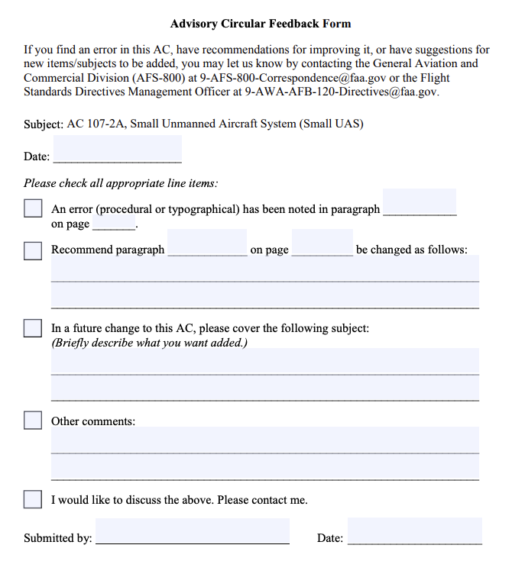

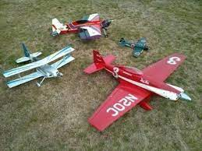
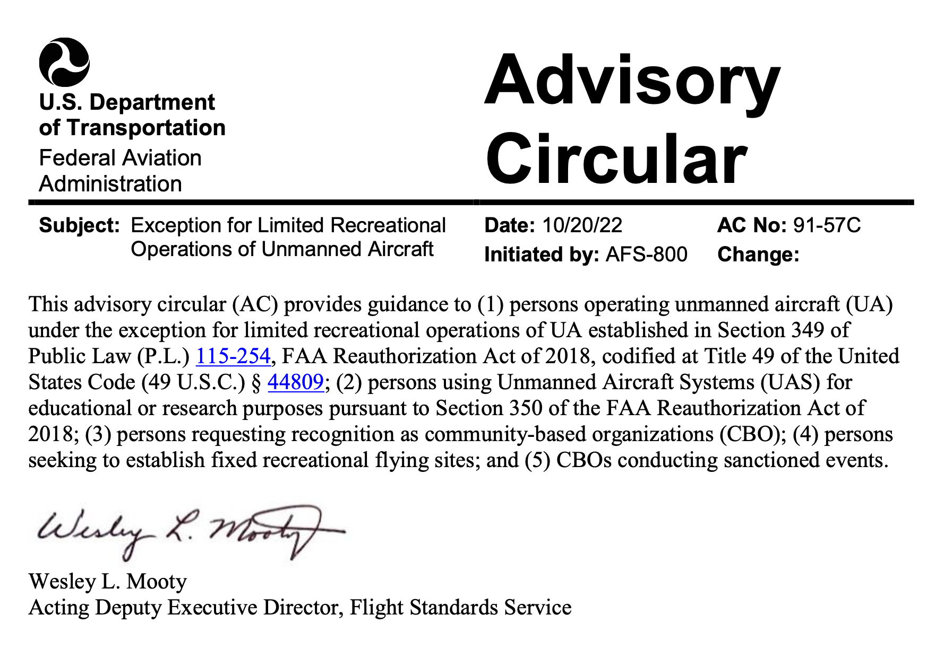

AC 91-57C
CHAPTER 1. GENERAL
1.1 Purpose of This Advisory Circular (AC). The guidance provided in this AC supports the limited recreational operation of unmanned aircraft (UA) by explaining how a recreational flyer of UA may comply with the statutory requirements of Title 49 of the United States Code (49 U.S.C.) This AC provides guidance for operating UA under the exception, including operations for certain educational and research purposes; FAA recognition of community-based organizations (CBO); and application for fixed sites and CBO-sanctioned UA flying events. UA (sometimes referred to as “drones”) are aircraft operated without the possibility of direct human intervention from within or on the aircraft. Refer to 49 U.S.C. § 44801.
1.1.1 Effects of Guidance. The contents of this document do not have the force and effect of law and are not meant to bind the public in any way, and the document is intended only to provide information to the public regarding existing requirements under the law or agency policies.
  - Audience. This AC provides information to:
1. Persons operating UA under the exception for limited recreational operations of UA established in Section 349 of Public Law (P.L.) 115-254, FAA Reauthorization Act of 2018, codified at 49 U.S.C. § 44809.
2. Persons operating UA for educational or research purposes pursuant to Section 350 of the FAA Reauthorization Act of 2018, as amended by Section 10002 of P.L. 116-283, William M. (Mac) Thornberry National Defense Authorization Act for Fiscal
Year 2021.
3. Persons requesting FAA recognition as a CBO.
4. Persons seeking the establishment of fixed recreational flying sites.
5. Persons organizing UA-only CBO-sponsored events.
1.3 Where You Can Find This AC. You can find this AC on the FAA’s website at https://www.faa.gov/regulations_policies/advisory_circulars and the Dynamic Regulatory System (DRS) at https://drs.faa.gov.
1.4 What This AC Cancels. AC 91-57B, Exception for Limited Recreational Operations of Unmanned Aircraft, dated May 31, 2019, is canceled.
  - Related References (current editions).
1. Title 49 U.S.C. Subtitle VII, Aviation Programs, § 40101 et seq.
2. Title 49 U.S.C. § 44809, Exception for Limited Recreational Operations of Unmanned Aircraft.
3. P.L. 115-254, FAA Reauthorization Act of 2018.
4. P.L. 116-283, William M. (Mac) Thornberry National Defense Authorization Act for Fiscal Year 2021.
5. Title 14 of the Code of Federal Regulations (14 CFR) Part 45, Identification and Registration Marking.
6. Title 14 CFR Part 47, Aircraft Registration.
7. Title 14 CFR Part 48, Registration and Marking Requirements for Small Unmanned Aircraft.
8. Title 14 CFR Part 89, Remote Identification of Unmanned Aircraft.
9. Title 14 CFR Part 107, Small Unmanned Aircraft Systems.
10. AC 107-2, Small Unmanned Aircraft Systems (Small UAS).
11. FAADroneZone: https://faadronezone.faa.gov/.
12. Unmanned Aircraft Systems (UAS) Data Delivery System: https://udds-faa.opendata.arcgis.com/.
13. Temporary Flight Restriction (TFR) Listing: http://tfr.faa.gov/tfr2/list.html.
14. Aeronautical Navigation Products (Charts): https://www.faa.gov/air_traffic/flight_info/aeronav/productcatalog/.
15. Notices to Air Missions (NOTAM): https://www.faa.gov/air_traffic/publications/notices/.
16. National Aviation Events Program: https://www.faa.gov/about/initiatives/airshow/.
17. UA Registration Guidance: https://www.faa.gov/licenses_certificates/aircraft_certification/aircraft_registry/UA/.
1.6 Background. On October 5, 2018, the President signed the FAA Reauthorization Act of 2018 into law. Section 349 of the FAA Reauthorization Act of 2018, codified at
49 U.S.C. § 44809, repealed the special rule for model aircraft in Section 336 of
P.L. 112-95, FAA Modernization and Reform Act of 2012. Section 44809 allows a person to fly a UA without specific certification or operating authority from the FAA, so long as the operation meets certain limitations enumerated in the statute. Further, 49 U.S.C. § 44809(i) requires the FAA to publish an AC that identifies the limitations and process required for recognition of a CBO, as set forth in 49 U.S.C. § 44809(h).
1.7 Limited Recreational UA Operations.
1.7.1 Recreational flyers must ensure the operation of their UA complies with all applicable statutory and regulatory requirements.
1.7.2 The guidance provided in this AC explains how a recreational flyer can comply with the requirements of 49 U.S.C. § 44809 in order to operate a UA without FAA certification or operating authority. If the operation of a UA fails to meet all the operational limitations contained in 49 U.S.C. § 44809(a), such operation must be operated in accordance with the applicable FAA operating rules, and comply with the relevant FAA airman and aircraft certification requirements (e.g., 14 CFR part 21, 61, 91, or 107).
1.7.3 The Administrator may pursue an enforcement action against any person operating a UA under 49 U.S.C. § 44809 who endangers the safety of the National Airspace System (NAS). Refer to 49 U.S.C. § 44809(e). Such operations include, but are not limited to, careless or reckless operations, or operations endangering persons or property.
1.7.4 Recreational operators must comply with part 89. Refer to 49 U.S.C. § 44809(f)(3). The FAA notes that FAA-Recognized Identification Areas (FRIA) established under part 89 and “fixed sites” for purposes of recreational flying under 49 U.S.C. § 44809(c) are two different kinds of UA operating areas with different purposes, requirements, and application processes. A fixed site is a location with a standing airspace authorization for recreational flying, while a FRIA is a location where UA may operate without remote identification. In some places where an airspace authorization is required for recreational flying, such as in controlled airspace and where a CBO has also obtained approval for a FRIA, a FRIA and fixed site may overlap. If a CBO has obtained authorization for a fixed site but has not obtained approval for a FRIA, remote identification requirements will still apply.
1.8 AC Feedback Form. For your convenience, the AC Feedback Form is the last page of this AC. Note any deficiencies found, clarifications needed, or suggested improvements regarding the contents of this AC on the Feedback Form. The form includes instructions for submitting it to the FAA.

CHAPTER 2. RECREATIONAL FLYER STATUTORY LIMITATIONS
2.1 Recreational Flyer. For the purposes of this AC, a recreational flyer is a person who operates a UA strictly for recreational purposes in accordance with 49 U.S.C. § 44809. This is an operation-specific determination. Recreational operations that do not comply with the statutory parameters are not eligible for the recreational flyer exception of 49 U.S.C. § 44809.
2.2 Statutory Limitations. Recreational flyers operating small UA must adhere to all of the statutory limitations included in 49 U.S.C. § 44809(a) in order to operate under the statutory exception to operate a UA without specific certification or operating authority from the FAA. Pursuant to 49 U.S.C. § 44809(c)(2)(A) and (B), UA weighing more than 55 pounds must be operated under FAA-approved safety guidelines of a recognized CBO and operated solely at a fixed site. The statutory limitations for small UA operated under 49 U.S.C. § 44809 include the following:
2.2.1 Section 44809(a)(1). “The aircraft is flown strictly for recreational purposes.”
2.2.1.1 Recreational purposes may not include activities such as flights for any compensation, monetary or otherwise, and flights related to or in furtherance of a business. A person may not combine recreational and commercial purposes in a single flight.
Note: This AC references various types of operations or events that may typically be considered recreational; however, whether or not an operation is considered recreational is situation-specific. Each individual pilot must maintain responsibility for compliance with the 49 U.S.C. § 44809(a)(1) requirement for recreational purpose, regardless of whether the event is sanctioned by a CBO or otherwise presented as generally compliant with 49 U.S.C. § 44809(a)(1).
2.2.1.2 A “recreational purpose” includes, but is not limited to:
2.2.1.2.1 UAS operated by an institution of higher education, as defined in 20 U.S.C. § 1001(a) for educational or research purposes;
Note: The term “educational or research purposes,” with respect to the operation of a UAS by an institution of higher education, includes:
1. Instruction of students at the institution;
2. Academic or research-related uses of UAS that have been approved by the institution, including Federal research;
3. Activities undertaken by the institution as part of research projects, including research projects sponsored by the Federal Government; and
4. Other academic activities approved by the institution.
2.2.1.2.2 UAS flown as part of an established Junior Reserve Officers’ Training Corps (JROTC) program for educational or research purposes; or
2.2.1.2.3 UAS flown as part of an educational program that is chartered by a recognized CBO, as defined in 49 U.S.C. § 44809(h).
Note: Any elementary and secondary educational institutions, that are not institutions of higher education or do not fly UAS as part of a JROTC program, would either have to receive FAA recognition as a CBO or be chartered by a recognized CBO to operate under 49 U.S.C. § 44809; otherwise, such institutions must conduct all operations under part 107.
2.2.2 Section 44809(a)(2). “The aircraft is operated in accordance with or within the programming of a community-based organization’s set of safety guidelines that are developed in coordination with the Federal Aviation Administration.”
2.2.2.1 Recreational flyers should be able to explain to an FAA inspector or law enforcement officer which CBO’s safety guidelines they are operating under during any given flight. However, an operator does not need to be a member of a CBO to fly under its safety guidelines. The FAA maintains a website of officially recognized CBOs at https://www.faa.gov/uas/recreational_fliers/.
2.2.3 Section 44809(a)(3). “The aircraft is flown within the visual line of sight of the person operating the aircraft or a visual observer co-located and in direct communication with the operator.”
2.2.3.1 In order to be operating within visual line of sight (VLOS), either the operator or a visual observer (VO) must be able to see the UA (with vision unaided by any device other than corrective lenses) throughout the entire flight to ensure it does not present a collision hazard to other manned aircraft or persons or property on the ground. The use of a VO is optional, but a VO enables the recreational flyer to look away from the UA for extended periods. The use of a VO is necessary if the recreational flyer wants to use first person view (FPV) devices, which allow a view from an onboard camera but limit the operator’s ability to scan the surrounding airspace.
Note: For a VO to be considered co-located with the recreational flyer, the VO should be close enough to the recreational flyer to be able to communicate directly with him or her without the use of technological assistance and without creating a distraction to the recreational flyer.
2.2.4 Section 44809(a)(4). “The aircraft is operated in a manner that does not interfere with and gives way to any manned aircraft.”
2.2.4.1 The recreational flyer is responsible for knowing, at all times, the position of the aircraft in relation to other aircraft; for maintaining a safe distance from other aircraft; and for giving the right-of-way to all manned aircraft.
2.2.5 Section 44809(a)(5). “In Class B, Class C, or Class D airspace or within the lateral boundaries of the surface area of Class E airspace designated for an airport, the operator obtains prior authorization from the Administrator or designee before operating and complies with all airspace restrictions and prohibitions.”
2.2.5.1 The NAS includes both controlled and uncontrolled airspace. Recreational flyers must obtain specific airspace authorization from the FAA prior to operating UA in Class B, C, or D airspace or within the lateral boundaries of the surface area of Class E airspace designated for an airport (controlled airspace). Recreational flyers do not need to obtain authorization prior to operating in Class G (uncontrolled airspace) below 400 feet above ground level (AGL).
2.2.5.2 Recreational flyers may use the FAA’s Low Altitude Authorization and Notification Capability (LAANC) to check for airspace restrictions and obtain authorization to fly in controlled airspace. LAANC provides automated, near real-time authorization for airspace authorization requests in most controlled airspace. See subparagraph 2.2.5.3 below for instances in which LAANC does not provide authorization. Recreational flyers can access LAANC through FAA-approved third-party UAS Service Suppliers (USS). A list of companies approved to offer LAANC services, as well as additional information on LAANC is available on the FAA website at https://www.faa.gov/uas/program s_partnerships/data_exchange/. Recreational flyers may submit authorization requests up to 90 days prior to intended flight.
Note: Recreational flyers should not contact air traffic control (ATC) facilities to obtain airspace authorizations to fly in controlled airspace.
2.2.5.3 If a recreational flyer wants to fly near an airport in Class B, C, or D airspace or within the lateral boundaries of the surface area of Class E airspace designated for an airport that are not serviced by LAANC, the recreational flyer should use the FAADroneZone website (https://faadronezone.faa.gov/) to request an airspace authorization. The recreational flyer should submit the request at least 90 days prior to the proposed flight to allow the FAA time to review the airspace and the information provided for the flight.
2.2.5.4 The FAA recommends that recreational flyers refer to the FAA’s interactive map on the UAS Data Delivery System at https://udds- faa.opendata.arcgis.com/ to access information and graphical depictions regarding any UAS-specific flight restrictions. On the map, semi-transparent polygons depict airspace information. UAS flight restrictions are shown as red polygons. Recreational flyers are also responsible for complying with all special use airspace designations, including prohibited areas and restricted areas, as well as other special flight rules and TFRs published at http://tfr.faa.gov/tfr2/list.html, and Aeronautical Navigation Products (Charts) at https://www.faa.gov/air_traffic/flight_info/aeronav/productcatalog/.
2.2.5.5 The B4UFLY app is a useful resource for recreational flyers to use prior to operating their UA (whether in controlled or uncontrolled airspace). It provides critical airspace information to the user including the locations of airports, national parks, stadiums, special use airspace (including restricted and prohibited airspace), TFRs, other special flight rules, and more. More information on B4UFLY is provided at https://www.faa.gov/uas/recreational_fliers/where_can_i_fly/b4ufly/.
2.2.6 Section 44809(a)(6). “In Class G airspace, the aircraft is flown from the surface to not more than 400 feet above ground level and complies with all airspace restrictions and prohibitions.”
2.2.6.1 “Ground level” begins at the Earth’s surface and does not include man-made structures, trees, or any obstacle. For example, a UA engaged in recreational operations under 49 U.S.C. § 44809(a) may not be launched from a 10-story rooftop and fly up an additional 400 feet.
2.2.7 Section 44809(a)(7). “The operator has passed an aeronautical knowledge and safety test ... and maintains proof of test passage to be made available to the Administrator or law enforcement upon request.”
2.2.7.1 A list of FAA-approved test administrators for The Recreational UAS
Safety Test (TRUST) is provided at https://www.faa.gov/uas/recreational_flier s/knowledge_test_updates/.
2.2.7.2 The proof of test passage may be in any format (e.g., paper or electronic) so long as it is readily accessible, legible, and can be presented to the Administrator or law enforcement upon request.
2.2.8 Section 44809(a)(8). “The aircraft is registered and marked in accordance with chapter 441...and proof of registration is made available to the Administrator or a designee of the Administrator or law enforcement upon request.”
2.2.8.1 Recreational flyers must register UA weighing more than 0.55 pounds
(250 grams) at takeoff including those used in limited recreational operations. Owners of such UA may register electronically in accordance with part 48 through the FAADroneZone website at https://faadronezone.faa.gov/ or through the part 47 paper-based process described at https://www.faa.gov/licenses_certificates/aircraft_certification/aircraft_registry/UA.
2.2.8.2 The owner of a small UA weighing more than 0.55 pounds (250 grams) that will be flown exclusively in limited recreational operations may obtain a single registration number for multiple UA by registering under part 48. However, any small UA operated under part 107, regardless of weight must have a unique registration number. Owners of UA more than 55 pounds must register each aircraft individually under part 47.
2.2.8.3 Owners of UA operated in limited recreational operations must mark all such UA with the registration number for the aircraft in accordance with the applicable requirements of 14 CFR parts 45 and 47. For small UA registered under part 48, § 48.205 requires that the marking be maintained in a condition that is legible, affixed in a manner that ensures it will remain affixed for the duration of each flight, and legibly displayed on an external surface of the UA.

CHAPTER 3. FAA-RECOGNIZED COMMUNITY-BASED ORGANIZATIONS
3.1 Community-Based Organizations (CBO).
3.1.1 A CBO is defined in 49 U.S.C. § 44809(h) as a membership-based association entity that:
“(1) is described in section 501(c)(3) of the Internal Revenue Code of 1986;
(2) is exempt from tax under section 501(a) of the Internal Revenue Code of 1986;
(3) the mission of which is demonstrably the furtherance of model aviation;
(4) provides a comprehensive set of safety guidelines for all aspects of model aviation addressing the assembly and operation of model aircraft and that emphasize safe aeromodelling operations within the national airspace system and the protection and safety of individuals and property on the ground, and may provide a comprehensive set of safety rules and programming for the operation of unmanned aircraft that have the advanced flight capabilities enabling active, sustained, and controlled navigation of the aircraft beyond visual line of sight of the operator;
(5) provides programming and support for any local charter organizations, affiliates, or clubs; and
(6) provides assistance and support in the development and operation of locally designated model aircraft flying sites.”
3.2 Applying for CBO Recognition. An organization requesting CBO recognition by the FAA must provide all information necessary to demonstrate compliance with the statutory requirements of 49 U.S.C. § 44809(h). Paragraph 3.1.1 lists those statutory requirements. Paragraph 3.3 provides further guidance on the development of safety guidelines for CBO recognition. When submitting a CBO recognition application, the applicant should provide a point of contact for the CBO whom the FAA may contact to request additional information. The FAA estimates that it may take up to 90 days to process requests for recognition. All documentation and information should be submitted via the FAADroneZone website at https://faadronezone.faa.gov/.
3.2.1 The FAA will recognize an applicant that submits information demonstrating compliance with 49 U.S.C. § 44809(h) as a CBO. If the FAA recognizes the CBO, the FAA will issue a letter of recognition to the CBO evidencing the organization’s status as a recognized CBO. The FAA will maintain a list of recognized CBOs at https://www.faa.gov/uas/recreational_fliers/. If any information that served as the basis for the underlying recognition changes subsequent to recognition, including its safety guidelines, the recognition may no longer be valid. The FAA recommends that a recognized CBO coordinate with the FAA prior to making any such changes to ensure continued recognition. The FAA also emphasizes that under 49 U.S.C. § 44809(a)(2), a CBO’s safety guidelines are to be “developed in coordination with the Federal Aviation Administration.” Therefore, if a recognized CBO changes its safety guidelines without coordination with the FAA or no longer meets the requirements of 49 U.S.C. § 44809(h), the FAA will notify the CBO of the deficiency. If the CBO is unable to meet the requirements of § 44809(a)(2) or (h) after such notification, the FAA will issue a letter of rescission and remove the CBO’s name from the website.
3.2.2 Any organization, including institutions of higher education, elementary and secondary educational institutions, and JROTC programs, may request recognition as a CBO. However, they must meet all of the requirements for CBO recognition, including demonstrating recreational purpose. Educational programs in the elementary and secondary schools are not considered a recreational purpose under 49 U.S.C. § 44809 unless associated with a CBO, though such programs are considered recreational when conducted by institutes of higher education.
3.3 Safety Guidelines.
3.3.1 An organization seeking recognition as a CBO is required under 49 U.S.C. § 44809(h)(4) to provide a set of safety guidelines for all aspects of model aviation. The safety guidelines should address the assembly and operation of model aircraft, as well as emphasize safe aeromodelling operations within the NAS and the protection and the safety of individuals and property on the ground. CBOs should prepare and keep current safety guidelines setting forth the organization’s procedures and policies for safe recreational operations of UA. The guidelines should be readily available to FAA personnel upon request.
3.3.2 The limitations identified in 49 U.S.C. § 44809(a) should serve as the baseline for developing safety guidelines. A CBO’s guidelines should be consistent with the requirements addressed in 49 U.S.C. § 44809(a). A comprehensive set of safety guidelines may include topics that span beyond the requirements of 49 U.S.C. § 44809(a). Although the guidelines must be comprehensive, they need not discuss operations that are irrelevant to the CBO. For example, if a CBO is not engaged in a particular type of operation (e.g., FPV or turbine-powered flight), they would not be expected to develop safety guidelines related to that type of operation. An individual operating under a CBO’s safety guidelines may only operate the types of operations addressed in those safety guidelines.
3.3.2.1 General Safety Measures and Practices.
3.3.2.1.1 Recommended Safety Guidelines. The FAA recommends that comprehensive safety guidelines should include at least the following:
1. Adequate protections and mitigations to prevent the UA from causing harm to any person. CBOs should consider addressing how they will mitigate hazards to avoid creating a risk to people. CBOs are encouraged to include the following safe practices in their safety guidelines: restrictions on operations over people, establishing buffer areas between an aircraft’s planned flightpath and any people in the area, and limitations on ground access to areas for certain activities such as racing.
2. Prohibition on modifying UA and the carriage of hazardous materials or weapons. The FAA recommends that CBOs consider including a restriction on customizing or modifying the aircraft in such a way that creates a hazard to the public or the NAS in their safety guidelines. CBOs are strongly encouraged to include a statement reminding operators that they must comply with applicable regulations for the carriage of hazardous materials. Refer to applicable provisions of the Hazardous Materials Regulations, 49 CFR parts 171 through 180. The FAA also recommends that CBOs remind operators that Federal law prohibits operating a UA that is equipped or armed with a dangerous weapon unless authorized by the Administrator. Refer to Section 363 of the FAA Reauthorization Act of 2018.
3. Prohibition on engaging in careless or reckless behavior. CBOs are encouraged to include information in their guidelines on avoiding careless or reckless behavior. The FAA recommends including information on the five hazardous attitudes in aeronautical decision making (refer to the Pilot’s Handbook of Aeronautical Knowledge, Figure 2-4) and the “Dirty Dozen” human behaviors in aircraft maintenance (refer to https://www.faasafety.gov/files/gslac/library/documents/2012/Nov/71574/ DirtyDozenWeb3.pdf).
4. Airspace restrictions and prohibitions. The FAA recommends that safety guidelines provide information to recreational flyers on how to become aware of all restricted and prohibited airspace. The guidelines should also emphasize that Federal law requires each member to comply with all airspace restrictions and prohibitions applicable to the airspace in which the operation will occur. Refer to 49 U.S.C. § 44809(a)(5) and (6).
5. Preflight safety. To mitigate hazards, the FAA encourages CBOs to include in their guidelines, as appropriate, information concerning preflight assessments, flight planning, hazard identification techniques, and scanning techniques for aircraft and other people entering an area of operation. AC 107-2, Appendix E, Sample Preflight Assessment and Inspection Checklist, provides a detailed example of a preflight checklist that CBOs may consider adapting for their particular needs. CBOs may also choose to develop a through-flight or turnaround checklist for preflight inspections between successive flights that are flown back-to-back. Such a preflight checklist could cover those items that should be checked before flight, such as confirmation of general condition or that control surfaces are functioning.
6. In-flight safety. The FAA recommends that guidelines for in-flight safety remind recreational flyers to assess the performance of the UA continually; monitor the strength of command and control links; watch for changing weather conditions; and watch for unexpected people or aircraft in the area of operation. Additionally, the FAA recommends that guidelines instruct recreational flyers to be familiar with the automated features a UA may have, and how the UA would behave when those features are activated. For instance, it is important that operators know that a return-to-home protocol on a UA could initiate a straight-line path toward the person operating it that could cross over people or possibly strike an obstacle such as a tree or power lines.
7. Post-flight safety. Guidelines for post-flight inspection may include encouraging recreational flyers to review the flight and consider whether any unplanned events occurred that presented a risk. Guidelines may also include recommendations for safely securing UA between flights to include removing batteries and protecting fragile parts from wear and tear per the manufacturer’s recommendations (if applicable).
3.3.2.2 Regulatory and Statutory Compliance.
3.3.2.2.1 Recommended Safety Statement. The FAA encourages CBOs to include in their guidelines a safety statement that reminds recreational operators that they must comply with applicable FAA regulations and other Federal laws, in addition to the CBO’s safety guidelines.
3.3.2.3 First Person View (FPV).
3.3.2.3.1 Recommended Safety Guidelines. If a CBO supports FPV flying in recreational operations, the CBO should include in its comprehensive safety guidelines, a list of guidelines for operating UA under FPV. The following suggested guidelines are provided as examples to assist CBOs and can be tailored to fit a CBO’s particular needs.
1. Guidelines that FPV flyers be proficient in operating their UA without FPV equipment prior to starting FPV flights.
2. Guidelines for preflight inspections of the FPV device’s video, control, power source, and mechanical systems before each flight.
3. Guidelines for VOs during FPV operations to watch the UA, and the surrounding airspace at all times to ensure safe operations. Guidelines for the responsibilities of VOs may include guidance, such as informing the observer how to maintain VLOS with the aircraft at all times, scan the surrounding airspace for hazards, and be able to see the aircraft with unaided vision, except in the case of vision that is corrected by the use of eyeglasses or contact lenses. Vision aids, such as binoculars, may be used only momentarily to enhance situational awareness.
4. Guidelines about co-location of VOs with the FPV flyer, such as requiring VOs to be in direct communication with the FPV flyer without the use of technological assistance and without creating a distraction to the recreational flyer.
5. Guidelines for the ability of the FPV flyer to see the aircraft throughout the entire flight.
6. Guidelines for communications, such as requiring that the FPV flyer and VOs have preplanned communications and procedures to ensure the UA remains under control and within VLOS during any event when the safe operation of the aircraft is in question.
7. If the CBO wishes to address FPV operations for UA more than 55 pounds in its safety guidelines, the FAA recommends the CBO develop guidelines specific to such operation.
3.3.2.4 Small UA Maintenance, Inspections, and Minimum Conditions for Safe Operation.
3.3.2.4.1 Recommended Safety Guidelines. A comprehensive set of safety guidelines should include guidance for UA maintenance, inspections, and minimum conditions for safe operations to ensure recreational flyers are taking proper care of their UA between flights. The following are suggestions for guidance that a CBO may provide in its safety guidelines.
1. Guidance that a UA and its associated elements should be maintained in accordance with the manufacturer’s instructions. For homebuilt UA or those without manufacturer instructions, safety guidelines should provide general maintenance guidance. Refer to AC 107-2, Paragraphs 7.2.1.1 and 7.3.5, Benefits of Recordkeeping, for further recommendations.
2. Guidance regarding frequency of checking for software updates and updating UA software prior to flight.
3. Guidelines for checking flight-critical systems (e.g., rotors, battery, controls) for damage prior to flight and guidance to repair or replace those discrepancies if any damage is found.
4. Guidance to test control links prior to flight and to not attempt flight if command and control signal strength is, or is anticipated to be, inadequate for the duration of the flight.
5. Guidelines for moving parts, such as servos and rotors to move freely or respond to controls as expected.
6. Guidance for all systems to have adequate energy supply to complete the planned flight safely.
7. Guidelines that guidance systems and instruments (e.g., Global Positioning System (GPS), compass, altimeter) must be accurate and performing as expected.
8. Guidance that automated features (e.g., return to home, autoland) are functioning correctly and as expected.
9. Guidelines for carrying external loads, such as how external loads should be attached to the aircraft, the recommended weight limit of external loads, and that such loads do not negatively affect the balance or control of the aircraft.
10. Guidelines for flying site suitability, such as checking the expected flight path for other people, aircraft, and obstacles.
Note: When addressing maintenance and inspections in comprehensive safety guidelines, CBOs may build on the recommendations of the manufacturer. A sample inspection chart can be found in AC 107-2, Appendix C, Small UAS Maintenance and Inspection Best Practices.
3.3.2.5 Night Flight. Under 49 U.S.C. § 44809(a)(3), recreational flyers or VOs must maintain VLOS throughout the flight, including when operating at night. For UA operations at night, the FAA strongly recommends CBOs develop comprehensive safety guidelines that include equipping UA with anti-collision lights that can be seen from 3 statute miles away and to arrange lights on the UA in such a way that allows recreational flyers to determine the orientation and flight path of the aircraft. Alternatively, the safety guidelines can also permit recreational flyers to conduct operations at night without requiring UA lighting in areas that are sufficiently illuminated so that recreational flyers can maintain VLOS of the aircraft throughout the flight and identify any potential ground or airborne hazards. Lastly, night flight presents visual perception challenges to aircraft operators. CBOs are highly encouraged to include guidelines to make recreational flyers aware of these physiological challenges for night operations. For an explanation of the physiological challenges of night operations, CBOs may reference FAA-H-8083-3C, Airplane Flying Handbook, Chapter 11, Night Operations.
3.3.2.6 Determining a Recreational Flyer’s Medical Condition.
3.3.2.6.1 Recommended Safety Guidelines. Comprehensive safety guidelines should include certain criteria that recreational flyers should consider in ascertaining whether they are fit for flight prior to conducting any limited recreational aircraft operation. For example, in their guidelines, CBOs can address operating a UA, serving as a VO, or participating in the operation of a UA if the person knows, or has reason to know, that they have a physical or mental condition that would interfere with the safe operation of the UA.
3.3.2.6.2 Alcohol or Drug Use. The FAA highly recommends that comprehensive safety guidelines address how the use of alcohol or drugs would interfere with the recreational flyer’s ability to operate the UA safely.
3.3.2.6.3 IMSAFE. The FAA also recommends the inclusion of the IMSAFE checklist for recreational flyers in CBO guidelines:
- Illness—Is the recreational flyer suffering from any illness or symptoms that might affect the safe operation of the UAS?
- Medication—Is the recreational flyer taking any drugs (prescription or other) that might affect the safe operation of the UAS?
- Stress—Is the recreational flyer experiencing any psychological or emotional factors which might adversely affect his or her performance?
- Alcohol—Has the recreational flyer been drinking within the last 8 hours? Depending on the amount of alcohol consumed, full metabolization can take up to 24 hours. Recreational flyers should be aware that as little as one ounce of liquor, one bottle of beer, or four ounces of wine can impair flying skills.
- Fatigue—Has the recreational flyer received sufficient sleep and adequate rest in the recent past?
- Emotion—Is the recreational flyer emotionally upset?
3.3.2.7 Emergency Procedures.
3.3.2.7.1 Recommended Safety Guidelines. An emergency is the actual or impending loss of control of a UA or violation of an operational limitation. The FAA recommends that comprehensive safety guidelines address potential in-flight emergencies involving recreational flying, such as:
1. Sustained loss, weak or intermittent radio signals, control signals experiencing interference, or a UA not responding predictably to control inputs.
2. Loss of power or propulsion.
3. Loss of navigation (GPS) or loss of sight of the UA.
4. Flight instruments losing performance or displaying incorrect information.
5. Unanticipated people or aircraft entering the area of operation.
6. Parts or attachments on the UA becoming loose or breaking off.
7. Electrical arcing, or battery or component fires.
8. Unexpected weather (e.g., high winds, sudden storms, fog).
3.3.2.7.2 Responsibility for Safety. The FAA recommends that the comprehensive safety guidelines emphasize that the recreational flyer is responsible for the safety of the flight during emergencies. While CBOs may encourage use and familiarization with common automated recovery features (e.g., return to home, autoland), such features may not be sufficient to address an emergency. While conducting a hazard identification assessment or risk assessment is not necessary for developing acceptable safety guidelines, some CBOs may find it helpful to consult the recommended methods for assessing potential hazards and planning appropriate emergency procedures found in AC 107-2, Appendix A, Risk Assessment Tools.
3.3.2.8 Safety Incident Reporting Program. To support and promote a safety culture among all CBOs and recreational flyers, the FAA recommends that comprehensive safety guidelines address safety incidents. For the purpose of this AC, a “safety incident” is defined as an occurrence associated with the operation of the aircraft that affects or could affect the safety of operations. CBOs may consider including a safety incident reporting program for recreational flyers. Gathering such data may provide substantial benefits to CBOs, as the data would enable better understanding of the trends and risks that may be posed by UA operations. CBOs could then use the data to identify appropriate mitigations.
3.3.2.9 Safety Guidelines for Certain UA Operations. In addition to general guidelines addressed throughout this AC, comprehensive safety guidelines should include safety procedures, standards, limitations, and guidelines for specific types of operations that will be conducted by recreational flyers operating under that CBO’s safety guidelines, such as, but not limited to:
1. UA more than 55 pounds including the weight of anything attached to or carried by the aircraft.
Note: CBO standards and limitations for UA more than 55 pounds must be approved by the FAA. Large UA may only be operated from a fixed site. Refer to 49 U.S.C. § 44809(c)(2).
2. Turbine engine operations.
3. Combat simulations.
4. Racing operations.
5. Aerobatics.
6. Training.
7. Research conducted by institutions of higher education.
Note: Whether or not the specific operations listed here are considered recreational depends on the specific situation. Each individual pilot bears the responsibility for compliance with the 49 U.S.C. § 44809(a)(1) requirement that the operation must be conducted for a recreational purpose.
3.4 Requests for Fixed Sites.
3.4.1 Interested parties may request authorization for a fixed site by submitting their request through the FAADroneZone website at https://faadronezone.faa.gov/.
3.4.2 Compliance with the requirements of part 89 for remote identification is required at fixed sites. For more details, see paragraph 1.7.4.
3.4.3 As stated in paragraph 3.1.1 above, a CBO “provides assistance and support in the development and operation of locally designated model aircraft flying sites.”
3.4.4 A CBO does not have to request the establishment of a fixed site as part of the CBO recognition process. However, a CBO may submit a request to the FAA for the authorization of a fixed site. When a fixed site has received FAA authorization, recreational flyers will be able to use the site to conduct recreational operations using small UA or UA more than 55 pounds, or participate in a CBO-sanctioned event in such controlled airspace (i.e., Class B, C, or D airspace or within the lateral boundaries of the surface area of Class E airspace designated for an airport), without additional airspace authorizations. These operations are subject to the parameters of a mutually agreed upon operating procedure with the ATC facility. Interested parties may request authorization for a fixed flying site by submitting their request through the FAADroneZone website at https://faadronezone.faa.gov/. Any request submitted to the FAA for the authorization of a fixed site should include the following information:
1. Latitudes and longitudes that define the boundaries of the proposed site. Text, picture, and geographic files are generally acceptable file formats for depicting the requested area.
2. Maximum altitudes requested for operations at the site.
3. Hours of operation at the site.
4. Description of any unique operations, if applicable, including:
- Large (more than 55 pounds) UA operations.
- Turbine engine operations.
- Combat simulations.
- Racing operations.
- Aerobatics.
5. Airspace classification.
6. Nearest airport.
7. Photos of site location.
8. Previous Letter of Agreement or Authorization, as applicable.
3.4.5 A request submitted to the FAA to allow operations at a fixed site should clearly indicate the kinds of operations anticipated to take place at the fixed site, such as aerobatics or air races, and include any information pertinent to the operations, such as additional safety procedures. These safety procedures should address the kinds of operations anticipated and how they will be followed at the fixed site. The FAA will review the submitted documents and determine whether it is appropriate to issue an authorization for the fixed site. If the FAA needs additional information, the FAA will contact the requester.
3.5 CBO-Sponsored Events.
3.5.1 Authorization for CBO-Sanctioned Event(s).
3.5.1.1 If a planned, UA-only event will occur at a fixed site in Class B, C, or D airspace or within the lateral boundaries of the surface area of Class E airspace designated for an airport, the CBO must request a fixed site authorization for the time and place of the event. Refer to 49 U.S.C. § 44809(c)(1). Requesters should submit all of the site-specific information in paragraph 3.4.4 above and the dates and duration of the event via the FAADroneZone website (https://faadronezone.faa.gov/) at least 90 days in advance of the event for authorization. CBOs intending to conduct events in Class G airspace that may exceed 400 feet AGL must contact the FAA for further information.
3.5.1.2 UA-only aviation events conducted under the 49 U.S.C. § 44809 exception, such as UA races or aerobatic displays, must adhere to CBO safety guidelines developed in coordination with the FAA or in the case of operations involving UA weighing more than 55 pounds, approved by the FAA. If a CBO wishes to conduct such sanctioned events periodically, the FAA recommends that the CBO develop safety guidelines for CBO-sanctioned events as part of its guidelines submitted for recognition. For any public event, the FAA strongly recommends including procedures to protect nonparticipants from all UA participating in the event and identify persons responsible (e.g., safety officer, contest director) for ensuring the safety of the operations conducted onsite.
Note: As mentioned in paragraph 2.2.1, the FAA will not predetermine that all participants in an event are compliant with 49 U.S.C. § 44809(a). Each individual pilot maintains responsibility for compliance with the 49 U.S.C. § 44809(a) requirement for recreational purpose.
3.5.1.3 When a CBO makes an application for a sanctioned event at a fixed site in DroneZone, the CBO should provide its safety guidelines for the sponsored events as part of the application. If a CBO has not incorporated sanctioned events into its safety guidelines, then that CBO should include in its application how it will conduct the event safely protecting nonparticipants from all UA participating in the event.
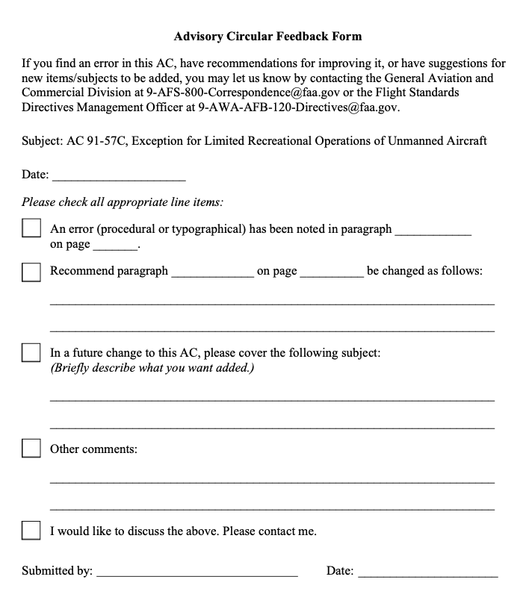

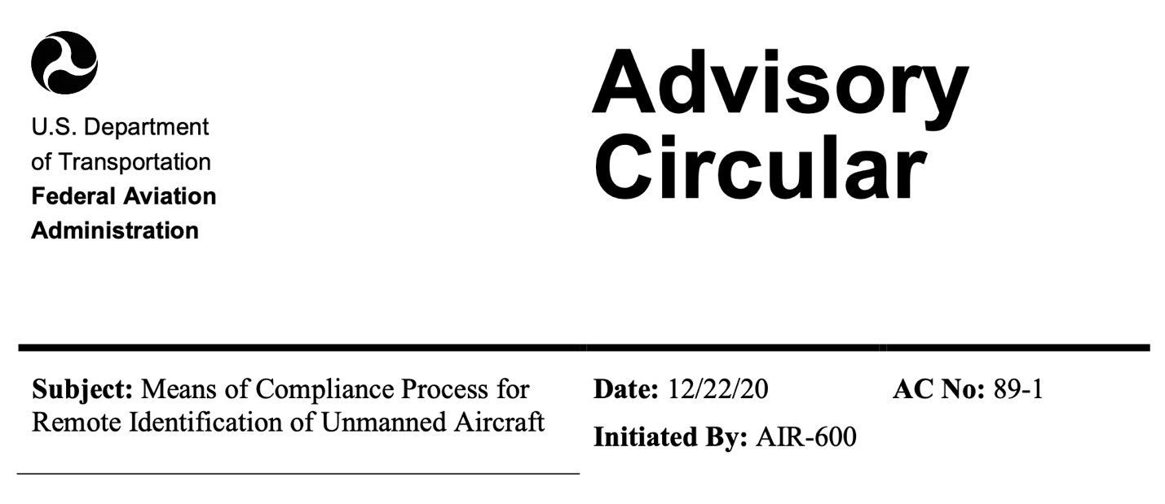
1 PURPOSE OF THIS ADVISORY CIRCULAR (AC): This AC provides guidance on the Means of Compliance (MOC) process described in Title 14, Code of Federal Regulations (14 CFR) part 89, Remote Identification of Unmanned Aircraft. This AC outlines the required information for submitting a MOC.
Effects of Guidance: The contents of this document do not have the force and effect of law and are not meant to bind the public in any way. This document is intended only to provide clarity to the public regarding existing requirements under the law or agency policies.
2 AUDIENCE: This AC is of interest to persons or entities who develop MOC for meeting the performance requirements of part 89, subpart D, for the design and production of standard remote identification unmanned aircraft or remote identification broadcast modules.
This AC addresses the development and process for submission of a MOC for standard remote identification unmanned aircraft and remote identification broadcast modules. The FAA will publish a list of FAA-accepted MOCs on the FAA website that are available to producers of standard remote identification unmanned aircraft under part 89 or part 21 and producers of remote identification broadcast modules under part 89. This AC only addresses MOCs for complying with the remote identification performance requirements of part 89. It does not address submission of MOCs for any other purpose.
3 RELATED READING MATERIAL (CURRENT EDITIONS)
The following regulations, guidance, and standards are applicable to this AC. Refer to the FAA’s website for the current list of FAA-accepted MOCs that may be used to comply with part 89.
  - FAA ACs
- AC 89-2, Declaration of Compliance Process for Remote Identification of Unmanned Aircraft
- AC 107-2, Small Unmanned Aircraft Systems
  - FAA Orders
- Order 8000.71, Aircraft Make, Model, and Series Taxonomy
- Order 8100.11, Requirements for Finding Undue Burden and No Undue Burden Under 14 CFR Part 21
- Order 8110.4, Type Certification
- Order 8130.2, Airworthiness Certification of Aircraft
- Order 8130.34, Airworthiness Certification of Unmanned Aircraft Systems and Optionally Piloted Aircraft
  - Title 14, Code of Federal Regulations (14 CFR)
- Part 21, Certification Procedures for Products and Articles
- Part 47, Aircraft Registration
- Part 48, Registration and Marking Requirements for Small Unmanned Aircraft
- Part 89, Remote Identification of Unmanned Aircraft
- Part 91, General Operating and Flight Rules
- Part 107, Small Unmanned Aircraft Systems
4 BACKGROUND
4.1 The remote identification of unmanned aircraft promotes public safety, accountability, and the safe and efficient use of U.S. airspace by enabling new technologies to furnish data specific to individual unmanned aircraft to people on the ground and other airspace users. Remote identification information allows the public and law enforcement to identify unmanned aircraft, as well as locate the corresponding control station or take-off location. Remote identification enables the FAA to monitor unmanned aircraft operations for compliance with applicable regulations and to oversee the safety and security of U.S. airspace. Standard remote identification unmanned aircraft broadcast the remote identification message elements directly from the unmanned aircraft. The remote identification broadcast module is a retrofit option that provides flexibility to achieve remote identification for operators of unmanned aircraft that do not qualify as standard remote identification unmanned aircraft.
4.2 Under part 89, persons or entities may develop MOCs for use in the design and production of standard remote identification unmanned aircraft or remote identification broadcast modules to document and demonstrate compliance with the remote identification requirements of part 89, subpart D.
4.3 Pursuant to part 89, producers of standard remote identification unmanned aircraft and remote identification broadcast modules must comply with the applicable remote identification performance requirements of subpart D. A person or entity must meet these requirements by following an FAA-accepted MOC for:
- The production of standard remote identification unmanned aircraft under § 89.510 for unmanned aircraft under part 21 or under § 89.515 for all other unmanned aircraft covered under part 89, subpart F.
- The production of remote identification broadcast modules under § 89.520.
4.4 Unmanned aircraft systems certificated under part 21 may be subject to either the type certification or supplemental type certification procedures of part 21 and applicable design and production standards for all systems on the unmanned aircraft or that comprise the unmanned aircraft system. Part 89 remote identification requirements apply during the type and supplemental type certification procedures. Additionally, part 89 requirements will be applied during the special airworthiness certification process under part 21.
4.5 Once the FAA accepts a MOC, producers may use the MOC to meet the requirements of part 89. Producers submit a Declaration of Compliance (DOC) to the FAA declaring the standard remote identification unmanned aircraft or remote identification broadcast module meets the requirements of part 89 because they have followed an FAA-accepted MOC. Submitters of DOCs must include the tracking number of the MOC used in the production on their DOC. See AC 89-2, Declaration of Compliance Process for Remote Identification of Unmanned Aircraft, for further information about the DOC submittal process.
5 MEANS OF COMPLIANCE—REQUIRED INFORMATION
5.1 The information described in this section is required pursuant to § 89.405.
5.2 Name: The submitter of a MOC for acceptance must provide the name of the individual or entity submitting the MOC. For an entity, this could be the name of a standards setting organization (SSO), a manufacturer of standard remote identification unmanned aircraft or remote identification broadcast modules, or any other entity that has developed a MOC.
5.3 Point of Contact (POC): The submitter of the MOC must identify the individual designated as the main point of contact for communications with the FAA.
5.4 Address: The submitter must provide the mailing address for the individual or entity submitting the MOC. For an SSO, this address is the address of the SSO’s headquarters, rather than an address for a particular committee responsible for the development of the MOC. For a producer of standard remote identification unmanned aircraft or remote identification broadcast modules submitting a MOC, the FAA expects that the address would be the headquarters of the company as opposed to a production facility where the entity intends to produce the unmanned aircraft or broadcast modules.
5.5 POC’s Email Address: The submitter must provide a valid email address for the point of contact listed in the MOC. The FAA will use this email address for MOC submission confirmation or for any other email communication related to the MOC.
5.6 Description of the MOC: The application must include: (1) detailed description of the means of compliance; and (2) justification, including any substantiating material showing the means of compliance fulfills the standards of §§ 89.310 and 89.320.
5.7 Supporting Documentation and Data Submission: When submitting a MOC, the submitter should include any supporting documentation (e.g., design, testing, analyses, and validation data) and justification that demonstrates that a standard remote identification unmanned aircraft or remote identification broadcast module produced in accordance with the MOC would meet all of the applicable performance requirements of part 89, subpart D. Please state “Contains proprietary information” on any document where any of the information provided is a trade secret or confidential commercial information.
5.8 Testing and Validation Procedures: A means of compliance submitted for acceptance by the FAA must include testing and validation procedures to demonstrate through analysis, ground test, or flight test, as appropriate, how the standard remote identification unmanned aircraft or the remote identification broadcast module performs its intended functions and meets the requirements of part 89, subpart D, including any applicable FAA performance requirements for radio station operation.
5.9 Means of Compliance Cover Page: Submitter of a MOC for a standard remote identification unmanned aircraft or a remote identification broadcast module to the FAA for acceptance should include a cover page that contains the information listed in sections 5.2 through 5.5 above, as well as a list of all documentation submitted in support of the MOC.
5.10 Data and Documentation Retention: In accordance with § 89.420, the individual or entity that submits a MOC for acceptance must retain and make available upon request the following information for as long as the MOC is FAA-accepted, plus an additional 24 calendar months:
- All documentation and substantiating information submitted to the FAA for acceptance of the MOC.
- All records of MOC test procedures, methodology, and other procedures, as applicable.
- Any other information necessary to justify and substantiate how following the MOC would allow a producer to manufacture standard remote identification unmanned aircraft or remote identification broadcast modules that comply with the remote identification requirements of part 89, including any referenced standards such as broadcast specifications that may be within the MOC.
5.11 Electronic Submission: A person or entity may electronically submit a complete MOC package, including the cover page and supporting documentation, to the FAA for acceptance. The email address for submission of MOC packages may be found on the FAA’s website.
6 FAA ACCEPTANCE OF A MOC
6.1 An individual or entity submitting a MOC for FAA acceptance must provide the required information and documentation described in section 5 of this AC to the FAA for review and consideration by the Administrator, pursuant to § 89.405.
6.2 Before the FAA will accept a MOC for use under part 89, the individual or entity requesting acceptance of a MOC must demonstrate to the FAA that the MOC addresses all of the applicable requirements of part 89, subparts D and E, and that any standard remote identification unmanned aircraft or remote identification broadcast module designed and produced in accordance with the MOC would meet the applicable performance requirements of part 89, subpart D. If the FAA determines the individual or entity has demonstrated that the MOC meets the requirements of part 89, subparts D and E, the FAA will notify the individual or entity that the FAA has accepted the MOC. If the FAA determines the individual or entity has not provided sufficient evidence to demonstrate the MOC meets the requirements of part 89, subparts D or E, the FAA will notify the individual or entity that the FAA has not accepted the MOC and will identify the areas in which the submission or the MOC is deficient. See § 89.410.
6.3 The FAA will assign a unique tracking number to each FAA-accepted MOC. The tracking number will be included in the notice sent to the submitter of the MOC, stating the FAA has accepted the MOC. The MOC tracking number should be included on all communications with the FAA.
6.4 The FAA will post a notice of availability in the Federal Register identifying when the FAA has accepted a MOC. All FAA-accepted MOCs will be listed on the FAA website and producers may use them to show compliance with the remote identification requirements of part 89. If a person or entity submitting a MOC informs the FAA that the proposed MOC contains proprietary information and may not be available to the public, the FAA may indicate that on the FAA website.
7 RESCISSION OF A MOC
7.1 A MOC is subject to ongoing review by the Administrator (See § 89.415). If the FAA determines that an FAA-accepted MOC does not meet the requirements of part 89, subparts D or E, the FAA will rescind its acceptance of the MOC.
7.2 After the Administrator rescinds acceptance of a MOC, the FAA will publish a notice of rescission in the Federal Register and will update the FAA website to remove the MOC from the list of FAA-accepted MOCs (See § 89.415).
7.3 No one may use a MOC that the FAA no longer accepts in the design and production of standard remote identification unmanned aircraft or remote identification broadcast modules.
7.4 The FAA may rescind acceptance of any DOC that utilized a MOC that is no longer accepted by the FAA (See § 89.540). Rescission of a MOC is a basis for rescission of all associated DOCs; however, the rescission of a DOC is not automatic. AC 89-2, Declaration of Compliance Process for Remote Identification of Unmanned Aircraft describes the process for rescission of a DOC.
7.5 If a consensus standard body decides to “sunset” (i.e., retire) a standard the FAA previously received and accepted as a MOC, then the FAA will issue a rescission of its acceptance of the MOC if it determines the MOC no longer meets the requirements of part 89, subparts D and E. As indicated in section 7.4, the FAA may also rescind acceptance of any DOC that used a MOC that is no longer accepted by the FAA. See § 89.540.
ORIGINAL SIGNED by
/s/ Victor W. Wicklund
for Dr. Michael C. Romanowski
Aviation Safety
Director, Policy and Innovation Division
Aircraft Certification Service

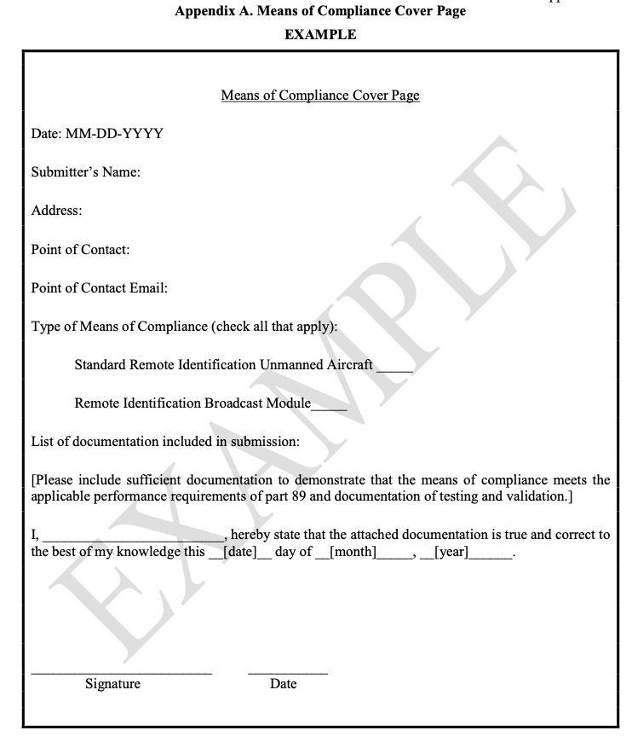
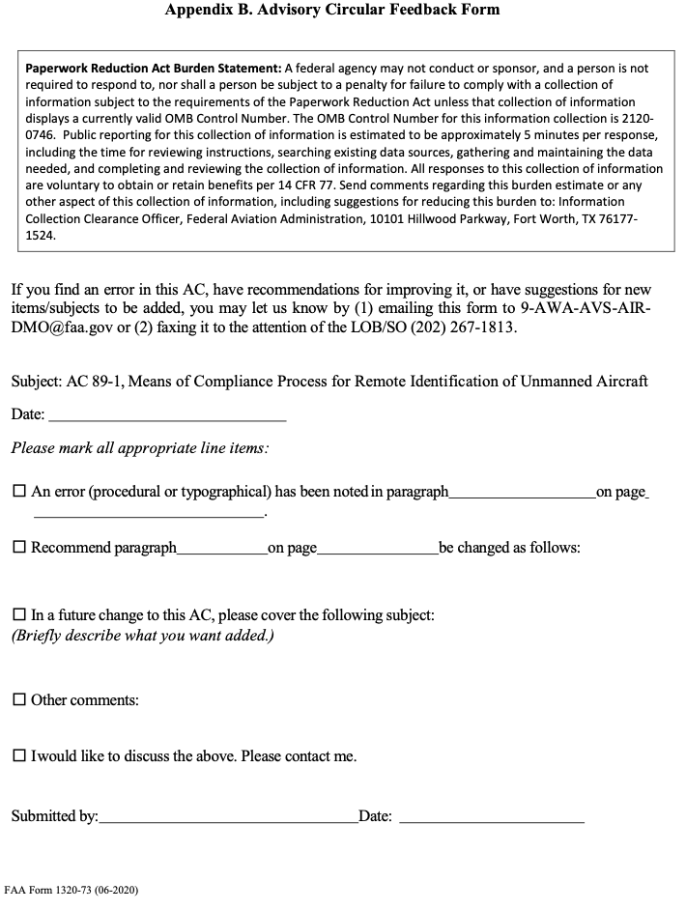

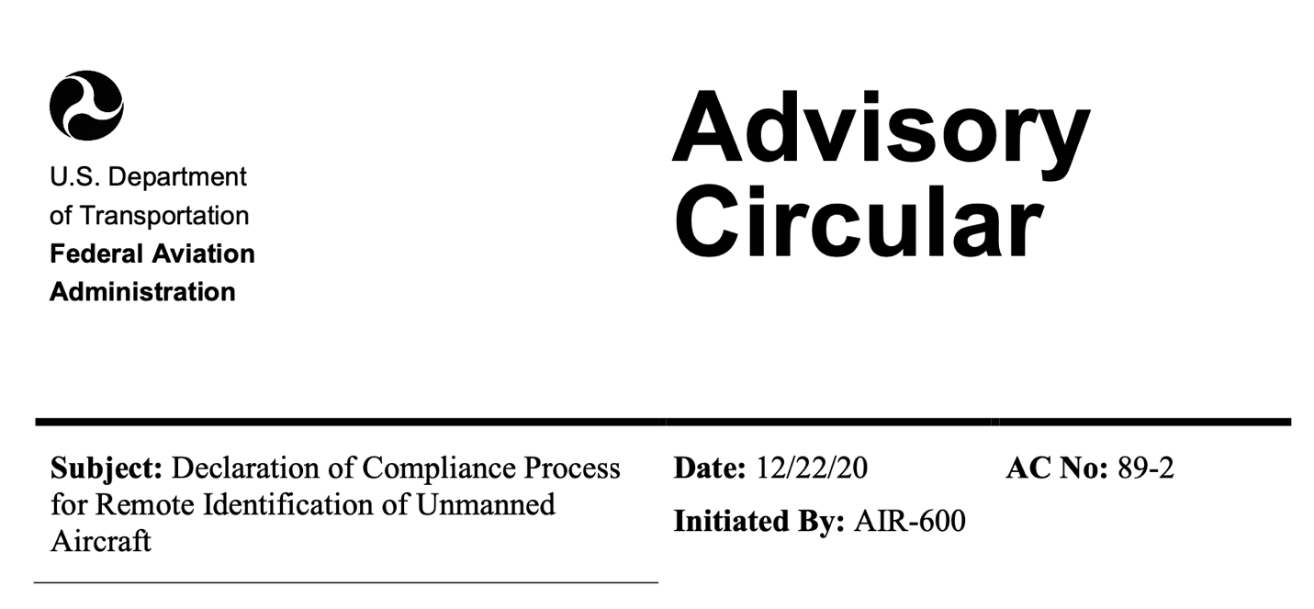
1 PURPOSE OF THIS ADVISORY CIRCULAR (AC): This AC provides guidance on the Declaration of Compliance (DOC) process described in Title 14, Code of Federal Regulations (14 CFR) part 89, Remote Identification of Unmanned Aircraft. This AC outlines the required information for submitting a DOC.
Effects of Guidance: The contents of this document do not have the force and effect of law and are not meant to bind the public in any way. This document is intended only to provide clarity to the public regarding existing requirements under the law or agency policies.
2 AUDIENCE: This AC is of interest to producers submitting a DOC for standard remote identification unmanned aircraft or remote identification broadcast modules pursuant to § 89.530.
3 RELATED READING MATERIAL (CURRENT EDITIONS)
The following regulations, guidance, and standards are applicable to this AC.
  - FAA ACs
- AC 89-1, Means of Compliance Process for Remote Identification of Unmanned Aircraft
- AC 107-2, Small Unmanned Aircraft Systems
3.2 FAA Orders
− Order 8000.71, Aircraft Make, Model, and Series Taxonomy
- Order 8100.11, Requirements for Finding Undue Burden and No Undue Burden Under 14 CFR Part 21
- Order 8110.4, Type Certification
- Order 8130.2, Airworthiness Certification of Aircraft
- Order 8130.34, Airworthiness Certification of Unmanned Aircraft Systems and Optionally Piloted Aircraft
− Order 8150.1, Technical Standard Order Program
3.3 Title 14, Code of Federal Regulations (14 CFR)
- Part 21, Certification Procedures for Products and Articles
- Part 47, Aircraft Registration
- Part 48, Registration and Marking Requirements for Small Unmanned Aircraft
- Part 89, Remote Identification of Unmanned Aircraft
- Part 91, General Operating and Flight Rules
- Part 107, Small Unmanned Aircraft Systems
3.4 FAA-Accepted Means of Compliance for Standard Remote Identification Unmanned Aircraft or Remote Identification Broadcast Modules
Refer to FAA website for the current list of FAA-accepted means of compliance.
4 BACKGROUND
4.1 The remote identification of unmanned aircraft promotes public safety, accountability, and the safe and efficient use of U.S. airspace by leveraging new technologies to furnish data specific to individual unmanned aircraft to people on the ground and other airspace users. Remote identification information allows the public and law enforcement to identify unmanned aircraft, as well as locate the corresponding control station or take-off location. Remote identification enables the FAA to monitor unmanned aircraft operations for compliance with applicable regulations and to oversee the safety and security of U.S. airspace. Standard remote identification unmanned aircraft broadcast the remote identification message elements directly from the unmanned aircraft. The remote identification broadcast module is a retrofit option that provides flexibility to achieve remote identification for operators of unmanned aircraft that do not qualify as standard remote identification unmanned aircraft.
4.2 Under part 89, producers of standard remote identification unmanned aircraft and remote identification broadcast modules must comply with applicable remote identification design and production requirements. A producer may—
- Produce standard remote identification unmanned aircraft following the requirements of § 89.510 for unmanned aircraft systems produced under a design or production approval under part 21.
- Produce standard remote identification unmanned aircraft following the requirements of § 89.515 for unmanned aircraft without a part 21 design approval or production approval.
- Produce remote identification broadcast modules in accordance with § 89.520.
4.3 Unmanned aircraft systems certificated under part 21 are subject to the type certification procedures and applicable airworthiness standards for all components of the unmanned aircraft system under that part. The FAA will apply part 89 remote identification requirements during the type and supplemental type certification procedures. However, in accordance with § 89.510, submission of a declaration of compliance for such aircraft is not required, as described in paragraph 5 of this AC.
4.4 A DOC is the method by which a producer declares that a standard remote identification unmanned aircraft or remote identification broadcast module has been designed and produced to meet the applicable minimum performance requirements of subpart D of part 89 by using an FAA-accepted means of compliance (MOC).
4.5 The FAA will rely on the DOC to ensure the standard remote identification unmanned aircraft or remote identification broadcast module identified on the DOC is designed and produced in accordance with an FAA-accepted MOC and complies with the applicable remote identification requirements of part 89.
4.6 Refer to the FAA website for the current list of FAA-accepted MOC that may be used to comply with the performance requirements of part 89.
5 DECLARATION OF COMPLIANCE (DOC)—REQUIRED INFORMATION
5.1 The information described in this section is required pursuant to § 89.530.
5.2 Producer’s Name: The submitter of a DOC for acceptance by the FAA must provide the full legal name of the producer of the standard remote identification unmanned aircraft or remote identification broadcast module(s). The producer identified in the DOC may be an individual or entity.
5.3 Address(es): The submitter must provide the physical and mailing address of the producer of the standard remote identification unmanned aircraft or remote identification broadcast module.
5.4 Point of Contact’s Name: When submitting a DOC, the FAA recommends the producer designate a point of contact for further communication and coordination with the FAA. The full legal name should be provided for any point of contact identified in the declaration.
5.5 Telephone Number: The submitter must provide a valid telephone number of the producer listed in the DOC. The FAA may use the telephone number for any communication related to the DOC.
5.6 Email Address: The submitter must provide a valid email address of the producer listed in the DOC. The FAA may use the email address for notice of DOC acceptance or any other communication related to the DOC. The FAA will send an email notifying the point of contact once the agency has accepted the DOC.
5.7 Make: Make is the name assigned to the standard remote identification unmanned aircraft or remote identification broadcast module by the manufacturer when it was produced. In most cases, the standard remote identification unmanned aircraft or remote identification broadcast module make is its common name (See FAA Order 8000.71, Aircraft Make, Model, and Series Taxonomy).
5.8 Model: A standard remote identification unmanned aircraft or remote identification broadcast module model is a designation given by the designer or producer to a grouping with similar design or structure styles. One DOC contains a single producer, make, and model.
5.9 Serial number(s): A producer must list in the DOC all serial numbers assigned to standard remote identification unmanned aircraft or remote identification broadcast modules of the make and model listed in the DOC. Each standard remote identification unmanned aircraft or remote identification broadcast module produced under a DOC must be assigned a unique serial number to allow it to be distinguished from others of the same make and model grouping. Each assigned serial number must comply with ANSI/CTA-2063-A in accordance with § 89.505.
A producer that wishes to include a batch of standard remote identification unmanned aircraft or remote identification broadcast modules on a DOC could list the first serial number of the batch and the last serial number of the batch. In such a situation, the producer should provide an explanation of the process by which individual serial numbers are assigned. For example, a producer should provide a description of all elements of a serial number if those elements provide specific information.
An example of a DOC submission is included in appendix A of this AC. A producer may amend an FAA-accepted DOC to include additional serial numbers to enable the production of more units of the same make and model listed in the DOC. Appendix B of this AC provides an example of an amended DOC incorporating a new batch of serial numbers.
5.10 FCC Identifier: The submitter must provide the FCC Identifier of the Title 47, Code of Federal Regulations (47 CFR) part 15, Radio Frequency Devices, compliant radio frequency equipment used and integrated into the standard remote identification unmanned aircraft or the remote identification broadcast module.
5.11 Initial and Amended DOC: If a DOC has not been filed previously for the standard remote identification unmanned aircraft or remote identification broadcast module models, the producer should file an initial DOC. A producer would file an amended DOC to modify an already FAA-accepted DOC. Reasons for submitting an amended DOC include, but are not limited to—
- Resolving a safety issue or non-compliance: If this is the case, the producer would provide, as part of the amended DOC, an explanation of the safety issue or non- compliance resolution;
- Correction of information, such as corrections of misspelled words;
- Updating required information such as the point of contact or producer address; or
- Adding serial numbers to an existing DOC.
The FAA will assign a unique tracking number to each FAA-accepted DOC. The tracking number will be included in the notice sent to the submitter of the DOC, to inform the submitter the DOC has been accepted. The appropriate DOC tracking number should be included on all communications with the FAA, including a submission for an amendment of the DOC. The FAA will provide an updated tracking number to the applicant upon acceptance of an amended DOC.
5.12 Means of Compliance (MOC) Tracking Number: Producers of standard remote identification unmanned aircraft or remote identification broadcast modules must meet the applicable performance requirements of part 89, subpart D, by following a MOC the FAA has accepted. Each accepted MOC is assigned a unique tracking number, which the FAA will list on the FAA website. Within the DOC form, the producer should provide the tracking number that is assigned to the associated FAA-accepted MOC the producer used to demonstrate that the standard remote identification unmanned aircraft or remote identification broadcast module complies with the applicable performance requirements in part 89. A producer of a standard remote identification unmanned aircraft or remote identification broadcast module may use multiple FAA-accepted MOCs, provided the standard remote identification unmanned aircraft or remote identification broadcast module meets all applicable requirements of subpart D, and as long as the producer meets all applicable requirements of part 89, subpart F. Information on the MOC submission and acceptance processes is provided in AC 89-1, Means of Compliance Process for Remote Identification of Unmanned Aircraft.
5.13 Declaration that Remote Identification Requirements Have Been Met: Pursuant to §§ 89.530(b)(7) or 89.530(c)(7), a person responsible for production of a standard remote identification unmanned aircraft or remote identification broadcast module must declare the standard remote identification unmanned aircraft or remote identification broadcast module(s) listed on the DOC have been produced following the FAA-accepted MOC listed on the DOC and meet all applicable part 89 requirements. The DOC form contains the following statement:
“Pursuant to §§ 89.530(b)(7) or 89.530(c)(7), as applicable, I declare that the standard remote identification unmanned aircraft or remote identification broadcast module(s) with serial numbers listed on this Declaration of Compliance comply with all applicable requirements of 14 CFR part 89 for remote identification of unmanned aircraft, as identified in the following means of compliance: [List applicable MOC tracking number(s) used for compliance in Section 4 above].”
5.14 Administrator’s Right to Inspect: Pursuant to §§ 89.515(b) or 89.520(b), as applicable, a person responsible for the production of a standard remote identification unmanned aircraft or remote identification broadcast module must, upon request, allow the FAA to inspect the facilities, technical data, and any standard remote identification unmanned aircraft or remote identification broadcast module listed on an FAA-accepted DOC. Such inspection may include witnessing tests. The DOC form contains the following statement:
“Pursuant to §§ 89.515(b) or 89.520(b), as applicable, I declare that the person responsible for the production of the standard remote identification unmanned aircraft or remote identification broadcast module listed on this Declaration of Compliance will allow the Federal Aviation Administration to inspect the facilities of the producer identified in the Declaration of Compliance, as well as any associated technical data and any produced standard remote identification unmanned aircraft or remote identification broadcast module, and to witness any tests necessary to determine compliance with 14 CFR part 89.”
5.15 Independent Audits: Pursuant to §§ 89.515(b) or 89.520(b), as applicable, the person responsible for the production of a standard remote identification unmanned aircraft or remote identification broadcast module is responsible for coordinating and performing independent audits to inspect the facilities, technical data, and any standard remote identification unmanned aircraft or remote identification broadcast module that is manufactured and listed under a DOC. The results of these audits must be provided to the FAA upon request. The producer listed on a DOC must also have an independent audit performed if FAA notifies the producers of non-compliance. The DOC form contains the following statement:
“Pursuant to §§ 89.515(b) or 89.520(b), as applicable, I declare that the producer listed on this Declaration of Compliance will conduct independent audits of the facilities, technical data, and any standard remote identification unmanned aircraft or remote identification broadcast modules that are produced and listed under this Declaration of Compliance on a recurring basis to ensure compliance with the requirements of 14 CFR part 89, or if the FAA notifies the producer of non-compliance concerns of any standard remote identification unmanned aircraft or remote identification broadcast modules listed on this Declaration of Compliance.”
5.16 Product Support and Notification Procedures: Pursuant to §§ 89.515(b) or 89.520(b), as applicable, the person responsible for the production of a standard remote identification unmanned aircraft or remote identification broadcast module must maintain product support and notification procedures for operators of unmanned aircraft with remote identification. The FAA does not require product support and notification procedures to take a specific form or manner. A website that allows operators to report issues and download software updates could be used to comply with the regulatory requirement to have product support procedures. A notification procedure could be an email sent to customers informing them of necessary software updates to ensure their unmanned aircraft remain compliant with part 89 requirements. The producer of the unmanned aircraft must notify the FAA and the public within 15 calendar days of becoming aware of a defect or condition that causes the standard remote identification unmanned aircraft or remote identification broadcast module to no longer meet the requirements of part 89. The DOC form contains the following statement:
“Pursuant to §§ 89.515(b) or 89.520(b), as applicable, I declare that the producer listed on this Declaration of Compliance has product support and notification procedures for the purpose of notifying the public and the FAA of any defect or condition that causes the standard remote identification unmanned aircraft or remote identification broadcast module listed under the Declaration of Compliance to no longer meet the requirements of 14 CFR part 89.”
5.17 Title 47 CFR Part 15—Compliant Radio Frequency Equipment: Pursuant to 14 CFR 89.530(b)(8) or 89.530(c)(8), as applicable, any radio frequency equipment used in a standard remote identification unmanned aircraft or remote identification broadcast module must comply with the applicable requirements of part 15 and be integrated into the unmanned aircraft or remote identification broadcast module without modification to its authorized radio frequency parameters. The producer is responsible for ensuring the radio frequency equipment meets all applicable Federal Communications Commission regulations. The DOC form contains the following statement:
“Pursuant to §§ 89.530(b)(8) or 89.530(c)(8), as applicable, I declare that the radio frequency equipment used in the standard remote identification unmanned aircraft or remote identification broadcast module(s) listed on this Declaration of Compliance are 47 CFR part 15-compliant and have been integrated into the unmanned aircraft or remote identification broadcast module(s) without modification to its/their authorized radio frequency parameters.”
5.18 Installation Instructions for Remote Identification Broadcast Module: Pursuant to
§ 89.530(c)(8), a producer of remote identification broadcast modules must make available instructions for installing the remote identification broadcast module on compatible unmanned aircraft to any person operating the remote identification broadcast module pursuant to § 89.115. Instructions should include how to minimize interference with the remote identification broadcast module and describe any limitations. This requirement does not apply to producers of standard remote identification unmanned aircraft. The DOC form contains the following statement:
“Pursuant to § 89.530(c)(8), I declare that instructions have been provided for installation of 47 CFR part 15-compliant remote identification broadcast module without modification to the broadcast module’s authorized radio frequency parameters.”
5.19 Electronic Submission: Declarations of compliance should be submitted electronically through the FAA website.
6 FAA ACCEPTANCE OF A DOC
6.1 The FAA will assign a unique tracking number to each FAA-accepted DOC. The tracking number will be included in the notice sent to the submitter of the DOC, to inform the submitter of the FAA’s acceptance of the DOC. The appropriate DOC tracking number should be included on all communications with the FAA.
6.2 All FAA-accepted DOCs will be listed on the FAA’s website.
7 COMPLIANCE REVIEW OF DECLARATIONS OF COMPLIANCE
7.1 If the FAA becomes aware that a standard remote identification unmanned aircraft or remote identification broadcast module listed on an FAA-accepted DOC does not, or may not, comply with the listed MOC(s), the FAA will issue a notification letter to the submitter of the FAA-accepted DOC stating the non-compliance concern. The notification letter will contain the date by which the FAA expects the submitter to respond.
7.2 If the Administrator determines it is in the public interest, prior to rescinding acceptance of a DOC, the Administrator may provide a reasonable period of time for the submitter of the DOC to remediate the non-compliance. A failure to remediate the non-compliance constitutes cause for rescission of the DOC.
7.3 During the time period listed in the notice of non-compliance or potential non- compliance, the producer of the standard remote identification unmanned aircraft or remote identification broadcast module must arrange for an independent audit to determine whether a non-compliance exists and must submit the audit report to the FAA upon request. The results of the audit should be submitted to the FAA, even if there is a finding that the standard remote identification unmanned aircraft or remote identification broadcast module is compliant. The FAA will notify the producer of the standard remote identification unmanned aircraft or remote identification broadcast module of the outcome of its review.
7.4 If the FAA concludes based on the audit that the producer or production does not comply with applicable requirements, the submitter of the FAA-accepted DOC should submit a proposal for corrective actions to the FAA for review. The FAA will notify the submitter of the outcome of its review and provide additional information as necessary.
7.5 If the FAA does not receive the results of the independent audit and proposal for corrective actions, as applicable, the FAA may determine the standard remote identification unmanned aircraft or remote identification broadcast module does not meet the minimum performance requirements of part 89 and may rescind the DOC.
7.6 Standard remote identification unmanned aircraft or remote identification broadcast modules with serial numbers listed on the DOC may continue to operate throughout the time period listed in the notice of non-compliance or potential non-compliance, unless the letter informs the submitter of the DOC of an immediate rescission of the acceptance of the DOC.
8 RESCISSION OF THE FAA’S ACCEPTANCE OF A DOC 8.1 The FAA may rescind an acceptance of a DOC if—
- The standard remote identification unmanned aircraft or remote identification broadcast module listed on the FAA-accepted DOC does not meet the applicable minimum performance requirements for remote identification in part 89, subpart D (i.e., the requirements of §§ 89.310 or 89.320).
- The previously accepted DOC does not meet the requirements of part 89, subpart F.
− The FAA rescinds its acceptance of the MOC listed in an FAA-accepted DOC.
8.2 The FAA will publish a notice of rescission in the Federal Register to provide notice of the rescission to all interested or affected parties. The FAA will notify the submitter of the FAA-accepted DOC of the FAA’s decision to rescind its acceptance of the DOC by sending a letter of rescission. The producer of an unmanned aircraft or broadcast module listed on a DOC that has been rescinded is responsible for notifying registered owners of the rescission as part of its product notification process. The FAA may also send a notice of rescission to the registered owners of unmanned aircraft listed under a DOC that has been rescinded by the FAA.
8.3 Unmanned aircraft listed in a DOC that has been rescinded that are not made compliant with the requirements of § 89.110 or § 89.115(a) (e.g., by using a remote identification broadcast module) may only fly at FAA-recognized identification areas.
9 PETITION FOR RECONSIDERATION
9.1 The submitter of the DOC, or any person adversely affected by the rescission of the Administrator’s acceptance of a DOC, may petition for reconsideration of the FAA’s decision by submitting a request to the FAA within 60 calendar days after the date of publication of the notice of rescission in the Federal Register. Specific information for submitting a petition will be provided in the notice of rescission in the Federal Register.
9.2 A petition to reconsider the rescission of the Administrator’s acceptance of a DOC must show that the petitioner is an interested party and has been adversely affected by the decision of the FAA. The petition must also demonstrate at least one of the following—
- The petitioner cites as evidence a significant additional fact not previously presented to the FAA.
- The Administrator made a material error of fact in the decision to rescind acceptance of the DOC.
- The Administrator did not correctly interpret a law, regulation, or precedent.
9.3 Upon consideration of the information submitted by the petitioner, the Administrator will notify the submitter of the DOC and the petitioner (if different) of the decision to reinstate or not to reinstate the Administrator’s acceptance of the DOC.
9.4 The provisions of 14 CFR part 13, subpart D, do not apply to petitions for reconsideration under part 89.
10 RECORD RETENTION REQUIREMENTS
10.1 Pursuant to § 89.545, the person who submits a DOC that the FAA has accepted must retain the following information for as long as the standard remote identification unmanned aircraft or remote identification broadcast modules listed on that DOC are produced, plus an additional 24 calendar months, and must make such information available for inspection by the Administrator—
− The MOC used, as well as all documentation and substantiating data related to the MOC used.
− Records of all test results.
− Any other information necessary to demonstrate the MOC was used to ensure the standard remote identification unmanned aircraft or remote identification broadcast module complies with the applicable performance requirements of part 89, subpart D, and the producer has met all applicable requirements of part 89, subpart F.
ORIGINAL SIGNED by
/s/ Victor W. Wicklund
for Dr. Michael C. Romanowski
Aviation Safety
Director, Policy and Innovation Division
Aircraft Certification Service

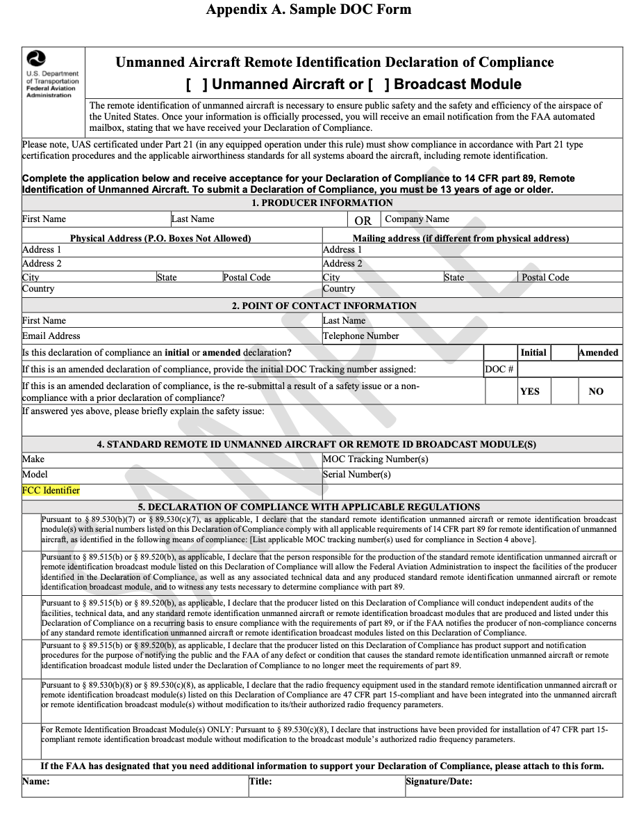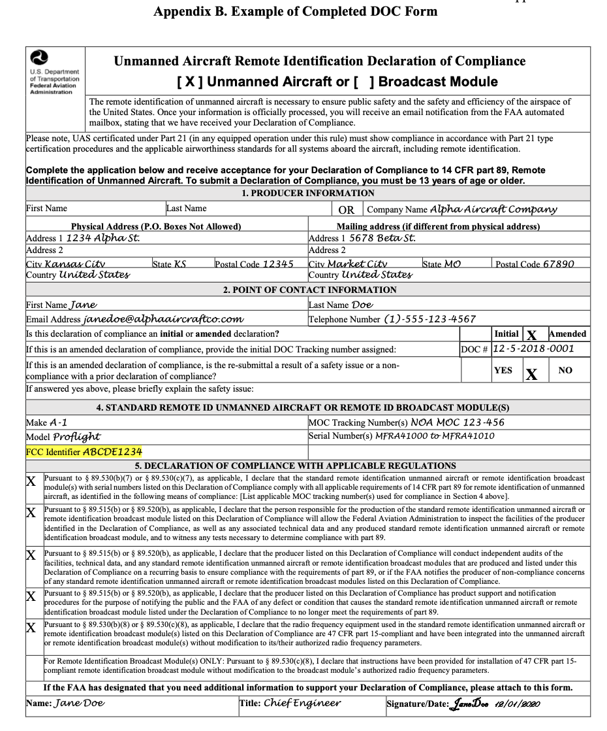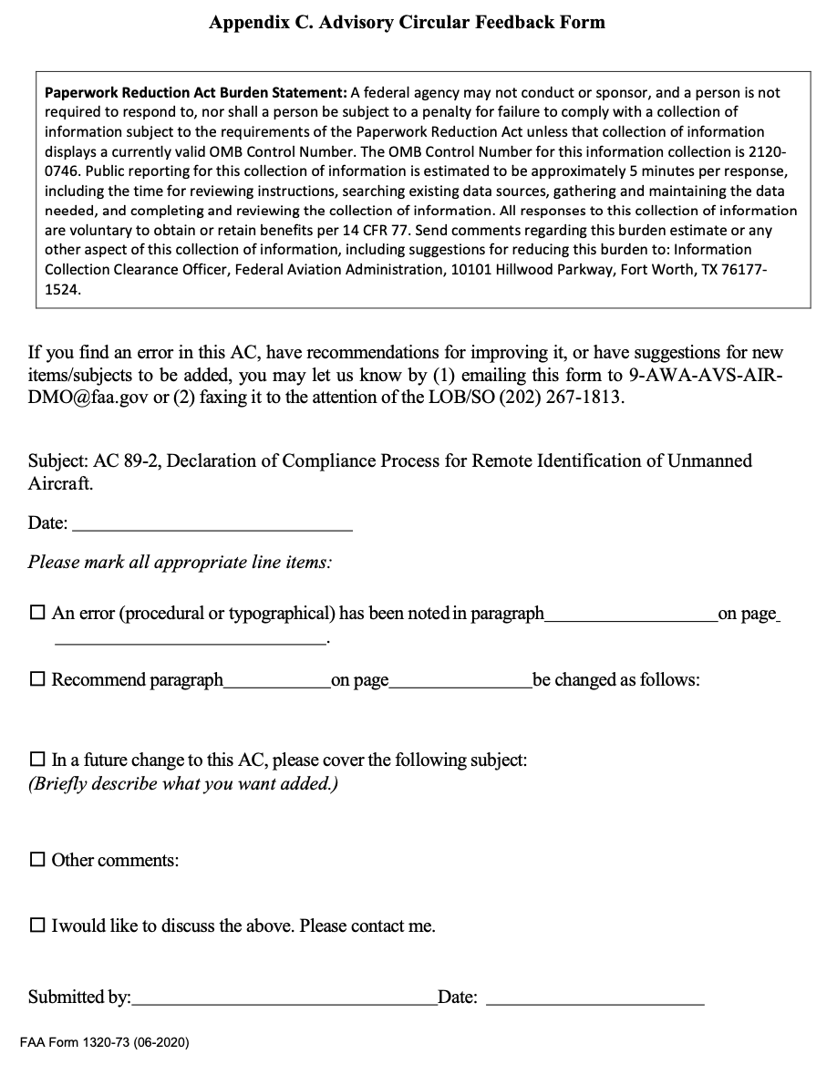

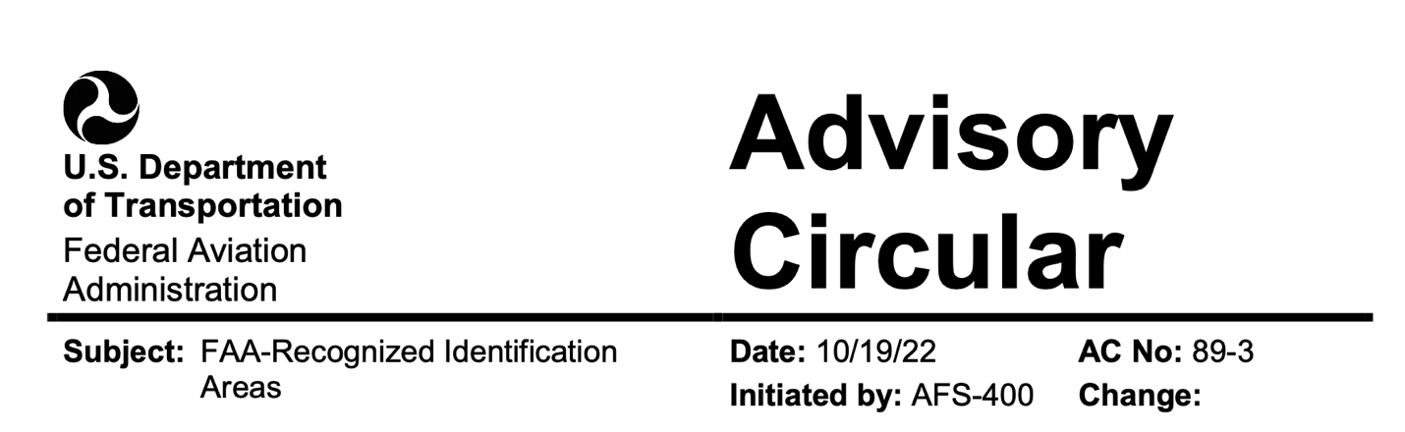
1 PURPOSE OF THIS ADVISORY CIRCULAR (AC). This AC provides guidance on applying for a Federal Aviation Administration (FAA)-Recognized Identification Area (FRIA), in accordance with Title 14 of the Code of Federal Regulations (14 CFR)
Part 89, Remote Identification of Unmanned Aircraft, subpart C. This AC does not change, create, or permit deviations from existing regulatory requirements.
1.1 Effects of Guidance. The contents of the document do not have the force and effect of law and are not meant to bind the public in any way, and the document is intended only to provide information to the public regarding existing requirements under the law or agency policies. Persons wishing to apply for a FRIA must meet the applicable requirements of part 89.
2 AUDIENCE. This AC applies to any person wishing to apply for the establishment of
a FRIA. The primary audience for this AC are those organizations or institutions eligible to apply for the establishment of a FRIA pursuant to part 89 subpart C.
3 WHERE YOU CAN FIND THIS AC. You can find this AC on the FAA’s website at https://www.faa.gov/regulations_policies/advisory_circulars and the Dynamic Regulatory System (DRS) at https://drs.faa.gov.
- RELATED READING MATERIAL (current editions):
1. Title 14 CFR Part 89, Remote Identification of Unmanned Aircraft.
2. Title 14 CFR Part 107, Small Unmanned Aircraft Systems.
3. Title 49 of the United States Code (49 U.S.C.) § 44809, Exception for Limited Recreational Operations of Unmanned Aircraft.
4. AC 91-57, Exception for Limited Recreational Operations of Unmanned Aircraft.
5. AC 107-2, Small Unmanned Aircraft Systems (Small UAS).
6. FAA Order 1050.1, Environmental Impacts: Policies and Procedures.
7. Aeronautical Information Manual (AIM).
8. Temporary Flight Restriction (TFR) listing, located at http://tfr.faa.gov/tfr2/list.html.
9. Aeronautical Navigation Products (Charts), located at https://www.faa.gov/air_traffic/flight_info/aeronav/.
10. Notices to Air Missions (NOTAM), located at https://www.faa.gov/air_traffic/publications/notices/.
5 BACKGROUND. Part 89 establishes requirements for the remote identification of unmanned aircraft (UA) operated in the airspace of the United States. The rule addresses safety, national security, and law enforcement concerns regarding the further integration of these aircraft into the airspace of the United States, laying a foundation for enabling greater operational capabilities. Persons operating UA without remote identification may operate within the boundaries of a FRIA pursuant to part 89, § 89.115(b). A FRIA is a defined geographic area where persons can operate a UA without remote identification equipment, provided they maintain visual line of sight. Part 89 subpart C contains the requirements for requesting the establishment of a FRIA, as well as regulations regarding the process for FAA approval of FRIAs, the duration of FRIAs, FRIA renewal procedures, and procedures for termination of FRIAs.
5.1 Operations in a FRIA. To operate a UA without remote identification pursuant to
§ 89.115(b), the UA and the person manipulating its flight controls must both remain within the boundaries of the FRIA throughout the operation. The person manipulating the flight controls must also be able to see the UA at all times. Other aircraft, including UA with remote identification, may also operate in a FRIA. Operators of a standard remote identification UA or UA equipped with a remote identification broadcast module must continue to remotely identify, even when operating within the boundaries of the FRIA, as part 89 does not allow for the remote identification capability to be disabled unless otherwise authorized by the Administrator. Additionally, all persons operating a UA within a FRIA must comply with any other regulations or statutory requirements applicable to their operation. For more information on which laws and rules apply to your operations, review the related reading materials or visit https://www.faa.gov/uas.
5.2 FRIAs and Fixed Sites Under 49 U.S.C. § 44809. FRIAs established under part 89 and “fixed sites” for purposes of recreational flying under 49 U.S.C. § 44809(c) are two different kinds of FAA-recognized UA operating areas with different purposes, requirements, and application processes. A fixed site is a location with a standing airspace authorization for recreational flying; whereas, a FRIA is a location where UA may operate without remote identification, pursuant to § 89.115(b). In some places where an airspace authorization is required for recreational flying, such as in controlled airspace, a FRIA and fixed site may overlap.
6 REQUESTING A FRIA.
6.1 Eligibility. Only FAA-recognized community-based organizations (CBO) and educational institutions are eligible to request the establishment of a FRIA. Refer to § 89.205.
6.1.1 CBO. A CBO is a membership-based association entity that meets all of the criteria in 49 U.S.C. § 44809(h).
6.1.2 Educational Institutions. Educational institutions include primary and secondary schools, trade schools, colleges, and universities. An educational institution should meet applicable laws and criteria establishing it as an educational institution, as defined in Section 8101 of the Elementary and Secondary Education Act of 1965 (20 U.S.C. § 7801) and those defined in Section 1001(a) and (b) of the Higher Education Act of 1965 (20 U.S.C. § 1001(a) and (b)).
6.2 Who Can Submit an Application. Individuals that have the authority to act on behalf of a CBO or educational institution can submit an application for the establishment of a FRIA on behalf of that CBO or educational institution.
6.3 When and How to Apply. The FAA will begin accepting FRIA applications on September 16, 2022. All documentation and information to apply for a FRIA should be submitted via the FAA’s FRIA application website located within DroneZone at https://faadronezone.faa.gov/.
6.4 What Information to Provide. Pursuant to § 89.210, applications must include the information identified in paragraphs 6.4.1 through 6.4.9, as applicable. The Administrator may also request other information, as needed, from a person applying for a FRIA. Refer to § 89.210(b)(9).
6.4.1 Name of the CBO or Educational Institution. The application must include the name of the eligible person applying for establishment of the FRIA. Refer to § 89.210(b)(1). For CBOs, the name should match the name of an FAA-recognized CBO as listed on the FAA website. For educational institutions, provide the institution’s full name.
6.4.2 Name of the Individual Making the Request. The application must include the name of the individual making the request for establishment of the FRIA on behalf of the CBO or educational institution. Refer to § 89.210(b)(2).
6.4.3 Declaration. On the application, the individual making the request must declare that they have the authority to request establishment of a FRIA on behalf of the CBO or educational institution. Refer to § 89.210(b)(3).
6.4.4 Primary Point of Contact (PPOC). The application must include the name, physical address, mailing address, phone number, and email address of a PPOC for communications with the FAA. The individual making the request and the PPOC can, but do not have to be, the same individual. However, the PPOC should be able to represent the CBO or educational institution in communications with the FAA. The FAA will contact the PPOC for all matters regarding the FRIA application as well as inquiries regarding the FRIA if the application is approved. Refer to § 89.210(b)(4).
6.4.5 Physical Address of the Proposed FRIA Location. The application must include the physical address of the proposed FRIA location. Refer to § 89.210(b)(5). If the requested FRIA location does not have a physical address, the applicant must provide a nearby physical address from where the FRIA can be accessed along with written directions for accessing the FRIA from the physical address provided.
6.4.6 Location of the Proposed FRIA. The application must include the location of the boundaries for the proposed FRIA. Refer to § 89.210(b)(6). The location of the boundaries of the proposed FRIA can be provided by specifying a geometric shape along with latitudes, longitudes, and other information as necessary. The FAA’s FRIA application website provides additional instructions for how to submit this information.
6.4.7 Airspace Authorization(s) or Letter(s) of Agreement (LOA). If an airspace authorization or LOA from the FAA applies to operations at the proposed FRIA, a copy of the applicable documents must be included in the application. Refer to § 89.210(b)(7). Airspace authorizations or LOAs may be issued for UA operations at fixed sites under 49 U.S.C. § 44809. An airspace authorization or LOA is not a prerequisite for a FRIA.
6.4.8 Description of Purpose and Need. The application must include the intended purpose of the FRIA and why a FRIA is needed to achieve the intended purpose. Refer to
§ 89.210(b)(8). For example, the intended purpose and need could be recreational flying of UA that are not equipped with remote identification equipment.
6.4.9 Additional Information. The application must include an estimate of the expected utilization of the proposed FRIA. Refer to § 89.210(b)(9). The estimate of expected utilization includes the average frequency and duration of UA flights, the types of UA expected to operate at the site, and the times of day when operations may occur.
7 FAA ASSESSMENT OF FRIA REQUESTS.
7.1 General. This section provides information on how the FAA will assess an application for the establishment of a FRIA based on the criteria detailed in § 89.215. The FAA may request further information as necessary to fully assess a FRIA application. The FAA will consider the criteria described below in reviewing FRIA applications.
7.2 The Existence of FAA-Established Flight or Airspace Restrictions. Refer to § 89.215(a).
7.2.1 Title 14 CFR Part 73, Special Use Airspace. The FAA may establish restricted areas or prohibited areas under part 73 in the interest of national defense, security, or welfare wherein activities must be confined because of their nature, or wherein limitations may be imposed upon aircraft operations that are not a part of those activities. Refer to FAA Order JO 7400.2, Procedures for Handling Airspace Matters, Part 5, Special Use Airspace. Due to the safety and security concerns present within Special Use Airspace (SUA), the FAA will deny requests to establish a FRIA in these areas.
7.2.2 Special Security Instructions (SSI). Under 14 CFR part 99, § 99.7, the FAA may issue SSI within an Air Defense Identification Zone or a Defense Area in the interest of national security pursuant to agreement with the Department of Defense (DOD) or another U.S. Federal security or intelligence agency. The FAA has issued Unmanned Aircraft System (UAS)-specific SSI at select Federal national security-sensitive locations in the United States. UAS-specific SSI are published via NOTAMs and impacted locations are depicted at https://udds-faa.opendata.arcgis.com/. The FAA will deny requests to establish a FRIA in areas overlapping existing SSI because the operation of UA without remote identification in those areas would compromise the operational security concern, supporting the basis of establishing the SSI.
7.2.3 Special Air Traffic Rules (SATR). The FAA establishes SATRs under 14 CFR part 93 for operating aircraft in specifically identified areas. These may include but are not limited to Special Flight Rules Areas (SFRA) and Flight Restriction Zones (FRZ). Refer to part 93 subparts U and V. Due to the safety and security concerns associated with SATRs, the FAA will deny requests to establish a FRIA in areas where SATRs apply.
7.2.4 Temporary Flight Restrictions (TFR). The FAA establishes TFRs under 14 CFR part 91 to restrict aircraft from operating within a defined area on a temporary basis. The FAA may consider the characteristics of any established TFR near or overlapping the requested FRIA location in determining whether to approve a request to establish a FRIA.
7.3 Safe and Efficient Use of Airspace by Other Aircraft. Refer to § 89.215(b).
7.3.1 Proximity to Airports and Heliports. The FAA will consider the proximity of airports and heliports to a proposed FRIA location. The FAA needs to be able to identify UA operating over and near airports and heliports in order to ensure the safe and efficient use of the airspace in areas where aircraft are taking off and landing. When aircraft are operating close to the ground, the potential for interactions between UA and other aircraft increases, as does the severity of potential consequences from failing to comply with applicable operating rules. The FAA will deny a request to establish a FRIA if the FAA determines that operations of UA without remote identification in the requested area pose an unacceptable risk to the safe and efficient use of the airspace near an airport or heliport.
7.3.2 Proximity to Areas of Other Aviation-Related Activity. The FAA will assess whether the requested FRIA is located near areas of known aviation-related activity such as parachute jump areas, hang glider launch areas, and hot air balloon launch areas. The FAA will deny a FRIA if the proximity to an area of aviation-related activity is such that operations of UA without remote identification pose an unacceptable risk to the safe and efficient use of the airspace.
7.4 Safety and Security of Persons or Property on the Ground. Refer to § 89.215(c). Remote identification is the primary tool for law enforcement and the public to identify UA operations that may pose a risk to persons and property on the ground. Therefore, the FAA will deny requests to establish a FRIA in areas where there is an unacceptable impact to the safety and security of persons or property on the ground. The FAA will assess if the proposed FRIA location overlaps with areas where members of the public may gather or regularly transit, such as housing developments, playgrounds, athletic fields, shopping centers, and public roadways. The FAA will also assess if the proposed FRIA location overlaps with sensitive or secure facilities, such as military bases, prisons, and power plants. The FAA would consider a proposed FRIA close to these types of sites incompatible with the objectives of the remote identification rule.
7.5 Need for the FRIA in the Proposed Location and Proximity of Other FRIAs. Refer to § 89.215(d). The FAA will assess the applicant’s intended purpose and need for the proposed FRIA. FRIAs should not be so closely located or cover too large an area such that their existence undermines the purpose and effectiveness of the remote identification rule. The approval of FRIAs that are very closely located or cover large areas would undermine the effectiveness of the rule, because law enforcement or members of the public would no longer be able to easily associate a UA without a remote identification broadcast with a particular location where the operator can be found. Additionally, when making the determination of whether to approve or deny a FRIA, the FAA will take into account how close the proposed FRIA is to other FRIAs that could support the same need described by the applicant. The FAA will also assess the size of the FRIA in relation to the stated purpose and need. The FAA may deny requests to establish a FRIA closely located to other established FRIAs that are capable of supporting the same need. For example, a requested site for a similar purpose that is a few minutes’ drive from an existing site may be denied. The FAA may also deny a request to establish a FRIA if the proposed size is found to be excessive considering the applicant’s stated need and purpose. For example, an application that requests a FRIA that covers hundreds of acres but does not provide information regarding why the large area is necessary for the intended purpose may be denied.
8 FAA RESPONSE.
8.1 Approvals. If the FAA grants an approval for a FRIA, the FRIA will be in effect for 48 calendar-months following the date of approval, as stated in § 89.225(a). As part of the FRIA approval process, the FAA will take the following actions:
8.1.1 Notice of Approval. The FAA will notify the PPOC listed in the application when a request for the establishment of a FRIA has been approved. This notice will include the effective date and expiration date of the FRIA.
8.1.2 Publication of FRIAs. The FAA will publish the locations of approved FRIAs on the FAA’s UAS Data Delivery Service (UDDS) website at https://udds- faa.opendata.arcgis.com/.
8.2 Denials. The FAA will deny a request for the establishment of a FRIA if, following its assessment, the provided data and documentation contained in an application does not meet one or more of the eligibility requirements described in paragraph 6 (refer to
§ 89.205) or the criteria described in paragraph 7 (refer to § 89.215). These criteria are assessed independently when making the determination to approve or deny the application. A request for the establishment of a FRIA may also be denied for missing, incomplete, or ambiguous information in the application, associated documentation, or requests for further information. The FAA will notify the PPOC listed in the application and will include the reason(s) for the denial. When a request for the establishment of a FRIA is denied, an applicant may submit a new FRIA application that addresses the reason for the denial.
9 AMENDMENTS, RENEWALS, EXPIRATIONS, AND TERMINATIONS.
9.1 Amendments. As stated in § 89.220, after the FAA approves of a FRIA, amendments may be made if there are changes to the FRIA. The CBO or educational institution that requested the FRIA should submit any requested changes via the FAA’s FRIA application website. Changes must be submitted by an individual with the appropriate authority to act on behalf of the CBO or educational institution.
9.1.1 Required Submissions. If there are any changes to the information submitted in the application for the FRIA, including but not limited to a change in the PPOC, the changes must be submitted to the FAA within 10 calendar-days of the change.
9.1.2 Changes to Boundaries. A CBO or educational institution that has received approval of a FRIA application may request amendments to the geographic boundaries of the FRIA, pursuant to § 89.220(b). The FAA will assess the request against applicable criteria described in paragraph 7. Operations without remote identification may not be conducted within the new boundaries unless the FAA has approved the requested amendment.
9.1.3 Ongoing Review. Pursuant to § 89.220(c), FRIAs are subject to ongoing FAA review. Certain changes or developments near or at a FRIA, such as the construction of a new airport or housing development, may lead the FAA to modify or to terminate the FRIA. The FAA will notify the PPOC for the FRIA if a change leads to the modification or termination of a FRIA.
9.2 Renewals. As described in § 89.225(b), a CBO or educational institution may submit a request to renew a FRIA via the FAA’s FRIA application website. Requests for renewal must be made no later than 120 days before the FRIA’s expiration date. Requests submitted after that time, but prior to the expiration date, may not be processed in time for an FAA decision prior to expiration. If the FRIA expires while the FAA is still reviewing the renewal request, the FRIA will no longer be effective and the UA operating in the location must meet applicable remote identification operating requirements under part 89. The FAA will review renewal requests against the criteria in paragraph 7.
9.3 Expirations. As described in §§ 89.225(a) and 89.230(a), FRIAs are in effect for
48 calendar-months following the date of approval, and expire automatically unless renewed. If a FRIA expires, a CBO or educational institution may submit a new FRIA application in order to reestablish the expired FRIA.
9.4 Terminations. As described in § 89.230, FRIAs may be terminated prior to the expiration date for either of the reasons discussed below.
9.4.1 Termination by Request. Pursuant to § 89.230(b)(1), if an established FRIA is no longer needed, the PPOC can submit a request that the FAA terminate the FRIA via the FAA’s FRIA application website. A CBO or educational institution that wishes to reestablish a FRIA that was previously terminated by request may submit a new FRIA application in order to reestablish the FRIA.
9.4.2 Termination by FAA. Pursuant to §§ 89.220(c) and 89.230(b)(2), all established FRIAs are subject to ongoing review by the FAA. In accordance with § 89.230(b), if the FAA finds that a FRIA poses a risk to aviation safety, public safety, homeland security, or national security, the FRIA is no longer associated with an FAA-recognized CBO or educational institution, or if the person who requested the FRIA provided false or misleading information during the submission, amendment, or renewal process, the FAA may terminate the FRIA. When a FRIA is terminated, the FAA will issue a notice of termination to the PPOC with the reasons for the termination. A person may petition the FAA to reconsider the termination within 30 calendar-days of the termination of the FRIA as stated in § 89.230(c). Instructions for submitting a petition will be provided in the notice of termination to the PPOC. A petition for reconsideration must provide the reasons justifying the request for reconsideration and include any supporting documentation. Upon consideration of the information submitted by the petitioner, the FAA will notify the petitioner of the decision on the request for reconsideration.
10 AC FEEDBACK FORM. For your convenience, the AC Feedback Form is the last page of this AC. Note any deficiencies found, clarifications needed, or suggested improvements regarding the contents of this AC on the Feedback Form.
Caitlin Locke
Acting Deputy Executive Director, Flight Standards Service
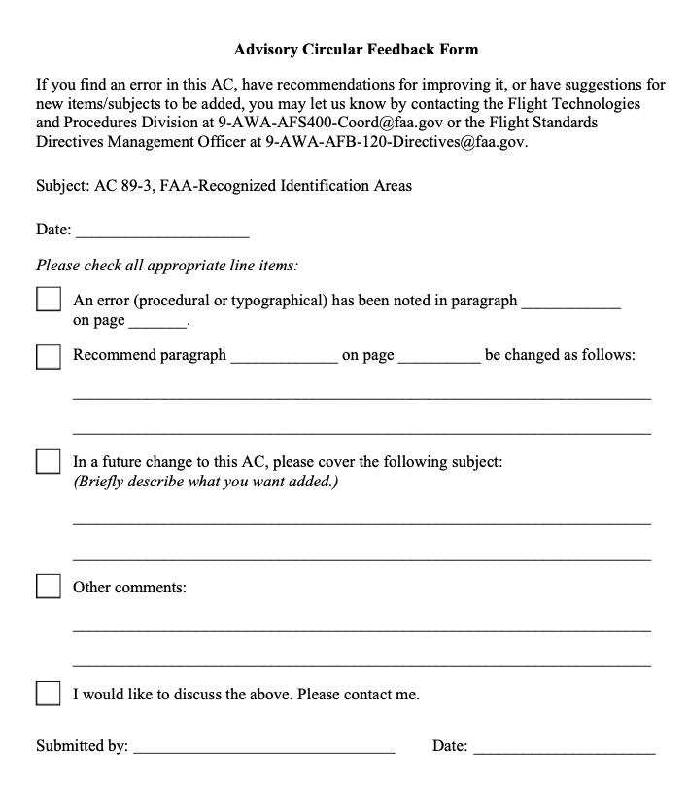
Flight Standards Information Management System (FSIMS)
8900.1 CHG 625 - VOLUME 16 UNMANNED AIRCRAFT SYSTEMS

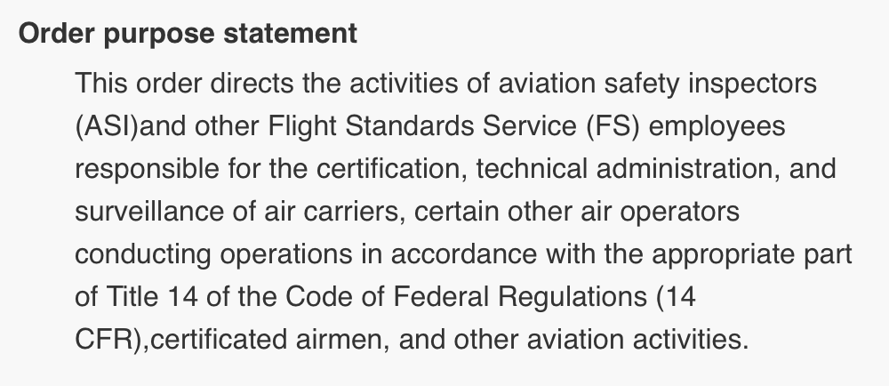
CHAPTER 1 BACKGROUND, ORGANIZATION, AND DEFINITIONS
Section 1 General Information
16-1-1-1 PURPOSE. This volume provides information and policy guidance regarding how civil Unmanned Aircraft Systems (UAS) operators, public UAS operators, and model aircraft operators are authorized to conduct flight operations in a manner which complies with the applicable Title 14 of the Code of Federal Regulations (14 CFR).
16-1-1-3 AUDIENCE. The primary audience for this volume is Flight Standards Service aviation safety inspectors (ASI), aviation safety technicians (AST), their managers and supervisors, and other operational and administrative employees. The aviation industry and the general public may find this volume helpful for informational and planning purposes.

16-1-1-5 POLICY. To operate in the National Airspace System (NAS), pilots and operators of
UAS must demonstrate compliance with the applicable parts of 14 CFR, including 14 CFR part 11 grants of exemption, and/or Certificates of Waiver or Authorization (CoW/A).
16-1-1-7 UAS INTEGRATION.
A. Diverse Purposes. UAS come in a variety of shapes and sizes and serve diverse purposes. They may weigh more than 10,000 pounds or less than 1 pound. UAS weighing less than 55 pounds total takeoff weight are considered by statute and regulation to be “small UAS.”
Regardless of size, the responsibility of a pilot to fly safely and within the regulatory construct
applies equally to all aircraft operations.
B. Significant Challenges. Introducing UAS operations into the National Airspace System (NAS) remains a significant challenge for the Federal Aviation Administration (FAA) as well as the aviation community, because they are inherently different from manned aircraft. As of the date of this change, UAS NAS integration has included:
1) The issuance of CoW/As to public and civil aircraft operators, as applicable;
2) The issuance of Special Airworthiness Certificates for civil UAS operations to include specific operating conditions and limitations;
3) The issuance of part 11 grants of exemptions for sUAS (less than 55 pounds) operations without an Airworthiness Certificate (also known as Public Law (PL) 112-95, section 333 Exemptions) and larger UAS that include specific conditions and limitations;
4) Small UAS operations conducted under 14 CFR part 107, including part 107 Certificates of Waiver (CoW) and Certificates of Authorization (CoA); and
5) Model Aircraft operations that are conducted in accordance with PL 112-95, section 336, and 14 CFR part 101 subpart E.

16-1-1-9 APPLICABILITY AND AUTHORIZATION CRITERIA. The applicability and
authorization for UAS operations are dependent on whether the operations are civil, public or
model aircraft (part 101) and the UAS operation being within the territorial airspace of the
United States (the airspace above the contiguous United States, Alaska, Hawaii, U.S. territories,
and U.S. territorial waters). UAS operations outside the territorial airspace of the United States
will be classified as either state or civil operations in accordance with international law.
16-1-1-11 TYPES OF UAS OPERATORS.
A. Civil. Civil aircraft operations must be conducted in accordance with one of the following:
1) Part 107 sUAS. Part 107, sUAS weighing less than 55 pounds, including those provisions of part 107 that are waived through a CoW/A.
2) Exemptions. Exemptions issued under section 333.
3) Special Airworthiness Certificate. Special Airworthiness Certificate issued by the FAA Aircraft Certification Service (AIR), including operational limitations.

NOTE: Special Airworthiness Certificates will be coordinated through the Delegation and Organizational Procedure Branch (AIR-160) staff with assistance from Air Traffic Organization (ATO) and Flight Standards Service for final approval and disposition.
4) Type Certification. Type certificate (TC) issued by AIR signifying the airworthiness of an aircraft manufacturing design. The certificate is issued by a regulating body and once issued, the design cannot be changed.
5) Other Certifications. Certificates issued for part 135, part 137, and other certifications applicable to the operational conditions.
6) Model Aircraft. UAS operated for hobby or recreation must be conducted in accordance with one of the following:
a) Part 101 subpart E Model Aircraft.
b) Part 107 sUAS, including any provisions of part 107 that are waived through a CoW.
c) Part 11 grants of exemption.
B. Public. A public aircraft operation is one that is intrinsically governmental in nature usually conducted by Federal, State and local government agencies. Refer to Advisory Circular (AC) 00-1.1, Public Aircraft Operations.
1) COA online application process, which can be found at the FAA COA Application Processing System website: https://caps.faa.gov. COA online applications for UAS flight operational approvals are processed through ATO and coordinated with Aviation Safety (AVS).
2) Part 107 sUAS provided that all of the provisions of part 107 are complied with, including any provisions of part 107 that are waived through a CoW.
3) Part 11 grants of exemption.
16-1-1-13 ADDITIONAL INFORMATION. You may find additional information regarding UAS regulations and policies at http://www.faa.gov/uas/.

Section 2 Definitions and Acronyms
16-1-2-1 DEFINITIONS. The following definitions are used by the Federal Aviation Administration (FAA) and many Unmanned Aircraft Systems (UAS) organizations to describe relevant differences between UAS operations and those of manned aircraft. Other organizations,
such as the International Civil Aviation Organization (ICAO) and RTCA, Inc., have also developed acronyms and definitions that may differ from those used by the FAA.
A. Aircraft. A device that is used or intended to be used for flight in the air.
B. Airworthy. UAS conformity to its type certificate (TC), if applicable, and has been determined to be in a condition for safe operation (Title 49 of the United States Code (49 U.S.C.)
§ 44704(d)(1)).
C. Airworthiness Statement. Letter from a public UAS applicant specifying self-certification of a UAS in compliance with the criteria of the public entity.

D. Beyond Visual Line of Sight (BVLOS). The operation of a UAS beyond the capability of the flight crew members (i.e., remote pilot in command (PIC)), the person manipulating the controls, and visual observer (VO), if used) to see the aircraft with vision unaided by any device other than corrective lenses (spectacles and contact lenses).
E. Certificate of Waiver or Authorization (CoW/A). A Certificate of Waiver (CoW) or Certificate of Authorization (CoA) is an FAA grant of approval for a specific flight operation
or airspace authorization or waiver.
F. Chase Aircraft. A manned aircraft that carries its own PIC and a separate qualified VO flying in proximity to an unmanned aircraft (UA) for the purpose of providing a safety function, (i.e., see and avoid).
G. Civil Aircraft. Aircraft other than public aircraft (Title 14 of the Code of Federal Regulations (14 CFR) part 1, § 1.1; 49 U.S.C. § 40102(a)(16)).

H. Civil Twilight. The period of time that begins 30 minutes before official sunrise and ends at official sunrise; and the period of time that begins at official sunset and ends 30 minutes after official sunset. In Alaska, the period of civil twilight is defined in the Air Almanac.
I. Control Station. An interface used by the remote pilot to control the operation and flightpath of the UA. The structure or system (ground-, ship-, or air-based) that controls the UAS and its interface to the aircraft, any sensor, and external systems.
J. Cooperative Aircraft. Aircraft that have an electronic means of identification (i.e., a transponder or Automatic Dependent Surveillance-Broadcast (ADS-B) transceiver) aboard in operation.

K. Corrective Lenses. Spectacles or contact lenses.
L. Crewmember (UAS). A person assigned to perform an operational duty during operations. A UAS crewmember includes the remote PIC, person manipulating the controls, and VOs, but may include other persons as appropriate or required to ensure safe operation of the UAS (i.e., sensor operator, ground control station operator).
M. Crew Resource Management (CRM). A management system to promote safety and enhance efficiency through the effective use of all available resources including human, hardware, software, and information resources.
N. Daisy-Chaining. The use of multiple, successive VOs to extend the flight of a UA beyond the direct Visual Line of Sight (VLOS) of the PIC or VO.
O. Data Link. A wireless communication channel between one control station and one UA. Its utility may include, but is not limited to, uplink Command and Control (C2) data, downlink telemetry, and payload data. A data link may consist of the following types:
1) Uplink. The transmittal of data from the control station to the UA.
2) Downlink. The transmittal of data from the UA to the control station.
P. Direct Control. The ability of a remote PIC to immediately take over the flight controls. For example, the operation could involve a “buddy box” type system that uses two control stations: one for the person manipulating the flight controls and one for the remote PIC that allows the remote PIC to override the other control station and immediately take direct control of the small unmanned aircraft. Another method could involve the remote PIC standing close enough to the person manipulating the flight controls so as to be able to physically take over the control station from the other person.
Q. First Person View (FPV). The ability of flightcrew members to control the UAS without having direct VLOS of the UAS. Crewmembers utilize various vision-enhancing imagery methods, devices, or goggles to replace direct visual contact while controlling the UAS.
R. Flight Termination. The intentional and deliberate process of terminating the flight in the event of lost link, loss of control, or other failure that compromises the safety of flight.
S. Flyaway. When the pilot is unable to effect control of the aircraft and, as a result, the UA is not operating in a predictable or planned manner.
T. Indirect Control. The capability of a remote pilot to affect the trajectory of the aircraft through computer rather than sensory input to an onboard flight control system.
U. Lost Link. An interruption or loss of positive control between the control station and UA, or when the pilot is unable to effect control of the aircraft. Lost link is not considered a flyaway.
V. Lost Link Procedures. Preprogrammed or predetermined mitigations to ensure the continued safe operations of the UA in the event of lost link. In the event positive link cannot be achieved, flight termination must be implemented.
W. Low Altitude Authorization and Notification Capability (LAANC). A program that enables air traffic control (ATC) notifications and authorizations of UAS operations in controlled airspace and near airports.
X. Model Aircraft. Per 14 CFR part 101, § 101.1(a)(5), a civil UA that is:
1) Capable of sustained flight in the atmosphere;
2) Flown within VLOS of the person operating the aircraft; and
3) Flown exclusively for hobby or recreational purposes.
Y. Nationwide Community-Based Organization (CBO). A “membership-based association that represents the aeromodeling community within the Unites States; [and] provides its members a comprehensive set of safety guidelines that underscores safe aeromodelling operations within the National Airspace System (NAS) and the protection and safety of the general public on the ground.”
Z. Non-Cooperative Aircraft. Aircraft that do not have an electronic means of identification (e.g., a transponder) aboard or that have inoperative equipment because of malfunction or deliberate action.
AA. Off-Airport. Any location used to launch or recover aircraft that is not considered an airport (e.g., an open field).
BB. Optionally Piloted Aircraft (OPA). An aircraft having UAS technology that can be flown unmanned and retains the capability of being flown by a Pilot Onboard (PO) using conventional control methods.
CC. Person Manipulating the Controls. A person other than the remote PIC who is controlling the flight of an sUAS under the supervision of the remote PIC.
DD. Remote Pilot in Command (PIC). A person who holds a remote pilot certificate with an sUAS rating and has the final authority and responsibility for the operation and safety of an sUAS operation conducted under 14 CFR part 107.
EE. Public Aircraft. Title 49 U.S.C. § 40102(a)(41) provides the definition of “Public Aircraft” and § 40125 provides the qualifications for public aircraft status.
FF. Small Unmanned Aircraft. A UA weighing less than 55 pounds on takeoff, including everything that is onboard or otherwise attached to the aircraft.

GG. Small Unmanned Aircraft System (small UAS). A small unmanned aircraft and its associated elements (including communication links and the components that control the small unmanned aircraft) that are required for the safe and efficient operation of the small unmanned aircraft in the national airspace system.
HH. Special Governmental Interest (SGI) CoW/A. Formerly called an eCOA or emergency COA. A temporary, emergency CoW/A that is issued to Public or Civil operators in cases where operations cannot be conducted under their existing COA, Memorandum of Agreement (MOA), or under part 107 including any waiver, to support a public interest.
II. Tethered UAS. A UA that is restrained by a cable and attached to the ground or an object thereon.
JJ. UAS Facility Maps (UASFM). Grid maps around airports in controlled airspace that depict the altitudes below which automatic requests for airspace authorization can be issued through LAANC

KK. Unmanned Aircraft (UA). An aircraft that is operated without the possibility of direct human intervention from within or on the aircraft.
LL. Unmanned Aircraft System (UAS). A UA and its associated elements (including communication links and the components that control the small UA) that are required for the safe and efficient operation of the small UA in the NAS.
MM. Visual Line of Sight (VLOS). Operation of a UAS within the capability of any flight crew member (i.e., remote PIC, the person manipulating the controls, and visual observer, if used) seeing the aircraft with vision unaided by any device other than corrective lenses, spectacles or contact lenses in order to know the UA’s location, determine the UA’s attitude, altitude, and direction of flight, observe the airspace for other air traffic or hazards, and determine that the UA does not endanger the life or property of another.
NN. Visual Observer (VO). A person who assists the remote PIC and the person manipulating the flight controls of the small UAS (if that person is not the remote PIC) to see and avoid other air traffic or objects aloft or on the ground. The VO must be able to effectively communicate:
• The small UA location, attitude, and direction of flight;
• The position of other aircraft or hazards in the airspace; and
• The determination that the UA does not endanger the life or property of another.

16-1-2-3 ACRONYMS.
Figure 16-1-2A. UAS Acronym List
AC Advisory Circular
AFPD Air Force Policy Directive
AGC Office of The Chief Counsel
AGL Above Ground Level
AIM Aeronautical Information Manual
ALoS Acceptable Level of Safety
AMOC Alternative Method of Compliance
AR Army Regulations
ASI Aviation Safety Inspector
ATC Air Traffic Control
ATCAA Air Traffic Control Assigned Airspace
ATCSCC Air Traffic Control System Command Center
ATO Air Traffic Organization
ATS Air Traffic Service
AVS Aviation Safety
BVLOS Beyond Visual Line of Sight
C2 Command and Control Link
CFIT Controlled Flight Into Terrain
CFR Code of Federal Regulations
CoA Certificate of Authorization
CoW Certificate of Waiver
CoW/A Certificate of Waiver or Authorization
CRM Crew Resource Management
CS Control Station
DCP Divert/Contingency Point
DHS Department of Homeland Security
DOD Department of Defense
DSA Detect, Sense, and Avoid System
FAA Federal Aviation Administration
FCC Federal Communications Commission
FHA Fault Hazard Analysis
FIR Flight Information Region
FL Flight Level
FPV First Person View
FSIMS Flight Standards Information Management System
FTP Flight Termination Point
FTS Flight Termination System
GCS Ground Control Station
GHz Gigahertz
GMF Government Master File
HQ Headquarters (FAA)
IFR Instrument Flight Rules
LAANC Low Altitude Authorization and Notification Capability
LLP Lost Link Point
LOA Letter of Agreement
MIDO Manufacturing Inspection District Office
MHz Megahertz
MOA Memorandum of Agreement
MSL Mean Sea Level
NAS National Airspace System
NASA National Aeronautics and Space Administration
NAVAIRINST Naval Air Systems Command Instruction
NM Nautical Mile
NTIA National Telecommunications and Information Administration
OPA Optionally Piloted Aircraft
PIC Pilot in Command
POC Point of Contact
R&D Research and Development
RF Radio Frequency
RM Risk Management
RNAV Area Navigation
RTB Return to Base
RVSM Reduced Vertical Separation Minimum
SM Statute Mile
SRM Safety Risk Management
SRMD Safety Risk Management Document
SSI Sensitive Security Information
STA Special Temporary Authority
sUA small Unmanned Aircraft
sUAS small Unmanned Aircraft System
TAS Traffic Advisory Systems
TC Type Certificate
TCAS Traffic Alert and Collision Avoidance System
UA Unmanned Aircraft
UAS Unmanned Aircraft System
UASFM UAS Facility Maps
USC United States Code
USCBP U.S. Customs and Border Protection
USCG U.S. Coast Guard
VFR Visual Flight Rules
VMC Visual Meteorological Conditions
VO Visual Observer

Section 3 Related Regulations and Publications
16-1-3-1 GENERAL. The Federal Aviation Administration (FAA) has developed the framework within Title 14 of the Code of Federal Regulations (14 CFR) part 107 to enable certain small Unmanned Aircraft System (sUAS) operations to be conducted for many different nonrecreational purposes without requiring an airworthiness certificate, exemption, or a Certificate of Waiver or Authorization (COA). Although part 107 is a standalone part, there are certain other regulatory parts and FAA policy and procedures that affect some operations conducted within the scope of part 107. This section provides related regulations and publications that can provide guidance when conducting certification and operational oversight.
For a complete listing of regulations, refer to
http://www.faa.gov/regulations_policies/faa_regulations/.
16-1-3-3 RELATED REGULATIONS AND PUBLICATIONS (current editions).
A. Title 14 CFR:
1) Part 1, Definitions and Abbreviations.
2) Part 45, Identification and Registration Marking.
3) Part 47, Aircraft Registration.
4) Part 48, Registration and Marking Requirements for Small Unmanned Aircraft.
5) Part 61, Certification: Pilots, Flight Instructors, and Ground Instructors:
• Section 61.56, Flight Review.
• Section 61.193, Flight Instructor Privileges.
• Section 61.413, What are the Privileges of My Flight Instructor Certificate with a Sport Pilot Rating?
6) Part 71, Designation of Class A, B, C, D, and E Airspace Areas; Air Traffic Service Routes; and Reporting Points.
7) Part 73, Special Use Airspace.
8) Part 91, General Operating and Flight Rules:
• Section 91.17, Alcohol or Drugs.
• Section 91.19, Carriage of Narcotic Drugs, Marihuana, and Depressant or Stimulant Drugs or Substances.
• Section 91.137, Temporary Flight Restrictions in the Vicinity of Disaster/Hazard Areas.
• Section 91.138, Temporary Flight Restrictions in National Disaster Areas in the State of Hawaii.
• Section 91.139, Emergency Air Traffic Rules.
• Section 91.141, Flight Restrictions in the Proximity of the Presidential and Other Parties.
• Section 91.143, Flight Limitation in the Proximity of Space Flight Operations.
• Section 91.144, Temporary Restriction on Flight Operations during Abnormally High Barometric Pressure Conditions.
• Section 91.145, Management of Aircraft Operations in the Vicinity of Aerial Demonstrations and Major Sporting Events.
• Section 91.203, Civil Aircraft: Certifications Required.
9) Part 93, Special Air Traffic Rules.
10) Part 99, Security Control of Air Traffic, Section 99.7, Special Security Instructions.
11) Part 101, Moored Balloons, Kites, Amateur Rockets, Unmanned Free Balloons, and Certain Model Aircraft.
• Section 101.1, Applicability.
• Section 101.41, Applicability.
• Section 101.43, Endangering the Safety of the National Airspace System.
12) Part 107, Small Unmanned Aircraft Systems.
• Section 107.1, Applicability.
• Section 107.3, Definitions.
• Section 107.5, Falsification, Reproduction or Alteration.
• Section 107.7, Inspection, Testing, and Demonstration of Compliance.
• Section 107.9, Accident Reporting.
• Section 107.11, Applicability.
• Section 107.12, Requirement for a Remote Pilot Certificate with a Small UAS Rating.
• Section 107.13, Registration, Certification, and Airworthiness Directives.
• Section 107.15, Civil Small Unmanned Aircraft System Unworthiness.
• Section 107.17, Medical Condition.
• Section 107.19, Remote Pilot in Command.
• Section 107.21, Maintenance and Inspection.
• Section 107.23, Hazardous Operation.
• Section 107.25, Operation from a Moving Vehicle or Aircraft.
• Section 107.27, Alcohol or Drugs.
• Section 107.29, Daylight Operation.
• Section 107.31, Visual Line of Sight Aircraft Operation.
• Section 107.33, Visual Observer.
• Section 107.35, Operation of Multiple Small Unmanned Aircraft System.
• Section 107.36, Carriage of Hazardous Material.
• Section 107.37, Operation Near Aircraft; Right-of-way Rules.
• Section 107.39, Operation Over People.
• Section 107.41, Operation in Certain Airspace.
• Section 107.43, Operation in the Vicinity of Airports.
• Section 107.45, Operation in Prohibited or Restricted Areas.
• Section 107.47, Flight Restrictions in the Proximity of Certain Areas Designated by Notice to Airmen.
• Section 107.49, Preflight Familiarization, Inspection, and Actions for Aircraft Operation.
• Section 107.51, Operating Limitations for Small Unmanned Aircraft.
• Section 107.53, Applicability.
• Section 107.57, Offenses Involving Alcohol or Drugs.
• Section 107.59, Refusal to Submit to an Alcohol Test or to Furnish Test Results.
• Section 107.61, Eligibility.
• Section 107.63, Issuance of an Unmanned Aircraft Operator Certificate with a Small UAS Rating.
• Section 107.65, Aeronautical Knowledge Recency.
• Section 107.67, Knowledge Tests: General Procedures and Passing Grades.
• Section 107.69, Knowledge Tests: Cheating or Other Unauthorized Conduct.
• Section 107.71, Retesting After Failure.
• Section 107.73, Initial and Recurrent Knowledge Tests.
• Section 107.74, Initial and Recurrent Training Courses.
• Section 107.77, Change of Name or Address.
• Section 107.79, Voluntary Surrender of Certificate.
• Section 107.200, Waiver Policy and Requirements.
• Section 107.205, List of Regulations Subject to Waiver.
13) Part 183, Representatives of the Administrator, Section 183. 23, Pilot Examiners.
B. Title 47 CFR:
• Part 87, Aviation Services.
• Part 300, National Telecommunications and Information Administration (NTIA) Manual, Chapter 7.11, Use of Frequencies by Certain Experimental Stations.
C. Title 49 CFR:
• Chapter I, Subchapter C, Hazardous Materials Regulations.
• Chapter XII, Part 1520, § 1520.5, Sensitive Security Information.
D. Advisory Circulars (AC):
• AC 00-1.1, Public Aircraft Operations.
• AC 00-6, Aviation Weather For Pilots and Flight Operations Personnel.
• AC 00-45, Aviation Weather Services.
• AC 60-28, English Language Skill Standards Required by 14 CFR Parts 61, 63, and 65.
• AC 91-57, Model Aircraft Operating Standards.
• AC 107-2, Small Unmanned Aircraft Systems (sUAS).
• AC 120-92, Safety Management Systems for Aviation Service Providers.
E. FAA Directives:
• FAA Order 8130.34, Airworthiness Certification of Unmanned Aircraft Systems and Optionally Piloted Aircraft.
• FAA Order 8900.1, Flight Standards Information Management System.
• FAA Order JO 7110.10, Flight Services.
• FAA Order JO 1000.37, Air Traffic Organization Safety Management System.
• FAA Order JO 7110.65, Air Traffic Control.
• FAA Order JO 7210.3, Facility Operation and Administration.
• FAA Order JO 7400.8, Special Use Airspace.
• FAA Order JO 7400.9, Airspace Designations and Reporting Points.
• FAA Order JO 7610.4, Special Operations.
F. Other Documents:
1) Title 49 of the United States Code (49 U.S.C.) § 40102(a)(41), Definitions; and § 40125, Qualifications for Public Aircraft Status.
2) FAA Air Traffic Organization (ATO) Safety Management System (SMS) Manual.
3) Memorandum of Agreement Concerning the Operation of Department of Defense Unmanned Aircraft Systems in the National Airspace System (DOD-FAA MOA).
4) Convention on International Civil Aviation (“Chicago Convention”), December 7, 1944, 61 Stat. 1180, 15 U.N.T.S. 295.
5) Public Law 112-95, Subtitle B — Unmanned Aircraft Systems, §§ 331 – 336.
Section 4 Flight Standards Divisions/ASI Interface, Tasks/Flows, and SAS AR
16-1-4-1 FLIGHT STANDARDS SERVICE (FS) DIVISIONS AVIATION SAFETY
INSPECTOR (ASI) AND AVIATION SAFETY TECHNICIAN (AST) INTERFACE.
16-1-4-3 TASKS/FLOWS.
16-1-4-5 REPORTING SYSTEM(S). Use Safety Assurance System (SAS) Activity Recording (AR) and use the appropriate specialty activity code.
A. Responsibilities. All inspectors, ASTs, managers, and supervisors are responsible for maintaining accurate and current records. The inspector or technician should see Volume 10 for
SAS AR entry and updates.
B. Recording Information. ASIs and ASTs record information in SAS by adding and updating applicable AR records. This is accomplished by using activity codes to identify specific activities that are conducted or accomplished by FS employees involving aircraft. Unmanned aircraft (UA) have been identified by law (Public Law (PL) 115-254, FAA Reauthorization Act of 2018) and the Federal Register (FR) as aircraft. SAS AR allows ASIs and ASTs to include Unmanned Aircraft Systems (UAS) in their reporting and documentation. AR guidance is well documented in the SAS Automation User Guide (AUG) and various sections of this order and remains the same for UAS with the following additional requirements.
1) “Activity Num” Field. All entries will use established SAS AR activity codes in the required “Activity Num” field. UAS activity records are further identified by populating the “14 CFR” field of the activity record with “91,” “107,” “137,” or other part, as applicable.
NOTE: While conducting surveillance, if it is determined to be a UAS operating under Title 14 of the Code of Federal Regulations (14 CFR) part 135, the FS office and assigned principal inspector (PI) responsible for certificate oversight must be informed of the findings.
2) “14 CFR” Field. Because there is not a code to mark recreational UAS operations at this time, select “part 107” for all small UAS operations (under 55 pounds) that are not certificated operations in the “14 CFR” field. Distinguish between operations that are truly part 107 and those that are recreational by entering the code “44809” in the “Local Use” field to refer to recreational operations that would fall under Section 349 of the FAA Reauthorization Act of 2018. Certificated operations should be coded with the correct regulation (e.g., 14 CFR part 91 or 137).
NOTE: “Recreational operations that would fall under Section 349 of the FAA Reauthorization Act of 2018” are those operations found to be in complete compliance with Title 49 of the United States Code (49 U.S.C.) § 44809, regardless of the operator’s intentions or beliefs. For example, an operator may believe their operation is in compliance with 49 U.S.C. § 44809, when in fact they are conducting operations that fall under part 107. In this case, “44809” would not
be entered in the “Local Use” field. Conversely, if a surveillance or investigation determines the operation was in fact in complete compliance with 49 U.S.C. § 44809, then “44809” would be populated in the “Local Use” field.
3) “Point of Departure” Field. Investigations triggered by UAS sightings near airports should include the airport code of the reporting aircraft or tower.
4) “Aircraft Reg #” (Aircraft Registration Number) Field. The “Aircraft Reg #” field is an optional field in the SAS AR record and shall be used if the UAS has a registration number that begins with “N” or the letters “FA.”
NOTE: When populating the “Aircraft Reg #” field for registration numbers that begin with the letters “FA,” the “Non N Registered” checkbox must be selected in order to allow the free text entry of the FA registration number and make/model/series (M/M/S).
5) “Non-Cert” (Non-Certificated) Field. The “Non-Cert” field is an optional field in SAS AR.
6) “Cert Number” (Airman Certificate Number) Field. The “Cert Number” field is an optional field in the SAS AR record and shall be used to record the operator/pilot certificate number.
7) “Make/Model/Series” Field. The “Make/Model/Series” field is an optional field in SAS AR and will automatically populate the M/M/S for N-number-registered UAS aircraft.
Inspectors should enter the M/M/S, as applicable, for UAS registration numbers that begin with
the letters “FA.”
8) “Misc” (Miscellaneous) Field. The “Misc” field is an optional field in SAS AR, but is required to be populated when UAS activity (preflight, flight, postflight) is either observed or not observed during a surveillance, or if an alleged offending UAS operator is either located or not located during investigations. Enter as:
• “UAS-OBSV,” or
• “UAS-NOT-OBSV.”
NOTE: The purpose of the codes UAS-OBSV and UAS-NOT-OBSV in the “Misc” field is to record when an operator conducting UAS activity (preflight, flight, postflight) is either identified or not identified during a surveillance, or if an alleged offending UAS operator is either located or not located during investigations. For example, if during a surveillance an operator is observed and identified flying the UA or conducting preflight or postflight activities, then “UAS-OBSV” would be populated in the “Misc” field. If during an investigation of an actionable UAS Sightings Report, an alleged offending operator has been identified and contacted, then “UAS-OBSV” would also be populated in the “Misc” field. Conversely, in this example, if an alleged offending operator cannot be located during the investigation, then “UAS-NOT-OBSV” would be populated in the “Misc” field.
9) “National Use” Field. Enter the codes as instructed in this paragraph to properly document the size of the UAS, and whether the UAS was used for public, civil, or military purposes, per Volume 3, Chapter 14, Sections 1 and 2. Specifically, enter “UAS,” a hyphen followed by the type of operator (Public (P), Civil (C), or Military (M)), and a hyphen followed by the size (Large (L) or Small (S)). For example:
• UAS-M-L = UAS, Military operator, Large aircraft (55 pounds and over).
• UAS-P-L = UAS, Public operator, Large aircraft.
• UAS-C-S = UAS, Civil operator, Small aircraft.
• UAS-U-S = UAS, Unknown operator, Small aircraft.
a) If the surveillance was a Conditional or a Targeted activity, enter “C” for Conditional or “T” for Targeted, as applicable, a hyphen followed by “UAS,” a hyphen followed by the type of operator (Public (P), Civil (C), or Military (M)), and a hyphen followed by the size (Large (L) or Small (S)). For example:
• C-UAS-M-L = Conditional, UAS, Military operator, Large aircraft (55 pounds and over).
• T-UAS-P-L = Targeted, UAS, Public operator, Large aircraft.
• C-UAS-C-S = Conditional, UAS, Civil operator, Small aircraft.
• T-UAS-U-S = Targeted, UAS, Unknown operator, Small aircraft.
b) If no UAS activity is observed during a Conditional or Targeted Required Surveillance Work Activity (R-item) surveillance, inspectors should enter “T-UAS-U-S” or “C-UAS-U-S” as applicable in the “National Use” field.
10) “Division Use” Field. The “Division Use” field is an optional data field in SAS AR, but is required to be populated for UAS Sightings Reports (e.g., Air Traffic Organization (ATO) reports, such as Mandatory Occurrence Reports (MOR) and Electronic Occurrence Reports (EOR), incidents, complaints, occurrences, etc.) as follows:
a) When UAS Sightings Reports have little or insufficient information that would lead to identifying a UAS or UAS operator, enter code “NON” in the “Division Use” field and close the SAS AR record as a non-actionable UAS Sightings Report.
b) When UAS Sightings Reports have sufficient information that would lead to identifying a UAS or UAS operator through an investigation, enter code “ACT” in the “Division Use” field to denote the investigation as an actionable UAS Sightings Report.
11) “Comments” Field. The “Comments” field is still available for use as needed by the user.

CHAPTER 2 MAINTENANCE, INSPECTIONS, AND CONDITIONS FOR SAFE OPERATION
Section 1 Public Operations
16-2-1-1 INTRODUCTION. This chapter and its applicable sections will address the airworthiness requirements and/or conditions for safe operation required of a Public Aircraft Operator operating under applicable authorizations.
16-2-1-3 PUBLIC OPERATIONS. Currently, public Unmanned Aircraft System (UAS) operations are authorized via a Certificate of Waiver or Authorization (CoW/A). One of the processes by which these CoW/As are granted requires a submission of the CoW/A application package to the Air Traffic Organization (ATO). ATO is solely responsible for processing requests for UAS that are less than 55 pounds and/or will operate less than 400 feet Above Ground Level (AGL). For those UAS operations that are 55 pounds and over and/or will operate more than 400 feet AGL, an additional safety review is required by a Flight Standards Service
Aviation Safety Inspector (ASI). In either case, the applicant must submit a declaration of public
aircraft status and a written statement of airworthiness certifying the UAS “will be maintained in
a condition for safe operation while conducting operations in the NAS.” Refer to Advisory Circular (AC) 00-1.1, Public Aircraft Operations, and/or Title 49 of the United States Code
(49 U.S.C.) § 40102(a)(41) for further information.
16-2-1-5 UAS AIRWORTHINESS. Before conducting any operations in the National Airspace System (NAS), a UAS (Public or Civil, including model) must be determined to be in a condition for safe operation without undue risk to other operations in the NAS, or to persons and/or property on the ground. It is the responsibility of the Public Aircraft Operator to make this determination. How a UAS is authorized to conduct these operations establishes the means (or plays a role) by which airworthiness of the UAS is determined. The Federal Aviation Administration (FAA) recognizes that some of the requirements for public operations of UAS can differ from those for manned aircraft, and civil UAS operations.
16-2-1-7 AIRWORTHINESS STATEMENT. Airworthiness or self-certifying statements are generally written for one UAS. If more than one UAS model is included on a single statement, each UAS will be listed, and specific information for each UAS will be included in the statement. Certifying statements must remain current for the duration of the CoW/A, including extensions. If a new or revised statement is required during the period a CoW/A is active, a copy of the statement must be provided to ATO. The statement must be provided on agency letterhead
and must include:
• A declaration that the UAS “will be maintained in a condition for safe operation while conducting operations in the NAS (for the duration of the CoW/A).”
• The signature/date of the responsible certifying authority within the agency.
• Certifying official contact information (i.e., phone, email, and address).
Section 2 Civil Operations
16-2-2-1 CIVIL OPERATIONS. Any operation that does not meet the statutory criteria for a public aircraft operation or model aircraft operation under Title 14 of the Code of Federal Regulations (14 CFR) part 101 is considered a civil aircraft operation and must be conducted in accordance with all Federal Aviation Administration (FAA) regulations applicable to the operation. Any civil Unmanned Aircraft Systems (UAS) operations that are not conducted under the regulatory requirements of 14 CFR part 107 would require operational approval by at least
one of the following means:
• A waiver to part 107,
• A Public Law (PL) 112-95, Section 333 exemption,
• A Standard/Special Airworthiness Certificate, or
• Other certifications, (i.e., part 135, part 137).
NOTE: These methods, associated maintenance requirements, and conditions for
safely operating in the National Airspace System (NAS) are addressed in this
section.
A. Part 107. The FAA has determined that small UAS (sUAS) (less than 55 pounds.) will not be required to obtain airworthiness certification if satisfying the regulatory requirements of part 107. However, in the absence of an airworthiness certification process, the FAA is still required to establish maintenance and inspection criteria that support safe operations. In establishing these criteria, the FAA takes into consideration the significantly reduced risk posed by sUAS operations as compared to that of typical manned aircraft. Therefore, in keeping with the sUAS rule, the maintenance and inspection requirements under this part consist of the following:
1) The remote pilot in command (PIC) must conduct a preflight inspection prior to each flight to ensure the sUAS is in a condition for safe operation.
2) The remote PIC will be prohibited from conducting any flight operations in the NAS if the sUAS is found not in a condition for safe operation.
3) The remote PIC will be required to discontinue flight operations of the sUAS if the remote PIC determines for any reason that positive control is compromised or the unmanned aircraft (UA) is no longer in a condition for safe operation.
4) In an effort to mitigate risks associated with possible loss of positive control, the remote PIC, while conducting the preflight inspection, must ensure that all control links between the control station and the UA are working properly.
NOTE: Guidance regarding how to determine that an sUAS is in a condition for safe operation and the expectations in performing maintenance and inspection of an sUAS can be found in Advisory Circular (AC) 107-2, Small Unmanned Aircraft Systems (sUAS).
B. Waivers. In some cases, sUAS compliance with part 107 may require operations be conducted with a Certificate of Waiver or Authorization (CoW/A). Guidance on waivers to part 107, § 107.200 can be found in Volume 16, Chapter 4, Section 3.
C. Exemptions. In order to make an effective evaluation of the requested relief, an analysis of the applicant’s proposed UAS operation and risk mitigations must be conducted. The following information must be included in the petitioner’s request:
1) Petitioners must describe how the proposed UAS operation will be safely conducted to minimize risk to the NAS or to persons and property on the ground. Specifically, petitioners should describe the design and operational characteristics for the type(s) of UAS they intend to operate (e.g., aircraft performance and performance limitations, operating procedures, and aircraft loading information) in as much detail as possible. This could be provided in the petition, or in an Aircraft Flight Manual (AFM) or similar document.
NOTE: The FAA will consider all information and data submitted by the petitioner that describes the UAS developmental and operational history. This could include statistical data or other documentation for the specific design and performance characteristics of the UAS, including the operational history and operational failure modes, obtained through previous Research & Development (R&D) and/or flight test activities (e.g., operations conducted under a CoW/A, with a Civil Airworthiness Certificate, or under other authorized operating conditions).
2) Petitioners must describe any procedures they would implement, such as preflight inspections, maintenance, and repair, to ensure that the UAS is in a condition for safe flight. This could be provided in the petition, an AFM, a Maintenance and Inspection Manual, or similar document.
3) Petitioners must describe any procedures they would implement for conducting a preflight safety risk assessment to determine that the UAS is in a condition for safe flight (14 CFR part 91, § 91.7(b)) and that the planned operation can be completed safely. These procedures can be addressed in the petition, an AFM, Operations Manual, or similar document.
16-2-2-3 SPECIAL AIRWORTHINESS CERTIFICATE. An FAA Manufacturing aviation safety inspector (ASI) has primary responsibility for the issuance of original Special Airworthiness Certificates to UAS, Optionally Piloted Aircraft (OPA), and OPA/UAS. The FAA
Airworthiness ASI has primary responsibility for the issuance of recurrent Special Airworthiness Certificates. Guidance and responsibilities for both ASI classifications can be found in the current edition of FAA Order 8130.34, Airworthiness Certification of Unmanned Aircraft Systems and Optionally Piloted Aircraft. For additional guidance and clarification, contact the Airworthiness Certification Service (AIR-113) at 202-267-1575, and Volume 8, Chapter 5,
Section 13.
16-2-2-5 STANDARD AIRWORTHINESS CERTIFICATE. Reserved.
16-2-2-7 OTHER CERTIFICATIONS. UAS may be operated under part 135 and/or part 137. Certification processes for these parts follow the same criteria as for manned aircraft and may include additional waivers or exemptions as required.

CHAPTER 3 AIRMEN CERTIFICATION
Section 1 Remote Pilots
16-3-1-1 OBJECTIVE. This section provides guidance to process an application for a Remote Pilot Certificate with a small Unmanned Aircraft Systems (sUAS) rating for civil sUAS operations. Once it is determined the applicant meets the eligibility requirements in accordance with Title 14 of the Code of Federal Regulations (14 CFR) Part 107, Small Unmanned Aircraft Systems, the application can be processed. The successful completion of this task results in the processing of the applicant’s application and the issuance of a temporary operating certificate, as appropriate.
16-3-1-3 PROGRAM TRACKING AND REPORTING SUBSYSTEM (PTRS) ACTIVITY CODE. 1509.
16-3-1-5 REMOTE PILOT ELIGIBILITY REQUIREMENTS FOR INITIAL CERTIFICATION.
A person applying for a Remote Pilot Certificate with an sUAS rating must meet and maintain, as applicable, the following eligibility requirements:
• Be at least 16 years of age.
• Be able to read, speak, write, and understand the English language. However, the Federal Aviation Administration (FAA) may make an exception if the person is unable to meet one of these requirements due to medical reasons, such as hearing impairment.
• Be in a physical and mental condition that would not interfere with the safe operation of an sUAS.
• Pass the initial aeronautical knowledge written examination at an FAA-approved knowledge testing center (KTC). However, a person who already holds an Airman Certificate issued under 14 CFR part 61 and has successfully completed a flight review in accordance with part 61, § 61.56 (or meets other criteria in § 61.56) within the previous 24 calendar-months is only required to successfully complete an online training course, ALC-451, Part 107 small Unmanned Aircraft Systems (sUAS), available at https://www.FAASafety.gov. (Refer to part 107, § 107.65.)
NOTE: Additionally, the Transportation Security Administration (TSA) screens all pilot certificate applicants and holders.
NOTE: Unmanned Aircraft Systems (UAS) pilot time may not be used to meet the aeronautical experience requirements towards the issuance of a pilot certificate under part 61.
NOTE: There is no provision for conversion of military UAS operational experience or time accrued to an FAA Remote Pilot Certificate. Additionally, there is no conversion process for foreign pilots of UAS wishing to receive Remote Pilot Certificates. In both cases, individuals must meet the requirements described in this section.
16-3-1-7 APPLICATION PROCEDURE. This paragraph provides guidance on how a person
can apply for a Remote Pilot Certificate.
A. Applicants Without a Part 61 Certificate. A person who does not hold a part 61 pilot certificate, a part 61 Airman Certificate holder1 who does not have a current flight review (or other criteria) in accordance with § 61.56, or a part 61 Airman Certificate holder who voluntarily elects to use this process must:
1) Pass an initial aeronautical knowledge test. An applicant must go to a KTC to take and pass the FAA sUAS knowledge test (Unmanned Aircraft General (UAG)).
2) Complete FAA Form 8710-13, FAA Remote Pilot Certificate and/or Rating Application.
a) Option 1, Online Form. This is the fastest and simplest method.
FAA Form 8710-13 should be completed online using the electronic FAA Integrated Airman
Certification and Rating Application (IACRA) system (https://iacra.faa.gov/iacra/).
The applicant must have already passed an initial aeronautical knowledge test. Once registered
with IACRA, he or she will log in with their username and password. The applicant will click on
“Start New Application” and 1) Application Type: “Pilot;” 2) Certifications: “Remote Pilot;”
3) “Other Path Information;” and 4) “Start Application.” The applicant will continue through the
application process and, when prompted, enter the 17-digit Knowledge Test Exam ID from the
knowledge test in IACRA. It may take up to 48 hours from the test date for the knowledge test to
appear in IACRA. The KTC test proctor will be the one that verified the identity of the applicant.
Once the applicant completes the online application in IACRA, he or she will sign the application electronically and submit it to the Airman Certification Branch for processing.
No FAA representative will be required to sign the application if the applicant was able to self-certify.
NOTE: When the applicant uses this online option, the application will be transmitted electronically from the applicant to the Airman Certification Branch.
The only electronic signature that will be reflected on the IACRA application will be the applicant’s. The applicant will then receive a confirmation email once his or her application has completed the TSA vetting process. The email will provide information that will allow the applicant to log into the IACRA system and print a copy of the temporary certificate.
Reference to “part 61 Airman Certificate holders” specifically includes sport pilot, recreational
pilot, private pilot, Commercial Pilot, and Airline Transport Pilot (ATP) Certificates. It does not
include a Student Pilot Certificate.
b) Option 2, Paper Application. An applicant could also submit a paper application. If the applicant chooses the paper method, the original initial aeronautical knowledge test report must be mailed with the application to the following address:
Federal Aviation Administration
Airmen Certification Branch
P.O. Box 25082
Oklahoma City, OK 73125
NOTE: A Temporary Airman Certificate will not be provided to the remote pilot applicant if they do not hold a part 61 certificate. For this reason, it would be in the applicant’s best interest to utilize Option 1 (IACRA system) instead of the paper method in order to receive a Temporary Airman Certificate once the application has completed the TSA vetting process.
3) Receive permanent Remote Pilot Certificate once all other FAA internal processing is complete.
B. Applicants With a Part 61 Pilot Certificate. Instead of the process described above, a person who holds a part 61 pilot certificate and meets the criteria of § 61.56, has completed a flight review, or meets the criteria in § 61.56 within the previous 24 calendar-months may elect to apply using the following process:
1) Complete the online course (ALC-451), located within the FAA Safety Team (FAASTeam) website (https://www.FAASafety.gov), and receive a completion certificate.
2) Complete FAA Form 8710-13.
a) Option 1 (Online Application). In almost all cases, the application should be completed online using the electronic FAA IACRA system (https://iacra.faa.gov/iacra/).
The applicant must include verification that he or she completed the online course or passed an initial aeronautical knowledge test. The applicable official document(s) must be uploaded into
IACRA either by the applicant or the certifying officer.
b) Option 2 (Paper). The application may be completed on paper. Using this method, the certificate of completion for the online course or the original initial aeronautical knowledge test report must be included with the application. Please note that the processing time will be increased if a paper application is used.
3) Contact a Flight Standards District Office (FSDO), an FAA Designated Pilot Examiner (DPE), an Airman Certification Representative (ACR), or an FAA certificated flight instructor (CFI) to make an appointment to validate the applicant’s identification. The applicant must present the completed FAA Form 8710-13 along with the online course completion certificate or knowledge test report (as applicable) and proof of a current flight review or other criteria required by § 61.56. FAA Form 8710-13 will be signed by the applicant after the FSDO, DPE, ACR, or CFI examines the applicant’s photo identification and verifies the applicant’s identity. The FAA representative will then sign the application. The identification presented must include a photograph of the applicant, the applicant’s signature, and the applicant’s actual residential address (if different from the mailing address). This information may be presented in more than one form of identification. Acceptable methods of identification include, but are not limited to, U.S. drivers’ licenses, government identification cards, passports, and military identification cards (refer to Advisory Circular (AC) 61-65, Certification: Pilots and Flight and Ground Instructors). If using paper or the IACRA method, an appropriate FSDO representative, a DPE, or an ACR will issue the applicant a Temporary Airman Certificate.
NOTE: A CFI is not authorized to issue a temporary certificate. If using IACRA and the applicant is utilizing a CFI as the FAA representative, the applicant can print their own Temporary Airman Certificate after receiving an email from the FAA notifying them that it is available. If using the paper method and the applicant is utilizing a CFI as the FAA representative, the applicant will not be issued a Temporary Airman Certificate. The CFI will sign and mail the paper application, along with any required attachments, to their responsible Flight Standards office for further processing. Once the FSDO has signed and approved the application, it will be mailed to the Airman Certification Branch for the issuance of the permanent certificate.
4) Receive the permanent Remote Pilot Certificate once all other FAA internal processing is complete.
16-3-1-9 TEMPORARY AIRMAN CERTIFICATE. Aviation safety inspectors (ASI), DPEs, and ACRs will fill out FAA Form 8060-4, Temporary Airman Certificate, in the same manner as any other type of pilot’s Temporary Airman Certificate. Block IX should be completed with “Remote Pilot.” Block XII will be completed with “small unmanned aircraft system” in the Ratings and Limitations section. No limitations should be inserted at this time.
All other blocks will be filled out in the same manner as any other Temporary Airman Certificate.

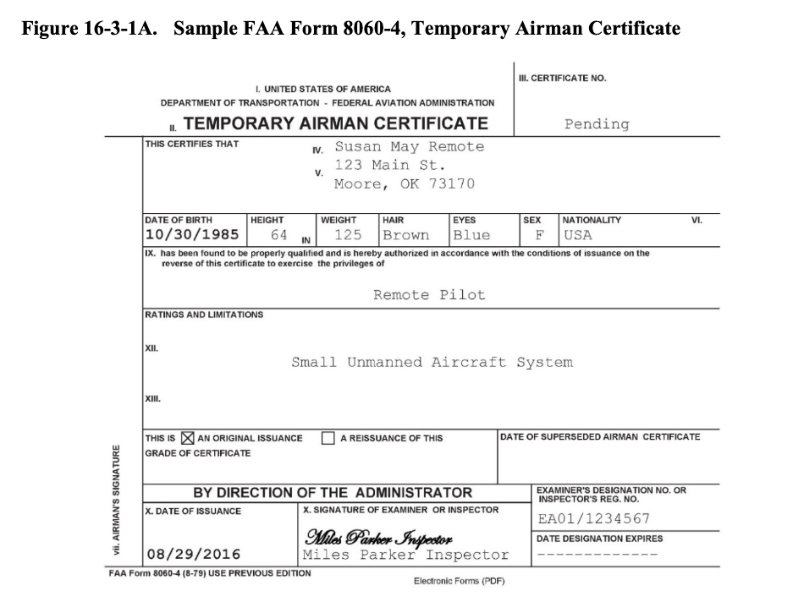

16-3-1-11 SECURITY DISQUALIFICATION. After the FAA receives the application, the TSA will automatically conduct a background security screening of the applicant prior to issuance of a Remote Pilot Certificate. If the security screening is successful, the FAA will issue a permanent Remote Pilot Certificate. If the security screening is not successful, the applicant will be disqualified and a temporary pilot certificate, if issued, will be revoked. Individuals who believe that they improperly failed a security threat assessment may appeal the decision to the TSA.
16-3-1-13 AERONAUTICAL KNOWLEDGE TESTS (INITIAL AND RECURRENT).
It is important to have and retain the knowledge necessary to operate a small unmanned aircraft (UA) in the National Airspace System (NAS). This aeronautical knowledge can be obtained through self-study, taking an online training course, taking an in-person training course, or any combination thereof. The FAA has published the Remote Pilot – Small Unmanned Aircraft Systems Airman Certification Standards (https://www.faa.gov/training_testing/testing/acs) that
provides the necessary reference material.
NOTE: The below information regarding initial and recurrent knowledge tests applies to persons who do not hold a current part 61 Airman Certificate.

A. Initial Test. As described above, a person applying for a Remote Pilot Certificate with an sUAS rating must pass the initial UAG knowledge test given by an FAA-approved KTC.
The initial knowledge test will cover aeronautical knowledge areas listed below and referenced
in § 107.73:
1) Applicable regulations relating to sUAS rating privileges, limitations, and flight operation;
2) Airspace classification, operating requirements, and flight restrictions affecting small UA operation;
3) Aviation weather sources and effects of weather on small UA performance;
4) Small UA loading;
5) Emergency procedures;
6) Crew Resource Management (CRM);
7) Radio communication procedures;
8) Determining the performance of small UA;
9) Physiological effects of drugs and alcohol;
10) Aeronautical decisionmaking and judgment;
11) Airport operations; and
12) Maintenance and preflight inspection procedures.
NOTE: A part 61 Airman Certificate holder who meets the criteria in § 61.56 within the previous 24 calendar-months may complete an initial online training course instead of taking the knowledge test.
B. Recurrent Test. After a person receives a Remote Pilot Certificate with an sUAS rating, that person must retain and periodically update the required aeronautical knowledge to continue to operate a small UA in the NAS. To continue exercising the privileges of a Remote Pilot Certificate, the certificate holder must pass the Recurrent Unmanned General Recurrent (UGR) knowledge test within 24 calendar-months after passing the initial UAG knowledge test.
A copy of the Airman Knowledge Test Report (AKTR) must be maintained as proof of recency
of aeronautical knowledge and make it available to the Administrator upon request. There is no
further IACRA processing required after taking and passing the recurrent exam. A part 61 pilot
certificate holder, not including a student pilot, who has completed a flight review within the
previous 24 calendar-months may complete a recurrent online training course found at
www.FAASafety.gov or take the recurrent knowledge test (UGR) at a KTC. The part 61 pilot
certificate holder must maintain the online training course completion certificate or the AKTR as
proof of recency of aeronautical knowledge and present it to the Administrator upon request.
Table 16-3-1A, Examples of Certification and Renewal Cycles, contains examples illustrating an
individual’s possible certification and renewal cycles.
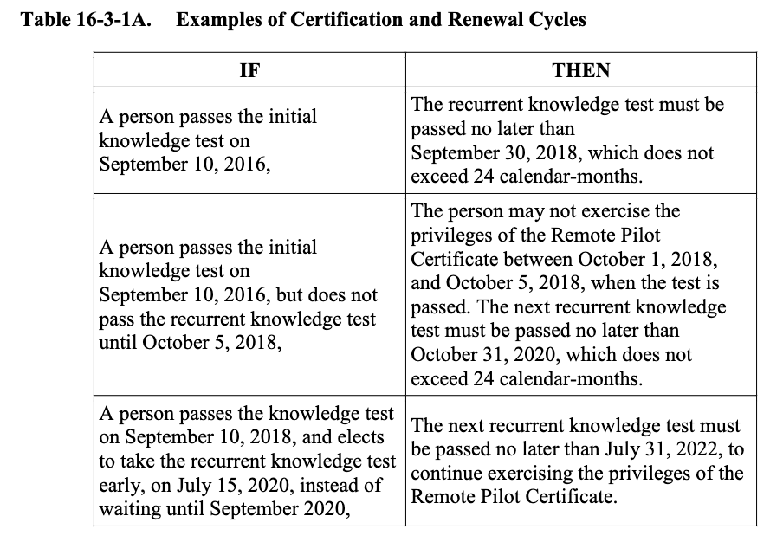

16-3-1-15 AERONAUTICAL KNOWLEDGE RECENCY (§ 107.65). A person may not operate an sUAS unless that person has completed one of the following, within the previous 24 calendar-months:
• Passed an initial aeronautical knowledge test covering the areas of knowledge specified in §§ 107.73(a) and 107.74(a); or
• Passed a recurrent aeronautical knowledge test covering the areas of knowledge specified in §§ 107.73(b) and 107.74(b).
NOTE: Test Providers: KTCs will administer initial and recurrent examinations provided by the FAA. In order to take an aeronautical knowledge test, an applicant will be required to schedule an appointment with the KTC and provide proper government-issued photo identification to the KTC on the day of the scheduled test. The location of the nearest KTC can be found at
http://www.faa.gov/training_testing/testing/media/test_centers.pdf.
NOTE: The remote pilot must retain the online training course completion certificate or Airman Knowledge Testing Report as proof of recency of aeronautical knowledge and make it available to the Administrator upon request.
16-3-1-17 PREREQUISITES AND COORDINATION REQUIREMENTS.
A. Prerequisites. This task requires knowledge of part 107 and FAA policies, and qualification as an ASI (Operations) or aviation safety technician (AST).
B. Coordination. This task may require coordination with the Airman Records Section of the Airman Certification Branch.
16-3-1-19 REFERENCES, FORMS, AND JOB AIDS.
A. References (current editions):
• Title 14 CFR Part 107.
• PTRS Procedures Manual (PPM).
• AC 107-2, Small Unmanned Aircraft Systems (sUAS).
• Airman Certification Standards (ACS), https://www.faa.gov/training_testing/testing/acs/.
B. Forms:
• FAA Form 8000-36, Program Tracking and Reporting System Data Sheet, or electronic PTRS.
• FAA Form 8710-13, Remote Pilot Certificate and/or Rating Application.
C. Job Aids. None.

Section 2 Public Operations
16-3-2-1 GENERAL PERSONNEL QUALIFICATIONS. This section addresses the qualifications for public operations of Unmanned Aircraft Systems (UAS) flight crew members, observers, maintainers, and other personnel, as appropriate. All references to a pilot certificate or Federal Aviation Administration (FAA) written examination refer to an FAA-issued pilot certificate. Additional information for public aircraft operations may be found in Volume 3,
Chapter 14.
16-3-2-3 UAS PUBLIC PILOT QUALIFICATIONS. The FAA is focused on ensuring that UAS pilots have an appropriate level of understanding of the Title 14 of the Code of Federal Regulations (14 CFR) sections applicable to the airspace where UAS operate. UAS pilots are responsible for controlling their aircraft to the same standards as the pilot of a manned aircraft.
A. UAS General Operational Requirements. The following operational requirements apply to all UAS pilots:
1) One pilot in command (PIC) must be designated at all times.
2) The PIC of an aircraft is directly responsible for, and is the final authority of, the operation of that aircraft.
3) Pilots are not allowed to perform concurrent duties both as the pilot and the visual observer (VO). In the case of Optionally Piloted Aircraft (OPA), the airborne pilot may assume the role of PIC at all times, but will only be the observer when the control station (CS) pilot operates the OPA.
4) Unless undergoing initial qualification training, pilots must be qualified on the aircraft being flown.
5) Only one PIC per aircraft is authorized, and the PIC must be in a position to assume control of the aircraft.
B. PIC.
1) The designated PIC:
a) Has been designated as PIC before or during the flight.
b) Is responsible for the UAS flight operation as described under 14 CFR parts 91 and 107, as applicable.
c) Is responsible for determining whether the UAS is in condition for safe flight.
d) Must land as soon as safely practical when any condition occurs that causes operations to be unsafe.
e) May be augmented by persons manipulating the controls; however the PIC retains complete and overall responsibility of the flight.
f) Has the ability to assume the duties of an internal or an external UAS pilot at any point during the flight.
g) May rotate duties as necessary to fulfill operational requirements.
h) Must have a thorough knowledge of the Certificate of Waiver or Authorization (COA) issued to the organization when conducting a public aircraft operation, and must retain a copy to reference during flight.
i) Must be trained and qualified on the specific UAS for the conduct of the flight.
j) May assume the duties of VO or PIC if piloting an OPA when the OPA is being utilized as a UAS and being flown by the CS pilot.
2) Rating requirements for the UAS PIC depend on the type of operation conducted; they fall into two categories:
• Operations that require an FAA-issued pilot certificate (civil); and
• Operations that do not require an FAA-issued pilot certificate (public).

CHAPTER 4 OPERATIONAL REQUIREMENTS AND APPROVAL
Section 1 Public Operations
16-4-1-1 GENERAL APPLICABILITY AND REQUIREMENTS. This section applies to Unmanned Aircraft Systems (UAS) operations conducted in the National Airspace System (NAS) other than in active restricted and prohibited areas designated for aviation use. This section provides information and limited guidance on air traffic policies and prescribes procedures for the planning, coordination, and services involving the operation of public aircraft operations (PAO) of UAS in the NAS.
16-4-1-3 AUDIENCE. The primary audience for this section is Flight Standards District Office (FSDO) aviation safety inspectors (ASI) and aviation safety technicians (AST). The secondary audience includes Flight Standards Service policy divisions responsible for implementation.
16-4-1-5 BACKGROUND. Title 49 of the United States Code (49 U.S.C.) § 40102(a)(41) provides the definition of “public aircraft,” and § 40125 provides the qualifications for public aircraft status. At a very high level, “public aircraft” are utilized in support of “governmental functions” as defined in 49 U.S.C., and may be owned and operated, or exclusively leased for at
least 90 continuous calendar-days, by the Federal Government or the government of a state, the
District of Columbia, or a territory or possession of the United States, or a political subdivision
of one of these governments, except as provided in 49 U.S.C. § 40125(b). Advisory Circular
(AC) 00-1.1, Public Aircraft Operations, describes applicable statutory provisions, and includes
contact information for policy questions. Additional information may be found in Volume 3,
Chapter 14, Sections 1 and 2.
16-4-1-7 OVERSIGHT. PAO are limited by statute to certain government operations within U.S. airspace, and must comply with certain general operating rules applicable to all aircraft in the NAS. Other civil certification and safety oversight regulations do not apply to PAO and most aspects of PAO are not subject to Federal Aviation Administration (FAA) oversight.
For example, PAO may self-certify standards for unmanned aircraft (UA) airworthiness, as well as pilot certification, qualification, and medical standards. However, if a public entity elects to operate under civil regulations, such as the conduct of operations under Public Law (PL) 112-95,
FAA Modernization and Reform Act of 2012 (FMRA), section 333, or the operation does not qualify as a public aircraft operation, then those operations would be subject to oversight by ASIs. Government agencies may conduct both PAOs and civil aircraft operations with the same aircraft. However, when conducting operations under civil regulations, the operator will be required to maintain the aircraft in accordance with the appropriate regulations applicable to civil aircraft operations. Any aircraft or operation certificated by the FAA is subject to surveillance
regardless of whether they are operating as public or civil. Government-owned aircraft operators
that are conducting PAOs should be included in annual planned surveillance activities to ensure
that the operator’s status remains unchanged.
16-4-1-9 CERTIFICATE OF WAIVER OR AUTHORIZATION (CoW/A). Current FAA policy for UAS operations is that no person may operate a UAS in the NAS without specific authority. For UAS operating as public aircraft, the authority is FAA Form 7711-1, Certificate of Waiver or Authorization (the CoW/A). The Air Traffic Organization (ATO) issues CoW/As to public operators for specific UA activities after receipt and a successful review of the operator’s application. Applicants must provide sufficient information to support the proposed operations, including a thorough description of their organizational structure, safety management process, and technical capabilities that may include the following information:
• Organizational and operational points of contact (POC).
• Operational description (e.g., method of navigation, see-and-avoid).
• Systems description (e.g., airframe, control station, communications).
• Airframe performance characteristics.
• Airworthiness.
• Contingency procedures (e.g., lost command/control link, lost communications, and emergency).
• Avionics equipment.
• Lighting.
• Frequency spectrum analysis.
• Method of air traffic control (ATC) communications.
• Surveillance capability (e.g., electronic and visual).
• System monitoring/recording capability.
• Flight crew qualifications.
• Flight operations description (flight plan (FP)).
• Special circumstances.
• Reports of past incidents or accidents (for those applicants who have previously held a CoW/A).
NOTE: For further information on ATO CoW/A processing requirements, refer to FAA Order JO 7210.3, Facility Operation and Administration, and Order JO 7200.23, Unmanned Aircraft System (UAS).
16-4-1-11 GENERAL OPERATING PROCEDURES. Public UA operations within restricted, prohibited, and active warning areas do not require a CoW/A; however, operations conducted outside of these areas require a CoW/A from the ATO. UAS operations may be conducted within Class A, B, C, D, E, and/or G airspace. Operators must submit an application to the ATO at least 60 business-days prior to the start of proposed operations.
A. CoW/A Expirations. CoW/As typically expire on the stated termination date (2 years from the effective date) unless sooner surrendered by the proponent or revoked by the issuing agency.
B. Special Governmental Issuance Certificates of Authorization (CoA). Issuance of a CoA during emergencies are available to law enforcement, first responders, and other government entities upon request. Public aircraft operators and civil operators with an existing CoW/A or incident command proponents may obtain a Special Governmental Interest (SGI) CoW/A (previously Emergency Certificate of Authorization (ECOA)) by contacting and receiving approval from System Operations Security (SysOpsSec). The emergency situation may include civil, non-governmental functions that aid relief efforts, such as utility restoration, national disaster relief, and the like. Title 14 of the Code of Federal Regulations (14 CFR) part 107 operators may fly (under part 107 rules, including any waiver authorizations) under an SGI CoW/A if their assistance has been specifically requested by the incident command proponent. They must present documentation that they are authorized by the incident command to fly for the proponent, and that SysOpsSec approval has been given, if requested. Waivers to any part 107 regulation would need to be documented as specifically granted in the SGI CoW/A approval.
16-4-1-13 RELATED PUBLICATIONS.
A. FAA Documents (current editions):
• FAA Order 1100.161, Air Traffic Safety Oversight.
• FAA Order 8900.1, Volume 3, Chapter 14.
• FAA Order JO 7110.65, Air Traffic Control.
• FAA Order JO 7210.3, Facility Operation and Administration.
• FAA Order JO 7610.4, Special Operations.
NOTE: Order JO 7610.4 contains Sensitive Unclassified Information (SUI) and is made available in accordance with FAA Order 1600.75, Protecting Sensitive Unclassified Information (SUI), on a need-to-know basis. For information, visit http://www.faa.gov/air_traffic/publications/spec_ops/.
• Order JO 7200.23, Unmanned Aircraft System (UAS).
• AC 00-1.1, Public Aircraft Operations.
B. Title 49 U.S.C. Sections:
• Section 40102(a)(41).
• Section 40125.

Section 2 Operations in Accordance With Public Law 112-95, Section 333, and Exemptions
16-4-2-1 PURPOSE. This section provides guidance and policy to aviation safety inspectors
(ASI) concerning the inspection and surveillance of civil Unmanned Aircraft Systems (UAS)
operations conducted in the National Airspace System (NAS) under Public Law (PL) 112-95,
FAA Modernization and Reform Act of 2012 (FMRA), Section 333, Special Rules for Certain
Unmanned Aircraft Systems, and a grant of exemption issued under Title 14 of the Code of
Federal Regulations (14 CFR) Part 11, General Rulemaking Procedures.
16-4-2-3 AUDIENCE. The primary audience for this notice is all Flight Standards District
Office (FSDO) ASIs. The secondary audience includes Flight Standards Service policy divisions
responsible for implementation.
16-4-2-5 BACKGROUND. In 2007, the Federal Aviation Administration (FAA) published a
notice in the Federal Register (FR) (72 FR 6689, Unmanned Aircraft Operations in the National
Airspace System, February 13, 2007) stating that all unmanned aircraft (UA), regardless of size,
performance capability, or purpose of flight, are considered aircraft. This determination was made in response to the dramatic growth in the number of unmanned operations being conducted; the reliance on complex, uncertified technologies; and the resulting overall increase
in risks to persons in the air and on the ground.
A. PL 112-95. On February 14, 2012, the President signed into law PL 112-95, which established in section 333 a requirement for the Secretary of Transportation to determine if certain UAS may operate safely in the NAS based on criteria set forth in section 333(b) prior to compliance with section 332 and/or section 334 of the Act.
B. Exemptions. The Secretary of Transportation has determined that certain UAS are eligible to operate in the NAS without possessing the airworthiness certification required under Title 49 of the United States Code (49 U.S.C.) § 44704. For civil UAS operations conducted under section 333 of PL 112-95, the Secretary has determined that specific requirements necessary for the safe operation are addressed in the form of grants of exemption(s).
1) Persons who desire this regulatory relief must petition the Administrator for exemption in accordance with part 11 and the guidance provided at https://www.faa.gov/uas/.
For a complete list of exemptions granted under section 333 of PL 112-95, visit
http://www.faa.gov/uas/beyond_the_basics/section_333/333_authorizations/.
2) Public/governmental entities may also petition the Administrator for a grant of exemption of applicable regulations to conduct civil operations using UAS. Examples of petitions that have been granted to conduct civil UAS operations include the following activities:
• Closed-set motion picture and television filming.
• Agricultural survey and spraying.
• Aerial photography.
• Land survey and inspection.
• Inspection of structures.
• Search and Rescue (SAR) operations.
• Pilot training.
• Research and development (R&D).
16-4-2-7 EXEMPTION APPLICATION. Petitioners seeking a grant of exemption fill out an
online application on the public docket at https://www.regulations.gov.
A. Guidance Materials. Detailed guidance, including a section 333 checklist and Frequently Asked Questions (FAQ) section, as well as other guidance materials, is available at
https://www.faa.gov/uas/beyond_the_basics/section_333/how_to_file_a_petition.
B. Federal Register. The FR is the official daily publication for rules, proposed rules, and notices of Federal agencies and organizations, as well as Executive Orders and other presidential documents.
1) The “Regulations.gov Docket Information” sidebar to the right on each FR document’s page identifies the public comment docket and links to the docket folder, the comments received, and any supporting materials contained in the docket.
2) The docket staff assigns a docket number. For petitions submitted under section 333, the sequence is “FAA-year-four-digit sequence number” (e.g., FAA-2016-1234).
16-4-2-9 OFFICE OF RULEMAKING (ARM). ARM receives all initial petitions for exemption, and requests for amendment, through the mail or via the docket. If received through the mail, the petition must be sent to the Docket Office for processing. When received from the docket, ARM downloads the documents to a dedicated computer drive, reviews the petition to determine the Office of Primary Responsibility (OPR), and assigns an analyst. Exemption requests representing unique or precedent-setting operations will be sent to the General Aviation and Commercial Division for an in depth review. If the petition is similar in all material respects to others previously granted, it remains within ARM and will be processed as a summary grant.
16-4-2-11 GRANTS OF EXEMPTION. Exemptions granted for the commercial operation of UAS under the provisions of section 333 of PL 112-95 will be in one of three forms: a full grant of exemption, a partial grant, or a summary grant of exemption. Petitioners submitting a petition for exemption representing unique or precedent-setting operations will receive an in depth review, and the petition, if approved, will lead to a full or partial grant of exemption.
A summary grant is granted when the FAA finds an exemption has been previously granted for
circumstances similar in all material respects to those presented in an individual’s petition.
16-4-2-13 CERTIFICATE OF WAIVER OR AUTHORIZATION (CoW/A). Under current
policy, when a petitioner is granted an exemption, they will also receive a CoW/A, FAA Form 7711-1, Certificate of Waiver or Authorization, approved by the FAA Air Traffic Organization (ATO) Emerging Technologies Team (AJV-115). Though approved by AJV-115, the CoW/A is issued by ARM when the grant of exemption is approved. In some instances, the CoW/A is issued to the petitioner by name; however, in most cases, the CoW/A is issued to “Any Operator with a valid Section 333 Grant of Exemption.” These CoW/As will be approved limiting operations to altitudes at or below 400 feet above ground level (AGL) and within certain
distances from airports as prescribed in the special provisions in the CoW/A. These CoW/As are
sometimes referred to as “broad area or blanket CoW/As.” If an exemption holder desires to
operate at a distance from an airport contrary to the special provisions prescribed in a “blanket
CoW/A,” they must make application for a site-specific CoW/A through the AJV-115. All
requests should be submitted at least 60 days in advance to https://www.faa.gov/about/office_org
/headquarters_offices/ato/service_units/systemops/aaim/organizations/uas/coa/.
16-4-2-15 ACTION. When a FSDO becomes aware that an exemption has been granted under
the provisions under section 333 of PL 112-95 to a UAS operator that is within their geographic
area of responsibility, the FSDO managers may elect to contact each exemption holder that resides within their respective districts to secure a copy of their grant of exemption, broad area
CoW/A, and operating documents to establish an office file for the exemption holder.
A. Compliance. PL 112-95 defines a UA as an “aircraft.” Therefore, compliance with all applicable Code of Federal Regulations (CFR) parts is required. FSDO managers should allocate sufficient resources, when available, to perform targeted surveillance of an exemption holder to determine compliance with the conditions and limitations set forth in their grant of exemption, the special provisions contained in a CoW/A, and the exemption holder’s operating documents, in the public interest.
B. Surveillance and Inspection. Surveillance and/or inspection of the holder of an exemption granted to a UAS operator under the provision of under section 333 of PL 112-95 should be conducted in accordance with the guidance contained in this volume.
C. Variations in FAA Order 8900.1. Inspectors should be aware that important chapters and/or sections in Order 8900.1 concerning surveillance are based on manned aircraft operations, and may vary noticeably from exemptions granted under section 333 of PL 112-95.
Similarly, there may be significant differences between guidance found in Volume 3 and the
processes used by ARM and the General Aviation and Commercial Division. For example,
operating documents submitted and referenced in a grant of exemption provide the basis for the
petitioner’s equivalent level, or no adverse impact upon safety per part 11, § 11.81.
1) This does not necessarily mean that the operating documents have been approved or accepted by the FAA unless specifically noted in a grant of exemption.
2) Therefore, an exemption holder may make revisions to their operating documents provided the revision does not change the basis for which relief was originally granted under the exemption, or are contrary to a conditions and limitations in an exemption.
D. Operating Documents. The operating documents are often generic, and produced by the UA manufacturer. The primary documents for surveillance or inspection are the grant of exemption, CoW/A, and the exemption holder’s operating documents. Adherence to those conditions and limitations within the exemption, the special provisions within the CoW/A and the operating documents are required for the operator to be in regulatory compliance.
1) Inspectors familiar with reviewing detailed manuals for typical commercial operations should exercise caution and not apply standards usually applied to 14 CFR part 119 certificate holders conducting operations under part 121, 125, or 135.
2) Where differences are encountered between the exemption holders’ operating documents and the conditions and limitations in a grant of exemption, the conditions and limitations in a grant of exemption take precedent.
E. Specific Examples. ASIs should pay particular attention to the following areas:
1) Pilot Certification. Each exemption includes numerous conditions and limitations which provide requirements related to pilot certification, currency, and training.
Medical requirements are also included where applicable. These requirements may vary considerably from one exemption to another (e.g., sport pilot with a valid state driver’s license, through airline transport pilot (ATP) with a first-class FAA medical, or any combination of pilot’s certificate and medical, including an ATP with driver’s license.) Adherence to the conditions and limitations section of the exemption is required.
2) Aircraft Registration. The exemption requires that each UAS is registered and marked prior to operations; however, registration is not required at the time an exemption is granted.
3) Aircraft Model Numbers. Similar to manned aircraft, UA model numbers may be entered in the Program Tracking and Reporting Subsystem (PTRS).
4) Regulatory Compliance. The remote pilot in command (PIC) is responsible for complying with all applicable regulations unless an exemption to a particular regulation has been granted.
5) Aircraft Maintenance. Exemptions granting relief from certain 14 CFR part 91 maintenance requirements will contain conditions and limitations related to maintenance and inspection requirements in the grant of exemption. The exemption holder’s operating documents must be adhered to when operating under the terms of exemptions.
6) Operational Area. Must be within Visual Line of Sight (VLOS) of the pilot. Depending on the size and speed of the UAS and current weather conditions, it may be challenging to keep the UA within VLOS of the PIC at all times.
7) Operations in Proximity to Persons, Vehicles, Structures, etc. ASIs should pay particular attention to the requirements of part 91, § 91.119, including relevant conditions and limitations in the exemption.
8) Compliance with Conditions and Limitations Listed in the Grant of Exemption and Special Provisions in the CoW/A. Conditions and limitations and/or special provisions contained within the exemption or CoW/A are considered to be mandatory. If the PIC fails to comply with any condition or limitation, the ASI must immediately notify the PIC and determine if follow up action is necessary.
9) Airworthiness Certification Per 49 U.S.C. § 44704. The Secretary of Transportation has made the determination that airworthiness certification per § 44704 is not necessary; therefore, UAS operated in accordance with a grant of exemption issued under the provisions of section 333 of PL 112-95 will not possess or require an airworthiness certificate.

16-4-2-17 COMPLIANCE AND ENFORCEMENT. UAS operations described in this notice
are conducted in accordance with our current regulatory structure. When an apparent violation
exists, ASIs must investigate in accordance with current guidance contained in FAA Order 2150.3, FAA Compliance and Enforcement Program, and FAA Order 8900.1, Volumes 14 and 16. ASIs must document all surveillance activities in accordance with PTRS guidance.
16-4-2-19 REFERENCE MATERIAL (current editions).
• FAA Unmanned Aircraft Systems website: www.faa.gov/uas (to access exemptions granted to UAS operators under the provisions of section 333 of PL 112-95, U.S. Government Printing Office (GPO)).
• Title 14 CFR Part 11, General Rulemaking Procedures, § 11.81, What Information Must I Include in My Petition for an Exemption?
• PL 112-95, FAA Modernization and Reform Act of 2012 (FMRA):
https://www.congress.gov (select “Public Laws” and enter “112-95” in the search row).
• Order JO 7200.23, Unmanned Aircraft Systems (UAS).
Section 3 Issue a Certificate of Waiver or Disapproval Letter to an Applicant for the Sections Subject to Waiver in Part 107
Source Basis:
• Section 107.200, Waiver Policy and Requirements.
• Section 107.205, List of Regulations Subject to Waiver.
16-4-3-1 PURPOSE. This section provides waiver evaluation guidance criteria to an individual assigned to review a waiver application submitted for a Title 14 of the Code of Federal Regulations (14 CFR) part 107 regulation listed in § 107.205. The term “evaluator” used in this document refers to an individual reviewing a waiver application to a part 107 regulation listed in § 107.205.
16-4-3-3 SAFETY ASSURANCE SYSTEM (SAS) ACTIVITY RECORDING (AR). Issue a Certificate of Waiver (CoW). Enter “1230” in the “Activity Code” field and “UASWAIVER”
in the “National Use” field.
16-4-3-5 OBJECTIVE. This section’s objective is to evaluate a Federal Aviation Administration (FAA) Form 7711-2, Application for Certificate of Waiver or Authorization, to determine whether to approve that application and issue an FAA Form 7711-1, Certificate of Waiver or Authorization, to an applicant for the specific regulations requested by the applicant, to the degree, and for the time period specified in the application. Completion of this task results in the issuance of a CoW or the disapproval of the application for a CoW.
16-4-3-7 GENERAL. Factors considered while reviewing an application for a CoW include, but are not limited to, the aircraft to be utilized in the operation, operational location, the unique hazards of the proposed waivered operation, and the risk mitigations proposed by the applicant.
The waiver process is designed to rapidly respond to industry change, technological developments, and knowledge gained from previous small Unmanned Aircraft System (sUAS)
operations and operational approvals.
A. Regulatory Authority. The Administrator is provided the authority to grant or deny waivers in § 107.200, provided they are contained within the regulations listed in § 107.205 (except as specified in subparagraph B).
B. Airspace Authorization and Waiver Requests. Airspace authorization requests and waiver applications to § 107.41 (airspace) are processed by the Air Traffic Organization (ATO) and issued separately from CoWs issued by the Flight Standards Service (FS).
16-4-3-9 ROLES AND RESPONSIBILITIES FOR FS.
A. Flight Technologies and Procedures Division (AFS-400). AFS-400 is responsible for tactical solutions (use of equipment or technology as a means to meet requirements of § 107.31 or § 107.37 by an applicant), to include evaluation and waiver authority for detect and avoid (DAA) solutions that would be used as a mitigation to Beyond Visual Line of Sight (BVLOS) applications. These would include, but are not be limited to, the following:
• Onboard camera(s) for DAA.
• Onboard radar for DAA.
• Airframe-based solutions.
• Chase plane (chase aircraft performance requirements and characteristics are to meet the pilot requirements of part 107).
• Ground-based DAA solutions that are new entrant technology and are non-National Airspace System (NAS) systems.
B. General Aviation and Commercial Division (AFS-800).
1) General Responsibilities. AFS-800 is responsible for:
a) Continuously improving the part 107 waiver process.
b) Developing, coordinating, and publishing guidance for part 107 sections subject to waiver.
c) Communicating with applicants for waivers during the review process when required.
d) Determining if an application requires a new or updated FAA Order 8040.4, Safety Risk Management Policy, or Order 8040.6, Unmanned Aircraft Systems Safety Risk Management Policy, Safety Risk Management (SRM) document to be drafted or signed.
e) Evaluating waiver applications and providing a response to the waiver applicant for the following sections subject to waiver:
• Section 107.25.
• Section 107.29.
• Section 107.31.
• Section 107.35.
• Section 107.39.
• Section 107.51.
NOTE: Responsibility for evaluation of applications to § 107.31 or § 107.51 are defined further in a Memorandum of Agreement between Aviation Safety (AVS) and ATO.
2) Division Manager Responsibilities. The division manager is responsible for:
a) Reviewing SRM documents and, in situations where the risk is acceptable, signing SRM documents.
b) Reviewing part 107 waivers and analysis documentation for which FS is the Office of Primary Responsibility (OPR) and in situations where the risk is at least equivalent to the safety risk provided by the rule through rule compliance, providing a waiver approval signature. The division manager may delegate the signature responsibility no lower than a section manager.
c) Determining if a recommended waiver application will be elevated to the Executive Steering Group (ESG) as described in the ESG Charter.
3) Special Programs Section Responsibilities. The AFS-800 Special Programs Section is responsible for:
a) Reviewing, evaluating, and responding to waiver applicants.
b) Determining if an SRM may be required in accordance with Order 8040.4 or Order 8040.6.
c) Providing a recommendation to the division manager for each waiver application accepted by the FAA of issuance of a CoW or disapproval.
d) Leading the coordination with other branches, divisions, or lines of business within the FAA for waiver applications warranting subject matter expert (SME) review or recommendations external to AFS-800.
e) Elevating risk decisions and presenting material to the division manager and ESG, as required.
f) Responding to and providing clear, concise, and detailed answers to waiver-related questions from the UAS Support Center.
g) Using clear, accurate, and plain language, documenting the Special Programs Section’s recommendation regarding the waiver application outcome, including rationale for the recommended decision. Include the recommendation and rationale in the “additional attachments” section of the waiver application file.
h) Monitoring the 9-AFS-800-Part107Waivers@faa.gov mailbox and forwarding communications to the appropriate person.
16-4-3-11 EXPECTATIONS FOR EVALUATORS REVIEWING WAIVER APPLICATIONS. Evaluators reviewing waiver applications are expected to:
A. Evaluation. Evaluate each assigned waiver application in an objective manner.
1) An evaluator should not use their personal subjective judgements to make a safety-based recommendation; think critically.
2) An evaluator should rely on the most recent and relevant research, to include research as input to the SRM analysis and utilizing relevant previous SRM monitoring plans to inform their data-driven objective decision on a recommended waiver application outcome.
B. Consistency. Be consistent with waiver application recommended outcomes.
1) Consistent in this context means a similar application, for a similar operation, in a similar operating environment, using a similar sUAS, with similar mitigation results in the same recommendation.
2) A change in operating environment or sUAS may result in a different recommendation.
3) When reviewed by another evaluator, the waiver application would receive the same recommended outcome.
C. Transparency. Be transparent in decision rationale and communications with stakeholders.
1) An evaluator should clearly communicate and document the safety basis and rationale for their decision.
2) The decision rationale should be documented in plain language in the FAA’s DroneZone.
3) The rationale should include a clear and concise statement or statements of why the waiver application either is within the previously accepted risk level, is an equivalent level of safety as described in the rule, or the risk is unacceptable.
D. Accountability. Be accountable for following the waiver evaluation process and their recommendations.
1) An evaluator should be accountable to adhere to the risk decision elevation process.
2) An evaluator should identify if an SRM may be required in accordance with Order 8040.4 or Order 8040.6 and coordinate with the AFS-800 Special Programs Section.
3) Orders 8040.4 and 8040.6 do not provide the authority for an evaluator to make a risk management decision for the agency. Only the positions described in Orders 8040.4 and 8040.6 may sign the risk documents for the agency.
4) An evaluator should follow the waiver evaluation process guidance provided in the Part 107 Waiver Section Specific Evaluation Information.
E. Communication. Communicate with internal and external stakeholders in a timely manner.
1) Timely manner in this context means communicating with the applicant via a Request for Information (RFI) or telephone discussion in sufficient time for the FAA to issue a disapproval letter or CoW in less than 90 calendar-days from the date the waiver application was submitted to the FAA.
2) An evaluator must promptly respond in a timely manner to internal and external stakeholder questions. Timely manner in this context means the evaluator will respond to the questioner within 3 business-days of receiving the question. If an evaluator is unable to provide an accurate and consistent answer to the questioner within 3 business-days, they should notify their section manager and inform the questioner their question has been elevated.
F. Apprise Leadership. Keep leadership apprised of innovative risk mitigation strategies or any application which may require a new level of risk acceptance.
1) An evaluator is responsible to ensure the AFS-800 Special Programs Section and leadership is made aware of any new or innovative risk mitigation strategy.
2) An evaluator is responsible to identify any new risk based on new information regarding the effectiveness of mitigations related to previously identified hazards (e.g., new research, SRM assessments, or metrics not met in monitoring plans, which trigger SRM reevaluation).
16-4-3-13 PROCESS FOR WAIVER ISSUANCE OR DISAPPROVAL DECISION ELEVATION. An evaluator should contact their manager if they have a question, safety concern, or are unsure about a waiver application’s presented or evaluated risk level. The Special
Programs Section manager will determine if an application needs to be raised for awareness.
16-4-3-15 TASK OUTCOMES.
• Recommend issuing a CoW (FAA Form 7711-1) or disapproval letter to the AFS-800 division manager or their designee.
• Approved CoWs (FAA Form 7711-1) will be posted on the FAA’s website at
https://www.faa.gov/uas/request_waiver/waivers_granted.
• The Enhanced Flight Standards Automation System (eFSAS) must be updated and the SAS AR record must be closed.
• The completed FAA Form 7711-1, CoW, or disapproval letter must be transmitted to the waiver applicant through the DroneZone.
16-4-3-17 WAIVER APPLICANT APPEAL PROCESS. Waiver applicants who have questions about a waiver disapproval, have a concern their waiver application outcome was not consistent, or the waiver process was not followed should be directed to contact the UAS Support Center. Contact information for the UAS Support Center can be located on the FAA website at https://www.faa.gov/uas/ (faa.gov/uas—Contact Us).
A. Contact AFS-800. If the UAS Support Center cannot address the concern or
question, they should contact AFS-800.
B. Consistency and Standardization Initiative (CSI). If the applicant is still not satisfied the concern or question is adequately addressed, they may use the CSI process to elevate their concern or question within the agency.
NOTE: Information about the CSI can be located on the FAA website by the following path: faa.gov homepage—About FAA—Aviation Safety—Consistency & Standardization Initiative

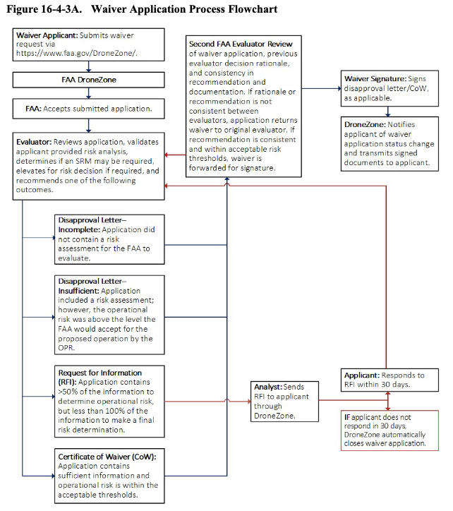
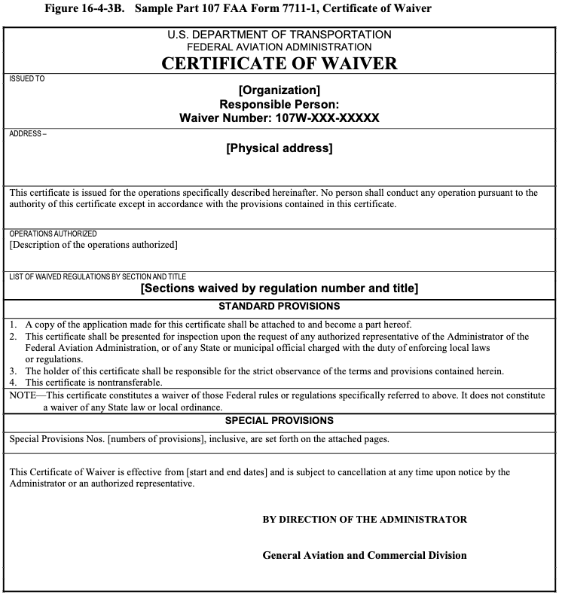
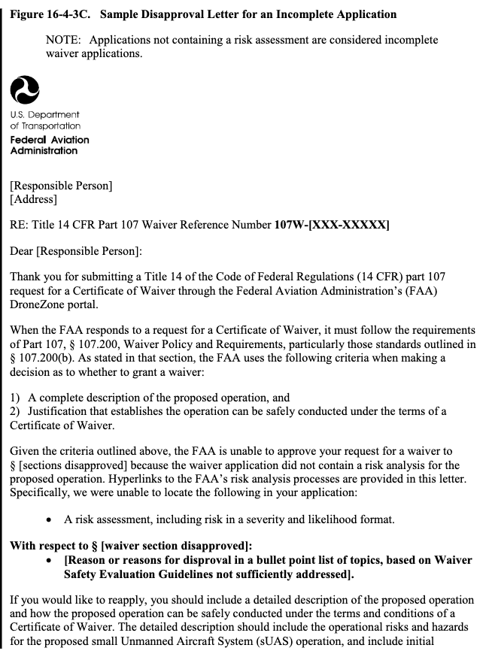

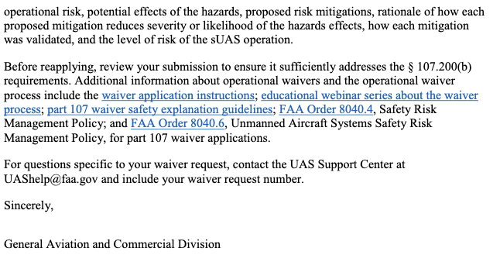
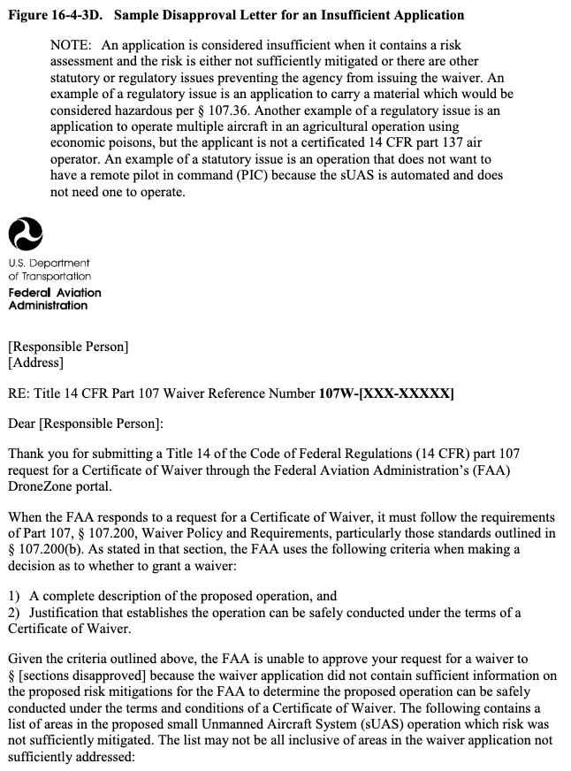
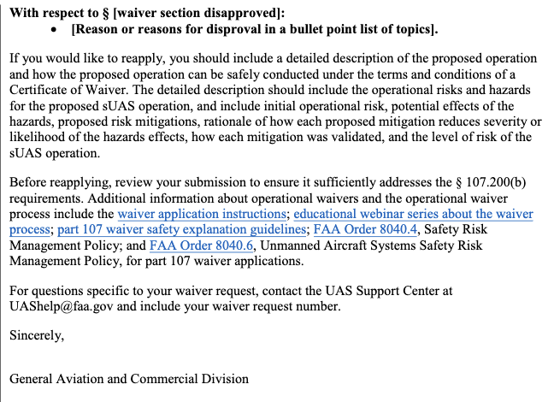

Section 4 Model Aircraft Operations and Aviation Events
16-4-4-1 PURPOSE. This section provides guidance to inspectors on how to determine if an
unmanned aircraft (UA) is being operated for hobby or recreation purposes and meets the statutory definition of “model aircraft” contained in Title 14 of the Code of Federal Regulations
(14 CFR) part 101 subpart E. This section describes the means by which model aircraft may be
operated in the National Airspace System (NAS) without additional authorization from the
Federal Aviation Administration (FAA).
16-4-4-3 AUDIENCE. The primary audience is Flight Standards Service aviation safety inspectors (ASI) and aviation safety technicians (AST), their managers and supervisors, and other operational and administrative employees.
16-4-4-5 BACKGROUND. While modelers generally are concerned about safety, and exercise good judgment when flying model aircraft for the hobby and recreational purposes for which they are intended, they may share the airspace in which manned aircraft are operating. UA, including model aircraft, may pose a hazard to manned aircraft in flight and to persons and property on the surface if not operated safely. Model aircraft operations that endanger the safety of the NAS, particularly careless or reckless operations or those that interfere with or fail to give
way to any manned aircraft, may be subject to FAA enforcement action.

16-4-4-7 SPECIAL RULE FOR MODEL AIRCRAFT. The FAA considers model aircraft to be aircraft that fall within the statutory and regulatory definitions of an aircraft, as they are contrivances or devices that are “invented, used, or designed to navigate, or fly in, the air.”
Refer to Title 49 of the United States Code (49 U.S.C.) § 40102 and 14 CFR part 1, § 1.1.
As aircraft, these devices generally are subject to FAA oversight and enforcement.
A. Applicability. Before conducting surveillance, investigation, or enforcement action, the inspector must first make a determination of the model aircraft status.
1) Per § 101.1(a)(5), for a UA to be considered a model aircraft, it must be:
a) Capable of sustained flight in the atmosphere;
b) Flown within Visual Line of Sight (VLOS) of the person operating the aircraft; and
c) Flown for hobby or recreational purposes.
2) Per § 101.41, for an operation to be deemed a model aircraft operation:
a) The aircraft is flown strictly for hobby or recreational use.
b) The aircraft operates in accordance with a community-based set of safety guidelines and within the programming of a nationwide community-based organization (CBO).
c) The aircraft is limited to not more than 55 pounds, unless otherwise certified through a design, construction, inspection, flight test, and operational safety program administered by a CBO.
d) The aircraft operates in a manner that does not interfere with, and gives way to, any manned aircraft.
e) When flown within 5 miles of an airport, the operator of the model aircraft provides the airport operator and the airport air traffic control (ATC) tower (when an air traffic facility is located at the airport) with prior notice of the operation.
NOTE: Model aircraft operators flying from a permanent location within 5 miles of an airport should establish a mutually agreed upon operating procedure with the airport operator and the airport ATC tower (when an air traffic facility is located at the airport).
B. Part 101 Subpart E. Whether a given UA operation may be considered a “model aircraft operation” is determined with reference to part 101, which codified the Special Rule for
Model Aircraft in Public Law (PL) 112-95, FAA Modernization and Reform Act of 2012 (FMRA), section 336. The FAA General Counsel has issued legal interpretations to section 336 to clarify what sort of operations may be conducted under the Special Rule for Model Aircraft.
The ASI should review and understand these legal interpretations before conducting surveillance,
investigation, or enforcement action. Refer to the Office of the Chief Counsel’s (AGC) legal
interpretation website for the various Unmanned Aircraft System (UAS) legal
interpretations at https://www.faa.gov/about/office_org/headquarters_offices/agc/practice_areas/r
egulations/Interpretations/.
C. Restrictions. Model aircraft conducting UAS operations are prohibited within the Washington, D.C., Special Flight Rules Areas (SFRA) unless in compliance with all of the requirements listed in flight data center (FDC) Notices to Airmen (NOTAM) 620069. Model operations are prohibited in the Washington National Capital Region Flight Restricted Zone (FRZ), and within temporary flight restrictions (TFR) unless specific authorizations for these operations are issued.
16-4-4-9 REGISTRATION. All UA over 0.55 pounds and less than 55 pounds that are components of small Unmanned Aircraft Systems (sUAS) and operated as model aircraft in the NAS must be registered under either 14 CFR part 47 or part 48. Inspectors may take enforcement
action for failure to register a model aircraft.
16-4-4-11 ACTION. The FAA could apply several regulations in 14 CFR part 91 when determining whether to take enforcement action against a model aircraft operator for endangering the NAS. Part 91 regulations are the baseline rules that apply to all aircraft operated
in the United States with limited exceptions, and are the appropriate rules to apply when evaluating model aircraft operations. When determining which rules are relevant to model aircraft operations, inspectors should consider:
• How the aircraft is operated;
• Operating rules for designated airspace; and
• Special restrictions such as TFRs and NOTAMs.
A. Operation Rules. Rules addressing operation of the aircraft may include prohibitions on careless or reckless operation and dropping objects so as to create a hazard to persons or property. Refer to part 91, §§ 91.13 through 91.15. Additionally, § 91.113 establishes right-of-way rules for converging aircraft. Model aircraft that do not comply with those rules could be subject to FAA enforcement action.
B. Designated Airspace Rules. Rules governing operations in designated airspace are found in §§ 91.126 through 91.135. In general, those rules establish requirements for operating in the various classes of airspace, and near airports in non-designated airspace to minimize risk of collision in higher-traffic airspace. Generally, if an operator is unable to comply with the regulatory requirements for operating in a particular class of airspace, the operator would need authorization from ATC to operate in that area. Operations within restricted areas designated in 14 CFR part 73 would be prohibited without permission from the using or controlling agency.
Accordingly, as part of the requirements for model aircraft operations within 5 miles of an airport set forth in part 101, the FAA would expect modelers operating model aircraft in airspace
covered by §§ 91.126 through 91.135 and part 73 to obtain authorization from ATC prior
to operating.
16-4-4-13 “MODEL-AIRCRAFT-ONLY” DEMONSTRATIONS. For model aircraft aerial
demonstration (aerobatic and non-aerobatic) during a model-aircraft-only aviation event, the issuance of a Certificate of Waiver or Authorization (CoW/A) is not required. Model aircraft
flown at model-aircraft-only aviation events shall operate under the guidelines and provisions of
a nationally recognized CBO.
16-4-4-15 MODEL AIRCRAFT OPERATIONS AT AN AVIATION EVENT. For model
aircraft demonstrations that are not for hobby or recreation, or for events that also include
demonstrations by manned aircraft, see Volume 3, Chapter 6, Section 1, Issue a Certificate
of Waiver or Authorization for an Aviation Event.

Section 5 General Operational Requirements
16-4-5-1 GENERAL APPLICABILITY AND REQUIREMENTS. This section applies to Unmanned Aircraft Systems (UAS) operations conducted in the National Airspace System (NAS) other than in active restricted and warning areas designated for aviation use or approved
prohibited areas. The Federal Aviation Administration (FAA) requires aircraft to operate safely
among all users of the NAS, including noncooperative aircraft (e.g., aircraft operated without
a transponder), and other airborne operations not reliably identifiable by air traffic control (ATC)
radar (e.g., balloons, gliders, and parachutists). Unless otherwise specifically authorized, UAS operators must use observers, either airborne or ground-based, to comply with Title 14 of the Code of Federal Regulations (14 CFR) part 107 and part 91 requirements.
16-4-5-3 RISK MITIGATION. While considerable work is ongoing to develop a certifiable detect, sense, and avoid system (DSA) as an alternative method of compliance (AMOC) with the
“see and avoid” aspect of part 91, § 91.113, no current solution exists. (At a high level, DSA can
be defined as: Detect—is something there? Sense—is it a threat/target? Avoid—maneuver to
miss.) As a result, compliance with the see-and-avoid requirement and navigational awareness
(a subset of situational awareness) are primary concerns in UAS operational approvals leading to
imposition of AMOC. Risk mitigation for these two issues is normally based on the use of observers or other methods of maintaining flight separation and collision avoidance or “segregation”; however, they may also include other concepts or systems that an operator/applicant may propose for FAA review. The FAA only approves UAS flight operations
that can be conducted at an Acceptable Level of Safety (ALoS). Refer to the current editions of:
• Advisory Circular (AC) 120-92, Safety Management Systems for Aviation Service Providers.
• FAA Order VS 8000.367, Aviation Safety (AVS) Safety Management System Requirements.
• FAA Order 8000.368, Flight Standards Service Oversight.
• FAA Order 8000.369, Safety Management System.
• FAA Order VS 8000.370, Aviation Safety (AVS) Safety Policy.
• FAA Order 8040.4, Safety Risk Management Policy.
NOTE: Risk mitigations that depend on the establishment of new types and categories of airspace are extremely difficult and time consuming. The NAS is established and configured through a rigorous regulatory process. Risk mitigations that result in the prohibition of the public’s right to transit airspace will require a very long lead time with no guarantee that they will be approved.
A. See-and-Avoid Strategies. It is the operator/applicant’s responsibility to mitigate risk and ensure that the remote pilot in command (PIC), person manipulating the controls, and visual
observer (VO) are able to see and avoid other aircraft and property when operating the unmanned aircraft (UA).
B. Risk Mitigation Responsibility. It is the operator/applicant’s responsibility to demonstrate that the risk of injury to persons or property along the flight path is appropriately mitigated. Aircraft with performance characteristics that impede, delay, or divert other normal air traffic operations may be restricted in their operations. It is the responsibility of the aviation safety inspector (ASI) to assess these risks and consider them when developing work programs.
The Flight Standards District Office (FSDO) should create work programs based on the areas of
highest risk levels consistent with the FAA guidance on risk-based decision making to control
risk to the lowest acceptable levels.
16-4-5-5 SYSTEM CONSIDERATIONS FOR UAS.
A. Traffic Alert and Collision Avoidance Systems (TCAS). The use of TCAS by UAS
has not been validated as an acceptable alternative for see-and-avoid requirements, and is not an
approved means of mitigation for UAS see-and-avoid requirements or strategies.
B. Automatic Dependent Surveillance-Broadcast (ADS-B). A precise satellite-based surveillance system. ADS-B Out uses Global Positioning Satellite (GPS) technology to determine an aircraft’s location, airspeed, and other data, and broadcasts that information to a network of ground stations, which relay the data to ATC displays and to nearby aircraft equipped to receive the data via ADS-B In. ADS-B is not approved for use with UAS at this time.
C. Onboard Cameras/Sensors. Although onboard cameras and sensors positioned to observe targets on the ground have demonstrated some capability, their use in detecting airborne operations for the purpose of segregation is still quite limited. To date, these types of systems
have not been approved as a sole mitigation in the see-and-avoid risk assessment.
D. Use of Equipment in Lieu of VOs.
1) Any equipment proposed for use on UAS to accomplish the function of see and avoid in lieu of VOs must:
a) Be certified as an aircraft system and equipment using standards, requirements, and processes commensurate with installation of equipment in aircraft by a recognized airworthiness authority.
b) Meet the requirements of 14 CFR part 25, § 25.1309, or equivalent process, for any UAS installation, regardless of its size, performance, or maximum takeoff weight (MTOW).
NOTE: For other equipment that is not proposed for use in meeting see-and-avoid requirements, 14 CFR part 23, § 23.2510, or an equivalent process, should be used.
2) It is the responsibility of the operator/applicant to show that the contemplated standards, requirements, and processes meet an ALoS.
E. Radar and Other Sensors. If the operator/applicant utilizes special types of radar systems or other sensors to mitigate risk, they must provide supporting data which demonstrates the following can be accomplished safely:
1) Both cooperative and noncooperative traffic can be detected and tracked to ensure appropriate separation and collision avoidance.
2) The proposed system can effectively mitigate a potential collision.
3) Operators are suitably trained and equipped to use them effectively.
4) Procedures are in place for the remote PIC to effectively use the data.
F. Lost Link Points (LLP).
1) LLPs are defined as a point, or sequence of points, where the aircraft will proceed and hold at a specified altitude, for a specified period of time, in the event the command and control link to the aircraft is lost. The aircraft utilize high levels of automation to hold, or loiter, at the LLP until the control link with the aircraft is restored or the specified time elapses. If the time period elapses, the aircraft may autoland, proceed to another LLP in an attempt to regain the control link, or proceed to a Flight Termination Point (FTP) for flight termination. LLPs may be used as FTPs. In this case, the aircraft may loiter at the LLP/FTP until link is reestablished or fuel exhaustion occurs.
2) For areas where multiple or concurrent UAS operations are authorized in the same operational area, a segregation plan must be in place in the event of a simultaneous lost link scenario. The deconfliction plan may include altitude offsets and horizontal separation by using independent LLPs whenever possible.
G. Flight Termination System (FTS). It is highly desirable that all UAS have system redundancies and independent functionality to ensure the overall safety and predictability of the system. UAS that lack these characteristics may be required to have an FTS whose architecture
and activation are independent of the UAS system and can be activated automatically or manually by the remote PIC to safeguard the public.
H. Spectrum Authorization.
1) Every UAS operator must have the appropriate National Telecommunications and Information Administration (NTIA) or Federal Communications Commission (FCC) authorization/approval to transmit on the radio frequencies (RF) used for UAS uplink and downlink of control, telemetry, and payload information.
2) Non-Federal public agencies, such as universities and state/local law enforcement, and all civil UAS operators generally require a license from the FCC as authorization to transmit on frequencies other than those in the unlicensed bands (900 megahertz (MHz), 2.4 gigahertz (GHz), and 5.8 GHz). This generally will be in the form of an experimental radio license or a special temporary authority (STA) issued by the FCC. Non-Federal public agencies and civil UAS operators that operate systems using frequencies assigned to the Federal Government (e.g., the Department of Defense (DOD)) must demonstrate they have the proper authorization through FCC-issued documentation.
3) DOD agencies will typically demonstrate UAS spectrum authorization through an STA issued by the NTIA or a frequency assignment in the NTIA-administered Government Master File (GMF). Authorizations issued under Title 47 of the Code of Federal Regulations (47 CFR) part 300, in the NTIA Manual, Chapter 7, paragraph 7.11, Use of Frequencies by Certain Experimental Stations, are not appropriate for UAS operations.
4) Federal public agencies other than the DOD, such as the National Aeronautics and Space Administration (NASA), the U.S. Coast Guard (USCG), and the U.S. Customs and Border Protection (USCBP), also need an STA issued by NTIA or a frequency assignment in the NTIA-administered GMF. This is especially important for systems designed to operate on frequencies assigned to the DOD.
16-4-5-7 OPERATIONAL REQUIREMENTS FOR UAS. Unless operating in an active restricted or warning area designated for aviation use, or approved prohibited areas, UAS operations must adhere to the following requirements.
A. Observer Requirement. Model aircraft and part 107 operations do not normally require the use of VOs. If the UAS operation authorization requires a VO, the VO may be ground-based or airborne on board a dedicated chase aircraft. A VO must be positioned to assist the remote PIC to exercise the see-and-avoid responsibilities required by §§ 91.111 and 91.113, by scanning the area around the aircraft for potentially conflicting traffic and assisting the remote PIC with navigational awareness.
1) VOs must:
a) Assist the remote PIC in not allowing the aircraft to operate beyond the Visual Line of Sight (VLOS) limit.
b) Be able to see the aircraft and the surrounding airspace sufficiently to assist the remote PIC with:
• Determining the UA’s proximity to all aviation activities and other hazards (e.g., terrain, weather, and structures);
• Exercising effective control of the UA;
• Complying with §§ 91.111 and 91.113; and
• Preventing the UA from creating a collision hazard.
c) Inform the remote PIC before losing sufficient visual contact with the UA or previously sighted collision hazard. This distance is predicated on the observer’s normal vision.
NOTE: Normal vision may include use of corrective lenses, spectacles, and contact lenses as necessary.
2) Because of field of view (FOV) and distortion issues with aids to vision such as binoculars, field glasses, night vision devices, or telephoto lenses, these are allowed only for augmentation of the observer’s visual capability; they cannot be used as the primary means of visual contact. When using other aids to vision, VOs must use caution to ensure the aircraft remains within normal VLOS of the observer. These aids to vision are not to be confused with corrective lenses or contact lenses, which do not alter the FOV or distort vision.
3) The responsibility of ensuring the safety of flight and adequate visual range coverage to avoid any potential collisions remains with the remote PIC. The remote PIC for each UAS operation must identify a location from which the observer will perform his or her duties. This location will be selected to afford the best available view of the entire area within which the
operation is to be conducted.
4) Daisy chaining of observers to increase operational distance is not normally approved; however, an operator or applicant may provide a safety case for daisy chaining in accordance with Volume 16, Chapter 4, Section 3, by demonstrating an acceptable level of risk to the NAS and requesting a waiver.
5) A good practice for observers is to be in place 30 minutes prior to night operations to ensure dark adaptation.
B. ATC Communications Requirements.
1) Model aircraft and part 107 operations do not normally require radio equipage.
If the UAS operation authorization requires radio equipage the UAS pilot must establish and maintain direct two-way radio communication with appropriate ATC facilities anytime:
a) The aircraft is being operated in Class A or D airspace (under § 91.135 or § 91.129) or, when required, in Class E and G airspace (under § 91.127 or § 91.126).
b) The aircraft is being operated under instrument flight rules (IFR).
c) It is stipulated under the requirements of any issued FAA waiver or authorizations.
2) It is preferred that communications between the UAS pilot and ATC be established through onboard radio equipment to provide a voice relay; however, for IFR flight this method of transmission is required.
C. Intercommunications Requirements. Any VO, sensor operator, or other person charged with providing see-and-avoid assistance must have immediate communication with the remote PIC. If a chase aircraft is being utilized, immediate communication between the chase aircraft and the remote PIC is required at all times. If the remote PIC is in communication with ATC, monitoring of the ATC frequency by all UAS crewmembers (pilots, observers, and chase pilots) is recommended for shared situational and navigational awareness. However, unless it is approved for others to do so, the remote PIC is the only crewmember that will communicate with ATC.
D. Electronic Devices. The use of electronic devices (including cell phones) is not permitted other than for mission-required usage. Use of electronic devices must not interfere with the UAS. The use of electronic devices (including cell phones) is not authorized for primary communication with ATC unless authorized by a Form 7711-1, Certificate of Waiver or
Authorization (CoW/A), or Special Airworthiness Certificate operating limitations.
E. Dropping Objects/Expendable Stores or Hazardous Materials (Hazmat).
Carriage of hazmat is prohibited under part 107. Objects may be dropped from UAS operating in
accordance with part 107, § 107.23 if they do not create an undue hazard to persons or property.
For operations other than part 107, if the intended UAS operation includes the carriage, dropping, or spraying of aircraft stores outside of active restricted or warning area airspace designated for aviation use, or approved prohibited areas, the operator/applicant must ensure that
specific approval is listed in the CoW/A (or Special Airworthiness Certificate operating limitations), all operational risks have been sufficiently mitigated as required by part 91 or part 107, and the hazmat requirements in Title 49 of the Code of Federal Regulations (49 CFR) have been met, if hazmat will be carried. The operator/applicant must provide to the FAA acceptable procedures for hung stores and loss of control link while carrying stores. A similar case must be made for hazmat carried aboard the aircraft and, if approved, will be listed in the special provision section of the CoW/A, or Special Airworthiness Certificate operating limitations.
F. Flight Over Congested Areas. Part 107 prohibits operations over nonparticipants.
UAS operations over nonparticipants may be approved under the terms of a waiver, conditions of
an exemption, where the level of airworthiness allows, or in emergency or national disaster relief
situations if the proposed mitigation strategies are found to be acceptable.
G. Aviation Event/Air Show. An operator is required to provide a safety case in accordance with Volume 16, Chapter 4 that demonstrates an ALoS and must receive a separate aviation event/air show waiver in accordance with this order.
H. Flight Over Heavily Trafficked Roads or Open-Air Assembly of People.
UAS operations must avoid these areas, except where the level of airworthiness allows. If flight
in these areas is required, the operator/applicant is required to support proposed mitigations with
system safety cases that indicate the operations can be conducted safely. Additionally, it is the
operator/applicant’s responsibility to demonstrate that risk of injury to persons or property along
the flightpath has been mitigated to an acceptable level. UAS with performance characteristics
that impede, delay, or divert other air traffic operations may be restricted in their operations.
Refer to AC 120-92 and Order 8000.369.
I. Day/Night Operations.
1) Day Operations. UAS operations outside of Class A Airspace, active restricted or warning areas designated for aviation use, or approved prohibited areas, will be conducted during daylight hours unless otherwise authorized.
2) Night Operations.
a) Night operations may be considered if the operator/applicant provides a safety case and sufficient mitigation to avoid collision hazards at night. Refer to § 107.29 for night operations.
b) UAS night operations are those operations that occur between the end of evening civil twilight and the beginning of morning civil twilight, as published in the American Air Almanac, converted to local time. (This is equal to approximately 30 minutes after sunset until 30 minutes before sunrise, except in Alaska.) Remote pilots and observers should be in place 30 minutes prior to night operations to ensure dark adaptation.
J. Flights Below Class A Airspace. All UAS operations outside of active restricted/warning/Special Security Instructions (SSI) airspace designated for aviation use, or approved prohibited areas must be conducted in visual meteorological conditions (VMC) if using
ground or airborne VOs. In addition, the following weather requirements apply:
1) If on IFR flight, remain clear of clouds. This requirement does not relieve the remote PIC from following the ATC clearance. According to § 107.19 the remote PIC retains responsibility for, and is the final authority as to, the operation of that aircraft.
2) If on a visual flight, maintain § 107.51 cloud clearances.
a) Special VFR is not permitted.
b) For chase aircraft, no less than 5 statute miles (sm) in-flight visibility.
K. Automation in UAS Operations. Although it is possible to have a completely manual (direct pilot intervention) UAS, the majority of UAS utilize high levels of automation to a certain degree. Only those UAS which have the capability of direct pilot intervention will be allowed in the NAS outside of active restricted or warning areas designated for aviation use, or approved prohibited areas. Because the pilot may be technically considered out-of-the-loop in a lost link scenario, this restriction does not apply to UAS operating under lost link.
L. Crew Resource Management (CRM). UAS crewmembers must be CRM knowledgeable. Refer to AC 120-51, Crew Resource Management Training, for best practices in UAS operations. The remote PIC of a UAS must ensure no activities other than those duties required for safe flight operation are performed. No UAS crewmember may engage in any activities unrelated to those required for safe operation of the UAS during critical phases of flight such as launch/takeoff and landing/recovery.
M. Sterile Cockpit. Operators are encouraged to comply with AC 120-71, Standard Operating Procedures for Flight Deck Crewmembers, or the FAA-recognized equivalent, for ensuring the remote PIC implements sterile cockpit procedures. During critical phases of flight, including all ground operations, takeoff, and landing, and all other flight operations in which safety or mission accomplishment might be compromised by distractions, no crewmember may perform any duties not required for the safe operation of the aircraft. No crewmember may engage in, nor may any remote PIC permit, any activity during a critical phase of flight which could distract any crewmember from the performance of his or her duties or interfere in any way with the proper conduct of those duties.
N. Operating Under IFR. (Public Aircraft Operators) Reserved.
O. Chase Aircraft Operations. The chase aircraft:
1) Must remain at a safe distance from the UA to ensure collision avoidance if a malfunction occurs.
2) Must remain close enough to the UA to provide visual detection of any conflicting aircraft and advise the remote PIC of the situation.
3) Must remain within radio control range of the UA to maintain appropriate signal coverage for flight control or activation of the FTS, for all operations when the UA is being flown by a pilot in the chase aircraft.
4) May be required to have communication with appropriate ATC facilities based on the operator’s application or mission profile.
5) Is not required by FAA in active restricted airspace designated for aviation use, or approved prohibited airspace.
6) Is not required for Optionally Piloted Aircraft (OPA) if a qualified VO is on board.
7) Is not required in Class A airspace unless stipulated in the CoW/A or Special Airworthiness Certificate operating limitations.
8) Operations must be conducted in accordance with the special provisions listed in the approved CoW/A or Special Airworthiness Certificate operating limitations.
9) Must maintain 5 sm in-flight visibility restrictions.
10) Pilot/observer:
a) Will not concurrently perform either observer or UAS pilot duties along with chase pilot duties unless otherwise authorized.
b) Must maintain direct voice communication with the UAS pilot.
11) Pilots operating as a formation flight will immediately notify ATC if they are using a nonstandard formation. Nonstandard formations must be preapproved by ATC. Operators
will adhere to FAA Order JO 7610.4, Special Operations, as applicable. See Volume 16,
Chapter 1, Section 2, for definitions of standard and nonstandard formations.
12) Operations will not be conducted in instrument meteorological conditions (IMC).
13) Operations will be thoroughly planned and briefed.
14) During a lost link situation, the pilot must be notified immediately along with ATC. The chase pilot will report to ATC that the UA is performing lost link procedures as planned or if deviations are occurring.
15) Pilot will ensure safe separation with the UA, and immediately notify ATC and the remote PIC during loss of visual contact with the UA by both the chase pilot and observer, when such contact cannot be promptly reestablished. The remote PIC will either execute lost link procedures to facilitate a rejoin, recover the UA, or terminate the flight as appropriate.
P. Airspace Considerations by Airspace Designation.
NOTE: UAS operating in airspace designated as Reduced Vertical Separation Minimum (RVSM) airspace must comply with § 91.180. The following guidance does not apply to part 107 operations. UAS operating under part 107 must comply with § 107.41 operation in certain airspace.
1) Class A. Observers are not normally required in Class A. All UAS must be operating under IFR and on an instrument flight plan.
2) Class B. UAS operations are currently not authorized. Class B airspace contains terminal areas with the highest density of manned aircraft in the NAS. On a case-by-case basis, the FAA may consider exceptional circumstances. For public aircraft, a letter of agreement (LOA) between the affected ATC facility and the operator describing UAS segregation procedures is required. For civil aircraft, segregation procedures should be incorporated into the operating limitations. UAS operations must not impede, delay, or divert other Class B operations.
3) Class C (and All Airspace from the Surface Upward to 10,000 Feet Mean Sea Level (MSL) Within 30 Nautical Miles (NM) of an Airport Listed in Part 91 Appendix D, Section 1). UAS operations approved for Class C must comply with §§ 91.130 and 91.215.
Requests for operations without this equipment will be handled on a case-by-case basis and may
be approved if sufficiently mitigated and a safety case has been established. For public aircraft, an LOA between the affected ATC facility and the operator describing UAS segregation procedures may be required. For civil aircraft, segregation procedures should be incorporated into the operating limitations. UAS operations must not impede, delay, or divert other Class C
operations.
4) Class D. Requests for approval will be handled on a case-by-case basis and may be approved if sufficiently mitigated. UAS operations approved for Class D must comply with § 91.129. For public aircraft, an LOA between the affected ATC facility and the operator describing UAS segregation procedures may be required. For civil aircraft, segregation procedures should be incorporated into the operating limitations. UAS operations must not impede, delay, or divert other Class D operations.
5) Class E. If there is an operating ATC tower, Class D rules may apply.
UAS operations approved for Class E must comply with § 91.127. For public aircraft, an LOA
between the affected ATC facility and the operator describing UAS segregation procedures may be required. For civil aircraft, segregation procedures should be incorporated into the operating
limitations. UAS operations must not impede, delay, or divert other Class E operations.
6) Class G. UAS operations approved for Class G must comply with § 91.126.
Q. ATC Visual Approach Clearances. The remote PIC must not accept a visual approach clearance, an instruction to follow another aircraft by visual means, or a clearance to maintain visual separation from another aircraft.
R. In-Flight Emergencies.
1) The remote PIC will notify ATC of any in-flight emergency or aircraft accident as soon as practical.
2) The remote PIC will notify ATC of any loss of control link as soon as practical. Loss of control link scenarios may be handled by ATC as a reportable incident.

Section 6 Accident Reporting—Civil
16-4-6-1 ACCIDENT REPORTING.
A. Report Accident to the Federal Aviation Administration (FAA). The remote pilot in command (PIC) of the small Unmanned Aircraft System (sUAS) is required to report an accident to the FAA within 10 days if it meets any of the following thresholds:
1) At least serious injury to any person or any loss of consciousness that meets the equivalent of “serious injury” as defined as level 3 or higher on the Abbreviated Injury Scale (AIS) of the Association for the Advancement of Automotive Medicine (AAAM). For example, it would be considered a serious injury if a person is injured to the extent that would normally require hospitalization; such as, but not limited to, head trauma, broken bone(s), or laceration(s)
to the skin that requires suturing.
2) Damage to any property, other than the small unmanned aircraft (UA), if the cost is greater than $500 to repair or replace the property (whichever is lower). For example, a small UA damages a property whose fair market value is $200, and it would cost $600 to repair the damage. Because the fair market value is below $500, the accident is not required to be reported.
Similarly, if the aircraft causes $200 worth of damage to property whose fair market value is $600, the accident is also not required to be reported because the repair cost is below $500.
B. Submit Accident Report. The accident report must be made within 10 days of the operation that created the injury or damage. The report may be given to the FAA electronically or by telephone. The report should include the following information:
• sUAS remote PIC’s name and contact information;
• sUAS remote PIC’s FAA Airman Certificate number;
• sUAS registration number issued to the aircraft, if required (FAA registration number);
• sUAS make and model;
• Location of the accident;
• Date of the accident;
• Time of the accident;
• Person(s) injured and extent of injury, if any or known;
• Property damaged and extent of damage, if any or known; and
• Description of what happened.
1) For electronic (online) reporting, refer to www.faa.gov/uas/.
2) For telephone reporting, see Table 16-4-6A, FAA Regional Operations Centers, below.
3) In addition, certain sUAS accidents must also be reported to the National Transportation Safety Board (NTSB). For more information, refer to Title 49 of the Code
of Federal Regulations (49 CFR) part 830.

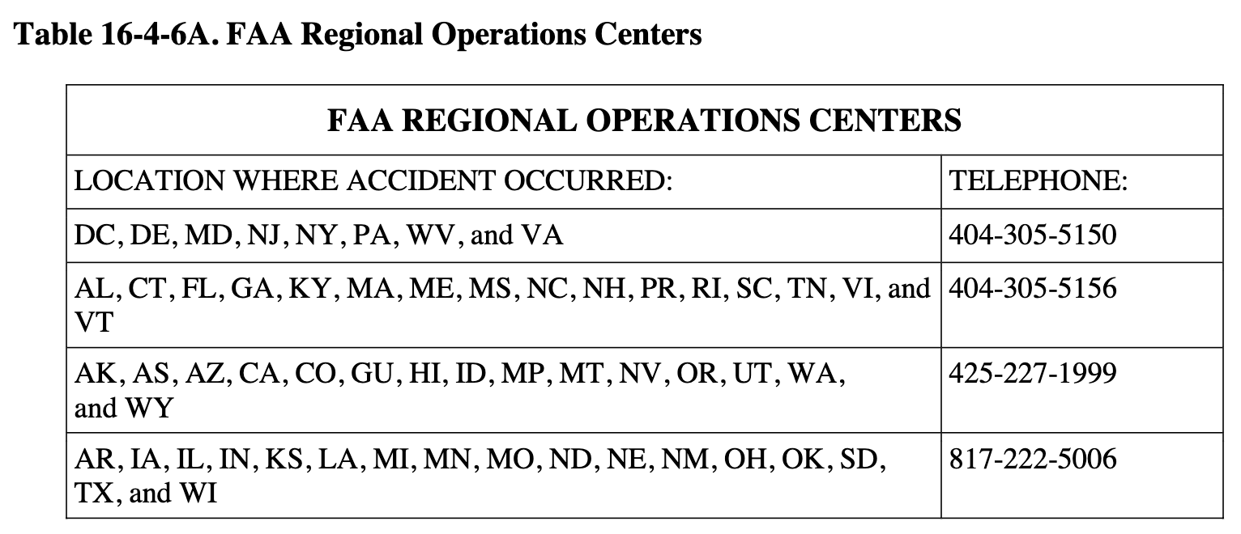
16-4-6-3 FLIGHT STANDARDS DISTRICT OFFICE (FSDO)/AVIATION SAFETY
INSPECTOR (ASI) ACTIONS. Monitor the FSDO Group Box as part of the normal routine for emails with the subject line “Preliminary 14 CFR part 107 small UAS Accident Report:
[ROC identifier: ASO, ASW, ANM, etc.] ROC.”
A. Assign Accident Report. Assign the Title 14 of the Code of Federal Regulations (14 CFR) part 107 accident report to an ASI.
B. Accident Reporting Criteria. The ASI determines if the preliminary report meets the part 107 accident reporting criteria.
C. Does Not Meet Criteria. If the ASI determines the report does not meet the criteria for part 107 reporting, contact the submitter to provide feedback.
D. Additional Information. If additional information becomes available that would indicate the event meets the reporting criteria for a part 107 NTSB reportable accident, process the accident in accordance with the following guidance.
16-4-6-5 INVESTIGATE AN UNMANNED AIRCRAFT ACCIDENT. Follow the guidance contained in FAA Order 8020.11, Aircraft Accident and Incident Notification, Investigation, and Reporting, and Volume 7, Chapter 1, Section 1. When completing the FAA Form 8020-23, FAA Accident/Incident Report, and when entering data into the Program Tracking and Reporting Subsystem (PTRS), use the following guidance:
A. Air Traffic Quality Assurance (ATQA) FAA Form 8020-23.
1) ATQA FAA Form 8020-23 Initial Screen Information.
a) FAR Part. Select “Other”.
b) Aircraft Registration Number. If an N registration number is assigned to the aircraft, which can be verified in the Multi-System Access Tool for Aircraft (MSAT-B), enter the N number. If the aircraft does not have an N number, select “Other.”
2) ATQA FAA Form 8020-23 Blocks.
a) Blocks 1 through 6. Follow the FAA Form 8020-23 instructions.
b) Block 7, Operator Name. Select “Not Applicable.” Any information concerning the operator of the UA should be entered in the block 33 narrative.
c) Blocks 8 through 12. Follow the FAA Form 8020-23 instructions.
d) Block 13, Aircraft Information. If an N registration number is assigned to the UA, which can be verified in the MSAT-B, enter the number in 13A. Otherwise, select “Other” and enter aircraft information in the block 33 narrative.
e) Block 14, FAR Part Number. If the operation was conducted under part 107, then select “M. Other, Specify” and enter “107” in the box. If the operation was not conducted under part 107, then select “M. Other, Specify” and enter “N/A” in the box. Provide details in the block 33 narrative.
f) Block 15A, Type of Aircraft. Select “K. Unmanned Aircraft Systems (UAS).”
g) Block 15B, Airworthiness Certificates. Select “H. None.” In the text box, enter “UAS.”
h) Blocks 16 through 19. Follow the FAA Form 8020-23 instructions.
i) Block 20, Injury/On-Board Summary. List the number of fatal and/or serious injuries using only the “Other” boxes.
j) Blocks 21 through 30. Follow the FAA Form 8020-23 instructions.
k) Block 31, Pilot Information. Only provide the remote pilot’s information if the pilot was at fault in the accident.
1. If the remote pilot was not at fault, select “Not Applicable.”
2. Otherwise, select “Unknown” and enter the pilot’s information. If the remote PIC has been issued an FAA remote pilot certificate, include the number in the block 33 narrative. Do not enter the pilot’s part 61 certificate number.
l) Block 32, Corrective Action. Follow the FAA Form 8020-23 instructions.
m) Block 33, Narrative. Provide:
• UA FA registration number.
• UA make, model, and serial number.
• Remote pilot certificate number.
• Frequency being used by the operator (72 MHz, 2.4 GHz, or other).
• Any additional information which adds value to the report. This could include information not adequately addressed in block 21; such as, inadequate equipment used, or improper use of equipment for the type of operation being conducted.
• Type of operation, if other than part 107 (public, model aircraft, etc.)
• Any additional information deemed necessary by the
Investigator-in-Charge (IIC).
n) Blocks 34 through 42. Follow the FAA Form 8020-23 instructions.
o) Block 43, Brief Explanation of Issues Involved. If a “Yes” response was selected in block 42, provide information in this block only for the reason(s) “Yes” was selected.
All additional information should be listed in the block 33 narrative.
B. Program Tracking and Reporting Subsystem (PTRS).
1) Title 14 CFR. 107.
2) Aircraft Registration Number. If an N registration number is assigned to the UA, which can be verified in MSAT-B, then enter the number. Otherwise, enter the aircraft registration and ownership information, such as the “FA” number, in the Comments section.
3) Make, Model, and Series (M/M/S). Enter the UAS and category, as appropriate.
4) Airman.
a) Certificate Number. Enter the remote PIC’s sUAS certificate number. If the remote PIC does not possess a certificate issued under part 107, or if the certificate number is unknown, leave blank. Do not enter the pilot’s part 61 certificate number.
b) Name (Last, First). Enter the remote PIC’s name. If unknown, leave blank.
5) National Use. Enter “UAS-X-Y”, where X is the type of operation (P=public, C=civil, M=military) and Y is the size of the UAS (L=large, S=small (small is less than 55 pounds)). For example, UAS-C-S or UAS-M-L.
6) Equipment. Enter the UA make, model, and serial number information.
Section 7 Accident/Incident Reporting and Investigation—Public
16-4-7-1 ACCIDENT/INCIDENT NOTIFICATION AND REPORTING. Any incident or accident and any flight operation involving Unmanned Aircraft Systems (UAS) that transgress the lateral or vertical boundaries of a flight test area, restricted airspace, or other operational boundary, such as a Certificate of Waiver or Authorization (COA), must be reported to the Federal Aviation Administration’s (FAA) UAS Integration Office (AFS-80) within 24 hours, to the FAA’s Emerging Technologies Team (AJV-115) via COA via email or the COA Online Application System (CAPS). The proponent must provide initial notification of the following to the FAA via 9-AJV-115-UASOrganization@faa.gov. If this is an emergency, contact local law enforcement, an FAA Regional Operations Center (ROC), or the Washington Operations Center (WOC). See Table 16-4-7A for contact information for the ROCs.
A. Reporting Accidents to the National Transportation Safety Board (NTSB).
Accidents must be reported to the NTSB per instructions contained on the NTSB Web site:
www.ntsb.gov.

B. Operating Unmanned Aircraft (UA) Under a Special Airworthiness Certificate.
When UA are operated under a Special Airworthiness Certificate, further flight operations must
not be conducted until AFS-80 reviews the incident and provides the applicant authorization to resume operations. The current edition of FAA Order 8130.34, Airworthiness Certification of Unmanned Aircraft Systems and Optionally Piloted Aircraft, outlines specific reporting requirements.

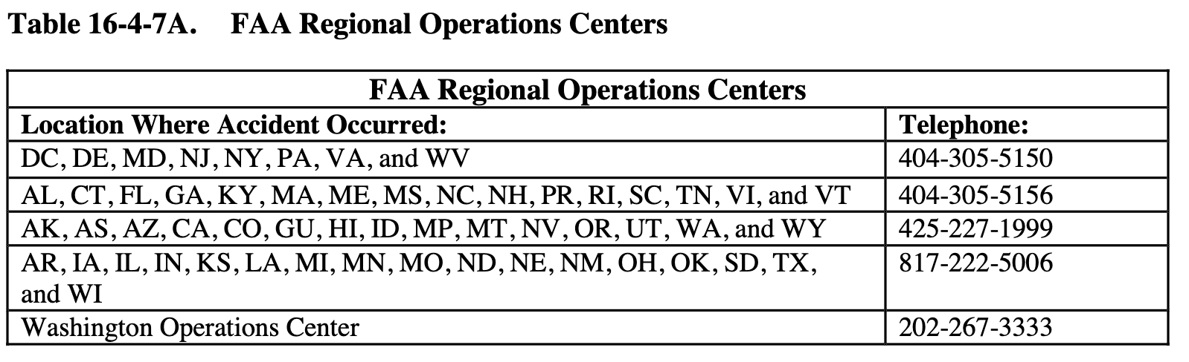

Section 8 Safety Risk Management
16-4-8-1 ALTERNATIVE METHOD OF COMPLIANCE (AMOC). Volume 16 defines certain requirements and procedures to conduct civil and public Unmanned Aircraft System (UAS) operations, but each application is evaluated on its own technical and operational characteristics, including the proposed operational profiles, mitigations, and systems. When an operator desires to deviate from these requirements and procedures, they must submit an AMOC that includes a safety case (recommended format provided) for approval. For an operator to make an acceptable safety case, they must provide information that outlines all hazards and risks associated with the requested AMOC. In addition, the operator must provide a description of the methods and procedures or equipment for mitigating each hazard and risk. As such, deviations and AMOCs may differ from the information presented in this volume. Therefore, if the operator provides an acceptable safety case with sufficient data that supports the proposal, the Federal Aviation Administration (FAA) will evaluate the AMOC for approval and issuance of a Certificate of Waiver/Authorization (CoW/A) or an exemption in accordance with Public Law (PL) 112-95, Section 333.
16-4-8-3 SAFETY RISK MANAGEMENT (SRM) PROCESS. Aviation safety inspectors (ASI) and other FAA personnel use SRM principles outlined in Advisory Circular (AC) 120-92, Safety Management Systems for Aviation Service Providers, to maintain or improve the safety of the National Airspace System (NAS) by identifying safety risks, hazards, and mitigations associated with proposed UAS operations.
A. SRM Reviews. When deemed appropriate, Safety Risk Management Documents (SRMD) are created through SRM reviews of specific operations or of risks associated with UAS operations in various classes of airspace. SRM reviews may result in the incorporation of additional mitigations or controls into all or some FAA Form 7711-1, Certificate of Waiver or Authorization, or Special Airworthiness Certificate operating limitations.
B. Safety Case Information. The operator should include, at a minimum:
1) A thorough description of the environment in which the aircraft will operate.
2) Criteria for categorizing hazards (e.g., severity and likelihood).
3) A detailed airworthiness description of the affected items associated with the proposed AMOC, which includes, as a minimum:
a) For civil UAS operators only:
• Certification status of components and systems, or statement of airworthiness for public aircraft;
• Reliability data;
• Redundant systems;
• Failure modes and effects, including system response to loss of control link; and
• An airworthiness determination.
b) For public aircraft operators only: a statement of airworthiness.
c) For all aircraft operators:
• Capabilities of the aircraft;
• Flight data (FDAT);
• Accident data;
• Emergency procedures; and
• Pilot/crew roles and responsibilities.
16-4-8-5 SAMPLE SAFETY CASE FORMAT. The following represents the FAA’s approach to documenting the process used for hazard identification and risk mitigation.
It is provided as an example for operators and applicants to use when developing and documenting a safety case. In addition to these, a safety case also provides acceptable hazard analysis tools. These include Preliminary Hazard Analysis (PHA), Operational Safety Assessment (OSA), Comparative Safety Assessment (CSA), and Fault Hazard Analysis (FHA).
A. Signature Page. Include the following information on the signature page:
1) Title. A clear and concise description of the proposed AMOC.
2) Originator Information. Originator’s name, organization, contact information, etc.
3) SRMD Information. Safety case submission date, revision number, etc.
B. Executive Summary. The summary should give a general description of the proposed AMOC, including a list of the hazards with associated risk level (high/medium/low) and their corresponding initial and predicted residual risk. Include a high-level system description, a summary of how the safety case was developed, and what process/method was used to move through the risk assessment process.
C. Introduction. Provide a brief reasoning/rationale for the initiative. The scope of the proposed AMOC, whether it is more complex or far-reaching, will determine the need for increased scope and detail of the analysis to be performed.
D. Section 1, Current System/System Baseline. Provide a description of the current system or existing procedures as well as the corresponding (operational) system states. If the proposal entails a procedural change, describe the current procedure and its operational environment. If the current system or procedure is unique and has challenges associated with its unique situation, be sure to delineate these.
E. Section 2, Proposed Change. Provide descriptions of the proposed change/procedure, identifying which safety parameters are involved.
F. Section 3, SRM Planning and Impacted Organizations. Prior to initiation of the safety analysis, SRM planning is necessary. It is essential to select the appropriate SRM participants, identify the SRM panel, schedule milestones, and assign tasks and responsibilities.
With regard to the organizations that the change impacts, describe the method used for collaboration between those organizations during the identification, mitigation, tracking, and monitoring of hazards associated with the change.
G. Section 4, Assumptions. If, in the process of developing a procedure to validate an AMOC, any assumptions are made to make the evaluation of the change more manageable, clearly define and document them in this section.
H. Section 5, Phase 1: System Description. The description of the system/procedure, its operational environment, the people involved/affected by the change/procedure, and the equipment required to accommodate the proposal must be provided.
I. Section 6, Phase 2: Identified Hazards. The SRM Panel identifies hazards as a collaborative effort. The tool(s) and technique(s) used to identify hazards should be specified and discussed. The identified hazards are documented as well as their corresponding causes, the corresponding system states considered, and the consequent potential outcome. It is important to realize that while identification of the worst credible outcome and the system state in which the worst credible outcome occurs is required, system states with less severe outcomes should not be
ignored.
J. Section 7, Phases 3 and 4: Risk Analysis and Risks Assessed. The process used to analyze the risks associated with the identified hazards must be provided. Specify what type of data was used to determine the likelihood of risk occurrence (e.g., quantitative or qualitative), as well as the sources of the data. A risk matrix should provide an illustration of the predicted initial/current risk(s) associated with the identified hazards.
K. Section 8, Phase 5: Treatment of Risks/Mitigation of Hazards. If the existing controls and mitigations do not acceptably mitigate the hazards, then additional recommended safety requirements should be identified. An explanation of how the recommended safety requirements are expected to reduce the initial/current risk to an acceptable predicted residual risk level should be included. Low-risk hazards may still warrant recommended safety requirements.
L. Section 9, Tracking and Monitoring of Hazards. Once the proposal has been approved and implemented, tracking of hazards and verification of the effectiveness of mitigation controls throughout the life cycle of the system or change are required. Also, the methodology for this tracking and monitoring should be outlined.
M. Appendices.
1) Documents Related to the SRMD. Include a list of documents (e.g., orders, directives, regulations, handbooks, and manuals) that pertain to the proposed change, which have been consulted in the development of the proposed change and the corresponding safety analysis.
2) Hazard Identification Tools. Provide information on the different tool(s), method(s), and technique(s) used during the safety analysis. (See Figure 16-4-8A, Acceptable Hazard Analysis Tools and Techniques.)
3) Hazard Analysis and Risk Matrix. Depending on the analyses necessary, there might be one or more appendices with analyses. A risk matrix reflecting the initial and predicted residual risks should also be included.
4) Glossary. Include any acronyms and definitions for any terms listed in the safety case.

Figure 16-4-8A. Acceptable Hazard Analysis Tools and Techniques
NOTE: This chart from the Air Traffic Organization (ATO) Safety Management System (SMS) Manual, available at https://employees.faa.gov/org/linebusiness/ato/safety/sms/guide, displays
acceptable hazard analysis tools for developing safety cases.

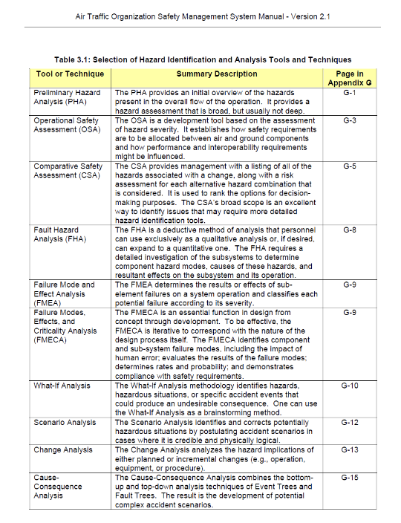
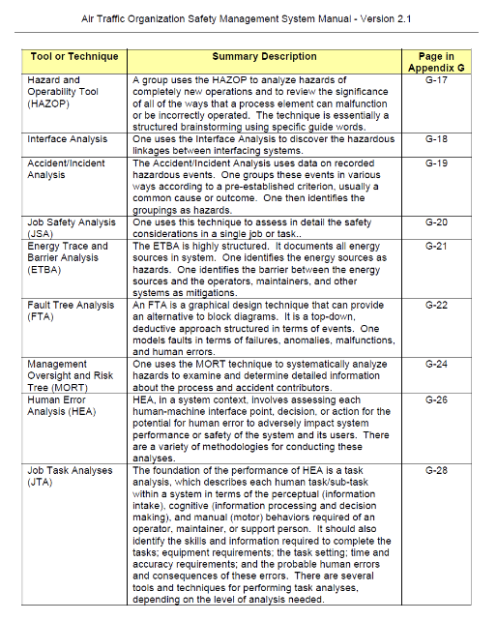

16-4-8-7 CONTINGENCY PLANNING.
A. Point Identification. The operator/applicant must submit contingency plans that address emergency recovery or flight termination of the unmanned aircraft (UA) in the event of unrecoverable system failure. These procedures will normally include Lost Link Points (LLP), Divert/Contingency Points (DCP), and Flight Termination Points (FTP) for each operation. LLPs and DCPs must be submitted in latitude/longitude (LAT/LONG) format along with a graphic representation plotted on an aviation sectional chart (or similar format). FTPs or other accepted contingency planning measures must also be submitted in LAT/LONG format, along with a graphic representation plotted on an aviation sectional chart, or other graphic representation acceptable to the FAA. The FAA accepts the LLPs, DCPs, FTPs, and other contingency planning measures submitted by the operator/applicant, but does not approve them. When conditions preclude the use of FTPs, operators/applicants must submit other contingency planning options for consideration and acceptance. At least one LLP, DCP, and FTP (or an acceptable alternative contingency planning measure) is required for each operation. Operators/applicants must furnish this data with the initial CoW/A or Special Airworthiness Certificate application.
Operators/applicants must provide any subsequent changes or modifications to this data to the
General Aviation and Commercial Division for evaluation no later than 30 days prior to
proposed flight operations.

B. Risk Mitigation Plans. For all operations, the operators/applicants must develop detailed plans to mitigate the risk of collision with other aircraft and the risk posed to persons and property on the ground in the event the UAS experiences a lost link, needs to divert, or the flight needs to be terminated. Operators/applicants must take into consideration all airspace constructs and minimize risk to other aircraft by avoiding published airways, military training routes (MTR), Navigational Aids (NAVAID), and congested areas. In the event of a contingency divert or flight termination, the use of a chase aircraft is preferred when the UAS is operated outside of Restricted or Warning Areas. If time permits, every attempt should be made to utilize a chase aircraft to monitor the aircraft to a DCP or to the FTP. In the event of a contingency divert or flight termination, operations will be conducted in Class A Airspace (CAAS) and Special Areas of Operation (SAO) to the maximum extent possible to reduce the risk of collision with nonparticipating air traffic.
1) Lost Link Procedures. There are many acceptable approaches to satisfy lost link requirements. The intent of any lost link procedure is to ensure that airborne operations remain predictable. Operators will comply with the UAS lost link procedures as specified in the CoW/A or Special Airworthiness Certificate operating limitations.
NOTE: Lost link is not considered flyaway. (See the definitions of these terms in Volume 16, Chapter 1, Section 2.)
a) Unless otherwise authorized, lost link procedures must comply with the last air traffic control (ATC) clearance (if ATC clearance is required) for a period of time sufficient for ATC to ensure conflict resolution without loss of required separation.
b) The General Aviation and Commercial Division coordinates lost link procedures with the appropriate ATC facility and includes the procedures in a CoW/A or Special Airworthiness Certificate operating limitations. They include, at a minimum, lost link route of flight, transponder use, lost link orbit points, communications procedures, and preplanned FTP or other contingency planning measures in the event recovery of the UAS is not feasible.
c) If lost link occurs within a Restricted Area, Warning Area, or CAAS, or a lost link procedure takes an aircraft into one of these areas, the aircraft will not exit that airspace, unless otherwise authorized, until the link is reestablished. Operators will submit all exceptions as part of the CoW/A application or Special Airworthiness Certificate operating limitations for review.

d) Unless otherwise authorized, lost link procedures will conform to the contingency planning limitations in paragraph 16-4-8-7 and, in general, include the following:
1. Limiting of UAS operations to operations over water or sparsely populated areas over the ground to transit to another Restricted Area, Warning Area, or to a preplanned lost link orbit point within Visual Line of Sight (VLOS) to reestablish the link. (The UAS lost link procedure will not transit over fixed structures on the water.)
2. Lost link programmed procedures will avoid unexpected turnaround and/or altitude changes and will provide sufficient time to communicate and coordinate with ATC.
3. Lost link orbit points will not be contained within any published holding area, airway, jet route, T-route, or other Area Navigation (RNAV) published route.
e) If the link is not reestablished within a predetermined time as defined by the FAA-approved authorization (CoW/A or Special Airworthiness Certificate operating limitations) the aircraft may do one of the following:
1. Autoland; however, the aircraft will not exit the Restricted Area or Warning Area in accordance with subparagraph 16-4-8-7B1)c).
2. Proceed to another LLP in an attempt to regain control link.
3. Proceed to an FTP or the location specified in other contingency planning measures for flight termination.
NOTE: LLPs may be used as FTPs. In this case, the aircraft may loiter at the LLP/FTP until a link is reestablished or fuel exhaustion occurs. UAS without autoland capability will proceed to a preplanned FTP or other acceptable contingency planning option prior to fuel exhaustion.
2) DCP Procedures.
a) A DCP is defined as an alternate landing/recovery site to be used in the event of an abnormal condition that requires a precautionary landing. Each DCP must incorporate the means of communication with ATC throughout the descent and landing (unless otherwise specified in the CoW/A or Special Airworthiness Certificate operating limitations) as well as a plan for ground operations and securing/parking the aircraft on the ground. This includes the availability of control stations (CS) capable of launch/recovery, communication equipment, and an adequate power source to operate all required equipment.

b) For local operations, the DCP specified will normally be the airport/facility used for launch and recovery; however, additional DCPs may be specified as alternates.
c) For transit and/or mission operations that are being conducted in CAAS or Class E airspace above flight level (FL) 600, DCPs will be identified during the flight to be no further than 1 hour of flight time at any given time, taking into consideration altitude, winds, fuel consumption, and other factors. If it is not possible to define DCPs along the entire flight plan route, the operator/applicant must identify qualified FTPs along the entire route and be prepared to execute flight termination at one of the specified FTPs if a return to base (RTB) is not possible.
d) It is preferred that specified DCPs are non-joint-use military airfields, other government-owned airfields, or private-use airfields. However, any suitable airfield may be submitted for review and consideration.
3) Flight Termination Procedures.
a) Flight termination is the intentional and deliberate process of performing controlled flight into terrain (CFIT). Flight termination must be executed in the event that all contingencies have been exhausted and further flight of the aircraft cannot be safely achieved, or other potential hazards exist that require immediate discontinuation of flight. FTPs or alternative contingency planning measures must be located within power-off glide distance of the aircraft during all phases of flight and must be submitted for review and acceptance.
Operators/applicants must ensure that sufficient FTPs or other contingency plan measures are defined to accommodate flight termination at any given point along the route of flight.
The location of these points is based on the assumption of an unrecoverable system failure and must take into consideration altitude, winds, and other factors.
b) Unless otherwise authorized, FTPs must be located in noncongested areas.
Except for on- or near-airport operations, FTPs will be located no closer than 5 nautical miles (NM) from any airport, heliport, airfield, NAVAID, airway, congested area, major roadway, oil rig, powerplant, or any other infrastructure. For offshore locations, appropriate United States Coast Guard (USCG) charts and other publications should be used to avoid maritime obstructions, shipping lanes, and other hazards.
1. It is preferred that flight termination occur in Restricted or Warning Areas, government-owned land, or offshore locations that are restricted from routine civil use.
However, any suitable location may be submitted for review and consideration.
2. Operators/applicants are required to survey all designated areas prior to their use as an FTP. All FTPs will be reviewed for suitability on a routine and periodic basis, not to exceed 6 months. The operator/applicant assumes full risk and all liability associated with the selection and use of any designated FTP.
3. It is desirable that prior permission from the landowner or using agency is received prior to designation of this area as an FTP. Operators/applicants should clearly communicate the purpose and intent of the FTP.
4. For each FTP, plans must incorporate the means of communication with ATC throughout the descent as well as a plan for retrieval/recovery of the aircraft.
5. Contingency planning must take into consideration all airspace constructs and minimize risk to other aircraft by avoiding published airways, MTRs, NAVAIDs, and congested areas to the maximum extent possible.
6. In the event of a contingency divert or flight termination, if time permits, the use of a chase aircraft is preferred when the UA is operated outside of Restricted or Warning Areas.
7. In the event of a contingency divert or flight termination or other approved contingency measures, operations will be conducted in CAAS and SAO to the maximum extent possible to reduce the risk of collision with nonparticipating air traffic.
Section 9 Public Certificate of Waiver or Authorization Safety Review
16-4-9-1 PURPOSE. This section provides guidance and policy to Federal Aviation Administration (FAA) aviation safety inspectors (ASI) concerning processes and requirements used within the General Aviation and Commercial Division to facilitate and track the review of
unmanned aircraft (UA) FAA Form 7711-1, Certificate of Waiver or Authorization (CoW/A),
requests from the FAA Air Traffic Organization (ATO) regarding public UA operations above
400 feet above ground level (AGL) and/or weighing over 55 pounds, or for any other nonstandard operations in the National Airspace System (NAS).
16-4-9-3 AUDIENCE. The audience for this section is all Flight Standards divisions and Flight Standards District Office (FSDO) ASIs, aviation safety technicians (AST), and Flight Standards Service policy divisions responsible for implementation.
16-4-9-5 BACKGROUND. A CoW/A is an authorization issued by the ATO to a public operator for a specific Unmanned Aircraft System (UAS) activity. Approval documents are required since UAS may not be compliant with applicable sections of the Code of Federal Regulations (CFR), and therefore require an alternative method of compliance (AMOC). After a public operator/applicant submits a complete application, the FAA conducts a comprehensive operational and technical review. If necessary, provisions or limitations may be imposed as part of the approval to ensure the UAS can operate safely with other airspace users. In most cases, the
typical CoW/A application approval process is completed within 60 business-days of receipt, provided there are no submittal errors, missing information, or safety or airspace issues.
Applicants submit a package requesting UAS operations in the directly into the FAA UAS Certificate of Authorization (COA) Application Processing System (CAPS)
(https://caps.faa.gov/). The package contains:
• Proponent information,
• Point of contact (POC) information,
• Operational description,
• Performance characteristics,
• Airworthiness,
• Procedures,
• Avionics/equipment,
• Lights,
• Spectrum analysis approval,
• Air traffic control (ATC) communications,
• Electronic surveillance detection capability,
• Visual surveillance detection capability,
• Aircraft performance recording,
• Flight operations area/plan, and
• Special circumstances.
16-4-9-7 SAFETY REVIEW.
A. Administrative Review. ATO/the Emerging Technologies Team review the submission for required documents to ensure it is complete. If deemed complete, the package is classified as “committed.” If it is not complete, ATO returns or “releases” the application back to the applicant for additional data. If the applicant provides the additional data, the package is termed “recommitted” back to ATO, which then undertakes a comprehensive review of the submission to verify it is a complete package. During this phase, ATO does both an administrative check and a feasibility check of the applicant’s request. ATO does the administrative review from a policy perspective, checking to ensure the application is completed correctly, and that all necessary documents and details are contained within the submission.
The appropriate ATO service area accomplishes the feasibility check from a high-level air traffic
perspective. “R” or renewal CoW/As differ in that a renewal CoW/A is the same exact copy of
a previous CoW/A for a different time period.
B. Safety Review. ATO will conduct the safety review unless the CoW/A application is for a UAS operation weighing more than 55 pounds and/or operating above 400 feet AGL, or for any other nonstandard operation. If the request is for a UAS weighing more than 55 pounds and/or above 400 feet AGL, or other nonstandard operations, ATO will forward the package to the General Aviation and Commercial Division to facilitate a safety review. The General Aviation and Commercial Division will facilitate the safety review of CoW/A applications from a technical analysis perspective and recommend risk mitigation provisions. The Flight Standards
safety review is intended to ensure that UAS, regardless of size, do not compromise the high
level of safety for aviation in the NAS, the public, and property on the ground. The administrative and safety review process officially commences upon receipt of the CoW/A
application.
Figure 16-4-9A General Aviation and Commercial Division Safety Review Process
1.0 ATO (UAS OFFICE) REQUESTS FLIGHT STANDARDS SAFETY REVIEW.
1.1 ATO validates a CoW/A application for UAS weighing more than 55 pounds and/or operating above 400 feet AGL, or for any other nonstandard operation, and sends an automatic
CAPS message to the General Aviation and Commercial Division Safety Manager, notifying him or her that a safety review of the CoW/A is requested.
1.1.1 ATO does not require Flight Standards safety reviews for CoW/As for the following proponents:
1.1.1.1 Department of Defense (DOD) (refer to ATO/AJV-115 March 7, 2014, and May 5, 2014, memoranda).
1.1.1.2 Department of Homeland Security (DHS), including Customs and Border Protection (CBP); Federal Bureau of Investigation (FBI); National Aeronautics and Space Administration (NASA); National Oceanic and Atmospheric Administration (NOAA); and Department
of Interior (DOI) (refer to ATO/AJV-1 October 31, 2014, memorandum).
1.1.1.3 Public UAS operators requesting CoW/As for UAS weighing 55 pounds or less and/or operating below 400 feet AGL, unless it is a nonstandard operation or when specifically requested by ATO.
1.1.2 Sensitive and/or emergency CoW/As, called Special Governmental Issue (SGI) CoW/As (formerly eCOAs), will not be transmitted to the General Aviation and Commercial Division.
2.0 THE GENERAL AVIATION AND COMMERCIAL DIVISION PROCESSES THE
REQUEST. The responsible General Aviation and Commercial Division ASI will conduct a safety review of the CoW/A application for requests for UAS operations over 55 pounds and/or
over 400 feet AGL, or for any other nonstandard operation.
2.1 The ASI assignment should be made as soon as possible.
2.2 To meet its part of the ATO policy of completing CoW/A actions within 60 days, the General Aviation and Commercial Division normally assigns ASIs a due date of 15 business-days from the date of the CoW/A Administrative Review. This allows for a 1- to 2-day review and a 3-day processing time at the General Aviation and Commercial Division. Flight Standards’ completion of this action occurs when the General Aviation and Commercial Division forwards the safety review memorandum back to ATO through CAPS.
3.0 ASI ASSIGNED. The General Aviation and Commercial Division CAPS Safety Manager assigns the CoW/A application package to the designated ASI through the CAPS process. The
package contains the validated application.
4.0 ASI TECHNICAL ANALYSIS. The assigned ASI will review the application for safety of
operational flight concerns, risk mitigation, etc.
4.1 The ASI completes and forwards a draft memorandum detailing the result of the review to the General Aviation and Commercial Division management.
4.2 The ASI will advise if the CoW/A safety review cannot be completed within the assigned timeframe. Under this circumstance, the ASI will coordinate with ATO.
4.3 The ASI will advise the ATO POC through the “request release” CAPS workflow regarding any information that is missing or needs to be revised in the proponent’s application and request the CoW/A be “released” back to the proponent. The reviewing ASI will make appropriate notes in the “Internal Comments” section in CAPS.
4.4 After the application is released back to the proponent, proponent updates the application and resubmits through CAPS. The ASI will be notified through CAPS to restart the safety review.
5.0 GENERAL AVIATION AND COMMERCIAL DIVISION MANAGEMENT REVIEW AND COORDINATION. The General Aviation and Commercial Division ASI processes the safety review memorandum and ensures it is compliant with correspondence guidelines.
5.1 When the CoW/A Safety Review Memorandum is ready, the ASI will upload the memo in CAPS. CAPS automatically advances the case back to ATO.
6.0 PROCESS MEASUREMENT. The target to complete processing of a validated CoW/A application by the General Aviation and Commercial Division is a maximum of 20 business-days from the time the CoW/A is validated as reported in CAPS. The measured time excludes any time during which:
6.1 The package was in release status. Note: Only ATO can release and revalidate a CoW/A. Flight Standards should request ATO to release an application when the application needs clarification, additional data, or for other reasons.
6.2 The package is put on administrative ATO hold status for further research.
7.0 GENERAL AVIATION AND COMMERCIAL DIVISION TIMELINE. The time in
General Aviation and Commercial Division control can be measured by calculating the number of days between the date the package received (i.e., validated in CAPS) and the date the package
is sent back to ATO, subtracting any days for administrative ATO hold or release status.
7.1 General timeline for a normal/new CoW/A: Goal 20 business-days.
7.2 ASI assignment: 2 days.
7.3 ASI assessment: 15 days.
7.4 General Aviation and Commercial Division coordination, signature, and closeout: 3 days.

CHAPTER 5 SURVEILLANCE/COMPLIANCE AND ENFORCEMENT
Section 1 Responsibilities of Aviation Safety Inspectors
16-5-1-1 GENERAL. This section addresses the additional responsibilities of aviation safety inspectors (ASI) as a result of the increase in Unmanned Aircraft Systems (UAS) operations
within the National Airspace System (NAS). This guidance serves to supplement the guidance
found in Volume 1, Chapter 3. Operations of UAS in the NAS increased with the availability of
small UAS (sUAS) and the issuance of Public Law (PL) 112-95, section 333 exemptions enabling commercial operations. The anticipated proliferation of sUAS with the publication of
Title 14 of the Code of Federal Regulations (14 CFR) part 107 will add to the responsibilities of ASIs to safeguard people and property not involved in these operations.
16-5-1-3 BACKGROUND. Since 2004, the Federal Aviation Administration (FAA) has focused attention on UAS and the development of 14 CFR part 48, Registration and Marking Requirements for Small Unmanned Aircraft, and part 107, Small Unmanned Aircraft Systems.
Other regulations have been revised as a result, notably 14 CFR part 101 now includes subpart E,
Special Rule for Model Aircraft, and 14 CFR part 91, § 91.1 has been modified to include model
aircraft for the purpose of compliance and enforcement. With these changes, the ASI’s
responsibilities have been expanded to include ensuring that model aircraft operations do not
endanger safety of the NAS. Part 107 became effective on August 29, 2016. The rules in part 107
are intended to ensure the safety of those not involved in unmanned aircraft operations, including
persons and property on the surface and other users of the airspace.
16-5-1-5 ADDITIONAL GUIDANCE. The FAA has published additional guidance, including the advisory circular (AC) for part 107, the current edition of AC 107-2, Small Unmanned Aircraft Systems (sUAS); Remote Pilot – Small Unmanned Aircraft Systems Airman Certification Standards (FAA-S-ACS-10); and the guidance in Volume 16.
16-5-1-7 INSPECTOR RESOURCES. As the capabilities of UAS technologies rapidly increase, the safety record of unmanned aircraft and advances in navigation and communication technologies will be the foremost factors in determining the need for further regulations.
The ASI is directed to review the latest information available on the FAA Web site at
http://www.faa.gov/uas. Particularly helpful is the section on Frequently Asked Questions
(FAQ). Another valuable resource is ALC-451, Part 107 small Unmanned Aircraft Systems
(sUAS), training course on http://www.FAASafety.gov. This course is designed for 14 CFR
part 61 pilot certificate holders who have a current flight review (in accordance with part 61,
§ 61.56) and wish to obtain a part 107 remote pilot certificate with an sUAS rating. The course
focuses on the knowledge areas of part 107 that are beyond the operational knowledge of
parts 61 and 91. Others may take this course as a self-study resource, including ASIs.

CHAPTER 5 SURVEILLANCE/COMPLIANCE AND ENFORCEMENT
Section 2 Surveillance of Unmanned Aircraft System Operations
16-5-2-1 REPORTING SYSTEM(S). Use Safety Assurance System (SAS) Activity Recording (AR) and use the following activity codes, as appropriate:
A. Operations: 1623.
B. Maintenance: 3631.
C. Avionics: 5631.
16-5-2-3 OBJECTIVE. This section contains direction and guidance for General Aviation Safety Assurance (GASA) personnel authorized to perform Unmanned Aircraft System (UAS) surveillance activities. For the purposes of this chapter, authorized GASA personnel are those
assigned UAS surveillance activities by their manager.
A. Surveillance Analysis. Flight Standards (FS) Safety Analysis and Promotion Division (AFS-900) analyzed the data from surveillance activities and investigations including occurrences, incidents, near midair collisions (NMAC), accidents, complaints, and compliance and enforcements to develop a more precise risk profile for UAS. The analysis identifies the areas with the most potential for risk to air transport and the National Airspace System (NAS) as areas where routine low-level rotorcraft operations are common and within the terminal environment of busy airports. Additionally, the analysis identifies potential risk to persons on the ground at large outdoor gatherings where UAS are likely to operate.
B. Surveillance Guidance. A current risk profile for UAS is sustained through continuous analysis of data by AFS-900 which informs future amendments to guidance for UAS surveillance. This chapter provides guidance for conducting surveillance of a UAS operating
under:
• The Federal Aviation Administration (FAA) Reauthorization Act of 2018 containing Title 49 of the United States Code (49 U.S.C.) §§ 44807 and 44809; and
• Civil aircraft (Title 14 of the Code of Federal Regulations (14 CFR) part 91 or 107).
C. General Inspection Methodologies. There are two types of methodologies applicable to UAS surveillance.
1) Operator-Based Inspection. Operator-based inspections are appropriate when the Flight Standards District Office (FSDO) has knowledge of the UAS operator. Examples may include a part 107 remote pilot. Operator-based site visits can be scheduled or unannounced. If scheduled, contact the operator and arrange a mutually agreed upon time and location for the inspection. Inform the operator of any required personnel, records, and aircraft necessary for the inspection. If unannounced, review the responsible Flight Standards office file on the operator and/or review applicable information in SAS, the Safety Performance Analysis System (SPAS), or other related database.
2) Location-Based Inspection. Location-based inspections are appropriate in specific places where UAS operations are likely to occur and risk-based decision making (RBDM) has determined surveillance activities are warranted.
D. General Inspection Objectives. The objective of this task is to determine an airman, operator, and/or aircraft is in continuing compliance with applicable statutory and regulatory requirements. The objectives for GASA personnel conducting the inspection are as follows:
• To verify compliance with the applicable requirements for the operational authority under which the flight is conducted (e.g., part 91, 107, and 49 U.S.C. § 44809);
• To verify compliance with the special provisions contained in any approved waiver, if applicable;
• To verify compliance with the conditions and limitations contained in the grant of exemption, if applicable;
• To verify compliance with the requirements in the Air Traffic Organization (ATO)-issued Certificate of Waiver or Authorization (CoW/A), if applicable;
• To evaluate the means by which the system was found to be in a condition for safe operation and the degree of compliance with FAA policy and regulations;
• To inspect the crewmember’s Remote Pilot Certificates, identification, recency of aeronautical knowledge, The Recreational UAS Safety Test (TRUST) completion, and training documentation, as applicable; and
• To inspect aircraft registration.
16-5-2-5 GENERAL. This section contains direction and guidance for authorized GASA personnel conducting inspections. Authorized GASA personnel who require additional information or guidance on UAS differences should request assistance from a colleague with knowledge and experience relevant to the information needed or requested. UAS performance support for authorized GASA personnel is available via email at 9-AFS-800-
Correspondence@faa.gov. Also, approximately 500 drone-related Frequently Asked Questions
(FAQ) are posted in the GASA UAS SharePoint site at https://avssp.faa.gov/avs/afs80/GASAOut
reach/SitePages/Home.aspx.
16-5-2-7 LOCATION OF INSPECTION. An operator-based inspection is seldom located at the operator’s place of business. The locations may vary as widely as the UAS operator’s activities differ, but documents necessary to show compliance with regulations or authorizations must be available for inspection. For information on location-based inspections, see paragraph 16-5-2-17.
16-5-2-9 INITIATION AND PLANNING.
A. Review Applicable Information. Prior to conducting an operator-based inspection, GASA authorized personnel should review applicable information for the UAS operator (e.g., the UAS operator’s Certificate of Authorization (CoA), exemptions issued to the operator, part 107 Certificates of Waiver (CoW) issued to the operator, SAS AR reports, and accident/incident files; contact the General Aviation and Commercial Division (AFS-800) at 9-AFS-800-Correspondence@faa.gov for more information on any of these documents) as
follows:
• If applicable, the grant of exemption and related documents that specify the holder’s conditions and limitations under the terms of the exemption (e.g., exemption documents may include a requirement to adhere to the procedures addressed in a Motion Picture and Television Operations Manual (MPTOM), or may state “Operations Manual” and specify requirements separately);
• CoA, which focuses on the operating area and altitude limit(s) authorized, and may include specific distances from airports;
• Part 107 CoW, which specifies special provisions under the terms of the waiver;
• Part 107 airspace authorizations, which specifies certain controlled airspace authorized for the operation;
• CoW/A, if applicable, regarding operations in certain airspace or near airports;
• Type of UAS authorized, if applicable;
• Charts, documents, and potential impacts concerning the proposed area of operation;
• Correspondence between the operator and FAA; and
• Previous site visit reports and records for possible problem areas, and incident history.
B. Access the Documents. GASA authorized personnel may access the documents above via the following:
1) The ATO CoA may be accessed upon request from ATO by email at 9-AJV-115-UASOrganization@faa.gov.
2) Exemptions may be accessed via the Automated Exemption System (AES) at https://aes.faa.gov/.
3) Access Part 107 waivers via the web page at https://www.faa.gov/uas/commercial
_operators/part_107_waivers/waivers_issued/. If specific information or format is required, but
not provided by the website, contact AFS-800 at 9-AFS-800-Part107Waivers@faa.gov.
4) UAS registration information is available from an FAA Law Enforcement Assistance Program (LEAP) agent. GASA authorized personnel should contact the LEAP agent for their area. If the LEAP agent for their area is not available, contact another LEAP agent or the manager of the LEAP office. For LEAP contact information, refer to the GASA UAS SharePoint site at https://avssp.faa.gov/avs/afs80/GASAOutreach/SitePages/Home.aspx.
16-5-2-11 MAINTENANCE RECORDS. Inspectors should request that the operator present maintenance records (if applicable) for review.
16-5-2-13 ACCIDENT AND INCIDENT NOTIFICATION. Notification of all UAS accidents and incidents must be in accordance with the National Transportation Safety Board (NTSB) and Title 49 of the Code of Federal Regulations (49 CFR) part 830. Additional reporting requirements may be required in exemptions, waivers, and authorizations. Authorized GASA
personnel should be aware of the following NTSB interpretations (for additional information, see
Volume 16, Chapter 4, Section 6, Paragraph 16-4-6-5, Investigate an Unmanned Aircraft
Accident, and Volume 7, Chapter 1, Section 1):
A. Accident Preservation. Preservation of aircraft wreckage, mail, cargo, and records involving all civil and certain public aircraft accidents, as specified in 49 CFR part 830, apply to UAS.
B. NTSB Approval. Once the operator provides notification, the NTSB may give approval to move or retrieve the aircraft and related support equipment, etc. This includes the operator’s personal computer or tablet used as a Ground Control Station (GCS) (similar to a General Aviation (GA) pilot with flight planning information on an iPad).
NOTE: A “flyaway” (when the pilot is unable to effect control of the aircraft and, as a result, the unmanned aircraft (UA) is not operating in a predictable or planned manner) may be considered a flight control malfunction requiring immediate NTSB notification in accordance with 49 CFR part 830, § 830.5.
NOTE: Refer to Volume 16, Chapter 4, Sections 6 and 7; part 107, § 107.9; Advisory Circular (AC) 107-2, Small Unmanned Aircraft System (Small UAS); 49 CFR part 830; and the NTSB’s Advisory to Operators of Civil Unmanned Aircraft Systems in the United States (at https://www.ntsb.gov/investigations/process/Documents/NTSB-Advisory-Drones.pdf) for additional information regarding accident reporting for both civil and public operations.
16-5-2-15 UAS OCCURRENCE AND INCIDENT NOTIFICATION. See Volume 7, Chapter 1, Section 2.
16-5-2-17 INSPECTION AREAS. Observe and evaluate six general areas during inspections as follows:
• Authorization and Authorizing Documents (e.g., exemptions, CoAs, and CoWs);
• Aircraft Registration;
• Crewmember;
• Area of Operation;
• Type of Operation; and
• Mission and Operation.
A. Authorization. The FAA authorizes UAS operations with different processes and authorizing documents depending on civil or public aircraft status of the UAS. A UAS may be operated as a civil or public aircraft, but cannot be operated as both at the same time. Civil UAS operators may operate a UAS as a recreational aircraft under part 91 or 107, 49 U.S.C. § 44807 exemptions, 49 U.S.C. § 44809, certifications under parts 135 and 137 or other certificates, type-certificated UAS, and the Special Airworthiness Certificate (SAC). Refer to AC 91-57, Exception for Limited Recreational Operations of Unmanned Aircraft, for additional information. Public UA and airmen are the responsibility of the public entity that operates the UAS in support of its operations. Public aircraft entities may choose to operate as civil aircraft under part 107, as 49 U.S.C § 44807 exemption aircraft, or as certified aircraft, but cannot operate as both public and civil aircraft at the same time, nor under part 107 and a 49 U.S.C. § 44807 exemption at the same time.
B. Aircraft Registration Requirements.
1) Registration is required regardless of weight for all UA operating in accordance with part 91, 107, 135, or 137. For recreational fliers, registration is required for UAS weighing greater than 0.55 pounds.
2) A registration (FA or N) number is required for each UA not operating under the 49 U.S.C § 44809 exception for limited recreational operations of UA.
3) UAS that are operated strictly as recreational aircraft need only one registration number per owner, not per aircraft.
4) The registration number for recreational and non-recreational aircraft must be affixed when required to the exterior of the aircraft by any means necessary to ensure that it will remain affixed for the duration of each operation and maintained in a condition that is legible.
5) Drones registered under part 107 may be flown for recreational purposes as well as under part 107.
6) Drones registered under the Exception for Recreational Flyers cannot be flown for part 107 operations.
7) Title 14 CFR part 47 registration is required for all UAS weighing 55 pounds or more, including recreational aircraft.
8) Parts 47 and 48 registration certificates must be available for inspection to the FAA and NTSB, and any Federal, state, or local Law Enforcement Officer (LEO) during UA operations.
C. Crewmember. This area includes examinations of the applicable documents (e.g., airmen certificates, identification, etc.) of the remote pilot in command (PIC), visual observer(s) (VO), supplemental pilots, pilots at the controls, sensor operators, and chase aircraft pilots, as applicable. Crewmember identification is required for civil and public aircraft operations (PAO). It is not a requirement for recreational aircraft operations, in accordance with Public Law (PL) 115-254, Section 44809. Refer to 14 CFR parts 61, 91, and 107.
1) PIC or Remote Pilot. The applicable regulation, grant of exemption, special provisions in a CoW or CoA specifies requirements for pilot certification. For operations under part 107, remote pilots are required to have a Remote Pilot Certificate and photo identification with signature and date of birth in their physical possession and readily accessible upon request from the FAA, NTSB, Transportation Security Administration (TSA), or any Federal, state, or local LEO. Non-recreational civil remote pilots are required to meet the currency requirements specified in 14 CFR part 61, § 61.56 or the recency requirements of § 107.65, as applicable.
Upon request by the FAA, remote pilots must make available proof of aeronautical knowledge
recency. Flight reviews may be a requirement for public aircraft PICs, as specified in their CoA.
Recreational aircraft operators are not required to have flight reviews but all recreational flyers
must pass an aeronautical knowledge and safety test and provide proof of test passage (the TRUST completion certificate) to the FAA or law enforcement upon request.
2) Chase Aircraft and Pilot.
a) The chase aircraft, if authorized and utilized, will always have at least two occupants: the chase aircraft PIC and the UAS observer. The PIC of the chase aircraft cannot serve as the UAS observer or UAS PIC while piloting the chase aircraft.
b) The chase aircraft PIC must meet all the regulatory requirements to serve as the PIC of the manned aircraft being operated. The chase aircraft PIC is required to have the medical certificate required by the operation. If the chase aircraft is operated for compensation or hire, a Commercial Pilot Certificate and second class medical is required. If the chase aircraft is operated as a public aircraft, the public entity is responsible for certification of the pilot and
aircraft.
3) Visual Observer (VO).
a) Since UA pilots cannot see from the aircraft, for the purpose of part 91, § 91.113(b) or § 107.33, a VO may be a required flight crewmember for certain operations (refer to the regulation, 49 U.S.C. § 44807 exemption, or CoA for applicability). Visual Line of Sight (VLOS) is required for the PIC or remote pilot and VO. Waivers and exemptions are available for both parts 91 and 107 requirements. The VO must be able to communicate to the pilot any
information required to remain clear of conflicting traffic, terrain, and obstructions, proper cloud
clearances, and provide navigation awareness. The VO should be familiar with air traffic, radio
communications, and appropriate sections of the Aeronautical Information Manual (AIM), in
accordance with the conditions and limitations specified in the grant of exemption, part 107 CoW, airspace authorization, etc. Unless specified in the authorizations documentation, there are
no medical requirements for VOs.
b) Some grants of exemption permit training for compensation, and part 107 permits a noncertificated person to manipulate the UA flight controls under the direct supervision of an FAA-certificated and qualified PIC or remote pilot. In both instances, the conditions and limitations of the authorization documentation may specify the requirement for a VO, dedicated only to VO responsibilities.
c) Under 49 U.S.C. § 44809, recreational flyers may use VOs to enable first person view (FPV) flight. However, VOs under 49 U.S.C. § 44809 must be co-located with the recreational flyer and extending VLOS using VOs is not permitted.
NOTE: In SAS AR, in the “Personnel and Equipment” drop-down menu under the “Enter Common Data Fields” tab, select the “Add New Personnel” button, and add to “Position” to record additional crewmembers, choosing “OTHER” and adding the position to “Remarks” (i.e., visual observer).
D. Area of Operation. During inspections, authorized GASA personnel should ensure UA operator compliance with airspace requirements, if applicable. Additionally, compliance with any operational waiver requirements for the area of operation (i.e., operations over people, moving vehicles, or Beyond VLOS (BVLOS)).
E. Types of Operations.
1) Public Aircraft Operations (PAO). PAO must conduct operations under the operational control of a public entity in accordance with AC 00-1.1, Public Aircraft Operations—Manned and Unmanned, and 49 U.S.C §§ 40102 and 40125.
2) Civil Aircraft Operations. Civil aircraft operations include recreational aircraft under 49 U.S.C. § 44809, part 107, 49 U.S.C. § 44807 exemptions, type-certificated UAS, and
SAC.
a) Recreational Aircraft Operations. Recreational operators must conduct operations in accordance with 49 U.S.C. § 44809 with exception for limited recreational operations of UA.
b) Part 91. UA operations conducted with Special Airworthiness Certificate—Experimental Category (SAC-EC) or type certificates (TC).
c) Part 107. Operations that are not conducted under 49 U.S.C. §§ 44807 and 44809, SAC, TC, or PAO.
d) Title 49 U.S.C. § 44807 Exemptions. Title 49 U.S.C. § 44807 exemptions are for aircraft operations over 55 pounds not issued an Airworthiness Certificate or TC.
e) Part 137. UA agricultural operations.
F. Mission and Operation. This inspection area is for the evaluation of crewmember(s) preparation for the mission, the quality of the mission, and compliance with preflight and
postflight procedures. Determine compliance with checklists, preflight inspection, filing of
Notice(s) to Air Missions (NOTAM), and programming of equipment for emergency and
abnormal procedures if applicable. It is important to observe the positioning of crewmembers and spectators, procedures used, sterile cockpit concept, and that there is no non-mission related use of electronic devices that may cause interference when UAS are in operation. Authorized
GASA personnel should evaluate operations during preflight, mission/flight operation, and
postflight inspection. The aircraft preflight inspection is a critical part of UAS safety.
16-5-2-19 GENERAL INSPECTION PRACTICES AND PROCEDURES.
A. Areas of Conduct to Observe. Inspections are appropriate any time UAS operate in the NAS. Authorized GASA personnel should observe the following areas of conduct during inspection activities:
1) Avoid interrupting crew or personnel when they are performing a particular phase of their duties;
2) When interacting directly with the crew or personnel, the activities should be timed to be accomplished when the crew or personnel are waiting to begin another phase of their duties, or after they have completed one phase of their duties and before they begin another phase;
3) Inspection activities must be timed so that they do not delay, interfere with, nor adversely impede UAS servicing or inspection; and
4) Authorized GASA personnel should use the UAS Operations Inspection Job Aid (see Figure 16-5-2A below) when conducting inspections. This job aid contains a list of items (“reminders”) to observe and evaluate during the inspection. There may be items evaluated during an inspection not listed on the job aid.
B. Working Relationships. Inspections provide GASA personnel with an excellent opportunity to establish a collaborative working relationship with the UAS operator. Many UAS operators have never had the opportunity to interact with FAA personnel. An effective outreach program will set the stage for continuous improvement in flight operations and establish a positive working relationship that encourages event reporting without fear of reprisal.
16-5-2-21 PROCEDURES.
A. Residual Risk Areas. GASA authorized personnel should leverage RBDM to determine if location-based inspections are appropriate within their areas of responsibility. This includes consideration of the residual risk areas identified below.
1) Terminal Environment of Airports and Helipads. Analysis of data identifies areas of potential risk to air transport and the NAS in areas where low-level rotorcraft operations are routine, and within the terminal environment of busy airports. The likelihood of a collision between aircraft and UA increases within this shared operational airspace and in particular the approach and departure corridors of busy airports. Additionally, many rotorcraft operators including air tour, helicopter air ambulance (HAA), law enforcement, military, and others operate within common use helicopter routes and/or operating zones located in high-density traffic areas. The likelihood of a collision between rotorcraft and UA increases within these areas. Location-based inspections are appropriate in the areas identified above where UAS operations are likely to occur and RBDM has determined surveillance activities are warranted.
a) To optimize these surveillance activities, authorized GASA personnel should coordinate with the applicable LEAP special agent who will establish partnerships with local Law Enforcement Agencies (LEA) utilizing UAS detection equipment. Authorized GASA personnel are encouraged to work in partnership with LEAP during the performance of these UAS surveillance activities.
b) Obtain approval from the office manager prior to conducting location-based inspections. Add a new Activity (SAS AR) to the Office Workload List (OWL) for resourcing by a Front Line Manager (FLM). Once the Activity is resourced, complete the inspection and SAS AR in accordance with this section.
c) Do not enter an “X4XX” code for PAO, use the “National Use” field to identify PAO.
2) Large Open-Air Assembly. Risk to persons on the ground increases at large open-air assemblies where UAS are likely to operate. For the purposes of this chapter, when making determinations of large open-air assemblies, GASA personnel should consider the density of people and size of the operational area. Such assemblies are usually associated with public spaces. The FAA considers some potential examples of large open-air assemblies may include sporting events, concerts, parades, protests, political rallies, community festivals, or parks and beaches during certain events/seasons. Some potential examples less likely to be considered large open-air assemblies include individual persons or families exiting a shopping center, athletes participating in friendly sports in an open area without spectators, individuals or small groups taking leisure in a park or on a beach, or individuals walking or riding a bike along a bike path, but whether a large open-air assembly exists depends on a case-by-case determination based on the facts and circumstances of each case.
a) Location-based inspections are appropriate at large open-air assemblies described above where UAS operations are likely to occur and RBDM has determined surveillance activities are warranted.
b) To optimize the surveillance activities, authorized GASA personnel should coordinate with the applicable LEAP special agent who will establish partnerships with local LEAs utilizing UAS detection equipment. Authorized GASA personnel are encouraged to work in partnership with LEAP during the performance of these UAS surveillance activities.
c) Obtain approval from the office manager prior to conducting location-based inspections. Add a new Activity (SAS AR) to the OWL for resourcing by an FLM. Once the Activity is resourced, complete the inspection and SAS AR in accordance with this section.
d) Do not enter an “X4XX” code for PAO, use the “National Use” field to identify PAO.
B. Open the SAS AR Record. Open the SAS AR record and use activity code 1623, 3631, or 5631.
C. Prepare for the Inspection. This could include:
• Coordinating with the FSDO’s UAS specialist and applicable LEAP agent.
• Coordinating with the local LEA utilizing UAS detection equipment.
D. Interview the UAS Operator and Other Crewmembers (if applicable). Introduce yourself and describe the purpose and scope of the inspection.
E. Operator/Flightcrew Certificates/Documents/Records/Authorizations.
1) For operations conducted in accordance with part 107, examine the Remote Pilot Certificate, photo identification, recency of knowledge, CoW, and airspace authorizations, if applicable.
2) For operations under 49 U.S.C. § 44809, examine the TRUST completion certificate and airspace authorization(s), if applicable.
3) For PAO, examine the CoA for flightcrew requirements.
F. Aircraft Registration.
1) Examine the aircraft registration certificate, if applicable.
2) Examine the aircraft registration markings, if applicable.
G. Examine the Maintenance Log (if applicable). Some UAS operations may require documentation of maintenance actions. These requirements are included in operating
authorizations, special provisions of a waiver, conditions and limitations of an exemption, or by TC. Ensure the operator records discrepancies and maintenance actions as required, if applicable.
H. Debrief the Operator, Personnel, or Flightcrew. Inform the flightcrew or appropriate personnel the inspection is complete. Discuss any discrepancies brought to the operator’s attention during the inspection. Return any documentation and advise the operator of UAS safety resources available from the FAA Safety Team (FAASTeam) at FAASafety.gov and the FAA’s public website at https://www.faa.gov/uas/. Additionally, provide the operator with the FAA’s UAS Support Center contact information (844-FLY-MY-UA and UASHELP@faa.gov).
I. Analyze Findings. Analyze each finding to determine if the discrepancies are the result of improper training, maintenance, and/or missing or inadequate operational procedures.
J. SAS AR. When reporting these UAS surveillance activities, it is extremely important for analysis purposes to properly record the type of operation that was observed. The SAS AR records should contain the appropriate 14 CFR parts being used, airman name(s), related certificates, waivers, or exemptions held, a clear description of the action taken to include location, start and end times of the surveillance, and the related enforcement investigative report
(EIR) number when applicable.
1) “14 CFR” Field. Because there is not a code to mark recreational UAS operations at this time, select “part 107” for all small UAS operations (under 55 pounds) that are not certificated operations in the “14 CFR” field. Distinguish between operations that are truly part 107 and those that are recreational by entering the code “44809” in the “Local Use” field to refer to recreational operations that would fall under Section 349 of the FAA Reauthorization Act of 2018. Code certificated operations with the correct regulation (e.g., 14 CFR part 91, 133,
or 137).
NOTE: Part 107 does allow for recreational operations, so knowledge of the requirements for both regulations is required to properly counsel the operator and record the event.
NOTE: “Recreational operations that would fall under Section 349 of the FAA Reauthorization Act of 2018” are those operations found to be in complete compliance with 49 U.S.C. § 44809, regardless of the operator’s intentions or beliefs. For example, an operator may believe their operation complies with 49 U.S.C. § 44809 when in fact they are conducting operations that fall under part 107. In this case, do not enter “44809” in the “Local Use” field. Conversely, if surveillance determines the operation was in fact in complete compliance with 49 U.S.C. § 44809, then enter “44809” in the “Local Use” field.
2) “Point of Departure” Field. Surveillance triggered by UAS sightings near airports should include the airport code of the reporting aircraft or tower.
3) “National Use” Field. Enter the codes as instructed in Volume 16, Chapter 1, Section 4, Paragraph 16-1-4-5, Reporting System(s), to properly document the size of the UAS, and whether the UAS was used for public, civil, or military purposes, per Volume 3, Chapter 14, Section 1, General Information on Public Aircraft Operations, and Section 2, Public Aircraft
Operations and Surveillance Government Aircraft Operations Versus Civil Aircraft Operations.
Specifically, enter “UAS,” a hyphen followed by the type of operator (Public (P), Civil (C), or
Military (M)), and a hyphen followed by the size (Large (L) or Small (S)). For example:
• UAS-M-L = UAS, Military operator, Large aircraft (55 pounds and over).
• UAS-P-L = UAS, Public operator, Large aircraft.
• UAS-C-S = UAS, Civil operator, Small aircraft.
• UAS-U-S = UAS, Unknown operator, Small aircraft.
4) “Comments” Field. Authorized GASA personnel must use the following template (cut and paste into SAS) for entries in the “Comments” field of the SAS AR record.

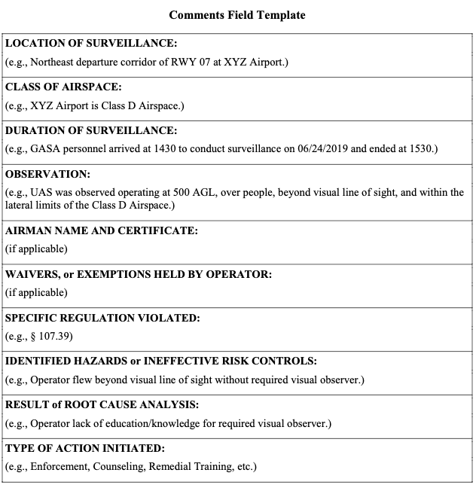

5) “Aircraft Reg #” (Aircraft Registration Number) Field. The “Aircraft Reg #” field is an optional field in the SAS AR record and shall be used if the UAS has a registration number that begins with “N” or the letters “FA.”
NOTE: When populating the “Aircraft Reg #” field for registration numbers that begin with the letters “FA,” the “Non N Registered” checkbox must be selected in order to allow the free text entry of the FA registration number and make/model/series (M/M/S).
6) “Non-Cert” (Non-Certificated) Field. The “Non-Cert” field is an optional field in a SAS AR.
7) “Cert Number” (Airman Certificate Number) Field. The “Cert Number” field is an optional field in the SAS AR record and shall be used to record the operator/pilot certificate number.
8) “Make/Model/Series” Field. The “Make/Model/Series” field is an optional field in SAS AR and will automatically populate the M/M/S for N-number-registered UAS aircraft. Authorized GASA personnel should enter the M/M/S, as applicable, for UAS registration numbers that begin with the letters “FA.”
NOTE: See Volume 16, Chapter 1, Section 4, paragraph 16-1-4-5 for more information about completing a SAS AR record for UAS activities.
16-5-2-23 FUTURE ACTIVITIES. Based on the inspection findings, determine if closer surveillance, outreach, enforcement, other job tasks, and/or additional coordination are required
to reestablish compliance.

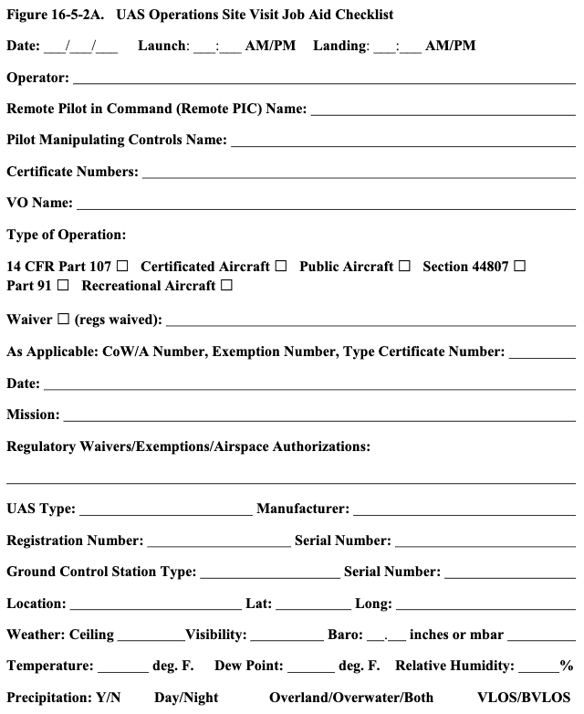
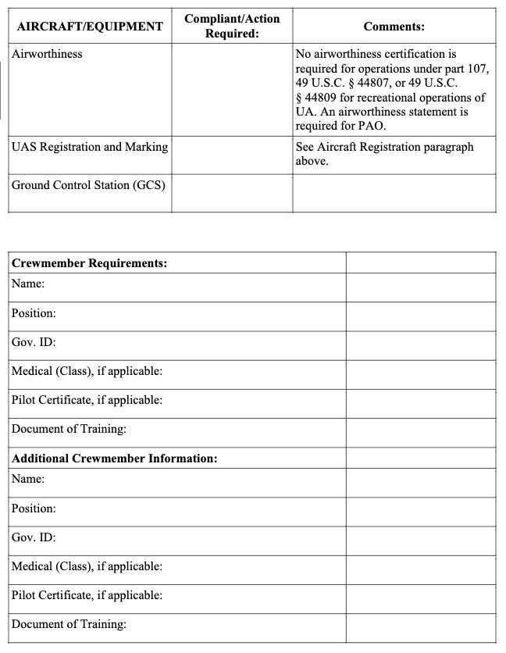

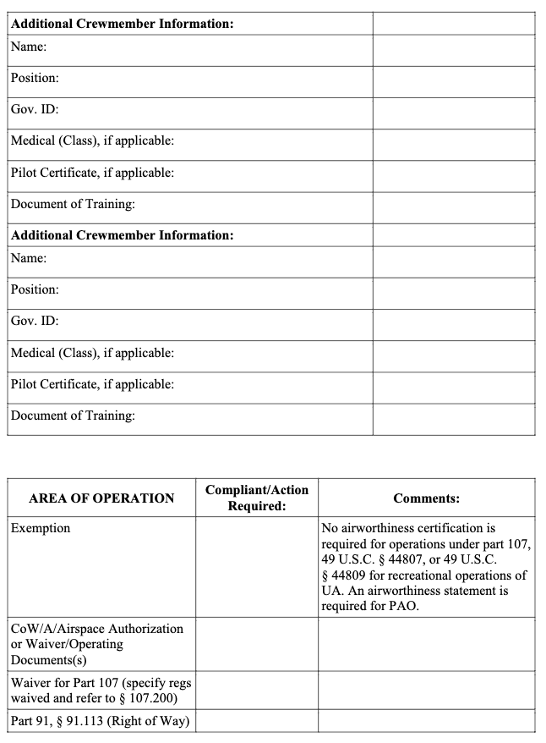
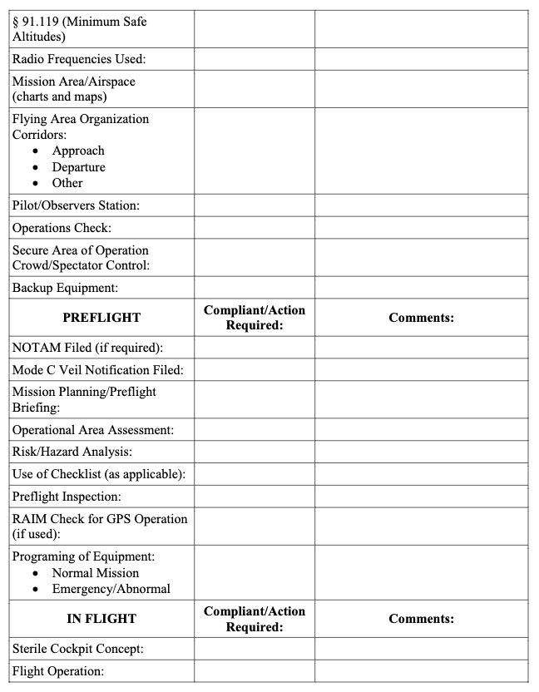

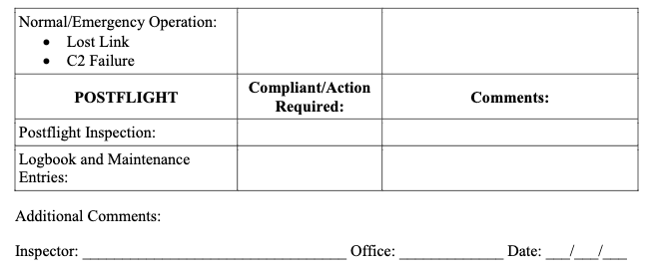

16-5-2-25 RELATED REGULATIONS AND PUBLICATIONS.
A. Title 14 CFR:
• Part 1, Definitions and Abbreviations.
• Part 11, General Rulemaking Procedures.
• Part 21, Certification Procedures for Products and Articles.
• Part 47, Aircraft Registration.
• Part 48, Registration and Marking Requirements for Small Unmanned Aircraft.
• Part 61, Certification: Pilots, Flight Instructors, and Ground Instructors.
• Part 89, Remote Identification of Unmanned Aircraft.
• Part 91, General Operating and Flight Rules.
• Part 107, Small Unmanned Aircraft Systems.
B. Title 49 CFR:
• Chapter I, Subchapter C, Hazardous Materials Regulations.
• Part 830, Notification and Reporting of Aircraft Accidents or Incidents and Overdue Aircraft, and Preservation of Aircraft Wreckage, Mail, Cargo, and Records.
• Part 1520, § 1520.5, Sensitive Security Information.
C. Related Publications (current editions).
1) ACs:
• AC 91-57, Exception for Limited Recreational Operations of Unmanned Aircraft.
• AC 107-2, Small Unmanned Aircraft System (Small UAS).
• *AC 120-51, Crew Resource Management Training.
• *AC 120-71, Standard Operating Procedures and Pilot Monitoring Duties for Flight Deck Crewmembers.
• *AC 120-92, Safety Management Systems for Aviation Service Providers.
2) FAA Orders:
• *Order JO 1000.37, Air Traffic Organization Safety Management System.
• Order JO 7110.65, Air Traffic Control.
• Order JO 7200.23, Processing of Unmanned Aircraft Systems Requests.
• Order JO 7210.3, Facility Operation and Administration.
• Order JO 7400.10, Special Use Airspace.
• Order JO 7610.4, Special Operations.
• *Order 8000.369, Safety Management System.
• Order 8020.11, Aircraft Accident and Incident Notification, Investigation, and Reporting.
• Order 8900.1, Flight Standards Information Management System.
D. Other Documents (current editions):
• FAA-S-ACS-10, Remote Pilot–Small Unmanned Aircraft Systems Airman Certification Standards (at https://www.faa.gov/training_testing/testing/acs/).
• FAASTeam Training Course, ALC-451, Part 107 Small UAS Initial —Part 61 Pilots (at https://www.faasafety.gov/gslac/ALC/course_content.aspx?pf=1&preview=true&cID=451).
• FAASTeam Training Course, ALC-515, Part 107 Small UAS Recurrent—Part 61 Pilots (at https://www.faasafety.gov/gslac/ALC/course_content.aspx?pf=1&preview=true&cID=515).
• FAASTeam Training Course, ALC-677, Part 107 Small UAS Recurrent (at https://www.faasafety.gov/gslac/ALC/course_content.aspx?pf=1&preview=true&
cID=677).
• Title 47 of the Code of Federal Regulations (47 CFR) Part 300, Manual of Regulations and Procedures for Federal Radio Frequency Management.
• Title 49 U.S.C. § 40102(a)(41).
• *Convention on International Civil Aviation (“Chicago Convention”), December 7, 1944, 61 Stat. 1180; 15 UNTS 295.
NOTE: Items marked with an asterisk (*) may only be appropriate as a reference or guidance to operators conducting flight operations under a grant of exemption.
Inspectors should exercise caution to ensure document applicability, and not apply regulatory requirements expected in traditional commercial flight operations. Though operators may be exempt from special airworthiness criteria, (e.g., commercial pilot training standards, typical training program criteria, etc.), inspectors should expect operators, flightcrew, maintenance staff, and VOs to be knowledgeable of, and adhere to, all relevant operating requirements (e.g., operating documents, grants of exemption, Letters of Authorization (LOA), Memorandums of Understanding (MOU), and CoW/A(s) issued by the FAA).

Section 3 Compliance and Enforcement
16-5-3-1 PURPOSE. This section provides guidance to inspectors on the process of contact and education generally to be provided to individuals who are the subject of an inquiry relating to an unauthorized or unsafe operation of Unmanned Aircraft Systems (UAS) in the National Airspace System (NAS) under certain parts of Public Law (PL) 112-95, Federal Aviation Administration (FAA) Reauthorization Act of 2018; Title 49 of the United States Code (49 U.S.C.) Chapter 447, Safety Regulations; 49 U.S.C. § 40102, Definitions; and Title 14 of the Code of Federal Regulations (14 CFR) parts 1 and 107.
16-5-3-3 AUDIENCE. The audience for this section is all Flight Standards District Office (FSDO) aviation safety inspectors (ASI) and aviation safety technicians (AST), and Flight Standards Service policy divisions responsible for implementation.
16-5-3-5 BACKGROUND. On February 14, 2012, the President signed into law the Modernization and Reform Act of 2012 (FMRA) (or “the Act”), which established FRMA Section 336, Special Rule for FRMA Model Aircraft. In October of 2018, the President signed
into law The FAA Reauthorization Act of 2018. The Reauthorization Act, Section 44809,
Exception for limited recreational operations of unmanned aircraft, repeals the Special Rule for
Model Aircraft and creates an exception for limited operations of unmanned aircraft. The
Reauthorization Act makes clear that the FAA has the authority under its existing regulations to
pursue legal enforcement action against a person operating any unmanned aircraft who endangers the safety of the National Airspace System.
A. Ensuring Safe UAS Operations. The increasing number of UAS-related incident reports arising from some model aircraft and small UAS operations indicates a potential risk to safety. In order to mitigate this risk, ensure compliance, and ensure safe operations from this community consistent with the compliance philosophy, the FAA will use outreach and education to encourage voluntary compliance with the applicable statutory and regulatory requirements that pertain to UAS operations. When necessary and in the interest of aviation safety, however, the
FAA will use administrative action or legal enforcement action to gain that compliance.
B. Aviation-Related Videos or Other Electronic Media on the Internet. UAS videos, in particular, are increasingly appearing on the internet. UAS videos may depict aircraft being flown in a variety of classes of airspace and at varying altitudes. Inspectors are to follow the protocol below when receiving notification of videos with potentially noncompliant UAS operations posted to the Internet.
C. Evidence. In all cases, the FAA must have acceptable evidence in support of all alleged facts in order to take legal enforcement action. Inspectors are reminded that:
1) Electronic media posted on the Internet is only one form of evidence which may be used to support an enforcement action and it must be authenticated.
2) Electronic media posted on the Internet is ordinarily not sufficient evidence alone to determine that an operation is not in compliance with 14 CFR. However, electronic media may serve as evidence of possible violations and may be retained for future enforcement action.
3) Inspectors have no authority to direct or suggest that electronic media posted on the Internet must be removed.
NOTE: Electronic media posted on a video website does not automatically constitute a commercial operation or commercial purpose, or other non-hobby or non-recreational use.
D. Program Tracking and Reporting Subsystem (PTRS) Documentation.
1) In the “14 CFR” field, enter “part 107.”
2) The inspector should list the remote pilot’s name in the “Airman” field and the certificate number in the “Cert Number” field. If the operator does not have an airman certificate, the inspector should list the operator’s name in the “Non Cert” field (last name, first name).
16-5-3-7 EDUCATION, COMPLIANCE, AND ENFORCEMENT PHILOSOPHY.
In determining what action to take, ASIs will evaluate the extent of the safety risk to the NAS that arises from any noncompliance associated with the UAS operation. An ASI should start by using counseling or an informational letter to advise and educate a UAS operator about the
requirements for regulatory compliance. This type of approach is most appropriate when an ASI
determines that regulatory compliance will likely be achieved by informing the operator about
how to comply with statutory and regulatory requirements. These informational letters will be
strictly advisory in nature, and will serve to provide the UAS operator with guidance on how to
conduct operations in accordance with applicable statutory and regulatory requirements. A sample informational letter is attached as Figure 16-5-3A, Sample UAS Informational Letter for
Inspectors.
A. NAS Enforcement Action. When an operator is uncooperative or intentionally noncompliant, or the operation poses medium to high risk to the NAS, enforcement action may be appropriate. In addition, repeat or intentional violations generally warrant legal enforcement action. In these cases, inspectors should follow the guidance provided in FAA Order 2150.3, Chapter 5, Voluntary Safety Programs; and Appendix H, Compliance and Enforcement Bulletin
No. 2014-2.
B. Administrative vs. Legal Enforcement Action. Inspector questions regarding how to evaluate a particular case with respect to taking administrative versus legal enforcement action should be coordinated with the Enforcement Division (AGC-300) contacts.
16-5-3-9 COMPLAINTS. ASIs are expected to investigate complaints in accordance with Volume 7 and use their judgment in determining the appropriate course of action. If the
investigating inspector or technician requires additional guidance or technical information
concerning UAS operations, he or she should contact the appropriate FSDO’s UAS specialist.
The FAA Compliance and Enforcement Policy is contained in Volume 14.
16-5-3-11 GUIDANCE.
A. Figure 16-5-3A, UAS Informational Letter Template for Inspectors.
B. References (current editions):
• FAA Order 2150.3, FAA Compliance and Enforcement Program.
• FAA Order 8130.34, Airworthiness Certification of Unmanned Aircraft Systems and Optionally Piloted Aircraft.
• FAA Order 8900.1, Volume 7, Investigation.
• FAA Order 8900.1, Volume 14, Compliance and Enforcement.

